T- Test
https://www.youtube.com/watch?v=2ARvj-8tJBs


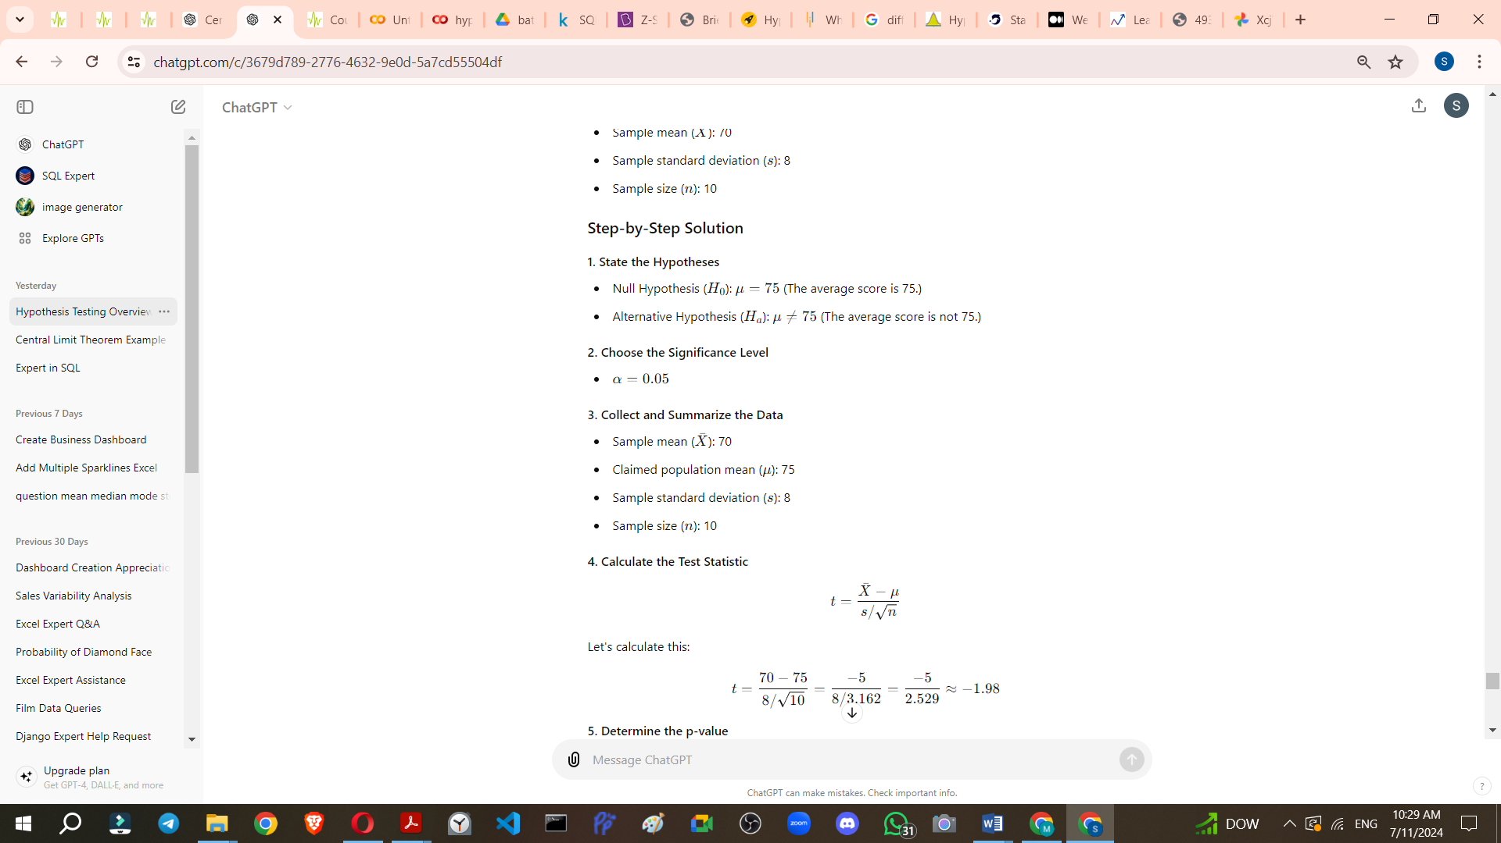
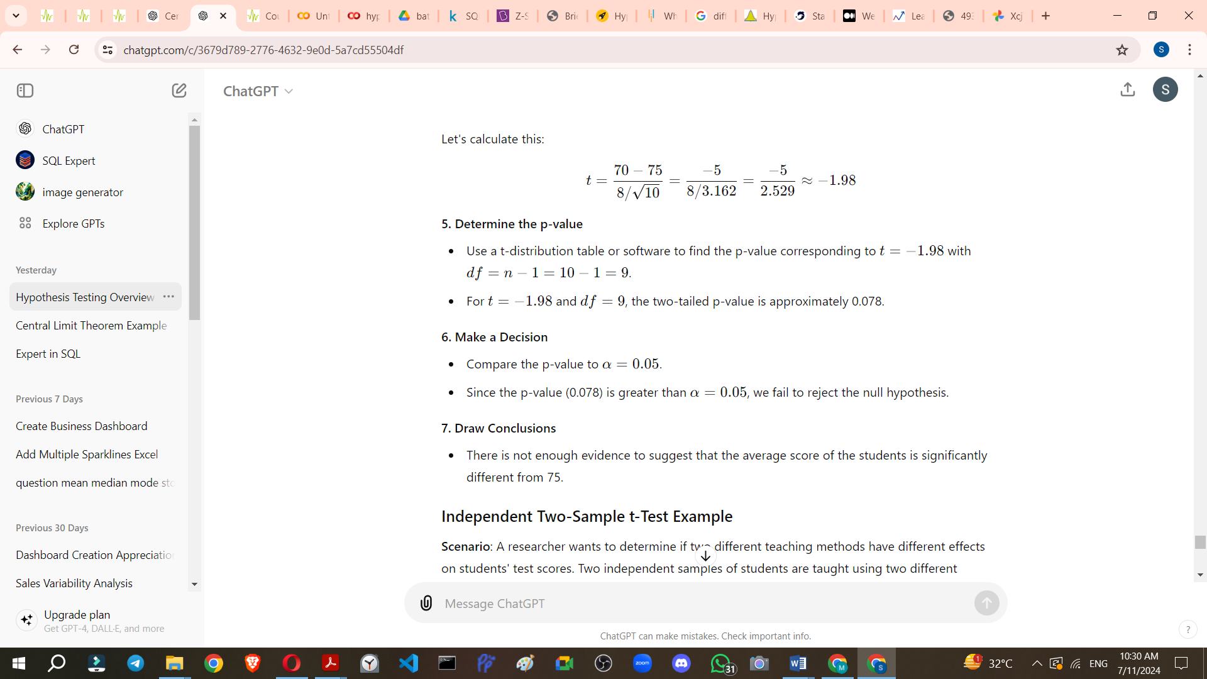
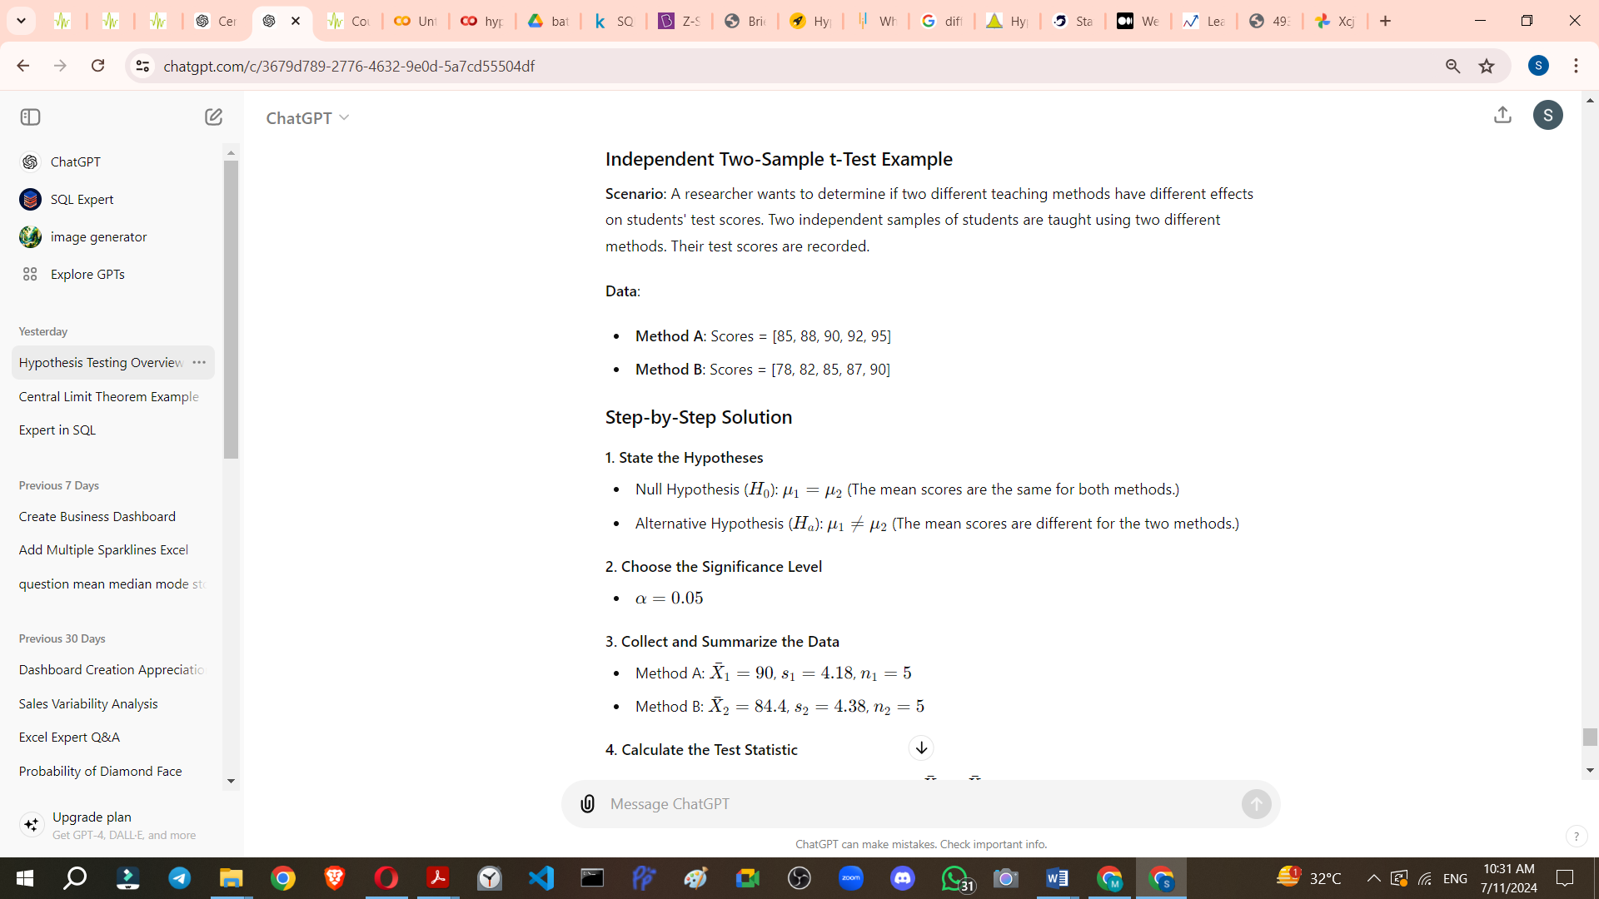

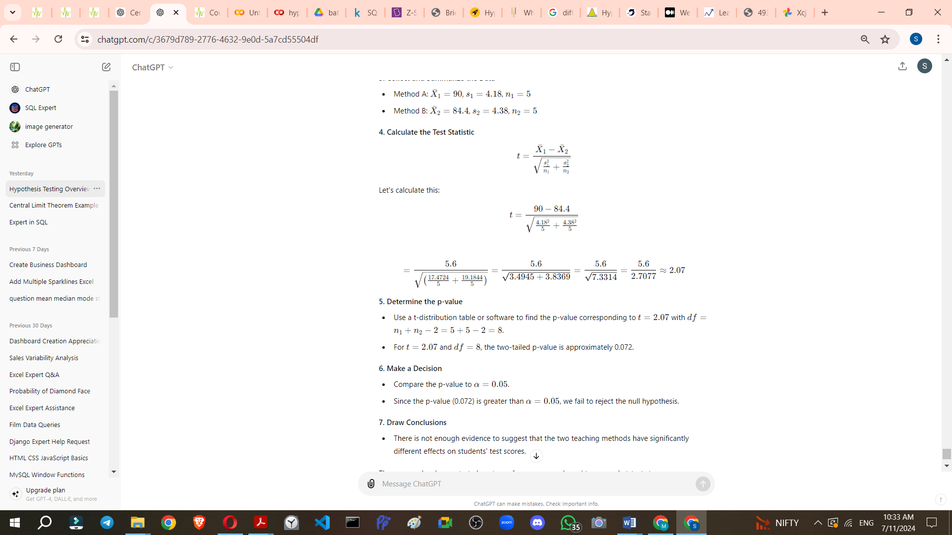

To calculate the p-value for a given t-statistic and degrees of freedom, you can follow these steps:
- Determine the t-statistic and degrees of freedom (df): These values are usually given from your t-test results.
- Use the cumulative distribution function (CDF): This function of the t-distribution gives the probability that a t-distributed random variable will fall below the given t-statistic.
- Calculate the p-value:
  - For a two-tailed test, you need to consider both tails of the distribution. Multiply the CDF result by 2.
  - For a one-tailed test, you can use the CDF result directly if the t-statistic is negative. If the t-statistic is positive, subtract the CDF result from 1.
Here are the steps in Python using the scipy.stats module:
from scipy.stats import t
# Given values
t_statistic = -1.98
df = 9
# Calculate the cumulative distribution function (CDF) for the given t-statistic and degrees of freedom
p_value_one_tailed = t.cdf(t_statistic, df)
# For a two-tailed test, multiply by 2
p_value_two_tailed = p_value_one_tailed * 2
print(p_value_two_tailed)

Explanation:
- t.cdf(t_statistic, df): This computes the cumulative probability up to the t-statistic value for the t-distribution with the given degrees of freedom.
- p_value = t.cdf(t_statistic, df) * 2: Since this is a two-tailed test, we multiply the one-tailed p-value by 2 to account for both tails of the distribution.
In the example provided:
- t_statistic = -1.98
- df = 9
- p_value = 0.07 9 (approximately)
The resulting p-value tells us the probability of observing a t-statistic as extreme as -1.98 under the null hypothesis.

