What is data modeling?
Data modeling is the process of analyzing and defining all the different data types your business collects and produces, as well as the relationships between those bits of data. By using text, symbols, and diagrams, data modeling concepts create visual representations of data as it’s captured, stored, and used at your business.

https://www.ibm.com/topics/data-modeling

The benefits of data modeling
By modeling your data, you can document what types of data you have, how you use it, and the data management requirements surrounding its usage, protection, and governance. The benefits of data modeling include:

- Creating a structure for collaboration between your IT and business teams.
- Revealing opportunities for improving business processes by defining data needs and uses.
- Saving time and money on IT and process investments through appropriate planning.
- Reducing errors (and error-prone redundant data entry) while improving data integrity.
- Increasing the speed and performance of data retrieval and analytics by planning for capacity and growth.
- Setting and tracking target key performance indicators tailored to your business objectives.
- it's not just about the results of data modeling, but how you get those results.

STAR SCHEMA
https://medium.com/@marcosanchezayala/data-modeling-the-star-schema-c37e7652e206

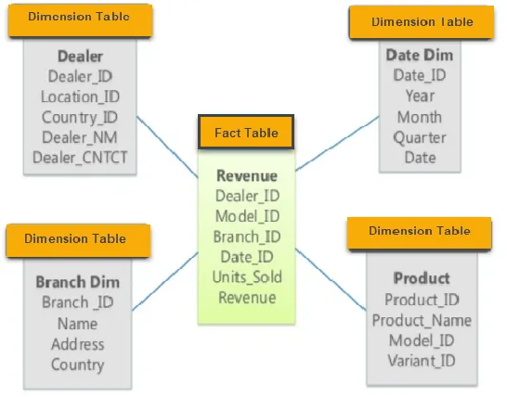

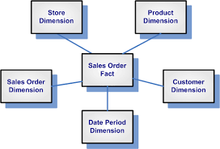

https://snowflakemasters.in/types-of-data-modelling/

