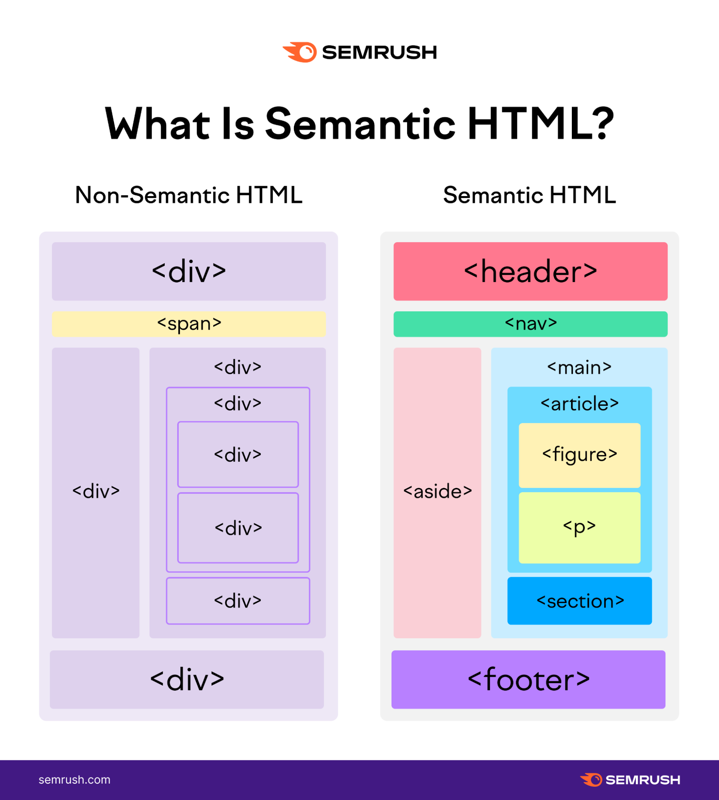

https://openclassrooms.com/en/courses/5265446-build-your-first-web-pages-with-html-and-css/5268106-create-general-page-structure

https://www.webcodegeeks.com/html5/html5-page-structure-example/

