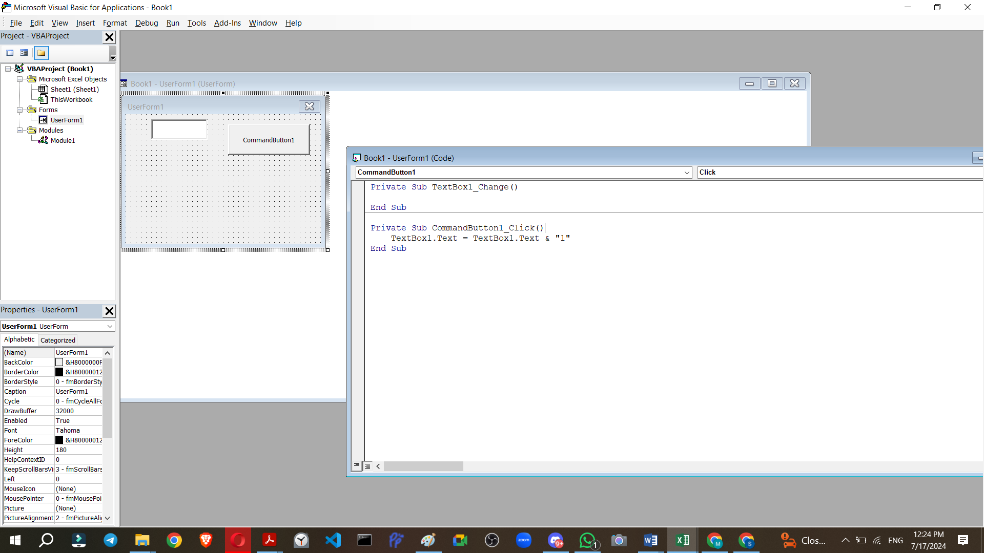

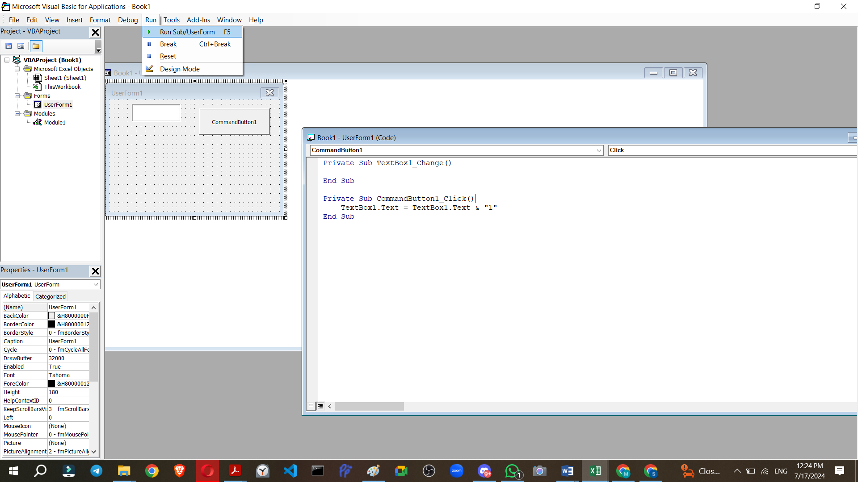

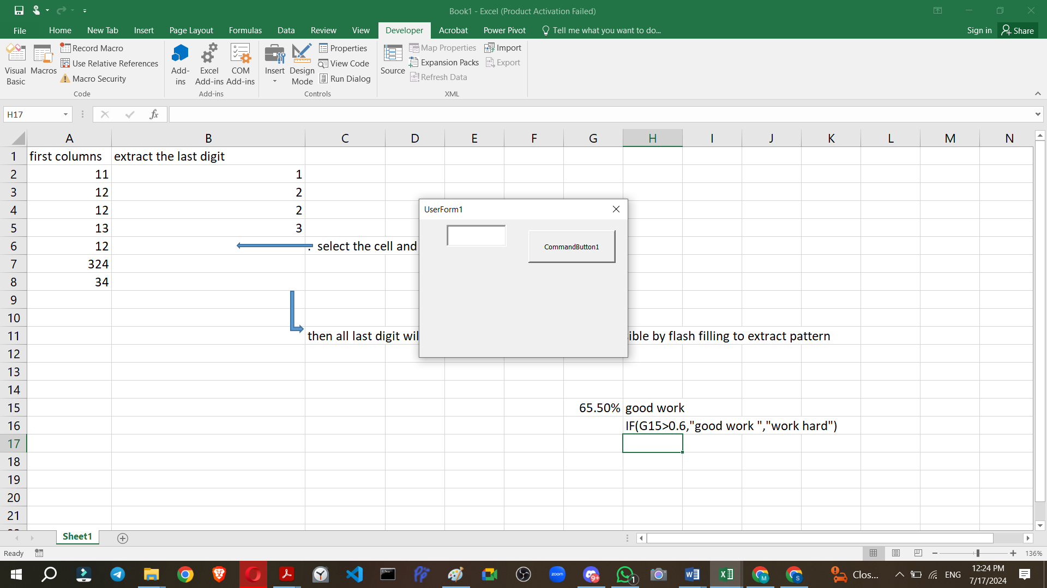

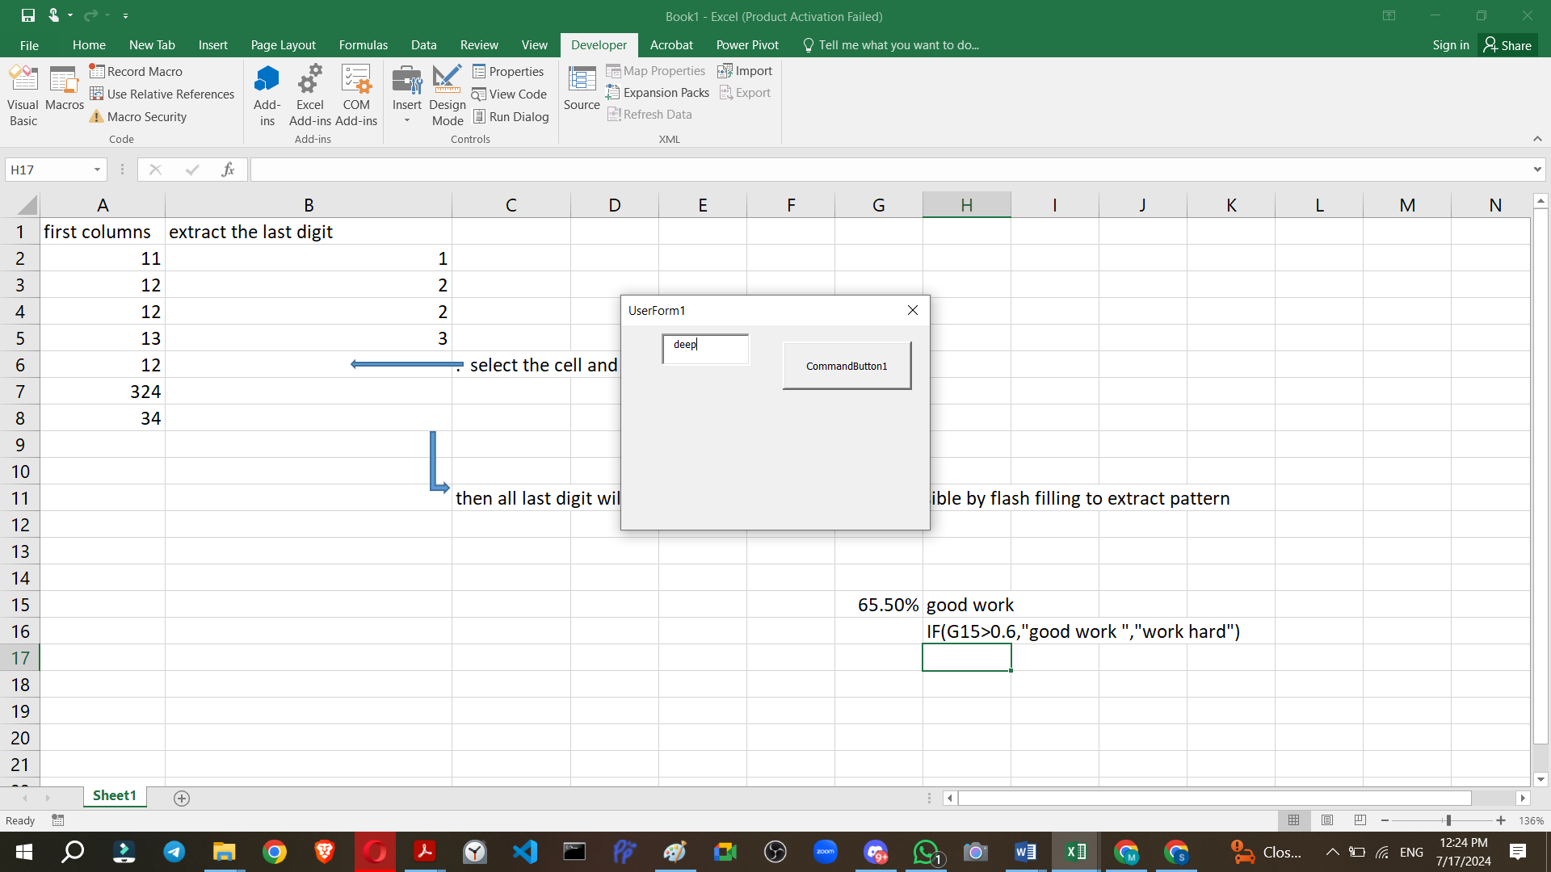

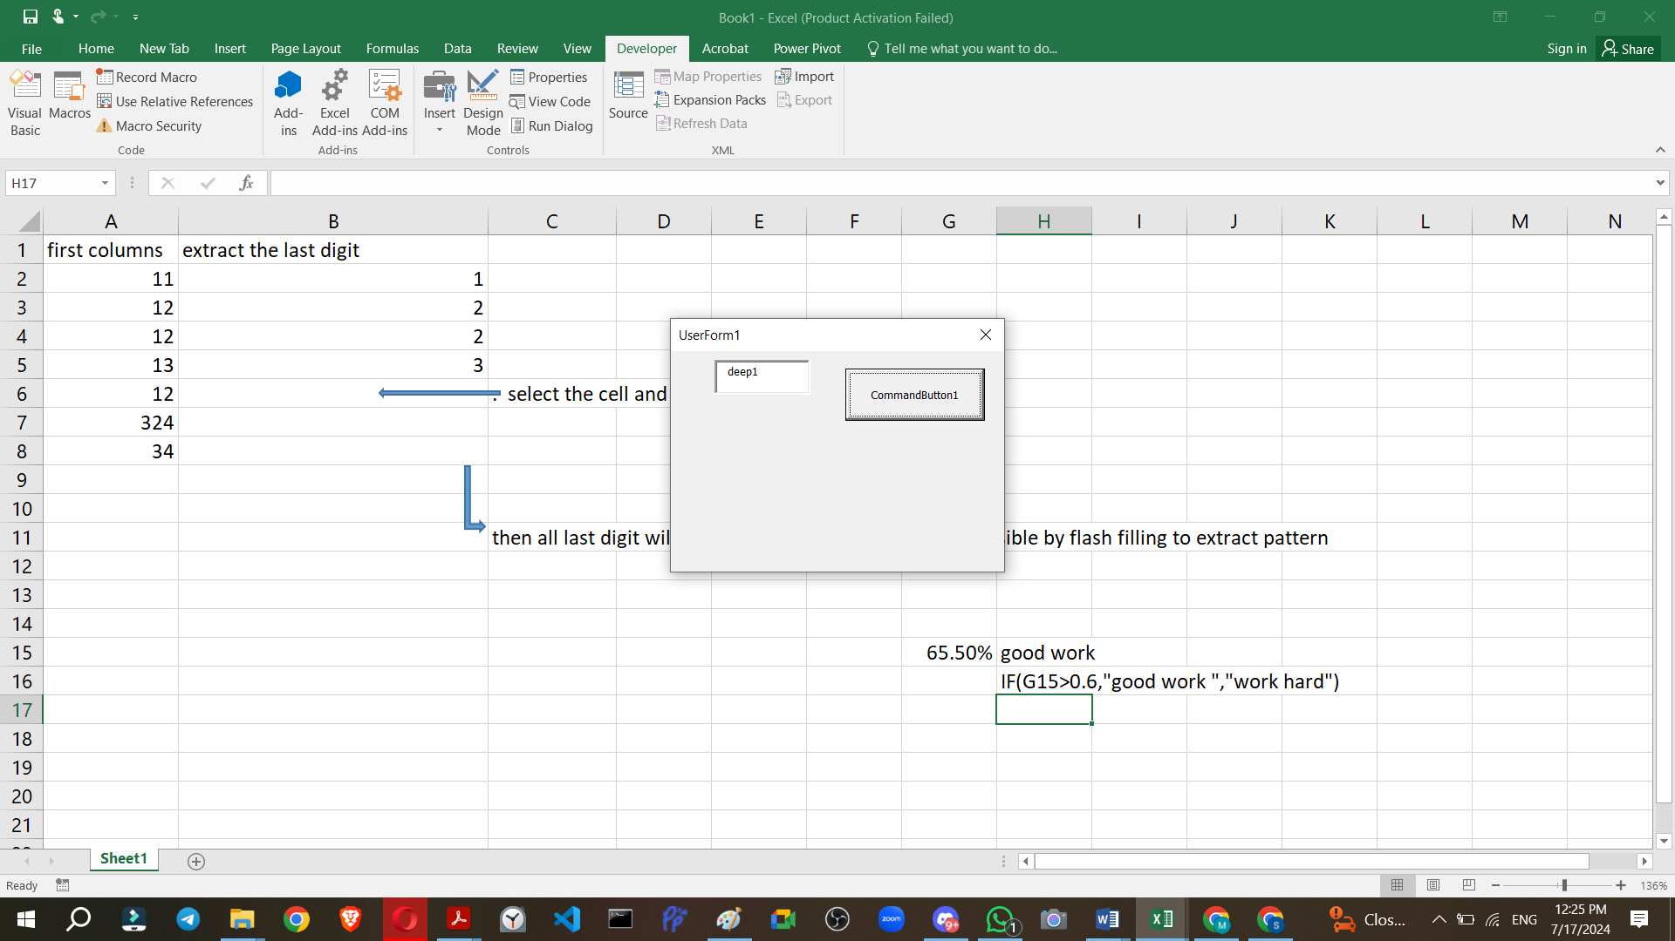



Here's a step-by-step guide to troubleshoot and resolve the error:

Step-by-Step Guide to Resolve Runtime Error

1. **Check Control Names**: Ensure that the control names in the VBA code match exactly with the names of the controls on the UserForm.
2. **Verify Control Existence**: Ensure that all the controls (TextBox1, CommandButton0, CommandButton00, CommandButton1, etc.) exist on the UserForm.
3. **Simplify and Test**: Start with a simplified version of the code to ensure that it works. Then gradually add more controls and code.

Step 1: Create a Simple UserForm

1. **Insert a UserForm**:
   * In the VBA editor, insert a new UserForm (Insert > UserForm).
2. **Add Controls**:
   * Add a TextBox to the UserForm and name it TextBox1.
   * Add a CommandButton to the UserForm and name it CommandButton1.
3. **Simplified Code**: Use the following simplified code to test:

Private Sub CommandButton1_Click()  
    TextBox1.Text = TextBox1.Text & "1"  
End Sub

Step 2: Test the Simplified UserForm

1. **Run the UserForm**:
   * Press F5 in the VBA editor to run the UserForm.
   * Click the CommandButton1 and ensure that "1" is appended to the TextBox1.

Step 3: Add Additional Controls

If the simplified UserForm works without any errors, proceed to add the remaining controls and code.

1. **Add More Controls**:
   * Add additional CommandButtons and name them CommandButton0, CommandButton00, CommandButton2, CommandButton3, CommandButton4, CommandButton5, CommandButton6, CommandButton7, CommandButton8, CommandButton9.
2. **Update the Code**: Update the VBA code to include the click events for the additional buttons.

Private Sub CommandButton0_Click()  
    TextBox1.Text = TextBox1.Text & "0"  
End Sub  
  
Private Sub CommandButton00_Click()  
    TextBox1.Text = TextBox1.Text & "0"  
End Sub  
  
Private Sub CommandButton1_Click()  
    TextBox1.Text = TextBox1.Text & "1"  
End Sub  
  
Private Sub CommandButton2_Click()  
    TextBox1.Text = TextBox1.Text & "2"  
End Sub  
  
Private Sub CommandButton3_Click()  
    TextBox1.Text = TextBox1.Text & "3"  
End Sub  
  
Private Sub CommandButton4_Click()  
    TextBox1.Text = TextBox1.Text & "4"  
End Sub  
  
Private Sub CommandButton5_Click()  
    TextBox1.Text = TextBox1.Text & "5"  
End Sub  
  
Private Sub CommandButton6_Click()  
    TextBox1.Text = TextBox1.Text & "6"  
End Sub  
  
Private Sub CommandButton7_Click()  
    TextBox1.Text = TextBox1.Text & "7"  
End Sub  
  
Private Sub CommandButton8_Click()  
    TextBox1.Text = TextBox1.Text & "8"  
End Sub  
  
Private Sub CommandButton9_Click()  
    TextBox1.Text = TextBox1.Text & "9"  
End Sub

Step 4: Test the UserForm Again

1. **Run the UserForm**:
   * Press F5 in the VBA editor to run the UserForm.
   * Click each CommandButton and ensure that the corresponding number is appended to the TextBox1.

Common Issues and Resolutions

* **Control Names**: Ensure all control names exactly match those in the code.
* **Form Initialization**: Ensure the UserForm and controls are correctly initialized.
* **Code Placement**: Ensure the code is placed within the correct UserForm module.

By following these steps, you should be able to identify and resolve the "Runtime Error 424: Object Required" in your VBA code. If issues persist, double-check the names and existence of the controls on your UserForm.