1. Longest Substring Without Repeating Characters: Given a string s, find the length of the longest substring without repeating characters.
2. 2 Sum Closest to Target: Given an array of integers nums and an integer target, find two numbers whose sum is closest to target and return that sum.
3. Rotate Image: Given an n x n 2D matrix, rotate it 90 degrees clockwise in place.

4. Kth Smallest Element in a Sorted Matrix: Given an n x n matrix where each row and column is sorted in ascending order, find the kth smallest element.

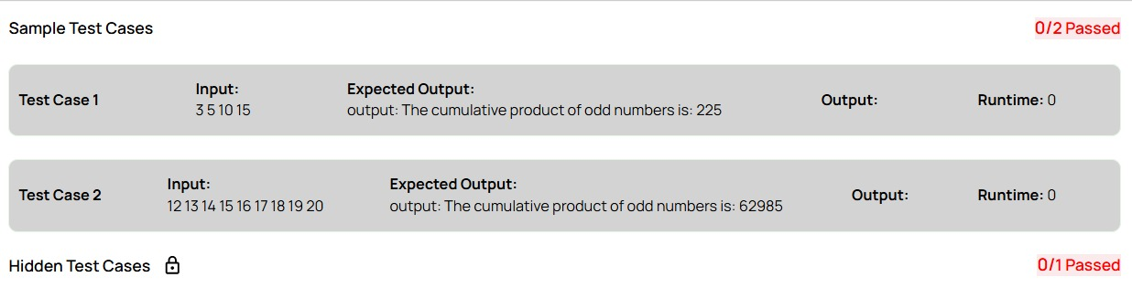

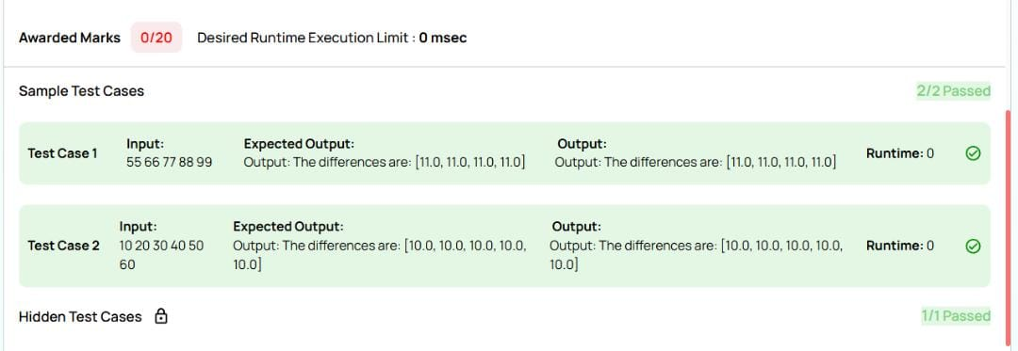

from functools import reduce

def cumulative_product_of_odds(data):

odd_numbers = [num for num in data if num % 2 != 0]

cumulative_product = reduce(lambda x, y: x * y, odd_numbers, 1)

return cumulative_product

# Test Case 1

input_data_1 = [3, 5, 10, 15]

print("The cumulative product of odd numbers is:", cumulative_product_of_odds(input_data_1))

# Test Case 2

input_data_2 = [12, 13, 14, 15, 16, 17, 18, 19, 20]

print("The cumulative product of odd numbers is:", cumulative_product_of_odds(input_data_2))

