Visualizing Continuous Data

Temperature data 🡪 **line** chart x, y value need , in line spike and dips show down, up stack,

Students marks 🡪 **Histograms** – group data in bins y frequency, x🡪 data aslo use in central tendency , distribution || normal distribution bell shap curve, also spred of data from central tendency

**Box blot chart** 🡪 median ,outlier, skwiness

**Scatter plot** 🡪 study score vs hours, show correlation

**Heat map** 🡪 color with

**Categorical data visualization**

**Bar chart** 🡪 frequency or count // also c || bar heights, high low, varying heights, also show trends when multiple cat data

**Pie chart** 🡪 relative to all

**Stack bar chart** 🡪 when multiple catogries and their subcategories

**Tree chart** 🡪 hierarical categorical data, in nested rectangles to represent the hierarchy perposional

**Word cloud** 🡪 spacily for text

# Visualizing Categorical Data

## Introduction:

Visualizing categorical data is a crucial step in exploratory data analysis. Categorical variables represent discrete and distinct groups or categories, such as gender, product types, or customer segments. By employing effective visualization techniques, we can gain insights into the distribution, relationships, and patterns within categorical data. In this article, we will explore various visualization methods and tools to effectively analyze and communicate categorical data.

**Bar Charts:**

Bar charts are one of the most common and intuitive ways to represent categorical data. They use rectangular bars to visualize the frequency or proportion of each category. The length of each bar represents the value, and the height represents the category. Bar charts can be simple, stacked, or grouped, depending on the complexity of the data. They allow for easy comparison between categories and are particularly useful for displaying nominal or ordinal variables.

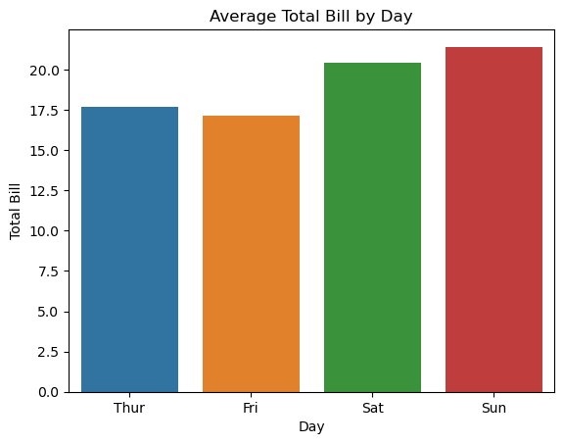

**Pie Charts:**

Pie charts are another popular choice for visualizing categorical data. They divide a circle into sectors, with each sector representing a category and the size of the sector corresponding to the proportion or percentage of that category. Pie charts provide a quick overview of the relative distribution of categories, making it easy to identify dominant or minority groups. However, they are best suited for representing a small number of categories to avoid clutter and confusion.

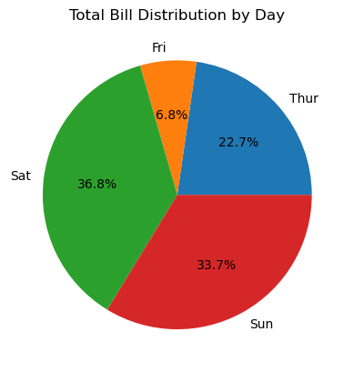

**Count Plots:**

Count plots are a specialized type of bar chart that displays the count of observations within each category. They are particularly useful for visualizing the frequency or occurrence of different categories. Count plots can be created using various libraries such as Seaborn, which provides additional customization options like color palettes and hue grouping.

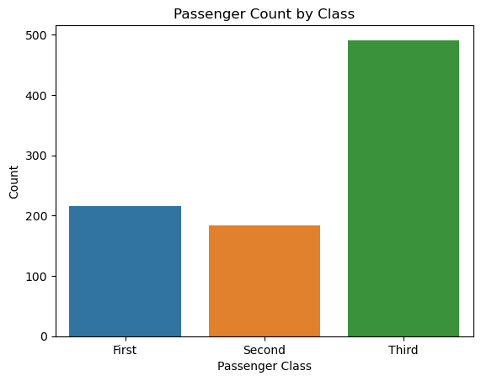

**Heatmaps:**

Heatmaps are effective for visualizing the relationship between two categorical variables. They use a grid of colored cells, with each cell representing the frequency or proportion of a particular combination of categories. Heatmaps help identify associations, dependencies, or disparities between categories, allowing us to uncover patterns and trends in the data.

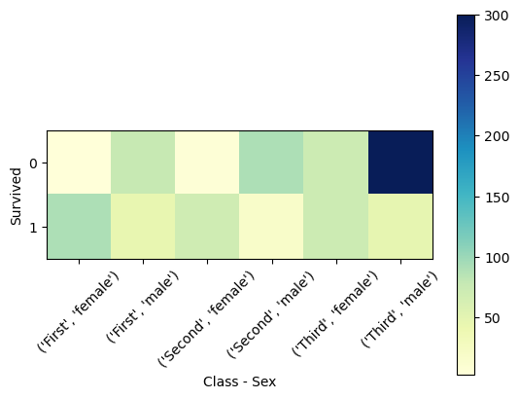

**Stacked Bar Charts:**

Stacked bar charts are useful when we want to compare the composition of categories across different groups or subcategories. They stack multiple bars representing different categories on top of each other, with each bar representing a subgroup or a specific category within a group. Stacked bar charts facilitate the comparison of proportions and provide insights into how the composition changes across groups.

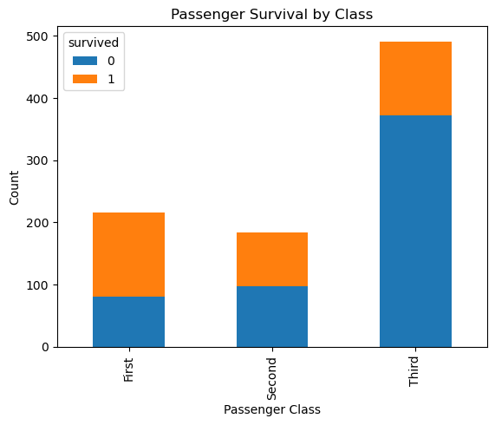

**Treemaps:**

Treemaps offer a unique way to visualize hierarchical categorical data. They use nested rectangles to represent categories, with the size of each rectangle reflecting its proportion within the hierarchy. Treemaps enable us to explore the composition of hierarchical structures, such as organizational hierarchies or nested product categories.

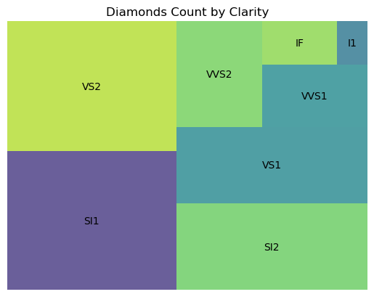

## Conclusion**:**

Visualizing categorical data is essential for understanding the distribution, patterns, and relationships within discrete groups. By utilizing techniques like bar charts, pie charts, count plots, heatmaps, stacked bar charts, and treemaps, we can gain valuable insights into categorical data. Whether we want to explore the frequency of categories, compare proportions, or analyze dependencies, visualizations provide a powerful tool to uncover meaningful information. By choosing the appropriate visualization method based on the data and objectives, we can effectively communicate and interpret categorical data, leading to better decision-making and deeper understanding.

# Visualizing Continuous Data

In the vast landscape of data analysis and exploration, one of the most crucial steps is transforming raw numbers into meaningful insights. Data visualization plays a vital role in this process, allowing us to understand complex patterns, relationships, and trends that might otherwise remain hidden. While data comes in various forms, continuous data is particularly fascinating due to its infinite nature. In this article, we will delve into the world of visualizing continuous data and explore the techniques that empower us to unlock valuable insights.

## What is Continuous Data?

Continuous data refers to information that can take on any value within a specific range. It is characterized by its unbroken, limitless nature, meaning it can take any value within a given interval. Examples of continuous data include temperature readings, time intervals, height measurements, and stock prices. Unlike categorical data, which consists of distinct categories or labels, continuous data provides a more granular representation of phenomena.

## Importance of Visualizing Continuous Data:

Continuous data often contains a wealth of information that can be difficult to grasp solely through numerical analysis. Visualizing this data helps to uncover patterns, trends, and anomalies that might be challenging to detect with statistical calculations alone. By representing continuous data visually, we can gain a deeper understanding of the underlying distributions, variations, and relationships within the dataset. This, in turn, enables us to make informed decisions and draw meaningful conclusions.

## Techniques for Visualizing Continuous Data:

**Histograms:**

Histograms are a widely used visualization technique for continuous data. They represent the distribution of data by dividing it into discrete bins or intervals along the x-axis and displaying the frequency or density of observations on the y-axis. Histograms provide insights into the shape, central tendency, and spread of the data, making it easier to identify patterns and outliers.

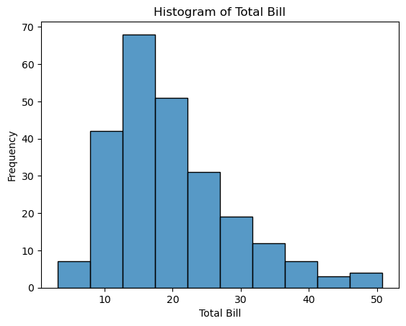

**Line Plots:**

Line plots, also known as line graphs, are effective for visualizing continuous data that changes over time or a continuous range. They display data points as individual markers connected by lines. Line plots are particularly useful for showcasing trends, fluctuations, and patterns in the data, allowing us to track changes and observe long-term behavior.

**EXCEL CHART**

<https://www.shiksha.com/online-courses/articles/types-of-charts-in-excel/>

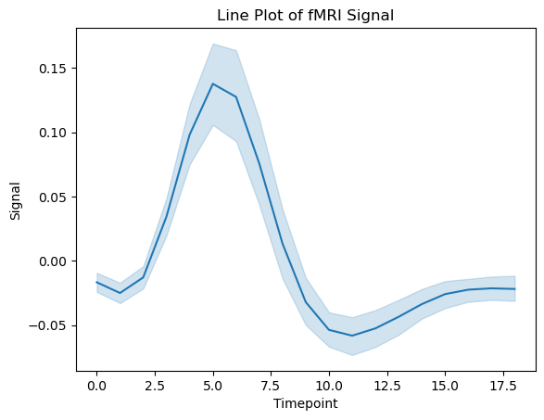

**Box Plots:**

Box plots, or box-and-whisker plots, provide a concise summary of the distribution of continuous data. They display the median, quartiles, and potential outliers, offering a visual representation of the dataset's central tendency, spread, and skewness. Box plots are valuable for comparing distributions and identifying unusual data points.

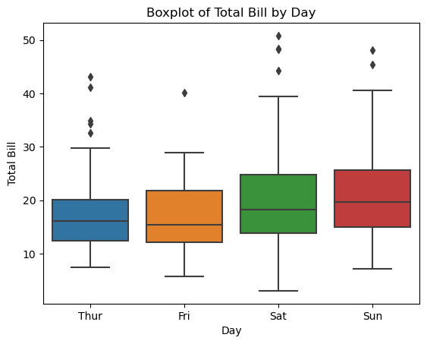

**Density Plots:**

Density plots illustrate the probability density function of continuous data. They provide an estimate of the underlying distribution by smoothing out individual observations. Density plots are useful for understanding the shape, multimodality, and symmetry of the data, enabling comparisons between different groups or variables.

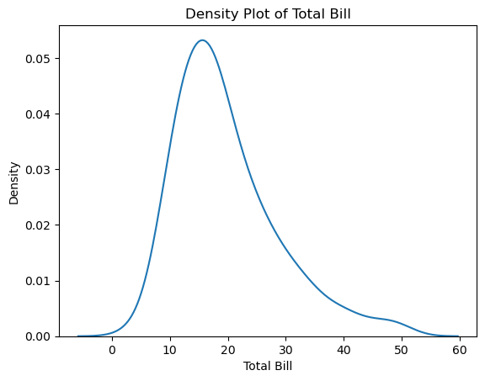

**Scatter Plots:**

Scatter plots are effective for visualizing the relationship between two continuous variables. Each data point is represented by a dot on a Cartesian plane, with one variable plotted on the x-axis and the other on the y-axis. Scatter plots allow us to observe patterns such as correlations, clusters, or outliers, enabling deeper insights into the association between variables.

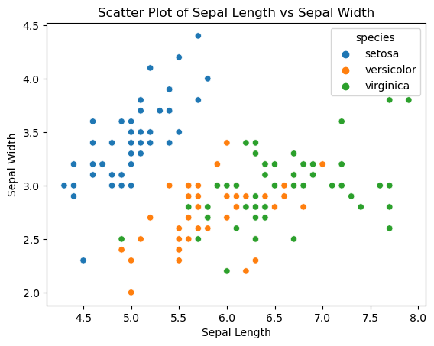

**Heatmaps:**

Heatmaps provide a visual representation of continuous data in a matrix format. They use colors to represent the magnitude or intensity of the values within the dataset. Heatmaps are commonly used in fields like genomics, finance, and meteorology to identify patterns, spatial relationships, and anomalies within large datasets.

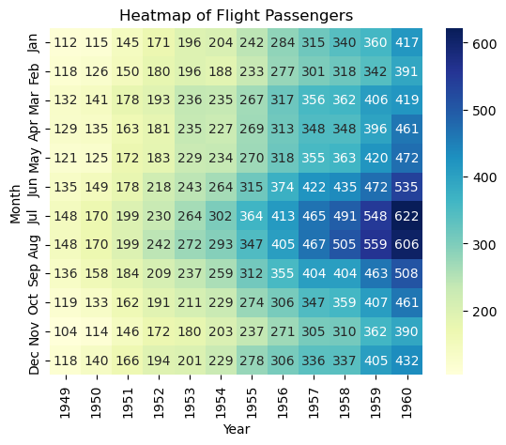

**Surface Plots:**

Surface plots, also known as 3D plots, are used to visualize continuous data in three dimensions. They represent the relationship between three continuous variables by mapping data onto a three-dimensional surface. Surface plots provide a comprehensive view of complex interactions and can uncover intricate patterns that might be challenging to grasp in lower dimensions.

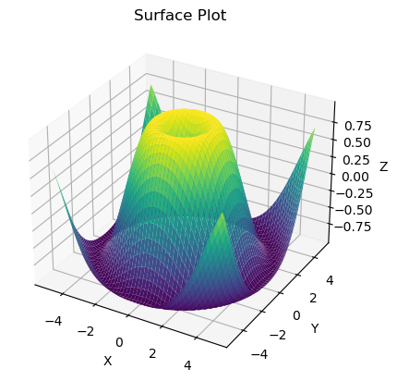

## Conclusion:

Visualizing continuous data is a powerful tool for gaining insights, identifying patterns, and making informed decisions. By employing techniques such as histograms, line plots, box plots, density plots, scatter plots, heatmaps, and surface plots, we can unlock the hidden potential of continuous data. These visualizations enable us to explore the distributions, relationships, and trends within the data, leading to deeper understanding and improved decision-making in various domains. So, harness the power of visualization and embark on a journey of discovery through your continuous data.

# Interpreting Graphs

Graphs and visualizations are powerful tools for presenting and analyzing data. They provide a visual representation of information that can help us understand complex relationships, patterns, and trends. Whether you are a data analyst, researcher, student, or simply curious about data, the ability to interpret graphs is a valuable skill. In this article, we will explore the importance of interpreting graphs and provide key insights into the process.

## Why Interpret Graphs?

Interpreting graphs allows us to extract meaningful insights from data and communicate those insights effectively. Here are a few reasons why interpreting graphs is crucial:

**Data Understanding:** Graphs provide a visual summary of data, allowing us to grasp the overall patterns and relationships. They help us understand the distribution of data, identify outliers, and observe trends and changes over time.

**Pattern Recognition:** Graphs enable us to recognize patterns that might not be immediately apparent from raw data. Patterns can be in the form of clusters, trends, correlations, or cycles. By identifying these patterns, we can gain a deeper understanding of the underlying phenomena.

**Comparison and Analysis:** Graphs facilitate the comparison of different datasets or variables. They allow us to analyze the relationships between variables, assess the impact of certain factors, and make informed decisions based on the observed patterns.

**Effective Communication:** Graphs provide a visual language that transcends barriers of technical jargon. They make it easier to communicate complex information to a diverse audience. A well-designed graph can convey insights more efficiently than lengthy textual explanations.

## Key Steps in Interpreting Graphs:

To effectively interpret graphs, it is important to follow a structured approach. Here are some key steps to consider:

**Understand the Data:** Start by gaining a clear understanding of the data being presented. Consider the source, context, and the variables represented in the graph. Pay attention to the units, scales, and any transformations applied to the data.

**Examine the Axes:** Analyze the axes of the graph, both the x-axis and y-axis. Identify the variables being plotted and their respective scales. Determine whether the scales are linear or logarithmic, as this can affect the interpretation of the data.

**Identify Patterns and Trends:** Look for patterns, trends, or any notable features in the graph. Are there any consistent upward or downward trends? Are there sudden spikes or dips? Identify clusters or groups of data points that may indicate distinct categories or subgroups.

**Assess Relationships:** If the graph represents the relationship between two or more variables, assess the nature of that relationship. Is it linear, exponential, or logarithmic? Are there any correlations or dependencies between the variables?

**Consider Context and External Factors:** Take into account the broader context and any external factors that may influence the observed patterns. Consider factors such as time, geography, demographics, or experimental conditions.

**Validate and Interpret:** Validate your initial observations by cross-referencing with additional data or information. Formulate hypotheses or explanations for the observed patterns based on your understanding of the data and domain knowledge.

**Communicate Insights:** Finally, effectively communicate your insights derived from the graph. Use clear and concise language to describe the observed patterns, trends, and relationships. Highlight the key takeaways and support your conclusions with evidence from the graph.

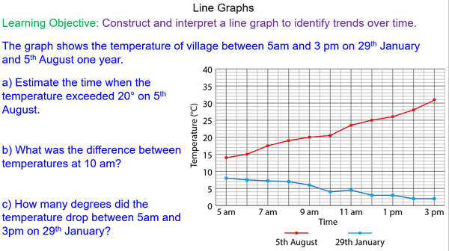

## Common Types of Graphs and Interpretation Tips:

Graphs come in various forms, each serving a specific purpose. Here are some common types of graphs and tips for interpreting them:

**Line Graphs:** Line graphs are useful for showing trends and changes over time. Pay attention to the slope of the line, as it indicates the rate of change. Identify any significant deviations or anomalies in the data.



**Bar Charts:** Bar charts display categorical data and allow for easy comparison between different categories. Analyze the height or length of the bars to determine the magnitude of each category. Look for patterns or differences between the categories.



**Pie Charts:** Pie charts represent parts of a whole and show the proportion or percentage distribution of categories. Identify the largest and smallest segments and assess the relative proportions. Be cautious with interpreting small slices or slices with similar sizes.



**Scatter Plots:** Scatter plots show the relationship between two variables. Assess the dispersion of points, the overall trend (if any), and the concentration of points in certain areas. Look for clusters or outliers that may indicate specific patterns or exceptions.



**Heatmaps:** Heatmaps display data using color gradients, often in a matrix format. Pay attention to the intensity of the colors to identify areas of high or low values. Look for patterns or clusters in the heatmap.



Remember, the interpretation of graphs should always be done in the context of the specific data and research question at hand. It is crucial to approach graph interpretation with curiosity, critical thinking, and an open mind.

## Conclusion:

Interpreting graphs is a valuable skill that allows us to extract insights, identify patterns, and communicate complex information effectively. By following a structured approach and considering key elements of the graph, we can unlock a deeper understanding of the data. Graphs empower us to explore and make sense of the world through visual representations of data. So, embrace the power of graphs, sharpen your interpretation skills, and embark on a journey of discovering meaningful insights in the vast realm of data.