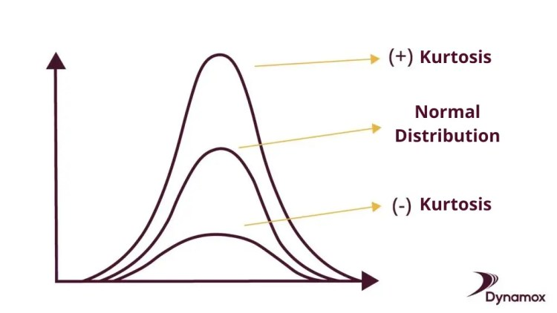

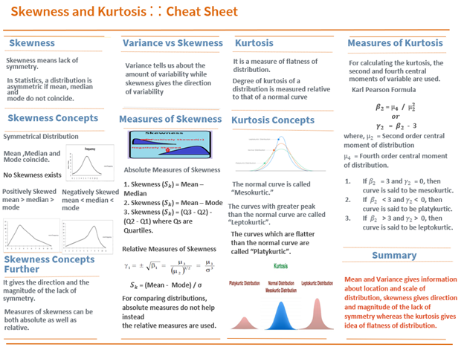



If k= 3 means good to go.

use case for skewness:

**Skewness Use Case: Analyzing Income Distribution**

* **Data Collection**: Gather monthly income data from diverse individuals.
* **Data Analysis**: Calculate skewness to understand income distribution shape.
* **Interpretation**: Positive skewness indicates income inequality.
* **Insights**: Inform policymaking, economic analysis, and modeling considerations.
* **Modeling**: Skewed data may require transformations for accurate modeling.

**Kurtosis Use Case: Analyzing Investment Returns**

* **Data Collection**: Gather historical return data for portfolios.
* **Data Analysis**: Calculate kurtosis to assess risk characteristics.
* **Interpretation**: Positive kurtosis indicates heavier tails, while negative kurtosis indicates lighter tails.
* **Risk Assessment**: Higher kurtosis implies higher risk of extreme returns.
* **Investment Strategy**: Use kurtosis to inform portfolio construction and risk management strategies.
* **Modeling Considerations**: Consider kurtosis in financial modeling for assessing portfolio risk and designing investment strategies.

**Kurtosis in Machine Learning**

* **Feature Engineering**:
  + Identify and transform features with non-normal distributions using kurtosis.
* **Transformation**:
  + Adjust feature distributions to improve model performance.
* **Improved Accuracy**:
  + By handling kurtosis, enhance model accuracy and generalization.
* **Iterative Process**:
  + Experiment and fine-tune feature engineering for optimal results.

Top of Form