**Statistical/Hypothesis Tests** are used to make the generalization/summarize about the population from the sample. These tests are used to check whether there is a enough evidence in sample data to conclude/deduce that any particular/specific/certain condition is also true for entire population.

**Certain condition/pattern of sample≈ Certain condition/pattern for population**

These test completely relies on the probability distribution, to support Hypothesis.We perform these tests to know the below :  
1) **Comparison**: Is there any difference between two data-sets/groups/data.  
2) **Relationship**: Is there any connection between two groups/columns/data/variables.

There are various ways to achieve/perform a Statistical/Hypothesis tests on data depending upon the type of variables in the data and type of test.  
There are two types of tests in Statistical/Hypothesis Tests.  
1) **Parametric tests**  
2) **Non Parametric Tests**

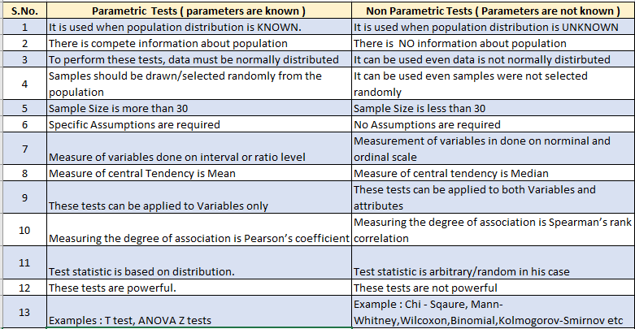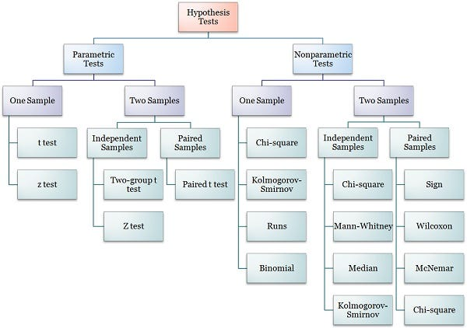

1. **Z-Test**( the sample is assumed to be normally distributed )  
   (population mean and population standard deviation are known)  
   Used to validate hypothesis that the sample drawn belongs to the same population. *Null : Mean of sample = Mean of population  
   Alternate : Mean of sample*≠*Mean of population*
2. **T-Test**( the sample is assumed to be normally distributed )  
   (population mean and population standard deviation are known)  
   Used to compare the mean of only two given samples. ( for three , we used ANOVA).  
   3 Types of T-Test : One sample , Independent and Paired. *Large T-Test Score = group are different  
   Small T-Test Score = Group are same  
   Null : Mean of one sample = Mean of other sample  
   Alternate : Mean of other sample*≠*Mean of other sample*
3. **ANOVA Test ( Analysis of Variance ) :**(random sample, Homogeneity, Normality) (2 Types of Anova: One Way Anova and Multi-Way Anova )  
   Used to compare multiple (three or more) samples with a single test/multiple tests and used to compare datasets as well. *Null : All samples are equal  
   Alternate : All samples are not equal*
4. **Chi-Square Test (χ2)**( Comparison and Categorical )  
   *Used to compare 2 or more categorical variables.*Types :  
   i. Goodness of fit test, which determines if a sample matches the population.  
   ii. A chi-square fit test for two independent variables is used to compare two variables in a contingency table to check if the data fits.  
   a. A small chi-square value means that data fits  
   b. A high chi-square value means that data doesn’t fit.  
   *Null: Variable A and Variable B are independent  
   Alternate: Variable A and Variable B are not independent.*

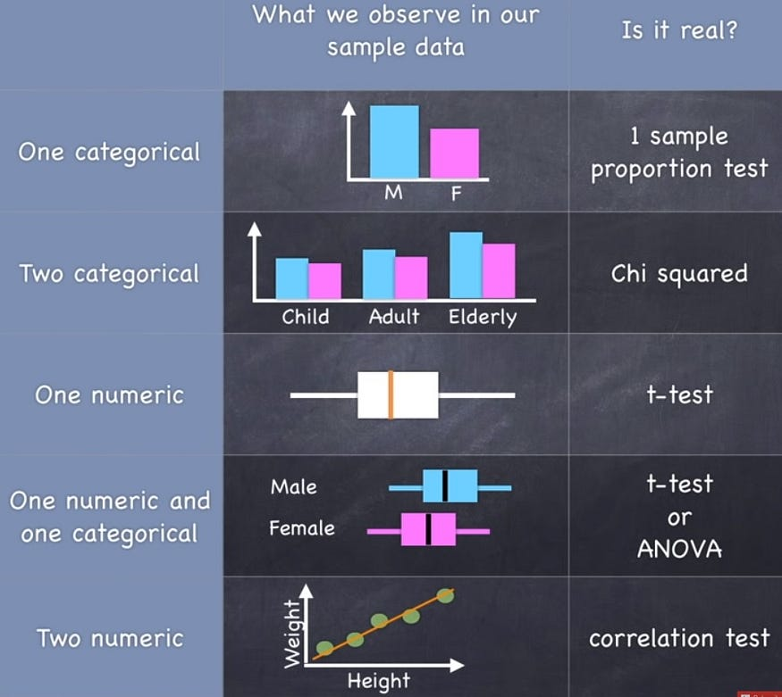

These topics are very complicated and i have tried my best to cut it down to very brief , not to bombard with formulas and heavy jargon

