T- Test

<https://www.youtube.com/watch?v=2ARvj-8tJBs>

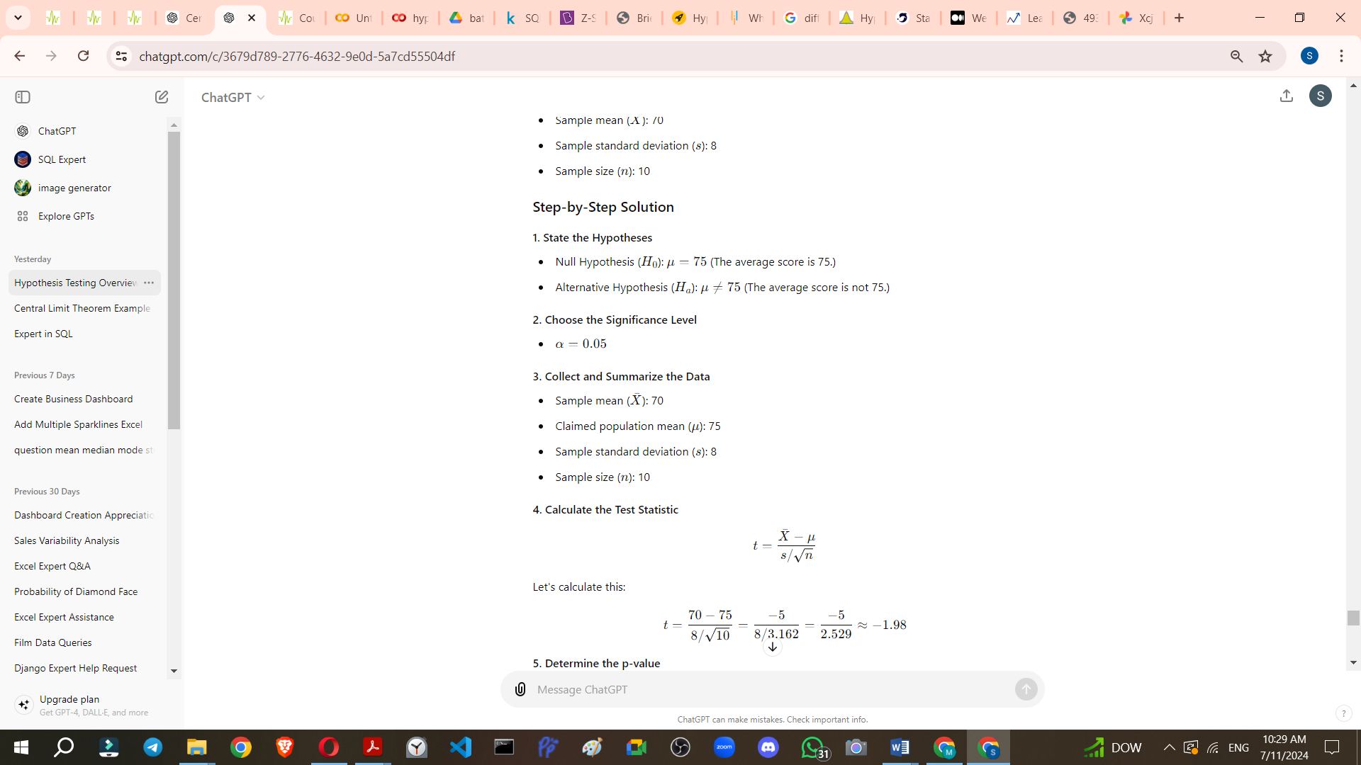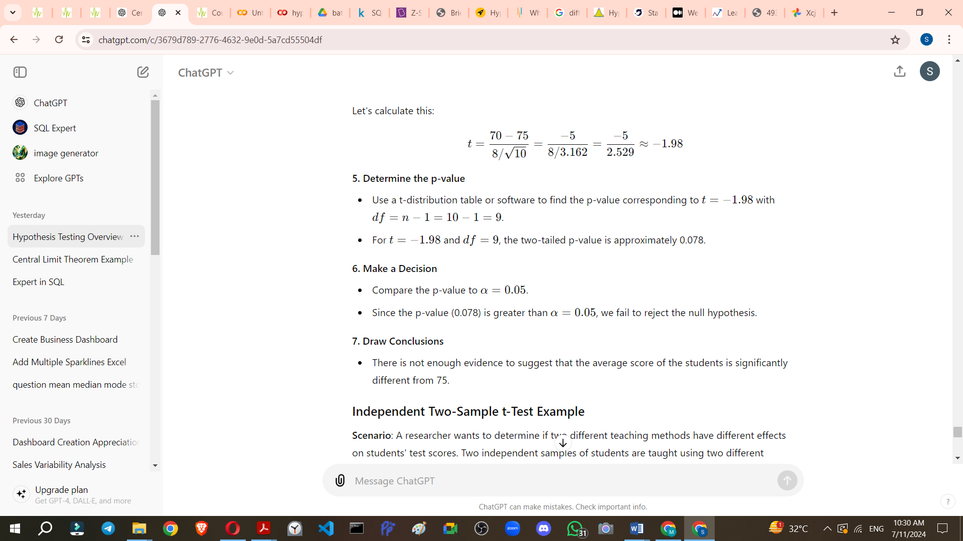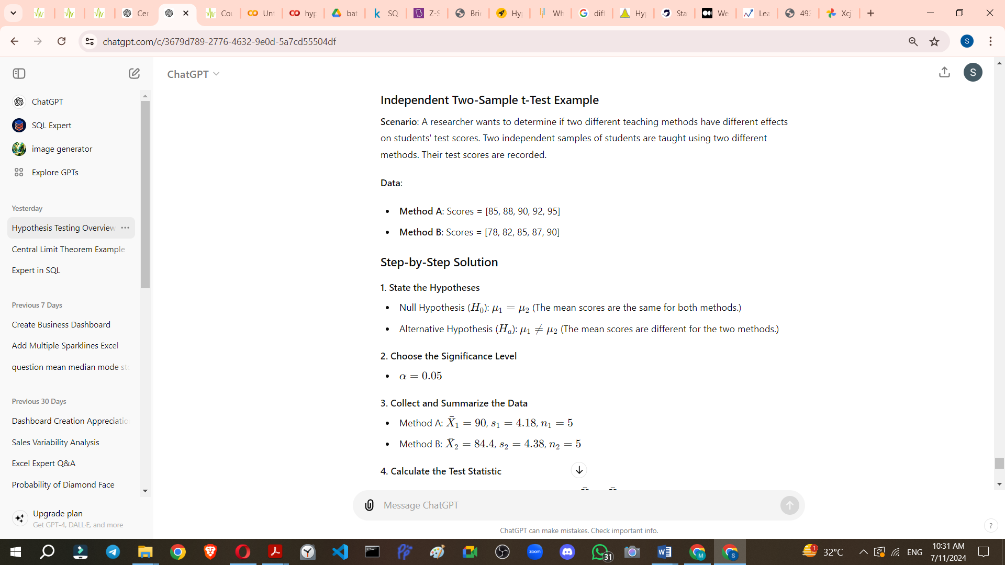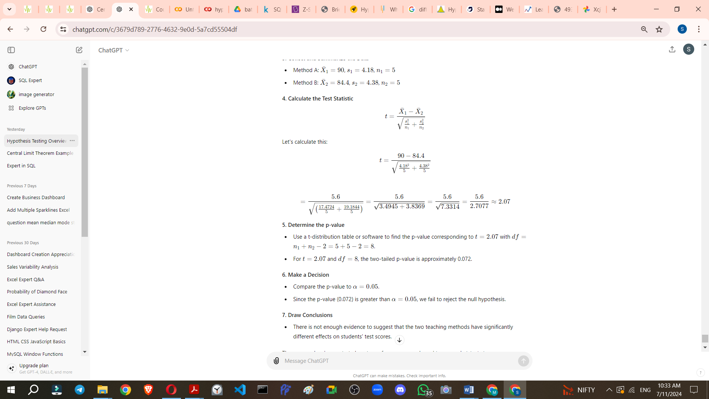

To calculate the p-value for a given t-statistic and degrees of freedom, you can follow these steps:

1. **Determine the t-statistic and degrees of freedom (df)**: These values are usually given from your t-test results.
2. **Use the cumulative distribution function (CDF)**: This function of the t-distribution gives the probability that a t-distributed random variable will fall below the given t-statistic.
3. **Calculate the p-value**:
   * For a two-tailed test, you need to consider both tails of the distribution. Multiply the CDF result by 2.
   * For a one-tailed test, you can use the CDF result directly if the t-statistic is negative. If the t-statistic is positive, subtract the CDF result from 1.

Here are the steps in Python using the scipy.stats module:

from scipy.stats import t  
  
# Given values  
t_statistic = -1.98  
df = 9  
  
# Calculate the cumulative distribution function (CDF) for the given t-statistic and degrees of freedom  
p_value_one_tailed = t.cdf(t_statistic, df)  
  
# For a two-tailed test, multiply by 2  
p_value_two_tailed = p_value_one_tailed * 2  
  
print(p_value_two_tailed)

Explanation:

1. **t.cdf(t_statistic, df)**: This computes the cumulative probability up to the t-statistic value for the t-distribution with the given degrees of freedom.
2. **p_value = t.cdf(t_statistic, df) * 2**: Since this is a two-tailed test, we multiply the one-tailed p-value by 2 to account for both tails of the distribution.

In the example provided:

* **t_statistic = -1.98**
* **df = 9**
* **p_value = 0.07 9 (approximately)**

The resulting p-value tells us the probability of observing a t-statistic as extreme as -1.98 under the null hypothesis.