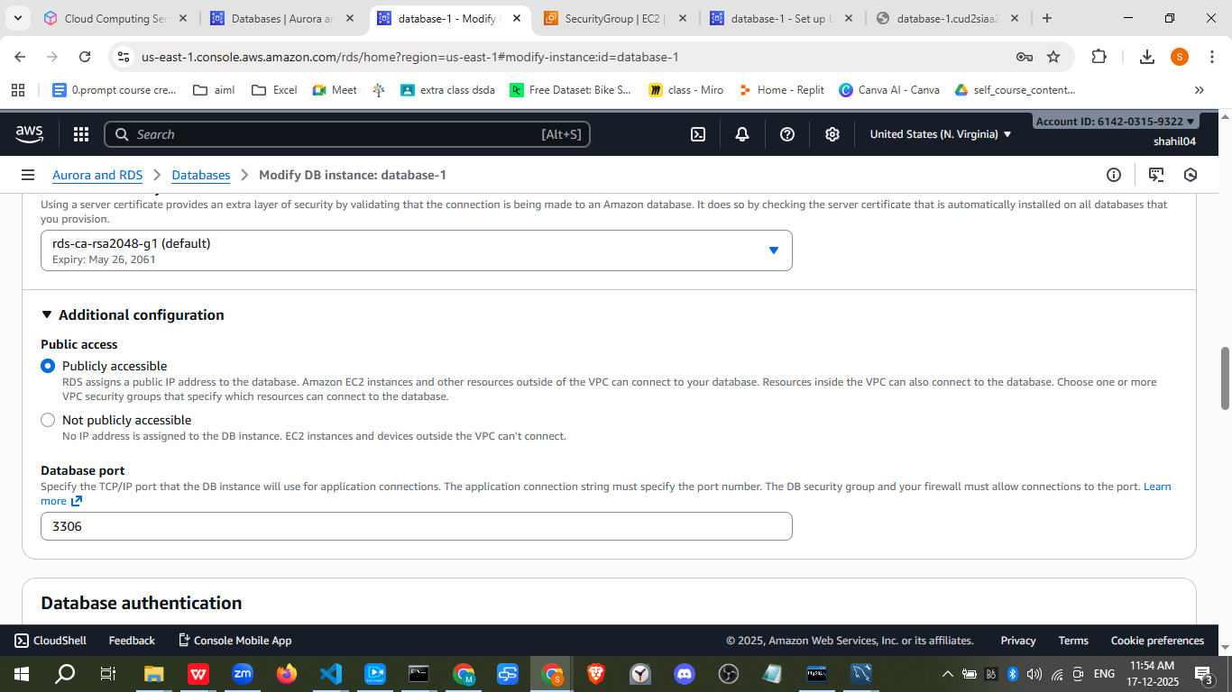

To connect to a MySQL database on Amazon RDS, you must configure both the AWS environment and your local database client.
1. Configure Connectivity in AWS
Before attempting to connect, ensure your RDS instance is accessible:
- Enable Public Access: In the Amazon RDS Console, select your DB instance and verify that Public accessibility is set to Yes.
- Configure Security Groups:
  - Navigate to the Connectivity & security tab of your RDS instance.
  - Click on the active VPC security group.
  - Select the Inbound rules tab and click Edit inbound rules.
  - Add a new rule: set Type to MySQL/Aurora, Port Range to 3306, and Source to My IP (recommended for security) or Anywhere-IPv4.
2. Retrieve Connection Details
Copy the following details from the Connectivity & security tab in the RDS console:
- Endpoint: The DNS name (e.g., mydb.cxyz.us-east-1.rds.amazonaws.com).
- Port: Default is 3306.
- Master Username & Password: These were set during the initial database creation.
3. Connect via Database Client
You can use standard SQL clients like MySQL Workbench or the command-line interface.

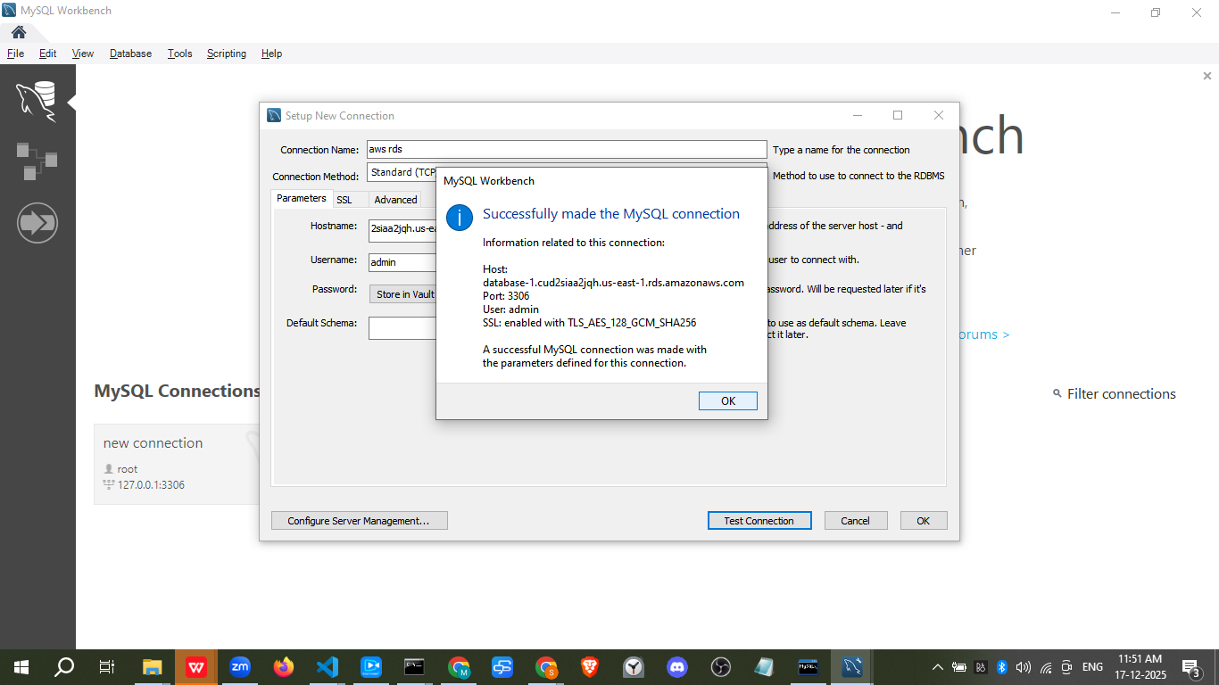

mysql -h database-1.cud2siaa2jqh.us-east-1.rds.amazonaws.com -P 3306 -u admin -p

