SMART PANTRY MANAGER
Android Application Project Report

Student: Shahil Lee Naidoo
Student Number: 402413326
Module: Mobile App Development 700
Submission Date: 21 October 2026

GitHub Repository
https://github.com/shahilnaidoo17-png/Smart-Pantry-Manage

Table of Contents
1. Introduction
2. System Design and Architecture
3. Application Screenshots and Core Functions
4. Code Examples and Explanations
5. Challenges and Solutions
6. Testing and Results
7. Conclusion and Reflection
8. References

1. Introduction
Smart Pantry Manager is an Android application designed to help users keep track of food and ingredients stored at home. Users can record pantry items, manage quantities and expiry dates, and explore recipe suggestions based on the ingredients they have available.
The project was developed in Java for Android. It uses Android Studio/Gradle project tooling and Room, an Android persistence library, over a local SQLite database. The application is intended to make household food management easier and help users make better use of ingredients before they expire.

Project objectives
- Provide a simple interface for viewing and managing pantry items.
- Support adding, editing and deleting pantry records.
- Store item quantities and expiry information locally.
- Suggest recipes using ingredient availability and matching rules.
- Provide recipe details and user settings.
- Test core matching logic with automated unit tests.

2. System Design and Architecture

2.1 Technology stack
- Language: Java.
- Platform: Android, with minimum SDK API 24 (Android 7.0).
- Local persistence: Room ORM with SQLite.
- Database name: smart_pantry.db.
- Build system: Gradle.
- Testing: JUnit 4.13.2; automated unit tests are run through Gradle.

2.2 Main application screens
The application is organised around five main screens or areas: the pantry list, add/edit item form, suggested recipes, recipe details, and settings. The pantry list is used to review stored ingredients. The form supports creating and updating records. Recipe suggestions use pantry contents to identify possible meals, while recipe details provide further information. Settings allow users to control expiry-related alerts and whether expired ingredients should be ignored.

2.3 Data model
The local database contains three principal entities: PantryItem, Recipe, and RecipeIngredient. Pantry items store the ingredients available to the user, including quantities and expiry dates. Recipes store recipe-level information. RecipeIngredient links a recipe to its required ingredients.
Entity | Purpose | Relationship
pantry_items | Stores pantry ingredient records and quantities. | Individual pantry records.
recipes | Stores recipe information. | One recipe can have multiple ingredient requirements.
recipe_ingredients | Stores the ingredients required by recipes. | Links to a recipe; foreign-key cascade behaviour is configured.
Room provides an abstraction over SQLite and helps map Java entity classes to database tables. The recipe-ingredient relationship uses a foreign key with cascade deletion, so related ingredient-requirement rows can be removed when their parent recipe is deleted. This is distinct from deleting an item from the user's pantry.

2.4 High-level screen flow
Open application
|
+--> Pantry list --> Add/Edit item --> Save --> Pantry list
|
+--> Suggested recipes --> Recipe details
|
+--> Settings --> Expiry and matching preferences
This flow describes the main user journeys. The exact navigation controls and layout are shown in the screenshots in the next section.

3. Application Screenshots and Core Functions

Figure 1: Pantry list
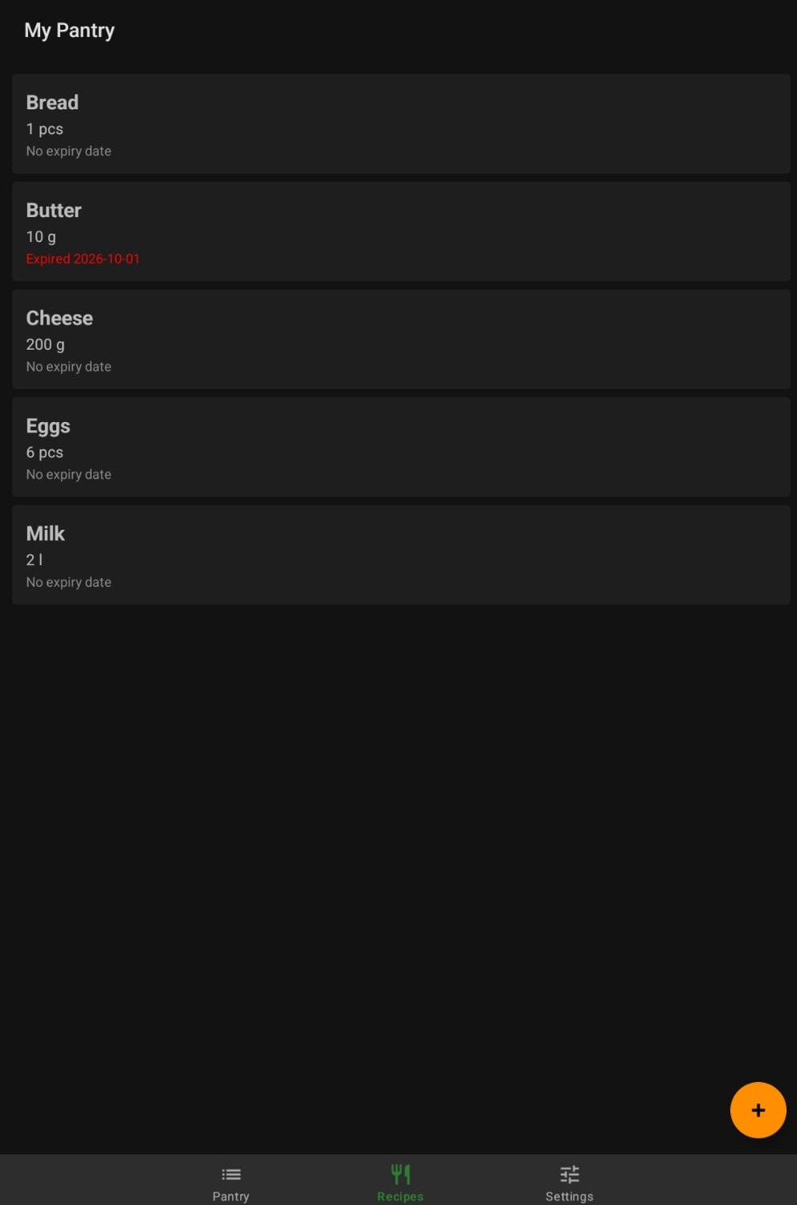
The pantry list presents saved ingredients so the user can review the items available at home. This is the main place to manage pantry stock.

Figure 2: Add or edit pantry item
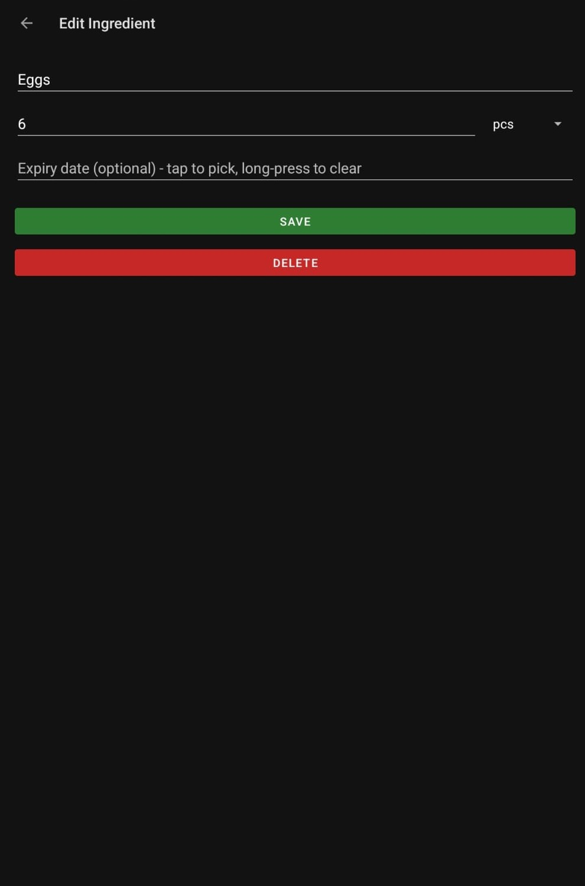
The item form allows the user to enter or update ingredient information, including quantity and expiry-related details where supported by the form.

Figure 3: Suggested recipes
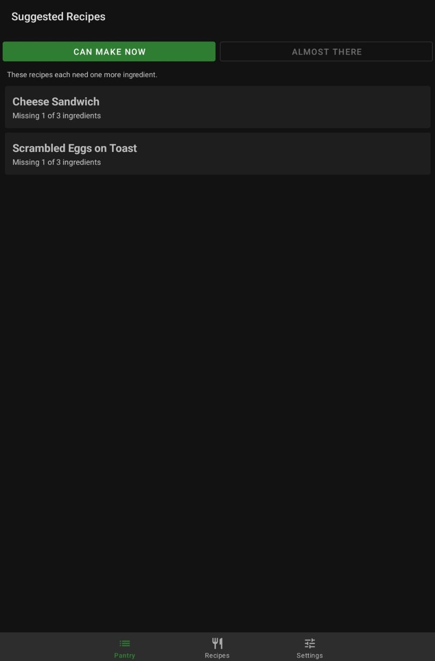
The suggestions screen presents recipes selected using the application's ingredient-matching logic. Matching behaviour is designed to avoid suggesting recipes when required ingredients are missing.

Figure 4: Recipe details

The details screen gives the user further information about a selected recipe and its ingredient requirements.

Figure 5: Settings

Settings include expiry-related preferences, including alert behaviour and whether expired pantry items should be ignored during recipe matching.

4. Code Examples and Explanations
The following examples are extracted from source files in the project when those files are available. They are intended to connect implementation choices to the application's behaviour.

Recipe matching logic
package com.example.smartpantry.logic;
import com.example.smartpantry.data.PantryItem;
import com.example.smartpantry.data.RecipeIngredient;
import java.util.HashMap;
import java.util.List;
import java.util.Locale;
import java.util.Map;
public class RecipeMatcher {
public static String normalizeName(String raw) {
if (raw == null) {
return "";
}
String name = raw.toLowerCase(Locale.ROOT)
.trim()
.replaceAll("\\s+", " ");
// Normalise common irregular and common plural ingredient names.
if (name.equals("eggs")) return "egg";
if (name.equals("tomatoes")) return "tomato";
if (name.equals("potatoes")) return "potato";
if (name.equals("loaves")) return "loaf";
if (name.equals("leaves")) return "leaf";
// ... remaining implementation omitted
Source file: app\src\main\java\com\example\smartpantry\logic\RecipeMatcher.java
The matching component evaluates whether the pantry contains the ingredients needed by a recipe. Strict matching helps avoid showing a recipe as available when a required ingredient is absent.

Room database setup
package com.example.smartpantry.data;
import android.content.Context;
import androidx.room.Database;
import androidx.room.Room;
import androidx.room.RoomDatabase;
import java.util.concurrent.ExecutorService;
import java.util.concurrent.Executors;
/**
* Room (SQLite) database singleton. All access happens on EXECUTOR, a single
* background thread, so the UI thread is never blocked and seeding always finishes
* before the first query that is queued after it.
*/
@Database(entities = {PantryItem.class, Recipe.class, RecipeIngredient.class},
version = 1, exportSchema = false)
public abstract class AppDatabase extends RoomDatabase {
public static final ExecutorService EXECUTOR = Executors.newSingleThreadExecutor();
private static volatile AppDatabase instance;
public abstract PantryDao pantryDao();
public abstract RecipeDao recipeDao();
public static AppDatabase get(Context context) {
if (instance == null) {
// ... remaining implementation omitted
Source file: app\src\main\java\com\example\smartpantry\data\AppDatabase.java
The database class configures the Room database singleton and provides the database instance used by the application. Centralising database creation helps keep persistence access consistent.

Pantry item entity
package com.example.smartpantry.data;
import androidx.room.Entity;
import androidx.room.Ignore;
import androidx.room.PrimaryKey;
/** One ingredient the user currently has at home. */
@Entity(tableName = "pantry_items")
public class PantryItem {
@PrimaryKey(autoGenerate = true)
public long id;
public String name;
public double quantity;
public String unit;
/** ISO date "yyyy-MM-dd", or null when the user did not enter one. */
public String expiryDate;
public PantryItem() { }
@Ignore
public PantryItem(String name, double quantity, String unit, String expiryDate) {
this.name = name;
this.quantity = quantity;
this.unit = unit;
this.expiryDate = expiryDate;
}
}
Source file: app\src\main\java\com\example\smartpantry\data\PantryItem.java
The pantry entity represents a pantry record in the local database. Entity annotations allow Room to map the Java class to a SQLite table.

Recipe ingredient relationship
package com.example.smartpantry.data;
import androidx.room.Entity;
import androidx.room.ForeignKey;
import androidx.room.Ignore;
import androidx.room.Index;
import androidx.room.PrimaryKey;
/** One required ingredient line of a recipe (one-to-many with Recipe). */
@Entity(tableName = "recipe_ingredients",
foreignKeys = @ForeignKey(entity = Recipe.class, parentColumns = "id",
childColumns = "recipeId", onDelete = ForeignKey.CASCADE),
indices = @Index("recipeId"))
public class RecipeIngredient {
@PrimaryKey(autoGenerate = true)
public long id;
public long recipeId;
public String name;
public double quantity;
public String unit;
public RecipeIngredient() { }
@Ignore
public RecipeIngredient(long recipeId, String name, double quantity, String unit) {
this.recipeId = recipeId;
this.name = name;
this.quantity = quantity;
// ... remaining implementation omitted
Source file: app\src\main\java\com\example\smartpantry\data\RecipeIngredient.java
The recipe ingredient entity represents the ingredients associated with a recipe and supports the relationship between recipe records and their required ingredients.

4.1 Recipe matching and normalisation
Ingredient names may be entered with different capitalisation or spacing. Normalising names before comparing them reduces mismatches caused by text formatting. The matcher should also check required recipe ingredients against available pantry records and apply the selected expired-item preference.

5. Challenges and Solutions

5.1 Reliable ingredient matching
A key challenge was making recipe suggestions reflect actual ingredient availability. Loose text matching can produce incorrect suggestions when a required ingredient is not present. The solution was to improve name normalisation and use stricter recipe matching rules, with automated tests for expected and unexpected matches.

5.2 Database consistency
Pantry and recipe data need to remain consistent as records are changed. Room entities and foreign-key relationships provide a defined structure for local storage. Cascade behaviour is configured for the recipe-to-ingredient relationship to help prevent orphaned recipe ingredient records.

5.3 Verifying the user interface
Changes to internal logic and removal of diagnostic information needed to be checked without breaking navigation. The application was rebuilt, installed on an Android tablet and manually checked. The main recipe tabs remained available after diagnostic sections were removed from the suggestions screen.

6. Testing and Results
Automated unit tests were executed through Gradle. The recorded test runs reported 13 tests with zero failures, zero errors and zero skipped tests for the Debug unit-test task, and the same result for the Release unit-test task.
Test run | Tests | Failures / errors | Skipped
Debug unit tests | 13 | 0 | 0
Release unit tests | 13 | 0 | 0
Total executions | 26 | 0 | 0

6.1 Reproducing the tests
From the project root, run the following command in PowerShell:
.\gradlew.bat test --rerun-tasks --no-daemon --console=plain
Gradle test reports are generated under app\build\reports\tests\. The reported results represent the test executions recorded during development; they should not be interpreted as proof that every possible device or user scenario has been tested.

6.2 Manual checks
- Installed and opened the application on an Android tablet.
- Checked the main pantry and recipe tabs.
- Checked that diagnostic sections no longer appeared on the suggestions screen.
- Reviewed the five main screens represented by the assignment screenshots.

7. Conclusion and Reflection
Smart Pantry Manager demonstrates how a Java-based Android application can combine a practical interface with local structured storage and application logic. The project supports pantry management, expiry-aware preferences and recipe suggestions based on ingredient availability. Room and SQLite provide local persistence, while unit tests help verify the recipe-matching rules.
The development process highlighted the importance of testing edge cases, keeping data relationships consistent and checking the application after changes. Further improvements could include more comprehensive UI tests, accessibility checks, backup and restore options, and additional recipe data.

8. References
- Android Developers. Room persistence library. https://developer.android.com/training/data-storage/room
- Android Developers. App fundamentals and Android platform documentation. https://developer.android.com/
- JUnit. JUnit 4 documentation. https://junit.org/junit4/
- Python Software Foundation. python-docx documentation. https://python-docx.readthedocs.io/
- Project source code and README. Smart Pantry Manager GitHub repository: https://github.com/shahilnaidoo17-png/Smart-Pantry-Manage

