Firstly, I haven't been able to create the launch files, so we need to manually create a rosnode and then run the codes.

Circle.py:
The file "circle.py" moves the turtle in a circle with constant Twist velocity.
It takes "speed", "angle", "time" and "cloclwise" (0 or 1) as the input.
The inputs are as follows:

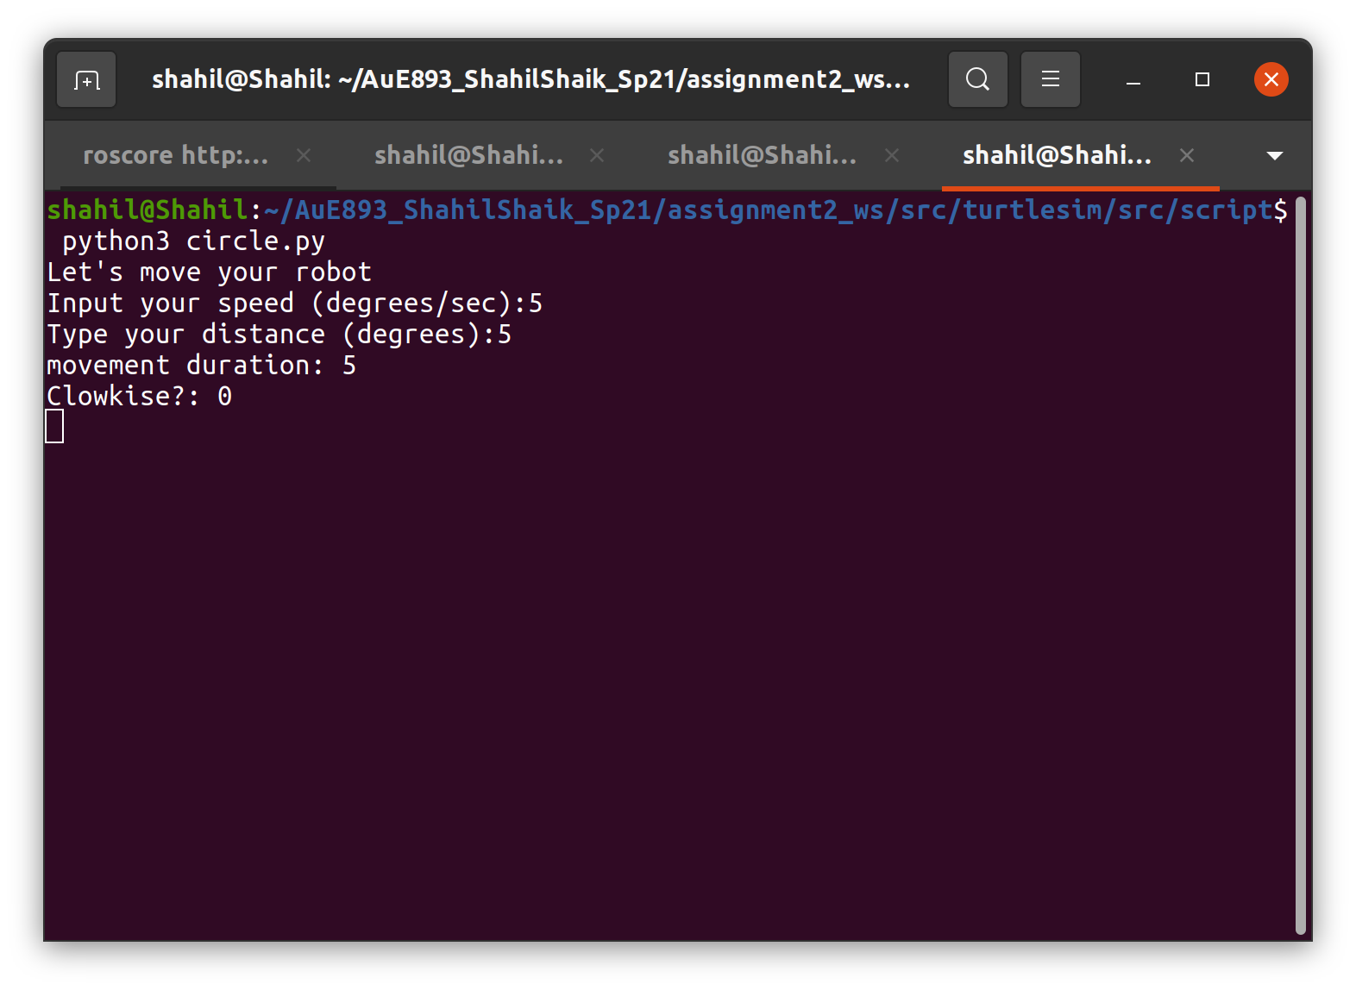
The results are as follows:

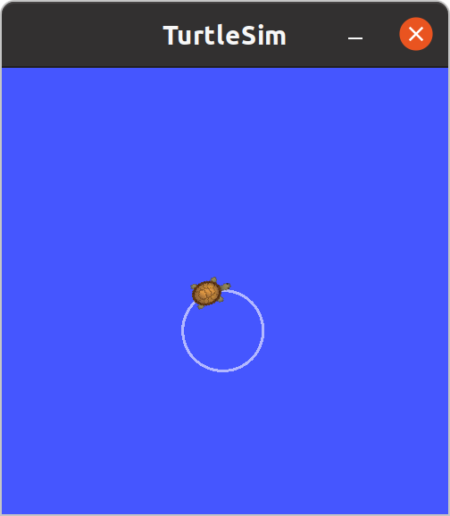
opneloop_square.py:

This codes moves the turtle in a 2x2 square with a constant linear velocity of 0.2 and constant angular velocity of 0.2rad/sec.

The results are as follows:

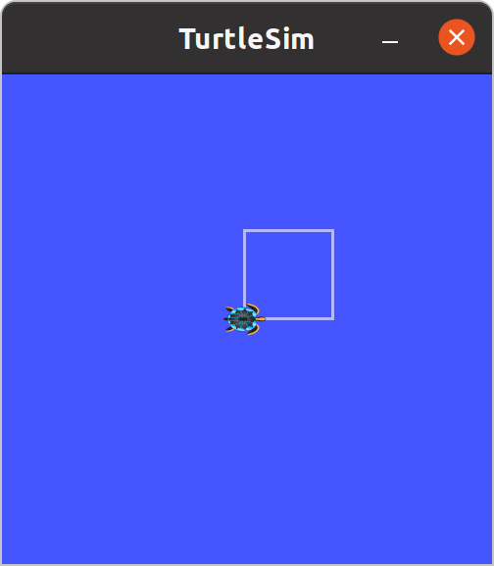
closedloop_square.py:

This codes moves the turtle in a 3x3 square with predefined coordinates (5,5) → (5,8) → (8,8) → (8,5) → (5,5). The turtle moves with control velocity in this case.

The results are as follows:

