High-Level Design (Detailed)

System Overview
This system implements Retrieval-Augmented Generation (RAG) for customer support. It grounds LLM responses in a PDF knowledge base to reduce hallucinations and improve accuracy.
- Scope: PDF ingestion, semantic retrieval, LLM answer generation, intent-based routing, Human-in-the-Loop (HITL).
- Non-goals: full CRM integration, real-time streaming updates.

Architecture
Layer | Component | Responsibility
UI | CLI/Web | Accept user queries, display answers
Ingestion | Loader/Chunker/Embedder | Process PDFs into embeddings
Storage | ChromaDB | Persist vectors + metadata
Retrieval | Retriever | Top-k semantic search
LLM | Generator | Answer synthesis with context
Orchestration | LangGraph | Stateful workflow + routing
HITL | Escalation | Human review for low confidence

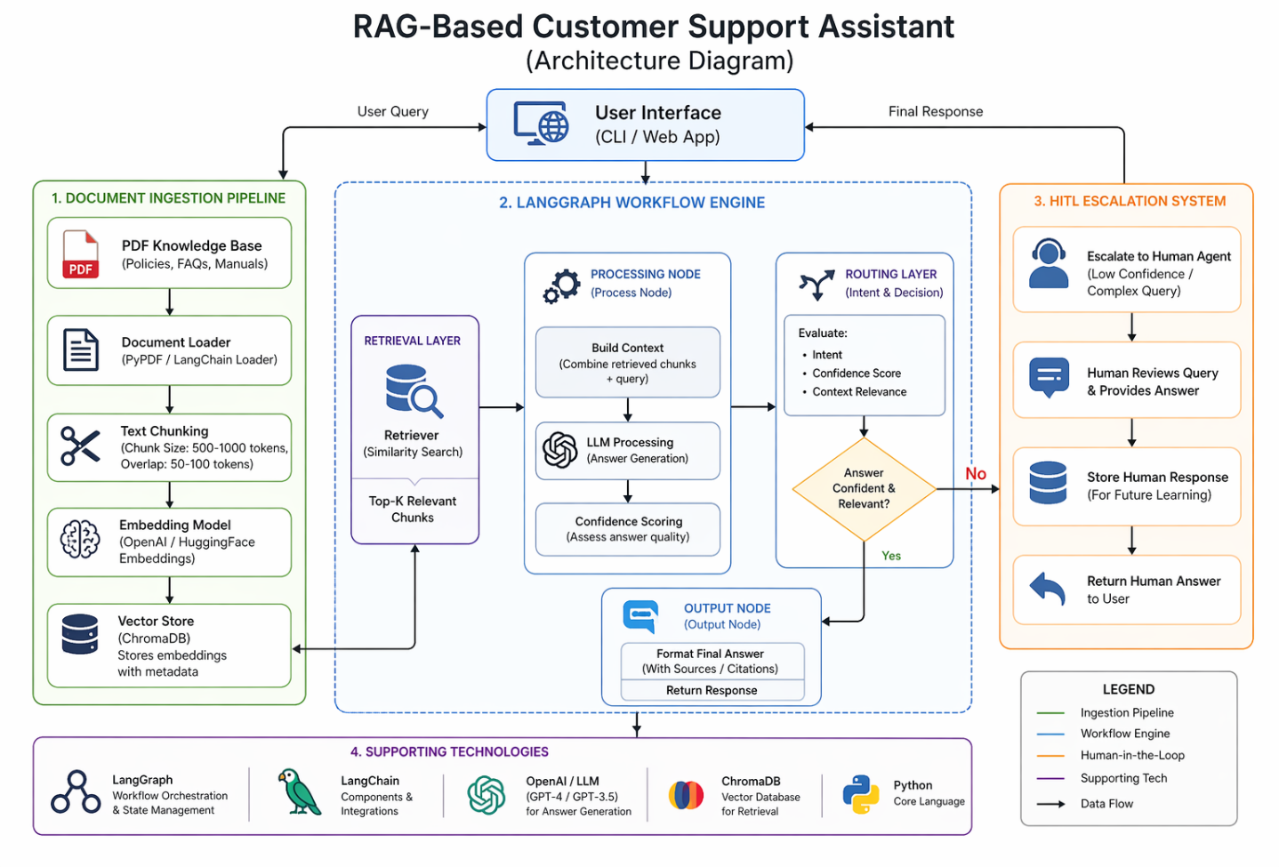

Data Flow
- Ingestion: PDF → Text → Chunks → Embeddings → Vector Store
- Query: User Query → Embed → Retrieve Top-k → Build Context → LLM → Confidence → Route → Output/HITL

Tech Choices (Why)
Choice | Reason
ChromaDB | Lightweight, local dev friendly, fast similarity search
LangGraph | Deterministic, stateful control vs linear chains
OpenAI/HF Embeddings | High semantic quality
GPT-class LLM | Strong reasoning and instruction following

Scalability & Reliability
- Batch embedding + async ingestion for large PDFs
- Caching frequent queries; add re-ranking for precision
- Sharding vector store; background compaction
- Timeouts, retries, circuit breakers for LLM calls

