**Low Level Design (LLD)**

**Wheat Kernel Classification**

Revision Number – 1.0

Last Date of Revision – 16-05-2023

**SHAHIN ANJUM**

**K M SUMANTH**

|  |  |  |  |  |  |  |  |  |  |  |  |  |  |  |  |  |
| --- | --- | --- | --- | --- | --- | --- | --- | --- | --- | --- | --- | --- | --- | --- | --- | --- |
| **Contents** | | | | | | | | | | | | | | | |  |
| [**Abstract**](https://docs.google.com/document/d/1ZLlZEVdMuxYl3o0PziQjZcUbNmAcz-PR/edit#heading=h.gjdgxs) | |  | | | | | | | | | | | | | | [4](https://docs.google.com/document/d/1ZLlZEVdMuxYl3o0PziQjZcUbNmAcz-PR/edit#heading=h.gjdgxs) | | | |
|  |  |  |  |  |  |  |  |  |  |  |  |  |  |  |  |  |
| [**INTRODUCTION**](https://docs.google.com/document/d/1ZLlZEVdMuxYl3o0PziQjZcUbNmAcz-PR/edit#heading=h.30j0zll) | | | | |  | | | | | | | | | | | [5](https://docs.google.com/document/d/1ZLlZEVdMuxYl3o0PziQjZcUbNmAcz-PR/edit#heading=h.30j0zll) | | | |
|  |  | |  |  |  |  |  |  |  |  |  |  |  |  |  |  |
|  | [**Why this LLD documentation?**](https://docs.google.com/document/d/1ZLlZEVdMuxYl3o0PziQjZcUbNmAcz-PR/edit#heading=h.1fob9te) | | | | | | | | | | | | | | | [5](https://docs.google.com/document/d/1ZLlZEVdMuxYl3o0PziQjZcUbNmAcz-PR/edit#heading=h.1fob9te) | | |
|  |  | |  |  |  |  |  |  |  |  |  |  |  |  |  |  |
| [**1 Architecture**](https://docs.google.com/document/d/1CawpaB-mO_T9ew2gcRJPxTYNEbUemWHc/edit#heading=h.3znysh7) | | | | | | | | | | | | | | | | [**3**](https://docs.google.com/document/d/1CawpaB-mO_T9ew2gcRJPxTYNEbUemWHc/edit#heading=h.3znysh7) | | | |
|  |  | |  |  |  |  |  |  |  |  |  |  | |  |  |  |
| [**2 Architecture Design**](https://docs.google.com/document/d/1CawpaB-mO_T9ew2gcRJPxTYNEbUemWHc/edit#heading=h.3dy6vkm) | | | | | | | |  | | | | | | | | [**6**](https://docs.google.com/document/d/1CawpaB-mO_T9ew2gcRJPxTYNEbUemWHc/edit#heading=h.3dy6vkm) | | | |
|  |  | | |  |  |  |  |  |  |  |  |  | |  |  |  |
|  | [**2.1 Data Gathering from Main Source**](https://docs.google.com/document/d/1CawpaB-mO_T9ew2gcRJPxTYNEbUemWHc/edit#heading=h.1t3h5sf) | | | | | | | | | | | | | | | [**6**](https://docs.google.com/document/d/1CawpaB-mO_T9ew2gcRJPxTYNEbUemWHc/edit#heading=h.1t3h5sf) | | |
|  |  | | |  |  |  |  | |  |  |  |  | |  |  |  |
|  | [**2.2 Tools Used**](https://docs.google.com/document/d/1CawpaB-mO_T9ew2gcRJPxTYNEbUemWHc/edit#heading=h.17dp8vu) | | | |  | | | | | | | | | | |  | |
|  |  | | |  |  |  |  | |  |  |  |  | |  |  |  |
|  | [**2.3 Data Description**](https://docs.google.com/document/d/1CawpaB-mO_T9ew2gcRJPxTYNEbUemWHc/edit#heading=h.3rdcrjn) | | | | | | | | | | | | | | | [**7**](https://docs.google.com/document/d/1CawpaB-mO_T9ew2gcRJPxTYNEbUemWHc/edit#heading=h.3rdcrjn) | | |
|  |  | | |  |  |  |  | |  |  |  |  | |  |  |  |
|  | [**2.4 Import Data into Database**](https://docs.google.com/document/d/1CawpaB-mO_T9ew2gcRJPxTYNEbUemWHc/edit#heading=h.26in1rg) | | | | | | | | | | | | |  | | [**7**](https://docs.google.com/document/d/1CawpaB-mO_T9ew2gcRJPxTYNEbUemWHc/edit#heading=h.26in1rg) | | |
|  |  | | |  |  |  |  | | |  |  |  | |  |  |  |
|  | [**2.5 Export Data from Database**](https://docs.google.com/document/d/1CawpaB-mO_T9ew2gcRJPxTYNEbUemWHc/edit#heading=h.lnxbz9) | | | | | | | | | | | | | |  | [**8**](https://docs.google.com/document/d/1CawpaB-mO_T9ew2gcRJPxTYNEbUemWHc/edit#heading=h.lnxbz9) | | |
|  |  | | |  |  |  |  | | |  |  |  | | |  |  |
|  | [**2.6 Data Pre-Processing**](https://docs.google.com/document/d/1CawpaB-mO_T9ew2gcRJPxTYNEbUemWHc/edit#heading=h.35nkun2) | | | | | | | | | |  | | | |  | [**8**](https://docs.google.com/document/d/1CawpaB-mO_T9ew2gcRJPxTYNEbUemWHc/edit#heading=h.35nkun2) | | |
|  |  | | |  |  |  |  | | |  |  |  | | | |  |
|  | [**2.7 Modelling**](https://docs.google.com/document/d/1CawpaB-mO_T9ew2gcRJPxTYNEbUemWHc/edit#heading=h.1ksv4uv) | | | | | | | | | |  | | | | | [**8**](https://docs.google.com/document/d/1CawpaB-mO_T9ew2gcRJPxTYNEbUemWHc/edit#heading=h.1ksv4uv) | | | |
|  |  | | |  |  |  |  | | |  | |  | | | |  |
|  | [**2.8 UI Integration**](https://docs.google.com/document/d/1CawpaB-mO_T9ew2gcRJPxTYNEbUemWHc/edit#heading=h.44sinio) | | | | |  | | | | | | | | | | [**8**](https://docs.google.com/document/d/1CawpaB-mO_T9ew2gcRJPxTYNEbUemWHc/edit#heading=h.44sinio) | | | |
|  |  | | | |  |  |  | | |  | |  | | | |  |
|  | [**2.9 Data From User**](https://docs.google.com/document/d/1CawpaB-mO_T9ew2gcRJPxTYNEbUemWHc/edit#heading=h.2jxsxqh) | | | | | |  | | | | | | | | | [**8**](https://docs.google.com/document/d/1CawpaB-mO_T9ew2gcRJPxTYNEbUemWHc/edit#heading=h.2jxsxqh) | | | |
|  |  | | | |  | |  | | |  | |  | | | |  |
|  | [**2.10 Data Validation**](https://docs.google.com/document/d/1CawpaB-mO_T9ew2gcRJPxTYNEbUemWHc/edit#heading=h.z337ya) | | | | | | | | |  | | | | | | [**8**](https://docs.google.com/document/d/1CawpaB-mO_T9ew2gcRJPxTYNEbUemWHc/edit#heading=h.z337ya) | | |
|  |  | | | |  | |  | | |  | |  | | | |  |
|  | [**2.11 Rendering the Results**](https://docs.google.com/document/d/1CawpaB-mO_T9ew2gcRJPxTYNEbUemWHc/edit#heading=h.3j2qqm3) | | | | | | | | | | |  | | | | [**8**](https://docs.google.com/document/d/1CawpaB-mO_T9ew2gcRJPxTYNEbUemWHc/edit#heading=h.3j2qqm3) | | |
|  |  | | | |  | |  | | | | |  | | | |  |
|  | [**3 Deployment**](https://docs.google.com/document/d/1CawpaB-mO_T9ew2gcRJPxTYNEbUemWHc/edit#heading=h.1y810tw) | | | |  | | | | | | |  | | | |  |
|  | [**3.1 Unit Test Cases**](https://docs.google.com/document/d/1CawpaB-mO_T9ew2gcRJPxTYNEbUemWHc/edit#heading=h.4i7ojhp) | | | | | |  | | | | | | | | | [**9**](https://docs.google.com/document/d/1CawpaB-mO_T9ew2gcRJPxTYNEbUemWHc/edit#heading=h.4i7ojhp) | | | |
|  |  |  |  |  |  |  |  |  |  |  |  |  |  |  |  |  |

**Abstract**

­ For this Internship, I examine the Wheat kernel classification dataset available at the UC Irvine Machine Learning Repository and Kaggle. I aim to build a model for find the variety (classification) of wheat after harvest on the bases of given attributes.

**Introduction**

Classification of wheat after harvest is a challenging task. Several techniques are prevalent for measuring the geometrical parameters of the wheat and for scrutinizing the wheat seeds. Parameters used for the classifier includes area, perimeter, compactness, length of kernel, width of kernel, asymmetry coefficient, length of kernel groove. Neural network pattern recognizer is used for the classification of the wheat seeds in this paper. The database for the Wheat seed is downloaded from the UCI machine learning repository. MSE, Accuracy Score Calculated as performance measure. Results show that Decision Tree classifier give most accuracy 95%.

**Why this Low-Level Design Document?**

The main purpose of this LLD documentation is to feature the required details of the project and supply the outline of the machine learning model and also the written code. This additionally provides the careful description on however the complete project has been designed end-to-end.

**1 Architecture**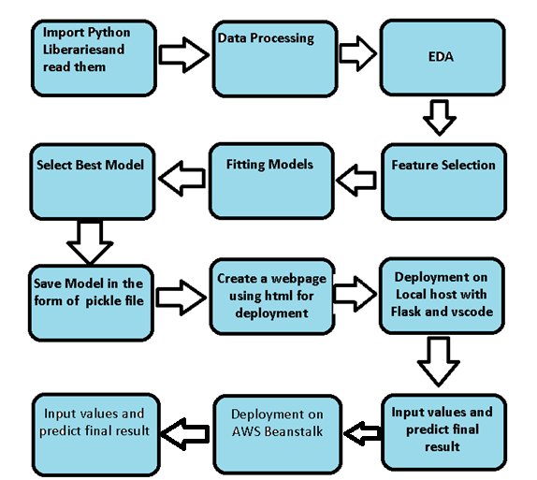

**2 Architecture design**

This project is to create an interface for the user to know the variety of wheat seed, in addition to this, in need of getting the real time project experience we are importing the gathered data into our own database and then start the project from the scratch.

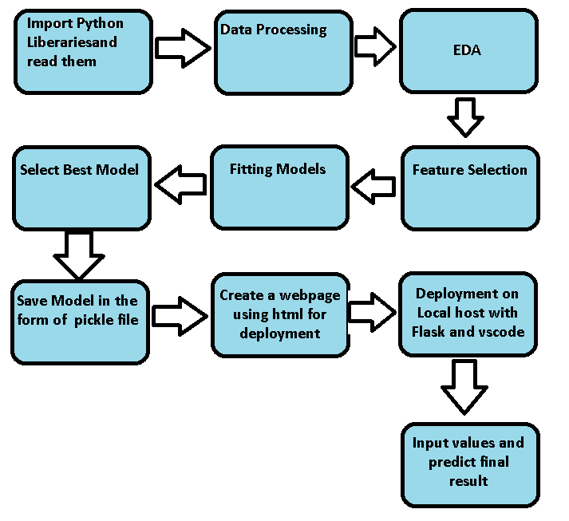

**2.1 Data gathering from main source**

The data for the current project is being gathered from UC Irvine Machine learning Repository, the link to the data is:

https://archive.ics.uci.edu/dataset/236/seeds

**2.2 Tools Used**

Python 3.8 is employed because the programming language and frame works like numpy, pandas, sklearn and alternative modules for building the model.

* For visualizations seaborn and components of matplotlib are getting used
* Vscode is employed as IDE(integrated development environment).
* For information assortment prophetess info is getting used.
* Front end development is completed victimization HTML/CSS.
* Flask is employed for each information and backend readying.
* GitHub is employed for version management.

**2.3 Data description**

The data was collected from UCI Machine learning repository. Soft X-ray technique was used for getting the kernel structure. 13 cm × 18 cm Xray KODAK plates were used for placing the wheat for the recording the images. The images were collected in the Institute of Agrophysics of Polish Academy of Science in Lublin. Seven geometric attributes of the wheat kernel image such as area, perimeter, compactness, kernel length, kernel width, asymmetry coefficient, kernel groove length was computed.

**2.4 Import data into Cassandra**

Created an api for the upload of the data into the Cassandra database, steps performed are:

* Connection is made with the database.
* Created a database with name Income Prediction.
* Cqlsh command is written for creating the data table with required parameters.
* And finally, a cqlsh command is written for uploading the dataset into data table by bulk insertion.

**2.5 Export data from database**

In the above created api, the download url is also being created, which downloads the data into a csv file format.

**2.6 Data pre-processing**

Steps performed in pre-processing are:

* First rename all columns
* The data types are being checked and found all columns are of type integer.
* Checked for null values as there are no null values.
* Checking outliers as looking box plot, there are 5 outliers present. Deleted all outliers
* Scaling is performed for required data.

And the data is ready for passing to the machine learning algorithm.

**2.7 Modelling**

The pre-processed data is then visualized, and all the required insights are being drawn. Although from the drawn insights, the data is randomly spread but still modelling is performed with different machine learning algorithms to make sure we cover all the possibilities. And finally, as expected random forest regression performed well.

**2.8 UI integration**

Both CSS and HTML files are being created and are being integrated with the created machine learning model. All the required files are then integrated to the app.py file and tested locally. Note I copy the code from internet and make the CSS and HTML File .

**2.9 Data from user**

The data from the user is retrieved from the created HTML web page.

**2.10 Data validation**

The data provided by the user is then being processed by app.py file and validated. The validated data is then sent for the prediction.

**2.11 Rendering the results**

The data sent for the prediction is then rendered to the web page.

**3 Deployment**

I deployed on AWS beanstalk. This is link:-