# **Wireframe**

Wireframe

**Wheat Kernel Classification**

Revision Number – 1.0

Last Date of Revision – 22-05-2023

**SHAHIN ANJUM**

**K M SUMANTH**

**Contents**

Wireframe

[**Abstract** 4](https://docs.google.com/document/d/1ZLlZEVdMuxYl3o0PziQjZcUbNmAcz-PR/edit#heading=h.gjdgxs)

**Web Interface 5**

**User Input 5**

**Result Page 6**

**Abstract**

Wireframe

This documentation is all about the user interface wireframe; here the home page of wheat kernel classification prediction is explained.

**1. Web Interface**

Wireframe

Our web page has two pages interface where on first page input from the user and on second page the prediction is displayed.

First Page-

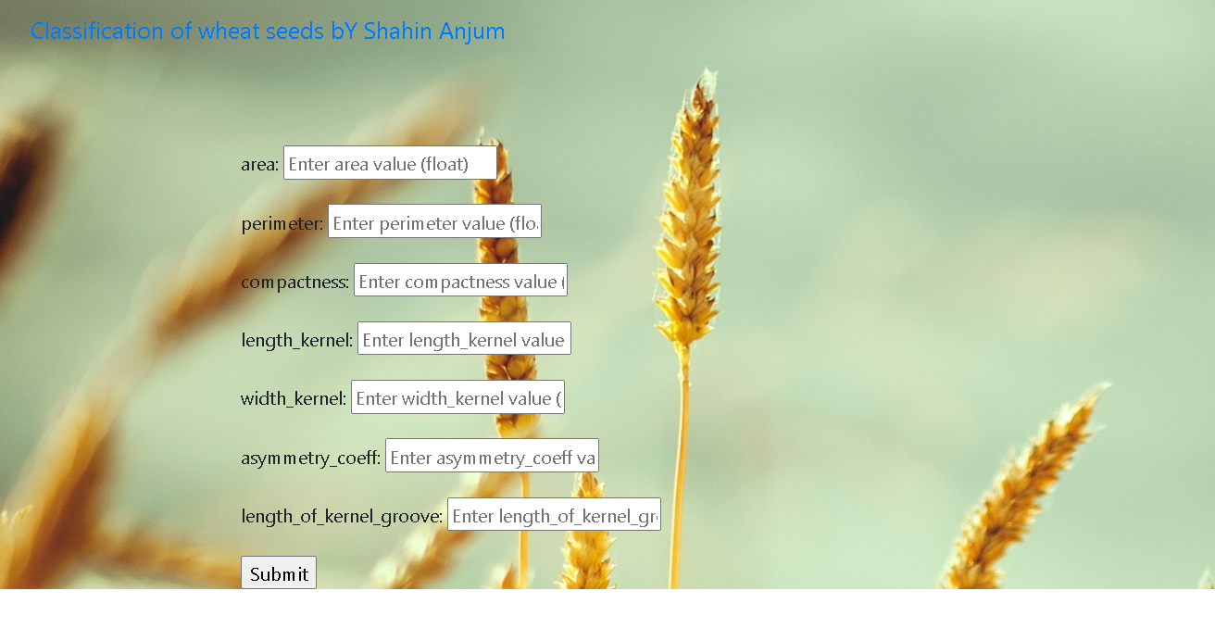

Second Page-

**2. User Input**

Whenever the user hits our URL , they first see the user input page here they have to provide the information like:

* Every user input their values and after providing the required input and pressing the submit button, the second page open and displays the output.

**3. Result Page**

Wireframe

After the user hits the submit button the second page gets opened and the results are being displayed.

The user can refill all the inputs in the first page and get the results in the same way.