Bootcamp Project 1
Global E-Commerce Sales End-to-End Batch Processing Solution

1. Goal
To provide an end-to-end data engineering solution for the Global E-Commerce Sales dataset, starting from data ingestion, storage, cleaning and transformation, and ending with Synapse SQL analytics. The project demonstrates a complete batch processing pipeline using Azure Data Factory, Azure Data Lake Storage Gen2, Azure Synapse Analytics, PySpark, and SQL.

2. Business Objectives
- Identify high-performing products and categories to support revenue growth.
- Analyze regional sales trends to identify strong and weak markets.
- Understand customer purchasing behavior using transaction-level data.
- Monitor monthly and seasonal sales patterns to support demand planning.
- Provide cleaned and analytics-ready data for business decision-making using Synapse SQL.

3. About the Dataset
The selected dataset is the Global E-Commerce Sales dataset downloaded from Kaggle. It contains transaction-level e-commerce records with customer, product, region, category, price, quantity, and transaction date fields. The dataset is suitable for batch processing because files can be ingested periodically and processed through a cloud data pipeline.
Column / Field | Description
Transaction Date | Date of the customer purchase transaction.
Customer ID | Unique customer identifier used for customer-level analysis.
Region | Geographic region where the transaction occurred.
Product | Product purchased by the customer.
Category | Product category used for category-level performance analysis.
Price | Unit price of the product.
Quantity | Number of units purchased.
Revenue | Derived field calculated as Price × Quantity.

4. Solution Architecture
The architecture follows a simple batch-processing flow. Raw data is ingested using Azure Data Factory, stored in Azure Data Lake Storage Gen2, cleaned using Synapse Spark and PySpark, saved as Parquet, and analyzed using Synapse Serverless SQL.
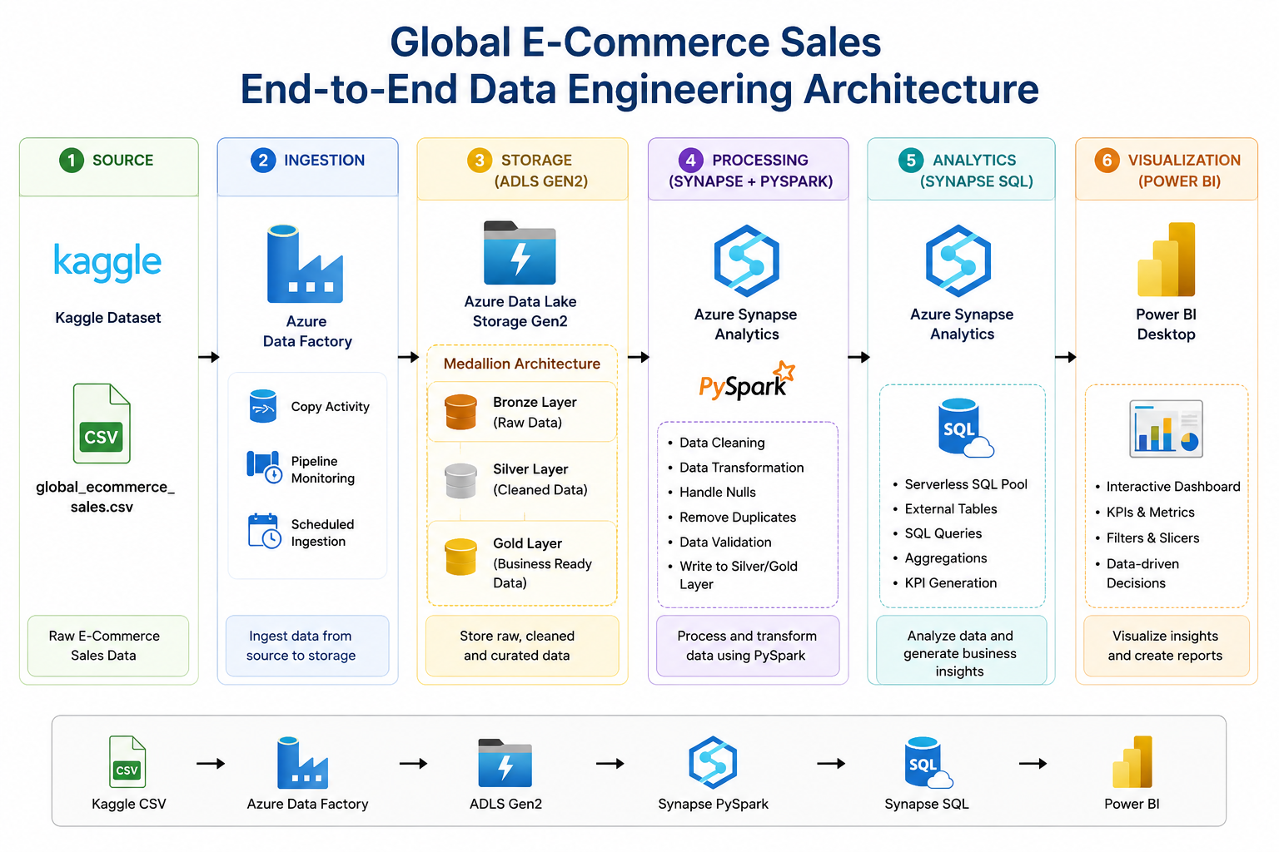
Layer | Service / Component | Purpose
Source | Kaggle CSV Dataset | Provides the original global e-commerce sales data.
Ingestion | Azure Data Factory | Copies dataset into Azure storage using Copy Activity.
Storage | Azure Data Lake Storage Gen2 | Stores raw, cleaned, and gold-layer data.
Transformation | Azure Synapse Spark Pool | Runs PySpark notebook to clean and transform data.
Analytics | Synapse Serverless SQL | Queries cleaned Parquet data for business insights.

5. Folder Structure for Submission
The GitHub repository is organized into Documentation, Code, and Screenshots folders as required by the submission instructions.
Global_Ecommerce_Sales_Pipeline_TeamName/
├── Documentation/
├── Code/
├── Screenshots/
└── README.md
Folder | Files to Attach
Documentation | Project report, architecture diagram, and written project explanation.
Code | PySpark notebook, PySpark script, SQL analytics scripts, and external data source setup script.
Screenshots | Azure screenshots showing storage, ADF pipeline, Synapse workspace, notebook execution, Parquet files, and SQL query results.
README.md | Project overview, technologies used, setup steps, folder structure, and contributors.

6. Naming Convention
File Type | Naming Convention | Example
Documentation | Step_X_Description | Step_1_Project_Overview.docx
Code | snake_case | ecommerce_data_cleaning.py
Screenshots | Step_X_Screenshot_Y | Step_4_Screenshot_1_ADF_Debug_Succeeded.png

7. Step-by-Step Implementation

Step 1: Azure Storage Account and Container Setup
A storage account was created with standard performance and LRS redundancy. A container named shinyblobcontainer was used to store the dataset and processed outputs. ADLS Gen2 was used as the main storage layer.

Step 2: Dataset Upload
The Global E-Commerce CSV dataset was extracted from the downloaded ZIP file and uploaded to Azure Data Lake Storage Gen2.

Step 3: Azure Data Factory Pipeline
Azure Data Factory was used to create a Copy Activity pipeline. The pipeline copied the source CSV file into Azure storage as part of the batch ingestion process. The debug run completed successfully.

Step 4: Synapse Workspace and Spark Pool
An Azure Synapse Analytics workspace and Spark pool were created. The Spark pool was used to run PySpark notebooks for data cleaning and transformation.

Step 5: PySpark Data Cleaning
The dataset was loaded into a Spark DataFrame. Duplicate records were removed, missing values were handled, date fields were standardized, numeric fields were cast to correct types, and a Revenue column was created.

Step 6: Save Cleaned Data as Parquet
The cleaned data was saved back into ADLS Gen2 in Parquet format under the cleaned/ecommerce_cleaned folder. Parquet was selected because it is optimized for analytics workloads.

Step 7: Synapse SQL Analytics
Synapse Serverless SQL was used to query the cleaned Parquet files using OPENROWSET. Analytics queries were created for revenue, region, category, and top product analysis.

8. Important Code Snippets

PySpark Cleaning Code
df_cleaned = df.dropDuplicates().dropna()
df_cleaned = df_cleaned.withColumn("Revenue", col("Price") * col("Quantity"))
df_cleaned.write.mode("overwrite").parquet(output_path)

Synapse SQL Query Example
SELECT Region, SUM(CAST(Price AS FLOAT) * CAST(Quantity AS FLOAT)) AS revenue
FROM OPENROWSET(
BULK 'cleaned/ecommerce_cleaned/**',
DATA_SOURCE = 'EcommerceLake',
FORMAT = 'PARQUET'
) AS data
GROUP BY Region
ORDER BY revenue DESC;

9. Business Analytics Performed
- Total record count
- Total revenue calculation
- Revenue by region
- Revenue by category
- Top products by revenue and quantity
- Preview of cleaned data using Synapse SQL

10. Challenges Encountered
Challenge | Resolution / Status
Storage account and path errors | Corrected the ADLS path and storage account name to shinyshastoreacc.
Synapse permissions | Assigned Storage Blob Data Reader and Contributor roles where needed.
External data source configuration | Created external data source and used OPENROWSET to query Parquet data.
Power BI connectivity | Power BI integration was attempted, but due to authentication and directory listing limitations, the final submitted scope focuses on Synapse SQL analytics.
Parquet folder listing issues | Used exact paths and SQL testing to validate data availability.

11. Achievements
- Built a working Azure Data Factory ingestion pipeline.
- Stored data in Azure Data Lake Storage Gen2.
- Created Synapse workspace and Spark pool.
- Successfully cleaned data using PySpark.
- Saved transformed output as Parquet.
- Queried cleaned Parquet data using Synapse Serverless SQL.
- Prepared a GitHub-ready project folder structure.

12. Conclusion
This project successfully demonstrates an end-to-end Azure data engineering batch pipeline for Global E-Commerce Sales analysis. The solution shows how raw CSV data can be ingested, stored, cleaned, transformed, and analyzed using Azure services. Although Power BI connectivity was not finalized due to access and authentication constraints, the core data engineering requirements were completed using Azure Data Factory, ADLS Gen2, Synapse Spark, PySpark, and Synapse SQL Analytics.

