Scalability Plan – Enterprise ML System

Goal
Ensure the system can scale ×10 (or more) users without downtime, maintaining high performance, reliability, and maintainability.
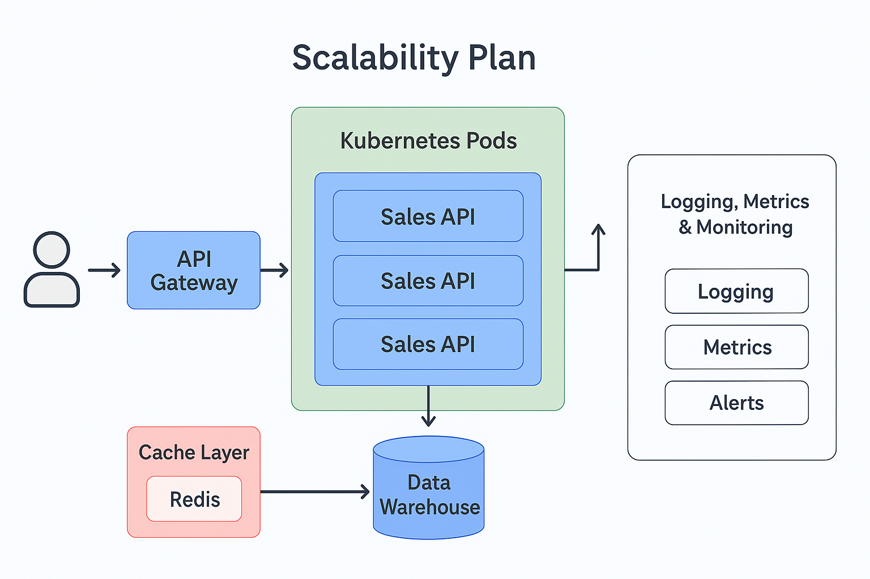

Focus Areas
Docker Containers → Isolation & Portability
Kubernetes Pods → Auto-scaling & Load Balancing
API Gateway → Unified access & traffic management
Autoscaling Triggers → Dynamic resource allocation
Cache Layer (Redis) → Fast repeated requests

1️⃣ Docker Containers

Purpose:
Run services consistently anywhere (local, cloud).
Isolate services: ML Model, API, Web App, Scheduler.
Simplify CI/CD and scaling.

Steps:
Prepare project files: code, requirements.txt, environment configs.
Create Dockerfile for each service:
Example Dockerfile:
FROM python:3.11-slim
WORKDIR /app
COPY requirements.txt .
RUN pip install --no-cache-dir -r requirements.txt
COPY . .
CMD ["uvicorn", "main:app", "--host", "0.0.0.0", "--port", "8000"]
Build & run locally:
docker build -t sales-api .
docker run -p 8000:8000 sales-api
Repeat for all services (Model, Web App, Scheduler).

2️⃣ Kubernetes Pods

Purpose:
Run multiple instances (pods) for high availability.
Auto-restart failed services.
Load balance traffic automatically.
Deployment Example (YAML):
apiVersion: apps/v1
kind: Deployment
metadata:
name: sales-api-deployment
spec:
replicas: 2
selector:
matchLabels:
app: sales-api
template:
metadata:
labels:
app: sales-api
spec:
containers:
- name: sales-api
image: your-dockerhub-username/sales-api:latest
ports:
- containerPort: 8000
Service (Load Balancer):
apiVersion: v1
kind: Service
metadata:
name: sales-api-service
spec:
selector:
app: sales-api
ports:
- protocol: TCP
port: 80
targetPort: 8000
type: LoadBalancer
Deployment:
kubectl apply -f deployment.yaml
kubectl apply -f service.yaml

3️⃣ Horizontal Pod Autoscaler (HPA)
Purpose: Automatically scale pods based on CPU/memory usage.
Example YAML:
apiVersion: autoscaling/v2
kind: HorizontalPodAutoscaler
metadata:
name: sales-api-hpa
spec:
scaleTargetRef:
apiVersion: apps/v1
kind: Deployment
name: sales-api-deployment
minReplicas: 2
maxReplicas: 10
metrics:
- type: Resource
resource:
name: cpu
target:
type: Utilization
averageUtilization: 60
Apply:
kubectl apply -f hpa.yaml

4️⃣ API Gateway
Single entry point for all APIs.
Load balancing, security (JWT/API keys), rate limiting.
Example (NGINX):
server {
listen 80;
location /api/ {
proxy_pass http://sales-api-service:8000/;
proxy_set_header Host $host;
proxy_set_header X-Real-IP $remote_addr;
}
}

5️⃣ Cache Layer – Redis
Speed up responses for repeated requests.
Reduce load on DB and model computation.
Deployment Example (YAML):
apiVersion: apps/v1
kind: Deployment
metadata:
name: redis-deployment
spec:
replicas: 1
selector:
matchLabels:
app: redis
template:
metadata:
labels:
app: redis
spec:
containers:
- name: redis
image: redis:7
ports:
- containerPort: 6379
Example Usage in API:
import redis
r = redis.Redis(host='redis-service', port=6379)
r.set('forecast_2025-11-28', forecast_data)
data = r.get('forecast_2025-11-28')

✅ Final Outcome – Scalability Ready
Docker → Isolated, portable services
Kubernetes → Auto-restart, Load Balancing, multi-pods
HPA → Automatic scaling based on resource usage
API Gateway → Single entry, traffic routing, security
Redis Cache → Fast repeated requests, optimized DB load

🔮 Advanced Touch
CI/CD ready with auto-deploy
Kubernetes pods auto-scale dynamically
Reinforced API Gateway security and traffic routing
Redis for ultra-fast repeated requests
Diagram placeholder: Add Architecture Diagram here

Next Phase – Phase 8: Monitoring & Observability
Logging (ELK / Cloud Logging)
Metrics (Prometheus / Grafana)
Alerts (Email, Slack)
Model Drift detection (Evidently AI)
High-Level Plan:
Connect all services to centralized logging.
Monitor CPU, memory, response time, request counts.
Set alerts for failures or performance degradation.
Monitor ML model predictions for drift and anomalies.

