PM2.5 Forecasting in Open-Pit Mining: Horizon-Dependent Predictive Value of Local Monitoring and Regional Atmospheric Information
Marjan Shahinfar¹, Vladislav Kecojevic¹, Yuksel Asli Sari¹
¹ Robert M. Buchan Department of Mining, Queen’s University, Kingston, Ontario, Canada
Corresponding authors: Vladislav Kecojevic (v.kecojevic@queensu.ca); Yuksel Asli Sari (y.sari@queensu.ca)
Abstract
Forecasting fine particulate matter (PM2.5) helps mines manage dust risk, but useful inputs can change with forecast horizon. Using 2020–2021 Tongliao data, we compared matched h1–h24 locked-test models with and without MERRA-2 information. One-hour forecasts explained 94.9% of variation. Mean explained variation was 41.3% without and 45.6% with MERRA-2, with the largest average gains at h7–h24. Seasonal analysis showed a planning-relevant contrast: winter had the highest mean PM2.5, whereas autumn showed the largest average MERRA-2 gain. Overall, the results support horizon-specific PM2.5 forecasting for mine air-quality planning; rare-event warning use should be validated with timely data and new mine-period observations.
Keywords: PM2.5 forecasting; MERRA-2 reanalysis; open-pit mining; CatBoost; SHAP attribution; rolling-origin evaluation
Abbreviations: PM2.5, fine particulate matter with an aerodynamic diameter of 2.5 µm or less; MERRA-2, Modern-Era Retrospective Analysis for Research and Applications, Version 2; CST, China Standard Time; SHAP, SHapley Additive exPlanations; R², coefficient of determination; RMSE, root-mean-square error; MAE, mean absolute error.
1. Introduction
Fine particulate matter (PM2.5) is a serious environmental and occupational health concern because it can enter deep into the lungs and is associated with heart and lung disease and premature death [1,2]. In open-pit coal mines, PM2.5 can be produced by haul-road traffic, excavation, blasting, loading, dumping, wind erosion, and material handling. Mine topography and stable weather can limit pollutant dispersion, while regional transport and particles formed in the atmosphere can also affect measured concentrations [3,4]. Forecasting PM2.5 is therefore challenging because concentrations reflect a changing combination of mine activity, local weather, recent pollution conditions, and broader regional conditions.
Researchers have used statistical methods, computer models of atmospheric transport, and machine-learning models for short-term air-quality forecasting [5–13]. Some approaches use data from nearby monitoring stations [9,11], while others separate complex pollution records into simpler patterns before forecasting [14,15]. Mining studies have applied similar methods to estimate and forecast dust concentrations and support dust-control systems, sometimes using mine-production data or connected sensor networks [14,16–23]. Wang et al. [3] developed a deep-learning model using hourly pollution and weather observations collected from a Tongliao open-pit coal mine during 2020–2021 and made the monitoring dataset publicly available. Their model predicted several future time steps together and was compared with alternative model designs. In contrast, the present study fits a separate model for each forecast horizon from 1 to 24 h, uses chronological partitions to prevent future target observations from entering model training or selection, and compares matched models with and without MERRA-2 to estimate its added predictive value.
Despite this progress, four gaps remain. First, forecast accuracy alone does not show which information supports a prediction or whether that information remains useful at longer lead times. Recent local readings may predict conditions well one hour ahead, but their predictive value can decrease at longer lead times as the information in those readings becomes less relevant to the future state of the atmosphere and mine. Second, MERRA-2 has been used to estimate surface particulate matter and assess atmospheric data at regional scales [24–26], but none of the studies we reviewed tested whether it adds predictive value beyond local monitoring at a mine across horizons from 1 to 24 h. MERRA-2 is a global NASA reanalysis that combines observations with an atmospheric model to provide consistent estimates of weather and airborne particles, including dust, sulfate, black carbon, and organic carbon [27,28]. Its coarse grid cannot represent individual haul-road or blasting events, but it may provide broader atmospheric information that becomes useful at longer horizons. Third, forecast performance can appear better than it really is when future observations enter model development through random splitting, full-record preprocessing, overlapping forecast windows, or data partitions that ignore the time being predicted [29–31].
Fourth, interpreting model inputs also requires care. SHAP is a method for explaining machine-learning predictions by showing how a fitted model distributes attribution among its inputs [32]. Because environmental variables often change together, closely related inputs may share this attribution. A high SHAP value therefore does not prove that a variable causes pollution or that including it improves forecast accuracy. We therefore interpret SHAP alongside several other checks: evaluation on a future test period that was opened only once; comparisons of models fitted with and without entire groups of inputs; uncertainty estimates that recognize that consecutive hourly observations are related; and sensitivity analyses under alternative assumptions. Together, these checks help us examine how the information used by the model changes with forecast horizon, rather than simply presenting a new algorithm.
This study addressed two questions: how the information supporting PM2.5 forecasts changes from 1 to 24 hours ahead, and when adding regional MERRA-2 data provides predictive value beyond a matched model without MERRA-2 inputs. We used a separate model for each forecast horizon, chronological validation, and a one-time locked test. Our four goals were to (1) measure forecast skill against simple baselines, including carrying the current PM2.5 value forward, using the average for the same month and hour, and using the matched model without MERRA-2 inputs; (2) estimate the incremental predictive value of MERRA-2 at each horizon; (3) compare the inputs receiving the greatest model attribution with the changes in accuracy observed when entire input groups were removed; and (4) assess whether the findings were consistent across seasons, under statistical resampling that accounted for related hourly observations, under alternative spatial and timing choices, and during high-pollution periods. We also examined whether a smaller input set could provide similar validation performance through a prespecified validation-only reduction analysis and a separate disclosed post-hoc investigation. Neither feature-reduction analysis accessed the locked test or changed the predefined locked-test 222-predictor model.
This study contributes a leakage-controlled framework in which future observations do not influence preprocessing, fitting, or selection. Within this framework, we test when MERRA-2 provides incremental predictive value rather than presenting one algorithm as universally best. We combine a one-time locked-test comparison with model attribution, input-group removal, and stability checks, separating inputs that receive model attribution from those that change predictive accuracy when added or removed. We expected local history to dominate short horizons and regional information to become more useful at longer horizons. Results are interpreted as predictive associations, not causal effects; this historical-data analysis estimates predictive value rather than real-time delivery.
2. Materials and methods
2.1 Study setting and data sources
This study reanalyzed the public hourly dataset reported by Wang et al. [3] for an open-pit coal mine in Tongliao City, Inner Mongolia, China (https://doi.org/10.6084/m9.figshare.21308433.v2). It spans 1 January 2020 00:00 to 31 December 2021 23:00, with 17,544 timestamps. The record contains six pollutants: PM2.5, PM10, NO2, SO2, O3, and CO, and six weather measurements: temperature, relative humidity, wind speed, wind direction, precipitation, and pressure. PM2.5 was the target; the other measurements and current and past PM2.5 values were origin-available predictors. Targets remained uncapped and unimputed in all periods. We also extracted all 731 daily subsets of NASA’s MERRA-2 hourly aerosol product (M2T1NXAER) for 2020–2021. For each horizon, the models were evaluated on identical target rows. The local-only model had 149 predictors; the full model had 222 predictors, including MERRA-2.
Figure 1 summarizes the information sources, leakage-controlled workflow, matched horizon-specific models, locked-test comparison, and supporting checks. The 222-predictor full model remained the predefined locked-test model; the post-hoc 59-predictor candidate used validation data only and needs new-data testing before operational use.

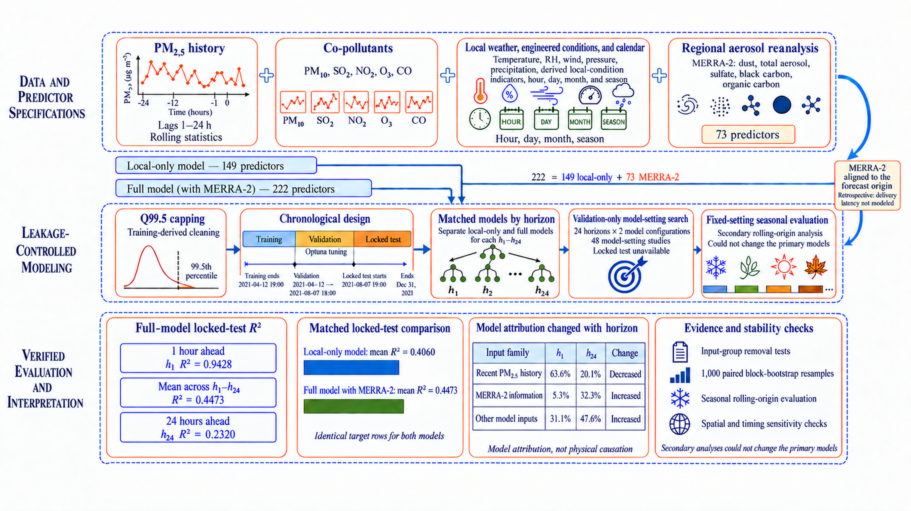
Fig. 1. Study workflow for leakage-controlled 1–24-hour PM2.5 forecasting. Local monitoring history, engineered local-condition indicators, calendar information, and regional MERRA-2 aerosol reanalysis formed the 149-predictor local-only and 222-predictor full models. Chronological splitting, training-derived preprocessing, horizon-specific model selection, and a locked test protected against future-data leakage. MERRA-2 was aligned to the forecast origin, so its value was assessed as historical predictive information. The lower row summarizes locked-test R², matched model comparisons, h1-to-h24 attribution, and stability checks. SHAP attribution is non-causal; supporting analyses interpret and stress-test the findings.

2.2 MERRA-2 data and regional spatial extraction
NASA’s MERRA-2 aerosol reanalysis product, M2T1NXAER, provides hourly estimates on a fixed spatial grid, labeled 30 minutes after each UTC hour. The study region overlapped two MERRA-2 grid cells. The primary series used area-weighted extraction, and a nearest-cell series was retained for a predefined sensitivity check.
Eight MERRA-2 variables represented particle loading: dust and PM2.5 dust column mass; dust, PM2.5 dust, and total aerosol optical thickness; and sulfate, black-carbon, and organic-carbon column mass. Supplementary Table S1 gives full names, codes, and definitions. Current values, 1-, 6-, and 24-hour lags, rolling averages, and winter/heating-season interactions produced 73 predictors. Adding them to 149 non-MERRA-2 predictors produced the 222-predictor model. These are regional, not mine-level, conditions; the analysis demonstrates historical predictive value rather than real-time availability.
2.3 Temporal alignment and forecast definition
Local records were matched to MERRA-2 information available at forecast issue. The primary alignment used China Standard Time (CST) and treated timestamps as hour-end labels: a 09:00 CST forecast used the completed 08:00–09:00 CST MERRA-2 interval. This matched 17,535 of 17,544 timestamps; the remaining nine followed the predefined missing-data procedure. Three alternative spatial and timing alignments were specified before fitting and used only as sensitivity checks (Supplementary Methods S2.3).
At each issue time $t$, separate h1–h24 models predicted the original PM2.5 value at $t+h$. Rows were assigned to training, validation, or test by target time, preventing boundary targets from entering the wrong period and yielding 406,668 eligible pairs. Environmental predictors came from observations or completed intervals available by $t$. Only target-time calendar information, such as month and hour, came from $t+h$, and it was already known at issuance.
2.4 Preprocessing and leakage prevention
Rows were split by target time: training ended 12 April 2021 at 19:00, validation ended 7 August 2021 at 18:00, and the locked test began one hour later. Depending on horizon, this yielded 10,767–10,790 training, 2,793 validation, and 3,373 locked-test observations. This order represents using earlier mine-area records to predict later conditions.
All preprocessing parameters came from training data. PM2.5, PM10, SO2, and CO predictors above their training 99.5th percentiles were capped at 223.070, 352.108, 121.260, and 2.620. Their missing values used post-capping training medians; other direct predictors used uncapped training medians. Observed PM2.5 targets were never capped or imputed. Rows were excluded only when the relevant target was missing.
Missing-data indicators accompanied replacement values. The nine unmatched MERRA-2 boundary timestamps used training medians and a separate availability indicator. Early-record lagged or rolling features, and derived features lacking inputs, remained missing for CatBoost rather than being filled with invented history.
Three pressure observations were 0.0 kPa. They remained in direct inputs, while values outside 80–110 kPa were treated as missing when constructing engineered local-condition indicators, producing 12 non-edge missing values in those indicators. This archived asymmetric treatment is a preprocessing limitation. A post-hoc sensitivity applied the filter before replacement and feature construction, reused the archived horizon settings, and used validation data only; the locked test remained untouched.
Data leakage occurs when future observations or final-test results influence model development. Target-time splitting, training-only caps and medians, uncapped held-out targets, backward-looking features, and exclusion of future MERRA-2 measurements prevented this. Automated checks verified feature order and sample counts (Supplementary Methods S2.4), supporting evaluation with information available at forecast issue.
2.5 Predictor construction and feature families
The full model used 222 predictors in eight groups: recent PM2.5 history (14), other-pollutant history (37), local weather (36), issue-time calendar and seasonal information (29), engineered local-condition features (23), MERRA-2 information (73; Section 2.2), target-time calendar information (9), and one cold-season indicator. Local histories included current and lagged measurements, recent summaries, and missingness indicators. The 23 engineered features represented wind, ventilation and stagnation, pressure change, humidity interactions, and precipitation using local data; they were not additional measurements. Supplementary Methods S2.5 gives full construction rules.
Because 359° and 1° indicate nearly the same direction, wind direction was encoded with sine and cosine components. It was a forecasting input, not evidence of a physical pollution source. The nine target-calendar predictors included hour, day of year, month, winter status, and heating-season status; all were known at issuance. Prespecified horizon groups were short (1–6 h), medium (7–12 h), and long (13–24 h).
The matched 149-predictor local-only model excluded MERRA-2 but retained local pollution, weather, engineered-condition, and calendar information. Comparison with the 222-predictor full model (with MERRA-2) estimated whether regional atmospheric information added predictive value and whether that value changed with horizon.
2.6 Forecasting models
CatBoost, which builds decision trees that correct earlier errors, was the primary method. It represents nonlinear relationships and interactions, accepts differently scaled predictors, and handles missing values [33]. Separate models were trained for every h1–h24 horizon and predictor specification.
Two reference methods were evaluated on the same target rows whenever their predictions were available. Persistence carried current PM2.5 forward unchanged. Month–hour climatology used the training average for the same month and hour, with monthly and overall fallbacks. These references showed whether CatBoost outperformed simple operational assumptions.
Optuna 4.9.0 selected seven CatBoost settings separately for each horizon and specification. The 48 searches (24 horizons × 2 specifications) ran 50 completed trials each, totaling 2,400 trials. Each search used 20 startup trials followed by the adaptive TPE stage, with a deterministic per-search sampler seed; CatBoost used random seed 42. Trials were ranked by validation root-mean-square error (RMSE), which emphasizes large errors; training stopped after 50 unimproved rounds.
The selected trial was the lowest-validation-RMSE completed trial within each 50-trial search. The locked test, warning metrics, and SHAP values were not used during selection. Supplementary Methods S2.6 reports the search space, startup budget, and deterministic seed schedule.
Ridge regression, random forest, and histogram gradient boosting were fixed-setting validation checks only. CatBoost remained the predefined modeling approach, and locked-test results were reserved for final evaluation.
2.7 Chronological validation and locked-test design
We selected the model settings using only the training and validation periods. The locked-test observations were kept unavailable during this process and first used only after all 48 model-setting searches were complete. After selecting the settings for each forecast horizon, we refitted each model using the combined training and validation data and archived one primary set of locked-test predictions.
One-time locked testing means that the final test period was opened only after all Draft 3 preprocessing, model-setting, and model-selection decisions had been completed. This kept primary model selection independent of test results and provided a more realistic estimate of performance on later mine-area data. Draft 3 reference comparisons and warning evaluation used the new primary predictions. SHAP attribution, input-group removal, feature reduction, and seasonal analyses were retained as separately scoped secondary evidence when their original protocols were not rerun under Draft 3.
The three alternative MERRA-2 spatial and timing alignments used the settings selected for the Draft 3 primary full model. They were not tuned independently, and no model was retuned or replaced after the locked-test results became available.
2.8 Seasonal rolling-origin evaluation
Because pollution and weather conditions vary throughout the year, we conducted an additional evaluation for spring, summer, autumn, and winter at every forecast horizon. We used a rolling-origin design, meaning that each model learned from an earlier period and was then evaluated on a later seasonal period. Records were assigned according to the time being predicted. Predictor caps and missing-value replacements were recalculated using only the training history available within each seasonal evaluation. The exact dates are reported in Supplementary Methods S2.8.
Complete winter coverage required two chronologically ordered winter evaluations: one covering January–February 2021 and another covering December 2021. We combined their out-of-sample predictions before calculating performance, producing 2,142 winter test targets for each forecast horizon. Composite winter performance was calculated from pooled predictions rather than averaged fold scores. The resulting composite winter spans the end of one meteorological winter and the beginning of the next, rather than one continuous winter season.
All seasonal models used the same fixed CatBoost settings. We did not tune the model separately for each season or fold. This provided a controlled comparison across seasons, but it also means that the seasonal results are not directly interchangeable with the primary locked-test results, which used separately selected settings for each forecast horizon and predictor specification.
We separately summarized seasonal PM2.5 concentrations using all available observations from 2020–2021. These full-record summaries describe the seasonal pollution burden. They are different from the rolling-origin analysis, which measures forecasting performance during specific held-out periods. For example, the full-record winter pollution average and the composite-winter model performance do not represent exactly the same observation window.
2.9 Performance metrics
We evaluated each forecast horizon with five measures [34]. R² compares prediction error with the error from always predicting the evaluation-data mean; higher values indicate closer agreement, and values below zero indicate larger error than that mean reference. Root-mean-square error (RMSE) weights large errors more heavily, mean absolute error (MAE) gives the average error size, mean bias shows systematic over- or underprediction, and sample count records the number of evaluated observations. We summarized the measures for h1–h6, h7–h12, h13–h24, and h1–h24, giving each horizon equal weight so that small differences in sample count did not dominate.
We also assessed detection of high-pollution events. At each horizon, P90 and P95 were the concentrations exceeded by the highest 10% and 5% of uncapped training targets, respectively, and the same thresholds were applied to held-out data. Precision measures how many predicted warnings matched observed events, recall measures how many observed events were detected, and F1 combines the two. Empty denominators produced a value of zero. Seasonal thresholds were calculated separately within each rolling-origin fold; for composite winter, event counts from the two winter folds were pooled before calculating precision, recall, and F1.
After the primary models and locked-test predictions were frozen, we calculated skill relative to each reference method. At horizon h, the skill score was $SS_{ref,h}=1−{SSE}_{model,h}/{SSE}_{ref,h}$, where SSE is the sum of squared forecast errors. For horizon group G, the pooled score was SSref,G=1−h∈G​SSEmodel,h/h∈G​SSEref,h, using all eligible observation–horizon errors. Positive, zero, and negative scores indicate respectively lower, equal, and higher squared error than the reference.
Persistence was unavailable when PM2.5 was missing at the forecast origin, so each pairwise skill calculation used only rows containing both predictions and the observed target. The same paired-row rule was used for climatology and the local-only model. These descriptive scores did not affect tuning, model selection, or access to the locked test. Together, the measures distinguish average error, systematic bias, and the ability to detect unusually high concentrations, which is important because good average accuracy does not guarantee reliable detection of hazardous peaks.
2.10 Block-bootstrap uncertainty
We estimated uncertainty with a paired gap-aware moving-block bootstrap. A bootstrap repeatedly resamples the data to show how much a result might vary, while moving blocks keep consecutive hours together so that dependence within pollution episodes is preserved. We used 1,000 resamples, 28-hour blocks, and seed 42; valid blocks did not cross gaps in the locked-test time series. The paired design kept predictions from the local-only and full models together for the same target hours. The block length was selected from residual-autocorrelation estimates after the primary models were frozen but before interval resampling began (Supplementary Methods S2.10).
We defined each 95% uncertainty interval using the 2.5th and 97.5th percentiles of the resampled results. Intervals were calculated for R², RMSE, MAE, mean bias, paired model differences, and P90/P95 precision, recall, and F1. For the composite-winter analysis, blocks were sampled separately within each continuous time segment and never crossed the gap between segments. These intervals describe the uncertainty of the reported comparisons; they were not used to select models.
2.11 Input-group removal and SHAP analysis
We used two complementary methods to examine which information contributed to the forecasts: input-group removal, also called block ablation, and exact SHAP analysis. Input-group removal tests whether forecast accuracy changes when an entire group of related predictors is excluded. SHAP explains a fitted model by assigning part of each prediction to its individual inputs. Together, they distinguish information frequently used by the model from information that changed accuracy when removed; SHAP attribution was not treated as proof of independent predictive value or causation.
At each forecast horizon, we refitted the primary 222-predictor model on the combined training and validation data using its locked model settings. We then fitted two comparison models using the same settings and random seed. One omitted all 73 MERRA-2 predictors, leaving 149 predictors. The other omitted all 23 engineered local-condition indicators, leaving 199 predictors. Although the first model also contained 149 predictors, it was not the independently tuned primary local-only model. Keeping the full model’s settings fixed allowed us to measure the change in accuracy after removing each input group without introducing different tuning choices. Before interpreting the results, we confirmed that the refitted full model reproduced its archived locked-test predictions to within 10⁻¹⁰.
We used CatBoost’s native ShapValues function to calculate exact SHAP values for every locked-test observation, all 222 predictors, and all 24 forecast horizons. We verified that the SHAP components summed correctly to each prediction. Seasonal SHAP summaries were calculated separately from the fixed-parameter rolling-origin models, producing 96 season–horizon combinations. For each predictor family, we summed the mean absolute SHAP values and expressed the result as a percentage of the total attribution at that horizon.
SHAP values describe attribution within the fitted model, not causal effects or the independent value of an input group. We therefore interpreted them alongside input-group removal results and feature-selection stability to assess the roles of regional atmospheric data and locally derived condition indicators at different planning horizons, without claiming that they identify the physical cause or location of pollution.
2.12 Feature-reduction sensitivity analysis
A secondary analysis tested whether fewer predictors could approach the full model’s accuracy without accessing the locked test. Target times through 31 December 2020 were used for model development. After a 48-hour gap, target times through 12 April 2021 were used for internal feature selection, allowing the reduction procedure to be fixed before validation testing.
The prespecified validation-only reduction combined exact SHAP values with 30 repeated 28-hour block-permutation tests on the internal-selection data. Block permutation measures importance by rearranging consecutive groups of hours while preserving the order within each group. Within each short-, medium-, and long-horizon band, we retained features covering 90% of cumulative SHAP attribution and those with positive permutation importance. We considered a feature stable when it was selected in at least 80% of the permutation repeats.
Before validation, we required the reduced model to lose no more than 0.01 in R² and increase RMSE and MAE by no more than 1% relative to the full model. All three requirements had to hold at every horizon. Both models used the same fixed CatBoost settings and were compared only on validation data.
After the prespecified reduction did not meet these strict requirements, we disclosed a separate post-hoc analysis planned after the earlier validation results were known. It examined 13 ranking methods: filter methods that rank inputs directly, embedded methods that rank them during fitting, wrapper methods that test subsets with a model, exact SHAP, and block permutation. Lasso and elastic net were excluded at a predefined checkpoint because they did not converge, leaving 11 methods for the all-horizon comparison.
For each method and horizon, importance scores were normalized and averaged, and the 59 highest-ranked predictors were retained. Predictors omitted by a correlation-pruned wrapper were not treated as having zero importance. The budget was therefore fixed at 59, although predictor identities could vary by horizon. Correlation pruning and alternative consensus, cumulative-importance, band-specific, and correlation-clustering configurations were evaluated separately; full details are in Supplementary Methods S2.12.
The post-hoc comparison used the same validation partition, a joint 5% performance-loss limit, a paired 28-hour moving-block bootstrap with 1,000 resamples, and 30 deterministic-seed refits with other settings fixed. Outcomes are reported in Section 3.8. The 59-predictor candidate remains validation-only and requires genuinely new data testing before any replacement decision for the predefined locked-test 222-predictor model. Thus, it indicates possible reductions in mining-data inputs and computational demands, not a confirmed operational replacement.
For reproducibility, we archived the protocols, SHA-256 hashes, machine-readable checks, models, predictions, and SHAP files. Supplementary Methods S2.12 reports software versions and the complete procedure. Randomized analyses used seed 42 unless a deterministic repeat schedule was specified.
Table 1. Data sources and sample construction.
Component | Description | Final quantity
Monitoring period | Hourly observations, 1 January 2020–31 December 2021 | 17,544 timestamps
Observed PM2.5 | Uncapped nonmissing observations | 16,957
PM2.5 range | Original observed concentration | 1.0–756.6 µg m−3
Primary temporal matches | Area-weighted CST hour-end alignment | 17,535/17,544
Forecast horizons | Separate direct forecasts | h1–h24
Eligible origin–target pairs | All horizons and partitions | 406,668
Training targets | h1 to h24 | 10,767–10,790 per horizon
Validation targets | Every horizon | 2,793 per horizon
Locked-test targets | Every horizon | 3,373 per horizon
Full model (with MERRA-2) | Origin and target-calendar predictors | 222
Local-only model | Full set excluding MERRA-2 family | 149
3. Results
The study revealed a clear and practically important change in mine-area PM2.5 forecasting across the 1–24 h range. Recent local information supported accurate short-horizon forecasts, while models with regional MERRA-2 information achieved higher average accuracy beyond six hours. This horizon-dependent result was supported by matched forecast comparisons, model attribution, input-group removal, and stability analyses.
3.1 Winter dominated the observed PM2.5 burden
The two-year record contained 16,957 observed PM2.5 values. Concentrations ranged from 1.0 to 756.6 µg m−3, with a mean of 35.4, median of 23.2, and standard deviation of 38.0 µg m−3. The mean exceeded the median, and isolated readings above 700 µg m−3 showed a pronounced upper tail. The descriptive training-period P90 and P95 thresholds were 88.8 and 117.06 µg m−3, respectively.
Winter carried the highest pollution burden: mean PM2.5 was 51.5 µg m−3, more than twice the summer mean of 22.7 µg m−3. Of 645 observations above the descriptive P95 threshold, 403 occurred in winter, compared with 134 in autumn, 108 in spring, and none in summer. Cold-season months also showed the strongest variation across the day (Fig. 2).
PM2.5 remained strongly related to recent concentrations. This relationship declined over the first 24 h but showed daily peaks through seven days. The source data comprised 17,544 hourly timestamps, with 587–605 missing values among the six pollutants and 0–55 among weather variables. After target construction, 406,668 eligible forecast pairs remained across h1–h24 (Table 1). The primary MERRA-2 alignment matched 17,535 of the 17,544 monitoring timestamps.

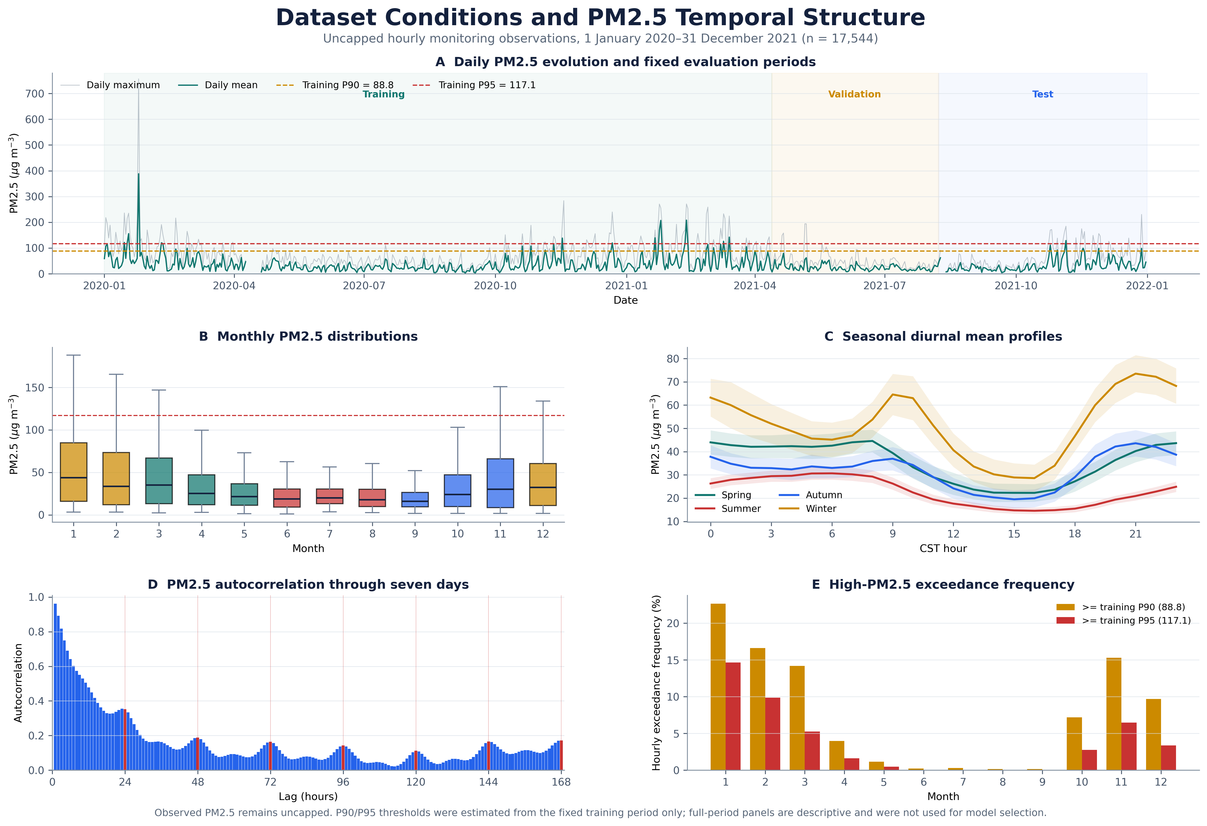
Fig. 2. Dataset conditions and temporal structure of hourly PM2.5 observations during 2020–2021. (A) Daily mean and maximum uncapped PM2.5, fixed data periods, and descriptive P90/P95 thresholds estimated from eligible h1 training origins; warning evaluation used separate horizon-specific thresholds. (B) Monthly distributions; outlier markers were omitted, but uncapped values were retained. (C) Seasonal mean diurnal profiles with approximate 95% confidence bands. (D) Autocorrelation through 168 h. (E) Monthly exceedance frequencies. Full-period summaries were descriptive and did not inform model or scenario selection.

3.2 Forecast accuracy was highest at short horizons and declined toward h24
The full model achieved highly accurate short-horizon forecasts and remained more informative than the simple references through h24. At one hour ahead, the full model achieved R²=0.9488, RMSE=7.019 µg m−3, and MAE=4.157 µg m−3 on 3,373 locked-test targets. The local-only model produced a similar h1 result (R²=0.9467; full-minus-local ΔR²=+0.0022), showing the strength of recent local information for immediate forecasting.
As expected, accuracy declined as the forecast extended further ahead (Fig. 3; Supplementary Table S2). Full-model R² changed from 0.9488 at h1 to 0.2044 at h24. At h24, the full model remained above month–hour climatology (R²=0.1550) but was slightly below the local-only model (R²=0.2102). Both CatBoost models outperformed the simple climatology reference across the reported horizons (Table 2).
Table 2. Mean locked-test performance across h1–h24.
Model | R² | RMSE (µg m−3) | MAE (µg m−3) | Bias (µg m−3)
Persistence | -0.0009 | 30.335 | 19.410 | -0.312
Month–hour climatology | 0.1550 | 28.524 | 20.063 | +1.155
Local-only model | 0.4125 | 23.142 | 15.331 | +0.099
Full model (with MERRA-2) | 0.4563 | 22.323 | 15.061 | +1.846
Table note: Values are unweighted means across the 24 horizons. CatBoost and climatology used 3,373 targets per horizon; persistence availability varied with forecast-origin PM2.5 availability. Baseline-relative skill was calculated only on rows shared by the compared forecasts.
Across h1–h24, the full model had higher R² than the local-only model at 22 of 24 horizons. Its mean R² was 0.4563, compared with 0.4125 for the local-only model, while mean RMSE decreased from 23.142 to 22.323 µg m−3 and MAE from 15.331 to 15.061 µg m−3. The local-only model had near-zero mean bias (+0.099 µg m−3), whereas the full model had modest average overprediction (+1.846 µg m−3). Section 3.3 shows how the difference between the two models changed with horizon.

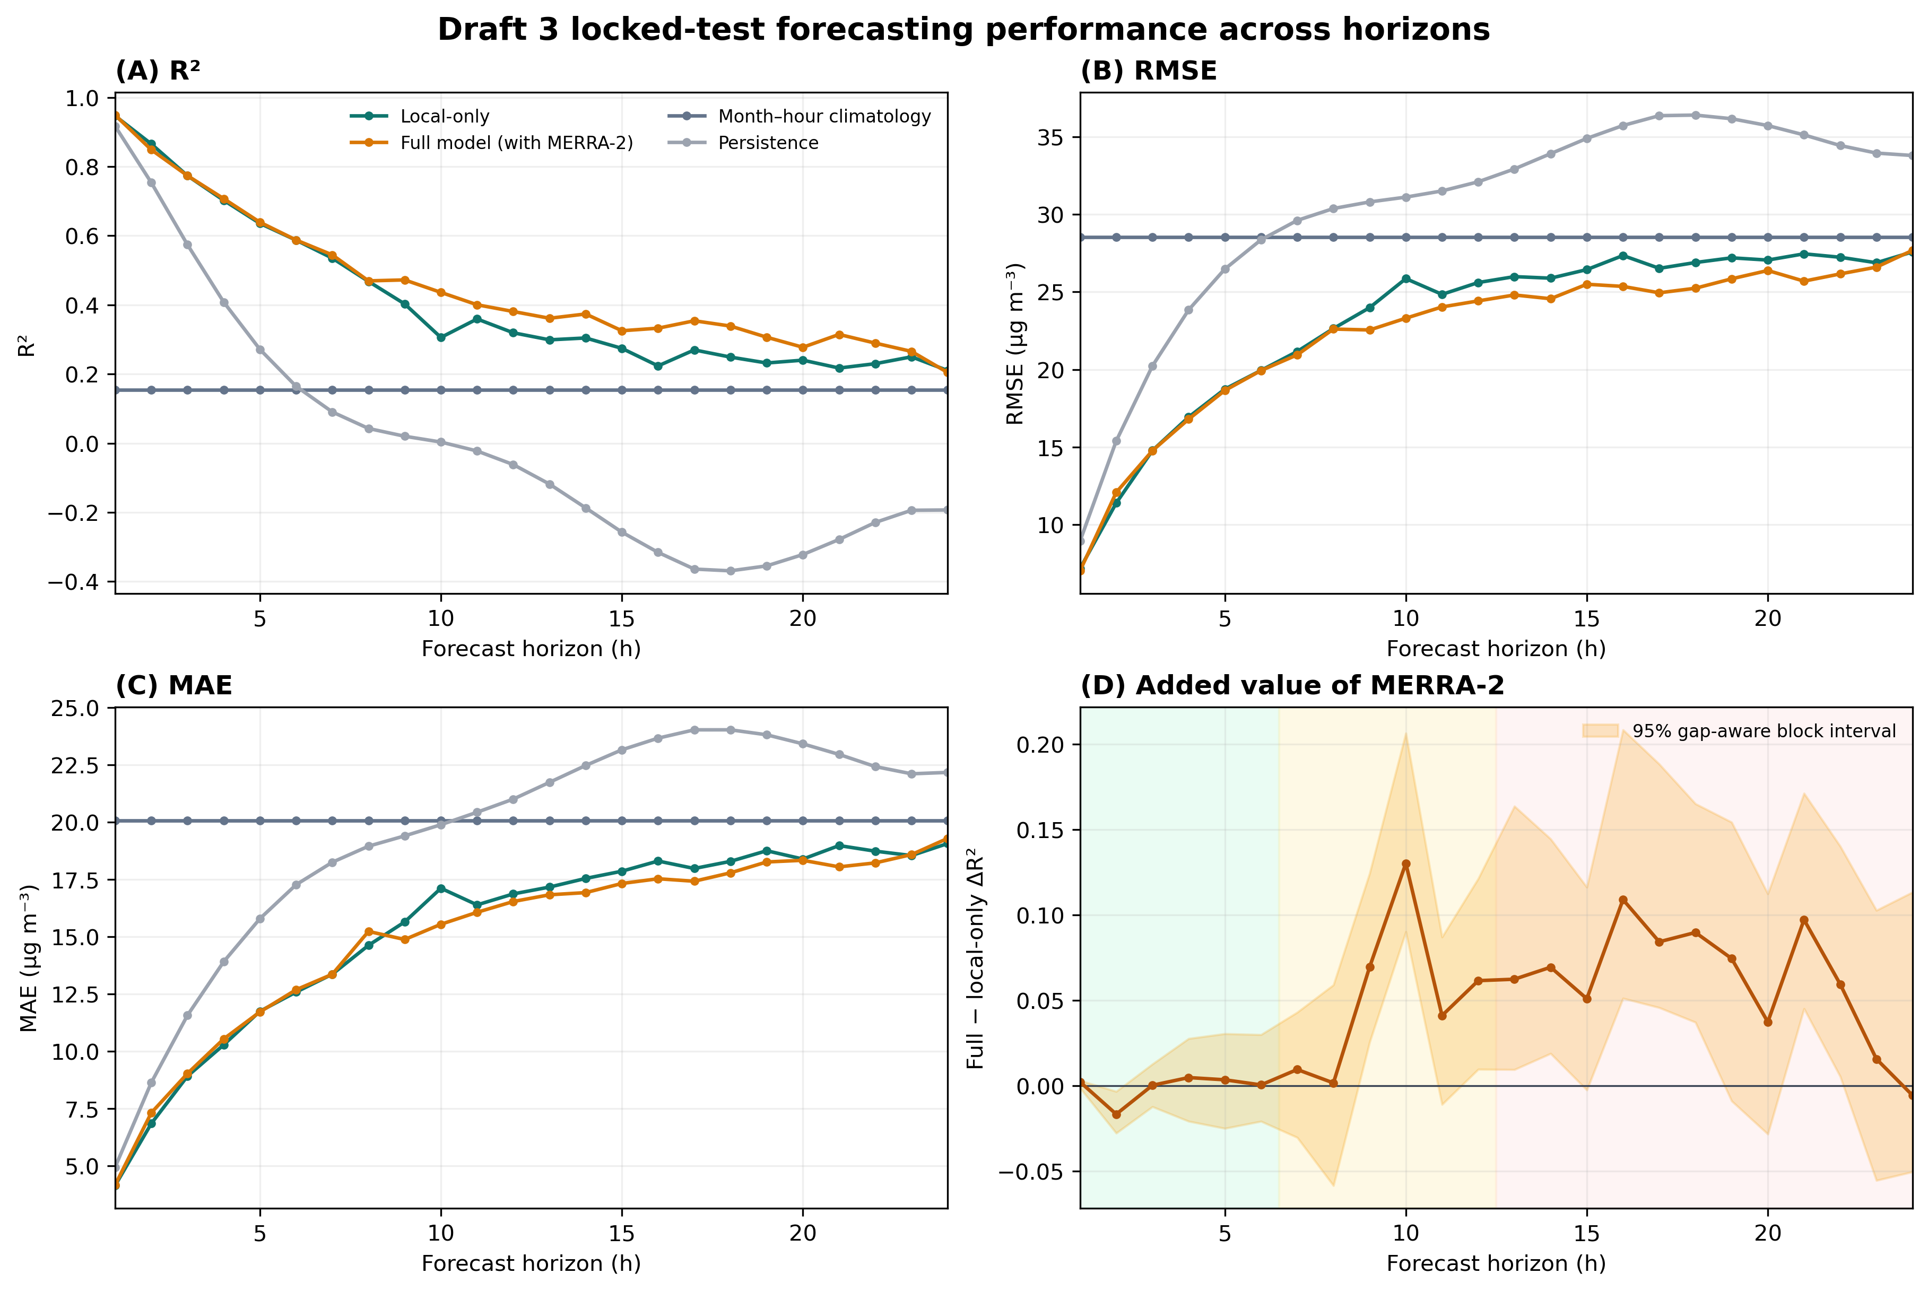
Fig. 3. Forecast performance across 1–24 h horizons on the Draft 3 locked test. Panels show (A) R², (B) RMSE, (C) MAE for persistence, month–hour climatology, the local-only model, and the full model with MERRA-2, and (D) full-minus-local-only ΔR² with paired 95% gap-aware 28-hour block-bootstrap intervals. Background colors distinguish h1–h6, h7–h12, and h13–h24.

Figure 4 provides a concrete view of these horizon patterns over a real 168-hour sequence from the locked test. The h1 forecasts followed rapid changes more closely, whereas h12 and h24 captured broader changes but underestimated several peaks. The sequence was selected using observed event timing rather than forecast error and is illustrative; Figure 3 and Table 2 provide the complete performance assessment.

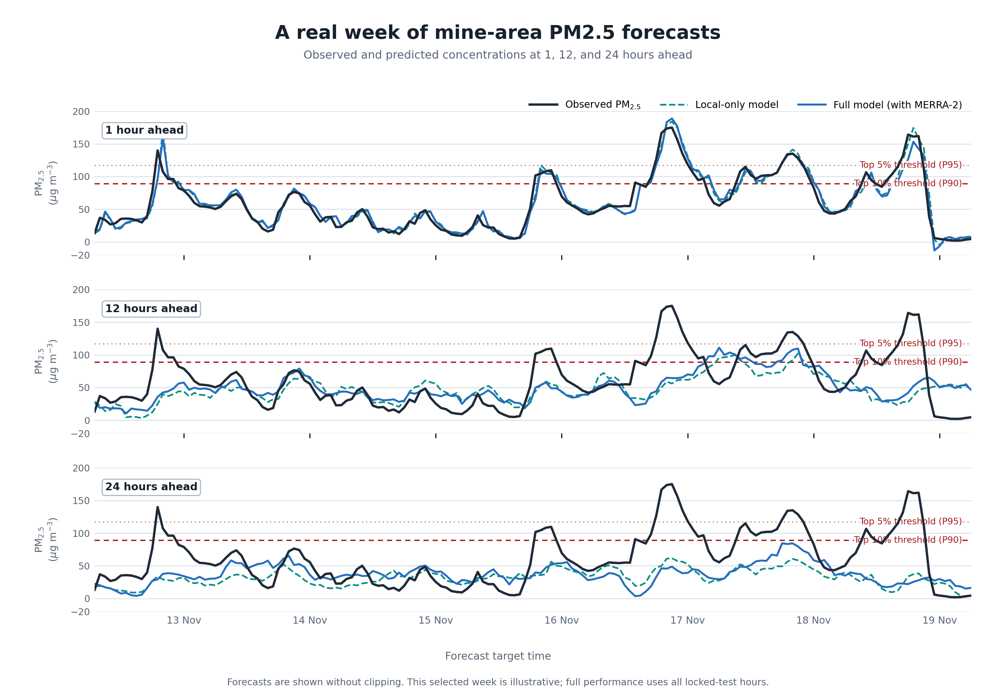
Fig. 4. Real seven-day locked-test PM2.5 forecast example. The 168-hour target-time sequence spans 12 November 2021 at 07:00 to 19 November 2021 at 06:00 and is centered on the first eligible observation above the descriptive P90 threshold. Observations are compared with the local-only model and the full model (with MERRA-2) at h1, h12, and h24. Selection used event timing, not forecast error. Red lines mark the descriptive training-period P90 and P95 thresholds. This illustrative example does not replace the complete evaluation in Figure 3 and Table 2.

3.3 Models with MERRA-2 achieved higher average accuracy after six hours, with little average difference earlier
Models with regional MERRA-2 information achieved higher average accuracy at medium and long forecast horizons. At h7–h12, mean R² was 0.3984 for the local-only model and 0.4506 for the full model (ΔR²=+0.0522). At h13–h24, the difference was 0.2500 versus 0.3120 (ΔR²=+0.0620). At h1–h6, the models were essentially equivalent on average (0.7517 versus 0.7508; ΔR²=−0.0009), showing that MERRA-2’s added predictive value emerged mainly after six hours.
Across all 24 horizons, the full model had higher R² and lower RMSE at 22 horizons; MAE was lower at 15. The mean full-minus-local differences were +0.0438 R², −0.819 µg m−3 RMSE, and −0.270 µg m−3 MAE. The paired uncertainty analysis is reported with the primary model comparisons and does not imply improvement at every individual horizon.
Input-group removal supported the same general horizon pattern in the frozen Draft 2 secondary analysis. That analysis reused the Draft 2 locked settings and found mean R² reductions of 0.0505 after removing all 73 MERRA-2 predictors and 0.0102 after removing the 23 engineered local-condition indicators. These secondary results were retained as supporting evidence and were not used to select or revise the Draft 3 primary models.
3.4 Model attribution showed the same horizon-dependent information shift
The frozen Draft 2 secondary attribution analysis showed a shift from recent local pollution at short horizons toward regional atmospheric information at longer horizons. Recent PM2.5 and other-pollutant history accounted for 63.6% of total SHAP attribution at h1 and 20.1% at h24, while MERRA-2 attribution increased from 5.3% to 32.3%. These values describe the earlier locked models and are reported as supporting, model-dependent evidence rather than as a re-estimate of the Draft 3 primary results.
The more detailed eight-family analysis was also retained from the frozen Draft 2 secondary package. PM2.5-history attribution fell from 26.93% at h1–h6 to 10.45% at h7–h12 and 6.74% at h13–h24, while MERRA-2 attribution rose from 15.04% to 25.56% and 30.99%. Because these SHAP values came from the frozen Draft 2 models, they provide supporting interpretation of the horizon pattern and do not alter the Draft 3 primary comparison.
SHAP describes how the fitted model assigned its predictions, not whether an input caused pollution or independently improved accuracy. The Draft 3 primary comparison is therefore based on matched locked-test metrics and gap-aware uncertainty; the frozen Draft 2 attribution and input-removal analyses are reported as supporting evidence. Feature-level results are provided in Supplementary Fig. S1 and additional importance summaries in Supplementary Figs. S3A–S3B.

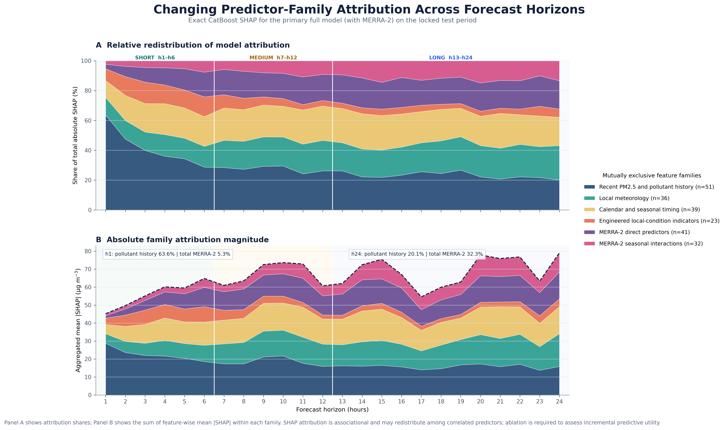
Fig. 5. Changing predictor-family attribution across h1–h24 in the frozen Draft 2 secondary analysis. (A) Percentage of total absolute SHAP attribution assigned to six mutually exclusive reporting groups. (B) Absolute family attribution magnitude. Combined MERRA-2 attribution increased from 5.3% at h1 to 32.3% at h24, while recent pollutant-history attribution declined from 63.6% to 20.1%. SHAP describes model attribution rather than causal effects; these values were not recomputed for the Draft 3 primary rerun.

3.5 Winter carried the highest PM2.5 burden, while autumn showed the largest MERRA-2 gain
Seasonal results showed a planning-relevant contrast: winter had the highest PM2.5 burden (51.5 µg m−3), while autumn showed the largest average MERRA-2 forecasting gain (ΔR²=+0.0481). In the separate rolling-origin evaluation, mean R² was also higher with MERRA-2 by 0.0203 in summer and 0.0043 in spring. Composite winter showed a near-zero average difference: mean R² changed from 0.2967 for the local-only model to 0.2944 for the full model (ΔR²=−0.0024). Full-model R² was higher at 12 winter horizons and lower at 12, and every horizon-specific interval included zero.
Winter defined the highest-burden season, autumn showed the largest MERRA-2 gain, and summer showed that regional information could still add forecasting value during lower-pollution conditions. Mean MERRA-2 SHAP attribution increased from the short to the long horizon band in every season, including from 15.10% to 32.74% in spring and from 14.55% to 28.44% in composite winter. Thus, greater model attribution did not necessarily correspond to better seasonal forecast accuracy.
Table 3. Coverage-corrected seasonal rolling-origin performance averaged across h1–h24.
Season | Targets per horizon | Local-only R² | Full-model R² | ΔR² | Full-model RMSE | Full-model MAE
Spring | 2,208 | 0.4386 | 0.4429 | +0.0043 | 27.001 | 17.995
Summer | 2,091 | 0.3660 | 0.3863 | +0.0203 | 10.760 | 7.901
Autumn | 2,163 | 0.4513 | 0.4995 | +0.0481 | 22.587 | 14.853
Composite winter | 2,142 | 0.2967 | 0.2944 | −0.0024 | 39.918 | 27.566

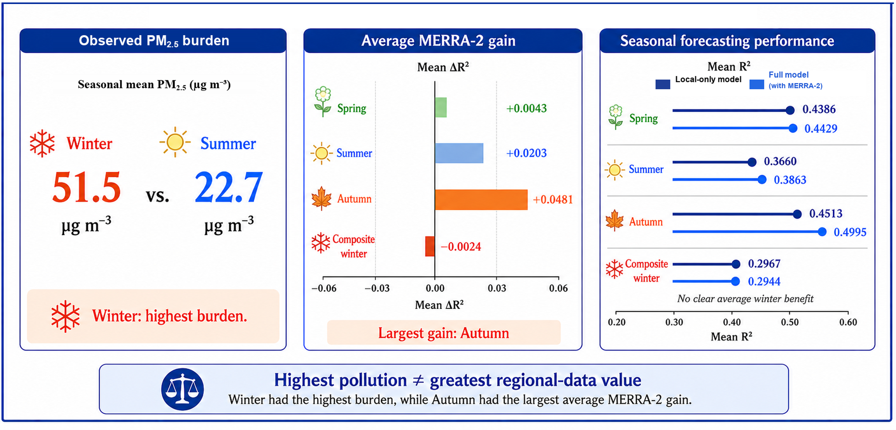
Fig. 6. Seasonal pollution burden and regional-data value. The left panel compares full-record seasonal mean PM2.5 for winter and summer. The center and right panels summarize mean R² from the separate held-out seasonal rolling-origin evaluation: bars show the full-minus-local-only difference, and paired lines compare the local-only model with the full model (with MERRA-2). Winter had the highest observed burden (51.5 µg m−3), while autumn had the largest average MERRA-2 gain (+0.0481). Composite winter had a near-zero average difference (ΔR²=−0.0024). The descriptive burden and forecasting panels use different observation windows; seasonal models used a fixed untuned CatBoost configuration rather than the primary horizon-specific tuned models.

3.6 Most point estimates favored MERRA-2, with five intervals entirely positive
Point estimates favored MERRA-2 at 22 of 24 locked-test horizons, and the two negative differences occurred at h2 and h24. The evidence therefore supports a positive average horizon-dependent pattern without claiming improvement at every individual horizon. At h24, the Draft 3 point estimates were R²=0.2044 for the full model and 0.2102 for the local-only model; the broad pattern therefore has an important endpoint exception.
Across the seasonal analysis, intervals were entirely positive at seven autumn and five summer horizons, but at none in spring or composite winter. None of the 96 season–horizon intervals was entirely negative. These paired intervals describe uncertainty in the difference between models; their frequent overlap with zero supports a conditional, rather than universal, MERRA-2 benefit.
3.7 The full model had higher P90 detection, while P95 alerts need further validation
The Draft 3 full model (with MERRA-2) had higher mean P90 detection performance than the local-only model: F1 was 0.301 versus 0.203, with mean precision of 0.579 versus 0.445 and mean recall of 0.236 versus 0.165. For the rarer P95 events, mean F1 was 0.123 for the full model and 0.110 for the local-only model, with recall of 0.099 and 0.090, respectively. These warning summaries use horizon-specific thresholds estimated from uncapped training targets; rare-event alerts require further validation before stand-alone use.
For P90 events, the full model achieved mean precision of 0.571 and recall of 0.228, compared with 0.470 and 0.163 for the local-only model. The higher F1 reflected gains in both precision and recall, although recall remained modest. For the rarer P95 events, mean recall was 0.095 for the full model and 0.094 for the local-only model, indicating that rare-event alerts require further validation before stand-alone use. Supplementary Fig. S4 shows one accurately predicted peak and one severe peak with large forecast error as examples, not as evidence of general performance.

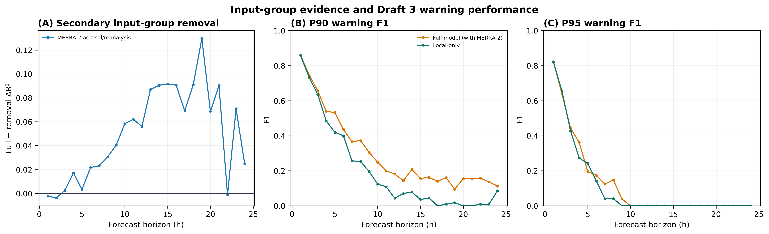
Fig. 7. Secondary input-group evidence and Draft 3 high-PM2.5 warning performance. (A) Full-model R² minus R² after removing MERRA-2 or engineered local-condition indicator groups, retained from the frozen Draft 2 secondary analysis. Positive values mean that the full model had higher R² than the corresponding removal model. (B) P90 and (C) P95 exceedance-warning F1 from the Draft 3 primary predictions, using horizon-specific thresholds estimated from uncapped training targets only. Warning panels use the Draft 3 primary full and local-only models; panel A is supporting secondary evidence and was not used for Draft 3 model selection.

3.8 The predefined locked-test model remained primary while a smaller candidate showed practical promise
The full 222-predictor model remained the predefined locked-test model, while the post-hoc 59-predictor candidate remained a candidate for future replacement testing. The full model’s mean locked-test R² ranged from 0.4518 to 0.4582 across the four spatial and timing scenarios; the predefined primary scenario produced R²=0.4563 and remained the reported specification. In validation-only algorithm checks using the same 222 predictors, mean R² was 0.3572 for fixed-setting CatBoost, 0.3513 for histogram gradient boosting, 0.3218 for random forest, and 0.1312 for ridge regression.
The prespecified validation-only reduction retained 119–140 predictors. R², RMSE, and MAE each met their individual requirements at 19 of 24 horizons, and all three requirements were met jointly at 17 of 24 horizons. The joint limits were not met at h1, h8, h16–h18, h23, and h24, with the largest full-model R² advantages at h18 (+0.0248), h17 (+0.0234), h24 (+0.0193), and h23 (+0.0191); paired intervals favored the full model at h18, h23, and h24. The reduced version therefore remained supporting validation evidence, and the 222-predictor model remained primary (Supplementary Fig. S2).
A later post-hoc analysis reduced the predictor budget by 73.4%, to 59 horizon-specific predictors. How often MERRA-2 inputs were selected rose from 0.086 in the short band to 0.461 in the long band, while how often engineered local-condition indicators were selected fell from 0.242 to 0.165. The candidate had a small mean ΔR² of −0.00472 (reduced model minus full model; negative values mean the reduced model was below the full model), showed a distinguishable h10 gap favoring the full model, and remains a validation-only candidate for future testing rather than a replacement model. At h10, h13, and h24, respectively, 28/30, 30/30, and 29/30 repeated-seed fits passed the 5% performance-loss limits; bootstrap pass frequencies were 83.3%, 90.1%, and 89.3%. The full-model advantage was distinguishable in all three metrics at h10, in MAE only at h13, and in none at h24. Smaller band-specific alternatives received less support: a 15-predictor candidate passed 5/30 seed fits at h6, while a 51-predictor candidate passed 23/30 at h10 but was indistinguishable from its 50-predictor neighbor. Figure 8 summarizes this validation-only evidence. As a validation-only analysis, the 59-predictor candidate should be evaluated on new data before any operational use.
Pressure handling provided additional validation evidence. Consistent cleaning changed 104 pressure-derived cells across 75 rows. Mean validation R² changed from 0.3616 to 0.3518 for the local-only model and from 0.3694 to 0.3561 for the full model. The full-minus-local difference remained positive but narrowed from 0.0078 to 0.0043 (Supplementary Table S12). Because this check used validation data only, the predefined locked-test estimates remained unchanged.
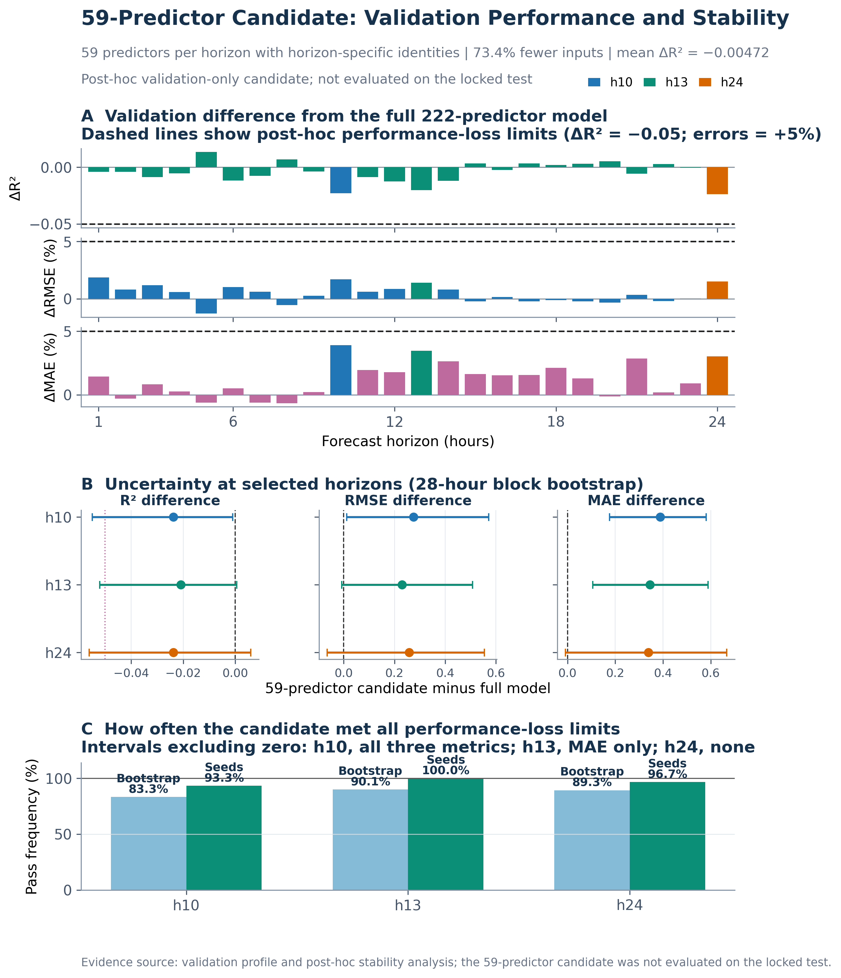
Fig. 8. Validation performance and stability of the 59-predictor candidate with horizon-specific feature identities. (A) Reduced model minus full model R² and relative RMSE and MAE changes across h1–h24 on the repeatedly examined validation partition; for R², negative values mean the reduced model was below the full model. Dashed lines show the 5% performance-loss limits predefined within this disclosed post-hoc analysis. (B) Paired 95% intervals from 1,000 28-hour moving-block-bootstrap resamples at h10, h13, and h24. At h10, all three intervals favored the full model; at h13, only MAE excluded zero; at h24, all intervals included zero. (C) Frequencies with which all 5% performance-loss limits were met under bootstrap resampling and 30 repeated-seed refits. The candidate remains validation-only and requires prospective new-period assessment.
4. Discussion
4.1 Forecast horizon changes which information is most useful for dust-risk planning
For open-pit mining, the useful forecasting information changed with the planning horizon. Recent local information supported highly accurate immediate forecasts (h1 full-model R²=0.9488), whereas the full model showed higher average accuracy at h13–h24 (ΔR²=+0.0620). The practical implication is a shift from immediate response to longer-range situational awareness.
This finding supports a complementary monitoring strategy. Local measurements remain central for describing current mine-area conditions, while regional atmospheric information can add context when the forecast extends beyond the period covered well by recent observations. These results describe predictive relationships, not causes. SHAP attribution can be shared among correlated inputs, and input removal can remove both unique and shared information.
SHAP attribution, fixed-parameter input removal, and validation-based selection counts all showed greater reliance on MERRA-2 at longer horizons. The independently tuned comparison and fixed-parameter removal test answer different questions, but both supported incremental average predictive value beyond h6. This agreement does not establish a causal role for any aerosol variable.
4.2 Regional predictive value varied by season
Seasonal pollution burden and regional-data value varied independently. Winter had the highest full-record PM2.5 mean (51.5 µg m−3), autumn had the largest MERRA-2 gain (+0.0481), and summer showed moderate added value during lower-pollution conditions (ΔR²=+0.0203). Spring changed little; the composite-winter average difference was near zero (ΔR²=−0.0024).
For dust-risk management, regional data should be interpreted season by season. This contrast may reflect different information scales: previous open-pit mine studies link dust to production intensity and near-surface meteorology, while MERRA-2 provides coarser regional aerosol and atmospheric information [21,22,25–28]. Autumn may have contained more usable regional atmospheric signal in this experiment, whereas winter peaks may have depended more on local or near-surface processes partly represented by local histories. This remains a hypothesis because haulage, blasting, watering, road-moisture, and production-rate records were unavailable. Winter SHAP attribution still increased with horizon, so greater attribution did not imply higher accuracy.
The composite winter result pooled two chronological folds covering January–February and December 2021, not one continuous season. Additional years, mines, and operational measurements are needed to determine whether the near-zero winter difference is reproducible.
4.3 Relation to previous PM2.5 and mine-dust studies
Published scores cannot be ranked directly because tasks, forecast horizons, data splits, and metrics differ [3,14,15,17–25,31,36,37]. Supplementary Table S13 summarizes the comparisons; Supplementary Tables S10 and S11 give evaluation details. For example, Boser showed that mishandling data structure could make a true R² of 0.09 appear as 0.73 or 0.82 [31]. The comparison should therefore be read as design context rather than a head-to-head ranking.
Wang et al. [3] reported R²=0.957 from ten randomly selected 24-hour multi-output test sequences using the same record. Because our chronological analysis used separate direct models and different aggregation, the scores do not compare neural networks with CatBoost directly.
Studies using MERRA-2 to estimate PM2.5 [24,25] support using regional atmospheric information but also show the need for design-aware evaluation. This study adds a matched local comparison across 24 horizons, a one-time locked test, uncertainty estimates, seasonal checks, and complementary attribution and input-removal analyses.
4.4 Implications for dust-risk management and model complexity
The results support using forecast horizon to match model inputs to mine-planning needs. The full 222-predictor model is the predefined locked-test model because it provided the reported locked-test evidence. The 59-predictor candidate could reduce data and computing requirements, but it was post-hoc, validation-only, and showed a distinguishable h10 gap favoring the full model. It remains a practical candidate for new-period testing, while the 222-predictor model remains the established locked-test model.
Average accuracy and rare-event alerting answer different operational questions. In the Draft 3 warning analysis, mean P90 F1 was 0.301 with MERRA-2 versus 0.203 for the local-only model, while mean P95 recall was 0.099 versus 0.090. This pattern supports use for short-horizon forecasting and longer-horizon situational awareness, while stand-alone alerts for the most severe events should be treated as a future validation target.
Warning applications should be developed with event-focused training, decision-linked thresholds, and prospective testing. This study establishes historical predictive value; real-time use also requires data available at issuance. Regional information should supplement local monitoring and operational observations.
4.5 Strengths, scope, and future validation
The study combined a one-time chronological locked test, complete h1–h24 reporting, matched models, dependence-aware uncertainty estimates, and separate seasonal evaluation. We limited optimistic performance estimates by using training-only preprocessing, leaving held-out PM2.5 values uncapped, and reporting the full range of estimates, including near-zero and negative values. SHAP attribution was interpreted alongside input-group removal and feature-selection stability, not as causal evidence.
Several factors define where the findings should be tested next: two years, one monitoring setting, and few independent extreme-pollution episodes. Missing inputs included haulage schedules, road moisture, watering, blasting, production rate, and detailed wind. MERRA-2 is coarse relative to mine-road processes, and timely delivery requires separate evaluation. Seasonal and reduction analyses used fixed settings; composite winter combined parts of two winters; and pressure cleaning changed validation performance. The 50-trial CatBoost searches used 20 startup trials and then the adaptive TPE stage, but a finite search budget does not establish global optimality; the selected settings should therefore be viewed as reproducible validation-selected settings. SHAP and permutation importance remain model-dependent with correlated predictors.
Future work should test the findings prospectively across years and mines, record mine activities and local conditions, and link warning thresholds to operational consequences. Real-time use requires inputs available at issuance. Alternative methods should be compared under the same chronological, leakage-controlled protocol. The 59-predictor candidate requires new-period and external-mine testing before it can be considered portable or equivalent to the full model.
5. Conclusions
PM2.5 forecasting for open-pit mines should be designed around the planning horizon. At h1, the full model achieved R²=0.9488, while the local-only result was 0.9467, showing the strength of recent local information for immediate forecasting. As the horizon extended, the full model achieved higher average accuracy: mean locked-test R² was 0.4125 for the local-only model and 0.4563 for the full model across h1–h24, with ΔR²=+0.0620 at h13–h24. Forecast comparisons, model attribution, input-group removal, and stability analysis all supported this horizon-dependent pattern. These findings describe predictive relationships rather than physical causes.
MERRA-2’s value was conditional. The largest seasonal model gain occurred in autumn, while winter had the highest observed PM2.5 burden but a near-zero average MERRA-2 difference. The full model (with MERRA-2) had higher P90 event-detection F1, whereas P95 recall of 0.095 showed that stand-alone warning of the most severe pollution events remains a future testing need. The models may therefore support immediate forecasting and longer-horizon situational awareness.
The 222-predictor model remains the predefined locked-test model. The post-hoc 59-predictor candidate may reduce data and computing demands, but requires testing on new data. Future studies should use prospectively available atmospheric inputs, mine-activity and local-condition measurements, and external validation across additional mines, years, seasons, and high-pollution episodes. Overall, the results show that local monitoring and regional atmospheric information can support horizon-specific PM2.5 forecasting for open-pit mine air-quality planning, while rare-event warning use should be validated with timely data and new mine-period observations.
Declarations
Generative AI statement
Author confirmation pending. The final Generative AI disclosure will be inserted after all authors approve its wording.
Conflicts of interest
Author confirmation pending. The final conflict-of-interest declaration will be inserted after every author confirms it.
Ethical statement
Author and institutional confirmation pending. The final ethical statement will be inserted after confirming whether an exemption or formal approval statement is required for this environmental-data-only study.
Funding body
Author confirmation pending. The final funding statement will be inserted after all authors confirm any grants, institutional support, scholarships, or project funding.
Acknowledgments
The authors acknowledge Wang et al. [3] for making the source monitoring dataset publicly available through Figshare.
Author contributions
Author confirmation pending. The final CRediT author-contribution statement will be inserted after all authors approve their roles.
Data availability
The hourly monitoring dataset from an open-pit coal mine in Tongliao City, Inner Mongolia, China, was made publicly available by Wang et al. [3] through Figshare (https://doi.org/10.6084/m9.figshare.21308433.v2). The analysis used NASA MERRA-2 reanalysis data from the M2T1NXAER collection [27,28] (https://doi.org/10.5067/KLICLTZ8EM9D).
References
- World Health Organization. WHO global air quality guidelines: particulate matter (PM2.5 and PM10), ozone, nitrogen dioxide, sulfur dioxide and carbon monoxide. Geneva: World Health Organization; 2021.
- GBD 2019 Risk Factors Collaborators. Global burden of 87 risk factors in 204 countries and territories, 1990–2019: a systematic analysis for the Global Burden of Disease Study 2019. Lancet. 2020;396:1223–1249. https://doi.org/10.1016/S0140-6736(20)30752-2.
- Wang M, Yang Z, Tai C, Zhang F, Zhang Q, Shen K, et al. Prediction of road dust concentration in open-pit coal mines based on multivariate mixed model. PLoS ONE. 2023;18:e0284815. https://doi.org/10.1371/journal.pone.0284815.
- Chemel C, Fisher BEA, Kong X, Francis XV, Sokhi RS, Good N, et al. Application of chemical transport model CMAQ to policy decisions regarding PM2.5 in the UK. Atmospheric Environment. 2014;82:410–417.
- Zhou G, Xu J, Xie Y, Chang L, Gao W, Gu Y, et al. Numerical air quality forecasting over eastern China: an operational application of WRF-Chem. Atmospheric Environment. 2017;153:94–108.
- Pan J, Yang P, Li Y, Liu B, Wang Z, Dong R, et al. Improved application of multiple linear regression method to PM2.5 forecast in Beijing. Environmental Monitoring in China. 2019;35:43–52.
- Zhong J, Zhang X, Gui K, Wang Y, Che H, Shen X, et al. Robust prediction of hourly PM2.5 from meteorological data using LightGBM. National Science Review. 2021;8:nwaa307. https://doi.org/10.1093/nsr/nwaa307.
- Kang J, Huang L, Zhang C, Zeng Z, Yao S. Hourly PM2.5 prediction and its comparative analysis under multi-machine learning model. China Environmental Science. 2020;40(5):1895–1905.
- Teng M, Li S, Song G, Yang J, Dong L, Lin H, et al. Including the feature of appropriate adjacent sites improves PM2.5 concentration prediction with a long short-term memory neural network model. Sustainable Cities and Society. 2022;76:103427. https://doi.org/10.1016/j.scs.2021.103427.
- Kang J, Tan J, Fang L, Xiao Y. Short-term PM2.5 concentration prediction based on XGBoost and LSTM variable weight combination model: a case study of Shanghai. China Environmental Science. 2021;41(9):4016–4025.
- Zhu M, Xie J. Investigation of nearby monitoring station for hourly PM2.5 forecasting using parallel multi-input 1D-CNN-biLSTM. Expert Systems with Applications. 2023;211:118707. https://doi.org/10.1016/j.eswa.2022.118707.
- Kow PY, Chang LC, Lin CY, Chou CCK, Chang FJ. Deep neural networks for spatiotemporal PM2.5 forecasts based on atmospheric chemical transport model output and monitoring data. Environmental Pollution. 2022;306:119348. https://doi.org/10.1016/j.envpol.2022.119348.
- Moursi ASAEA, El-Fishawy N, Djahel S, Shouman MA. Enhancing PM2.5 prediction using a NARX-based combined CNN and LSTM hybrid model. Sensors. 2022;22:4418. https://doi.org/10.3390/s22124418.
- Xiao S, Liu J, Yang Q, Chang Z, Zhang Y. Data-driven feature decomposition integrated prediction model for dust concentration in open-pit mines. Energy Science & Engineering. 2025;13:3218–3242. https://doi.org/10.1002/ese3.70099.
- Zaini N, Ean LW, Ahmed AN, Abdul Malek M, Chow MF. PM2.5 forecasting for an urban area based on deep learning and decomposition method. Scientific Reports. 2022;12:17565. https://doi.org/10.1038/s41598-022-21769-1.
- Wang M, Liu T, Guo C, Fang Z, Li X, Zhang X, et al. Research on intelligent dust concentration prediction and precise dust suppression collaborative system based on internet of things. Results in Engineering. 2025. https://doi.org/10.1016/j.rineng.2025.107305.
- Luan B, Zhou W, Jiskani IM, Wang Z. An improved machine learning approach for optimizing dust concentration estimation in open-pit mines. International Journal of Environmental Research and Public Health. 2023;20:1353. https://doi.org/10.3390/ijerph20021353.
- Qi C, Zhou W, Lu X, Luo H, Pham BT, Yaseen ZM. Particulate matter concentration from open-cut coal mines: a hybrid machine learning estimation. Environmental Pollution. 2020;263:114517. https://doi.org/10.1016/j.envpol.2020.114517.
- Lu X, Zhou W, Qi C, Luo H, Zhang D, Pham BT. Prediction into the future: a novel intelligent approach for PM2.5 forecasting in the ambient air of open-pit mining. Atmospheric Pollution Research. 2021;12:101084. https://doi.org/10.1016/j.apr.2021.101084.
- Li L, Zhang R, Sun J, He Q, Kong L, Liu X. Monitoring and prediction of dust concentration in an open-pit mine using a deep-learning algorithm. Journal of Environmental Health Science and Engineering. 2021;19:401–414. https://doi.org/10.1007/s40201-021-00613-0.
- Wang Z, Zhou W, Jiskani IM, Yang Y, Yan J, Luo H, et al. A novel approach to forecast dust concentration in open pit mines by integrating meteorological parameters and production intensity. Environmental Science and Pollution Research. 2023;30:114591–114609. https://doi.org/10.1007/s11356-023-30443-6.
- Yang Y, Zhou W, Wang Z, Jiskani IM, Yang Y. Accurate long-term dust concentration prediction in open-pit mines: a novel machine learning approach integrating meteorological conditions and mine production intensity. Journal of Cleaner Production. 2024;436:140411. https://doi.org/10.1016/j.jclepro.2023.140411.
- Ngoc LT, Nguyen H, Bui XN, Tran TT. Dynamic weighting and genetic algorithm-based hybrid SVR-Ridge model for improving PM2.5 forecasting in open-pit copper mines. International Journal of Mining, Reclamation and Environment. 2026;40:349–379. Published online 2025. https://doi.org/10.1080/17480930.2025.2492086.
- Dhandapani A, Iqbal J, Kumar RN. Application of machine learning (individual vs stacking) models on MERRA-2 data to predict surface PM2.5 concentrations over India. Chemosphere. 2023;340:139966. https://doi.org/10.1016/j.chemosphere.2023.139966.
- Sayeed A, Lin P, Gupta P, Tran NNM, Buchard V, Christopher S. Hourly and daily PM2.5 estimations using MERRA-2: a machine learning approach. Earth and Space Science. 2022;9:e2022EA002375. https://doi.org/10.1029/2022EA002375.
- Ali MA, Bilal M, Wang Y, Nichol JE, Mhawish A, Qiu Z, et al. Accuracy assessment of CAMS and MERRA-2 reanalysis PM2.5 and PM10 concentrations over China. Atmospheric Environment. 2022;288:119297. https://doi.org/10.1016/j.atmosenv.2022.119297.
- Gelaro R, McCarty W, Suárez MJ, Todling R, Molod A, Takacs L, et al. The Modern-Era Retrospective Analysis for Research and Applications, Version 2 (MERRA-2). Journal of Climate. 2017;30:5419–5454. https://doi.org/10.1175/JCLI-D-16-0758.1.
- Randles CA, da Silva AM, Buchard V, Colarco PR, Darmenov A, Govindaraju R, et al. The MERRA-2 aerosol reanalysis, 1980 onward. Part I: system description and data assimilation evaluation. Journal of Climate. 2017;30:6823–6850. https://doi.org/10.1175/JCLI-D-16-0609.1.
- Bergmeir C, Benítez JM. On the use of cross-validation for time series predictor evaluation. Information Sciences. 2012;191:192–213. https://doi.org/10.1016/j.ins.2011.12.028.
- Roberts DR, Bahn V, Ciuti S, Boyce MS, Elith J, Guillera-Arroita G, et al. Cross-validation strategies for data with temporal, spatial, hierarchical, or phylogenetic structure. Ecography. 2017;40:913–929. https://doi.org/10.1111/ecog.02881.
- Boser A. Validating spatio-temporal environmental machine learning models: Simpson’s paradox and data splits. Environmental Research Communications. 2024;6:031003. https://doi.org/10.1088/2515-7620/ad2e44.
- Lundberg SM, Lee SI. A unified approach to interpreting model predictions. In: Advances in Neural Information Processing Systems 30. 2017:4765–4774.
- Prokhorenkova L, Gusev G, Vorobev A, Dorogush AV, Gulin A. CatBoost: unbiased boosting with categorical features. In: Advances in Neural Information Processing Systems 31. 2018:6638–6648.
- Hyndman RJ, Koehler AB. Another look at measures of forecast accuracy. International Journal of Forecasting. 2006;22:679–688. https://doi.org/10.1016/j.ijforecast.2006.03.001.
- Künsch HR. The jackknife and the bootstrap for general stationary observations. Annals of Statistics. 1989;17:1217–1241. https://doi.org/10.1214/aos/1176347265.
- Ma J, Yu Z, Qu Y, Xu J, Cao Y. Application of the XGBoost machine learning method in PM2.5 prediction: a case study of Shanghai. Aerosol and Air Quality Research. 2020;20:128–138. https://doi.org/10.4209/aaqr.2019.08.0408.
- Hossen MK, Peng YT, Shao A, Chen MC. An ODE based neural network approach for PM2.5 forecasting. Scientific Reports. 2025;15:24830. https://doi.org/10.1038/s41598-025-05958-2.

