Hello, **Technometrics**

Myself Md. Mahmudul Hasan Shahin, Candidate of **Software Engineer (NLP) .**

Here short description are given below about the assignment and what I applied.

**Deep Neural Network (DNN):**

I applied Bi-Directional LSTM for model architecture, There are two different variation set I tried to get better result.

In **first** variation gives Train Accuracy 81.96 % , Train Loss 0.614 and Validation Accuracy 85.11 % , Validation Loss 0.478. **(Bi-LSTM_V1.ipynb)** for better understanding and **Graph of Performance.**

In **second** variation gives Train Accuracy 90.34 % , Train Loss 0.288 and Validation Accuracy 90.56 % , Validation Loss 0.279. **(Bi-LSTM_V2.ipynb)** for better understanding and **Graph of Performance.**

For preprocessing I applied Remove Stop Word, Tokenizing, Remove Outlier, Reshaping, Word Embedding, Apply Word2Vec with fastText model, One hot encoding.

Final input shape to feed the model was : X_Train (90118, 350, 20) and Y_Train (90118, 7)

**Sk-Learn Classification Algorithm:**

I also tried various Classification algorithm as like MultinomialNB, LinearSVC, DecisionTreeClassifier, KNeighborsClassifier.

To feed those model I preprocess data with Remove Stop Word, Tokenizing, Remove Outlier, Reshaping, TF-IDF, Label Encoding.

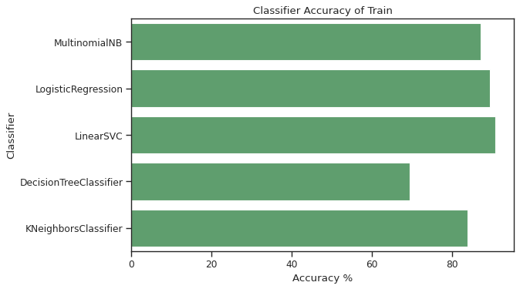**(Classification_Algo.ipynb)** for better understanding and **Graph of Performance and Matrix scores (F1, Precession, Recall).**

**File Description :**

* **Text_Data_Preprocessing**.ipynb : Most of preprocessing task done in this ipynb file.
* **Bi-LSTM_V1.**ipynb : DNN with Bi-LSTM architecture implemented in this ipynb file.
* **Bi-LSTM_V2**.ipynb : DNN with Bi-LSTM (different combination) done in this ipynb file.
* **Classification_Algo**.ipynb : Classification algorithm implemented using Sk-Learn.
* **Predict_Your_Text**.ipynb : Here you can check the saved model by giving your input.

**\*\*\* Some file can’t be uploaded because of file size and some of my personal Model are used which is not in Public \*\*\***

**What else can do :**

For classification we can apply Transformer based architecture as like BERT, GPT also Spacy, CNN and many more.

Preview of **Predict_Your_Text :**

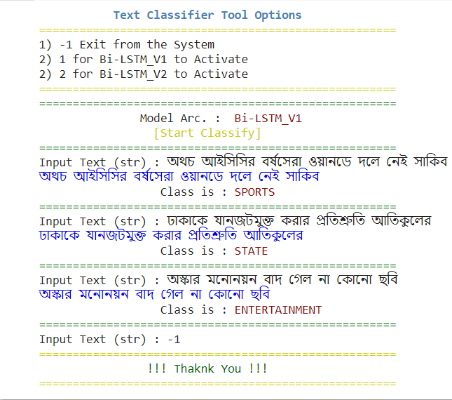

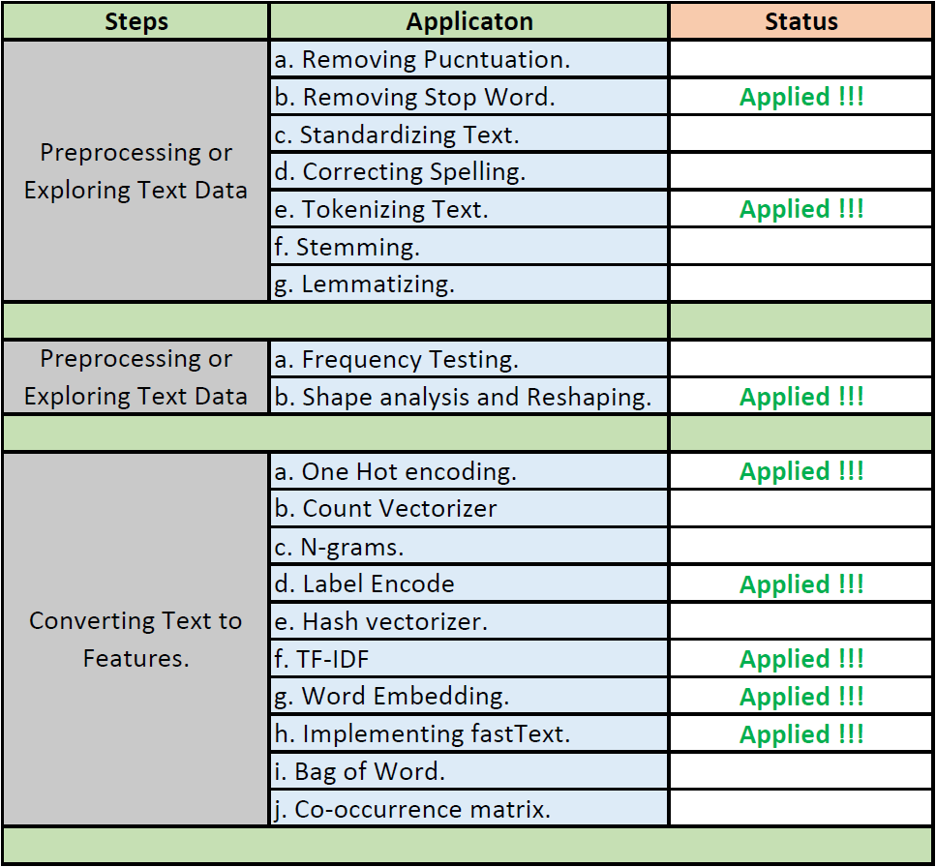

**Personal Resources (Not be uploaded):**

* fasttext_model.model
* bangla_stop_word_471.csv

*** For this fasttext_model.model and bangla_stop_word_471.csv you cant able to run those file properly, So if you want to please feel free to contact me ***

Contact,

Name : Md. Mahmudul Hasan Shahin Phone : +8801795814559 Email : shahinvx@gmail.com