LAB 02

Q1. You are working in a logistics company responsible for delivering packages. Design a flowchart to manage the process of receiving, sorting, and delivering packages. Include decision structures for handling fragile items and urgent deliveries.

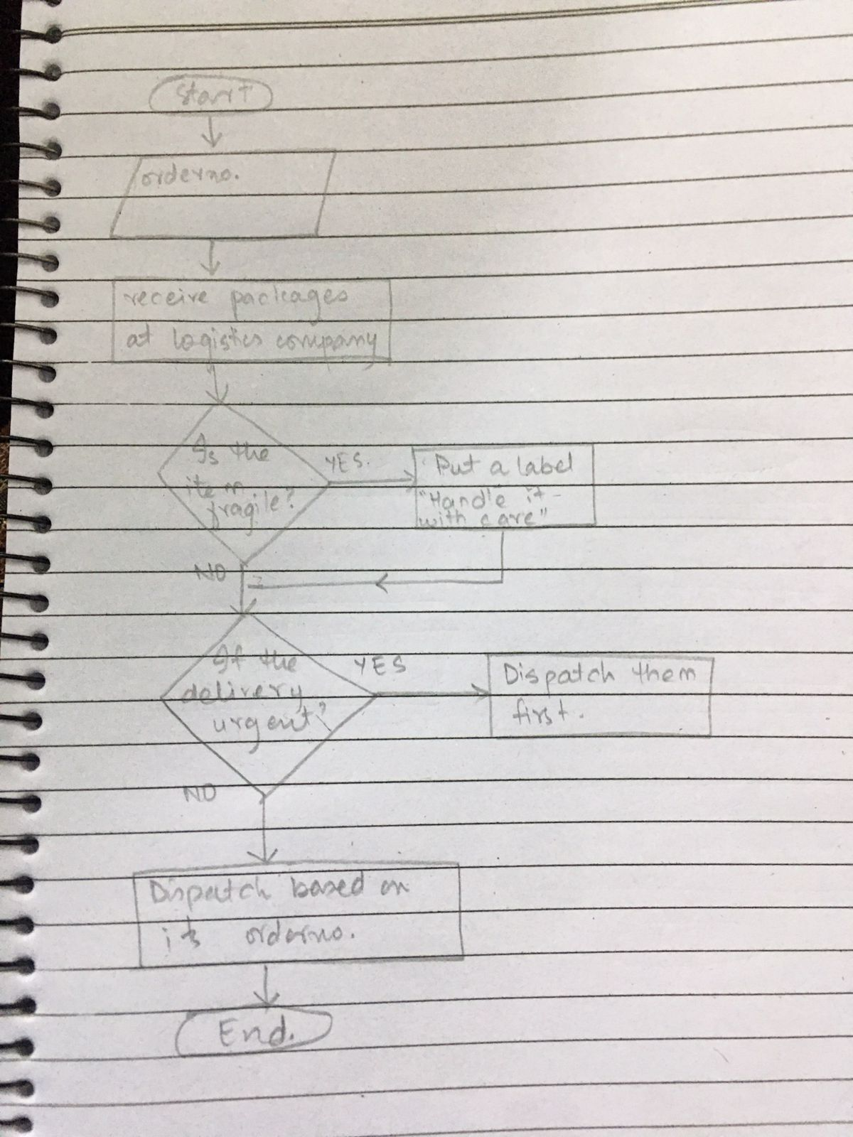

Q2. Imagine you are automating the process of a vending machine. Create a flowchart that includes decision points for user input, selecting products, accepting payment, and dispensing the correct item. Include error-handling for invalid inputs and insufficient funds.

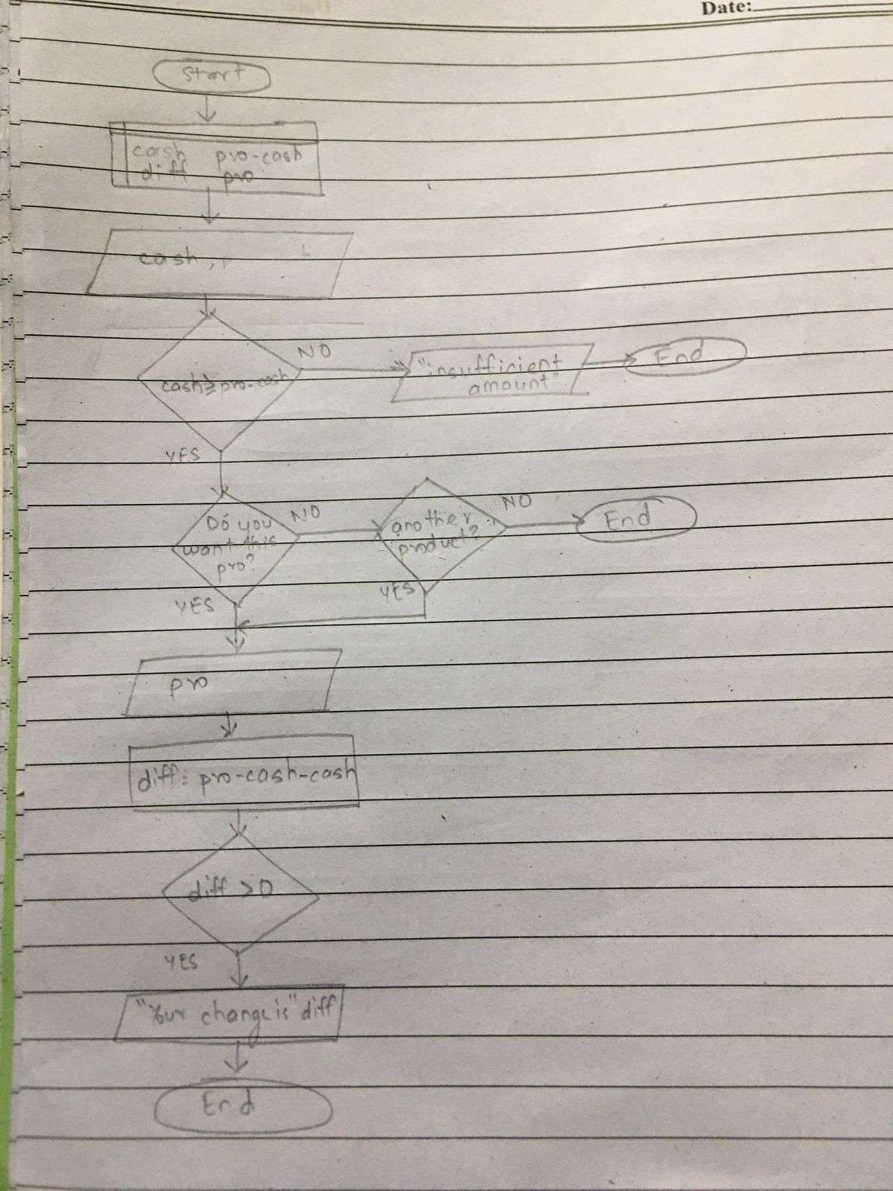

Q3. Write pseudocode to find the smallest number among three given variables. Implement a decision-making structure to compare the variables.

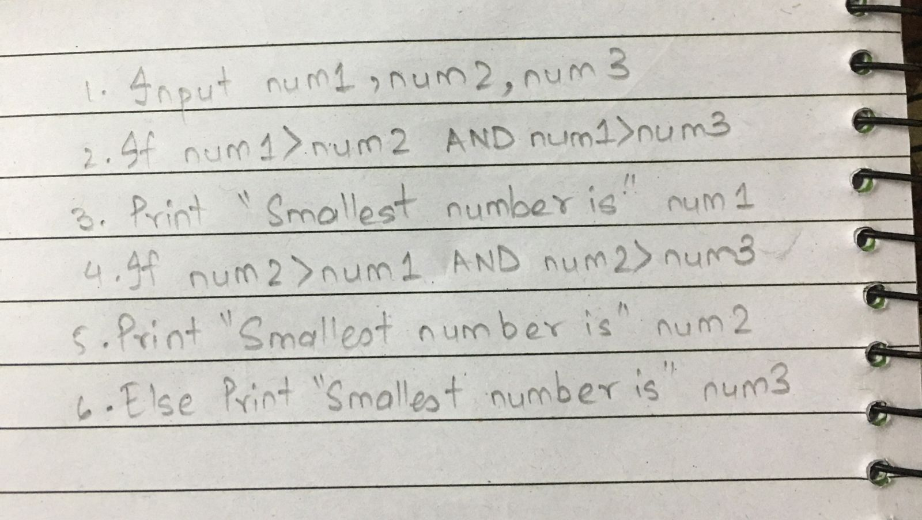

Q4. Develop pseudocode for a basic calculator that performs multiplication and division. The pseudocode should prompt the user for two numbers and an operator, then display the result of the operation.

Q5. Write an algorithm to determine whether a number is a prime number. The algorithm should iterate through possible divisors and determine if the number has any divisors other than 1 and itself.A paper with writing on it

Q6. Create an algorithm that asks the user for a day number(1-365) and outputs the corresponding day of the week, assuming that January 1st is a Monday.

