Research Methods in Data Science and Artificial Intelligence (COMP7090)
Student Submission Report Template
Assessment: Scientific Approaches to Problem Solving Using Data Science and AI
Use this template to prepare the 2,500-word technical report. Replace all bracketed guidance with your own work before submission.

Item | Assessment information
Unit | Research Methods in Data Science and Artificial Intelligence (COMP7090)
Assessment type | Individual technical report
Weighting | 100%
Submission method | Brightspace assignment / Turnitin
Deadline | 26 May 2026, 12:00 PM
Final submission format | PDF report only

Student and Project Details
Field | Complete this section
Student name | Shahir Ali
Student ID | S5517454
Programme | Data Science and Artificial Intelligence MSc
Project title | Automated Age Threshold Verification Using Deep Convolutional Architectures
Dataset / data source | https://www.kaggle.com/datasets/aibloy/fairface
Main AI/data science method | Computer vision, deep learning
Word count | 2500

Declaration of Originality and Responsible AI Use
I confirm that this submission is my own work. I have acknowledged all sources, datasets, tools, libraries, code, and external materials used in this project. I understand that basic spelling and grammar correction tools are permitted. I also understand that generative AI may be used for idea generation, summarising, and structuring only, and that no generative AI-generated content should appear in the final submission unless explicitly allowed by the assessment guidance.
Student signature: Shahir Ali
Date: 02/06/2026

Title
Automated Age Threshold Verification Using Deep Convolutional Architectures
Author: Shahir Ali (s5517454)

Abstract
Age-restricted sales rely on staff judgement, which mystery-shopping studies show to be unreliable. This project investigates whether convolutional neural networks can classify facial images as above or below an age threshold, as an automated first-pass check. Two ImageNet-pretrained architectures, ResNet34 and DenseNet121, were fine-tuned on FairFace, a dataset balanced by race, gender and age; because FairFace provides only age-group labels, the threshold was set at 20 rather than 18. After removing infant, greyscale and heavily blurred images and downsampling over-represented age groups, models were trained in two phases: classification head first, then the final convolutional blocks. Evaluation prioritised the false positive rate (FPR), minors classified as adults, with results disaggregated by race, gender and age and Grad-CAM used for interpretability. DenseNet121 achieved higher accuracy (86% vs 83%), but ResNet34 a lower FPR (0.11 vs 0.19). Errors concentrated in age groups adjacent to the threshold, accuracy differed by up to 14 percentage points between racial groups, and both models produced high-confidence false positives, ruling out a confidence-based human-referral scheme. The hypothesis is partially supported: ResNet34 misclassifies minors less often than staff fail to check ID, but neither model approaches commercial systems or is suitable for deployment.

1. Introduction (maximum 400 words)

1.1 Background and Context
Age verification is a critical safeguard in a wide range of real-world contexts, including the purchase of age-restricted goods (alcohol, tobacco, lottery products, knives), access to age-restricted digital content, and admission to age-restricted venues. In the United Kingdom, the Licensing Act 2003 and the Children and Young Persons Act 1933 place legal obligations on retailers and service providers to prevent the sale of restricted goods and services to individuals under the age of 18. Despite this, enforcement remains heavily reliant on human judgement, which is demonstrably inconsistent and subject to bias, with one study showing 89% of 17 year olds in mystery shopper tests were able to purchase alcohol at stores (Gosselt et al., 2007).

Frameworks such as Challenge 25 (or similarly named policies) aim to combat this by requiring staff approving age-restricted purchases to ask for ID from anyone who appears to be under 25 years of age, with the idea being that it’s easy for a person that’s 16 to look conceivably over 18, but much harder for them to look over 25. However, even when testing stores applying this policy, close to half of test purchasers are still served without being checked for ID (Miščikienė et al. 2023).

Automated facial age estimation and classification systems offer a potential solution. Rather than requiring a staff member to make a subjective judgement, or requiring a customer to present formal identification, such systems could provide a rapid, scalable, and consistent first-pass assessment of whether an individual is likely to be over or under 18. Systems of this nature are already commercially deployed — for example, Yoti's age estimation technology is approved by the UK government's Age Check Certification Scheme and is used in retail self-checkout environments, and achieves a True Positive Rate of 99.3% for classifying 13-17 year olds as under 21 (Yoti, 2023). The academic and practical foundations for this work are therefore well established.

1.2 Problem Definition
Problem statement: This project addresses the problem of the sale of age-restricted products to people under the age of 18 by using facial image data to classify faces as being over or under 18.

1.3 Aim and Objectives

- To review existing research on facial age estimation
- To identify or prepare a suitable dataset for facial age estimation.
- To design and implement state-of-the-art deep learning architectures.
- To evaluate the approach using precision, recall and area under the receiver operating characteristic (AUROC)
- To validate the hypothesis and reflect on limitations.

1.4 Research Question and Hypothesis
Research question: Can deep learning classifiers effectively classify faces over/under an age threshold using facial image data?
Testable hypothesis: A deep learning classifier trained on publicly available facial image data will be able to better classify faces as belong to a person over or under a given age than humans, and can provide similar performance (within 5% TPR) to a state-of-the-art commercial system in identifying 13-17 year olds.

1.5 Report Organisation
This report contains a review of existing work on the subject of this study, followed by an overview of the research methodology used and evaluation and inference of the key findings, ending with a review of the project and potential future steps.

2. Literature Review (maximum 600 words)

2.1 Overview of Related Research

2.1.1 Human Error in Age-Restricted Sales
Enforcing age restrictions manually is notoriously unreliable. Gosselt et al. (2007) found that supermarkets and liquor stores frequently failed to verify age, resulting in high rates of underage sales. Despite increased regulatory awareness, human compliance remains poor globally; Miščikienė et al. (2023) recently demonstrated persistent failures in enforcing legal purchasing ages in Lithuania. These systemic human errors highlight the operational need for automated facial age estimation systems to ensure consistent, objective age-gating.

2.1.2 Deep Learning Architectures
To automate age verification, computer vision deep learning architectures have become the standard, particularly Convolutional Neural Networks (CNNs). A CNN is a deep learning architecture first proposed by the neural network giant Yann LeCun et al. (1989) that uses layers of grid-like mathematical filters to automatically extract and learn spatial patterns, such as edges, textures, and shapes, from image data.

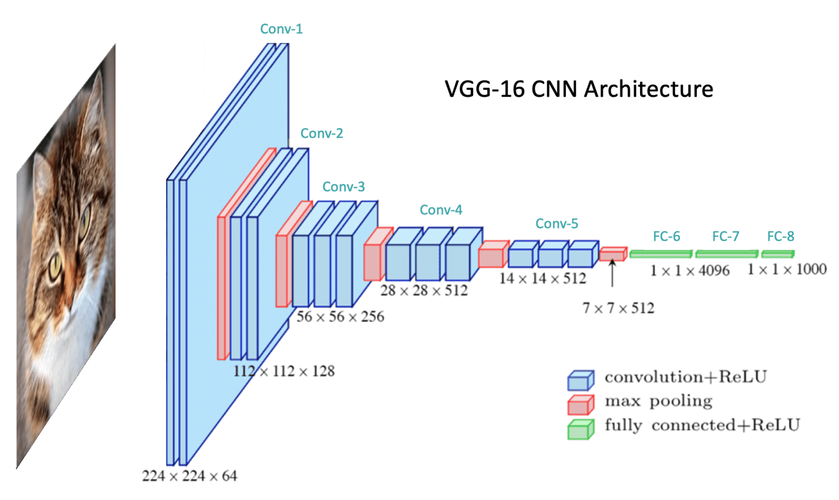
Figure 1: An Example CNN Architecture (From LearnOpenCV.com)
While early models attempted to predict exact integer ages, Niu et al. (2016) demonstrated that framing age estimation as an ordinal regression problem (predicting a relative sequence of ages) significantly reduces absolute error. For binary tasks targeting the 18-year threshold, the objective shifts to group classification. Mustapha et al. (2021) validated this approach, utilizing CNNs to successfully classify facial images into distinct developmental stages, such as adolescence and mature adulthood, and achieved an accuracy score of 85.12%, higher than the success rate of stores IDing underage mystery shoppers.

2.1.3 Ethical Implications and Interpretability
Many publicly available facial datasets over-represent certain demographics, particularly white Western subjects (Merler et al., 2019). A model trained on a biased dataset may perform well on average but exhibit systematically higher error rates for under-represented groups, raising serious ethical and legal concerns under the UK Equality Act 2010 and the EU AI Act (European Parliament, 2024). Addressing and measuring this bias is a core methodological challenge
Buolamwini and Gebru (2018) exposed intersectional accuracy disparities in commercial facial classifiers, revealing significantly higher error rates for darker-skinned females compared to lighter-skinned males. If an age verification system inherits these biases, it risks disproportionately denying service to certain demographics or failing to protect vulnerable minors.
To mitigate this, developers must look beyond global training metrics. Evaluating the model's performance on diverse validation sets using segmented confusion matrices is essential to isolate false positive and negative rates across specific intersectional groups. Additionally, explainability tools like gradient-weighted class activation mapping (Grad-CAM) allow developers to visualize the specific facial regions driving the prediction. This ensures the network is activating on genuine physiological aging markers rather than overfitting to biased demographic features.

2.2 Critical Comparison of Existing Studies
Author(s), year | Problem/task | Dataset | Method | Key results | Strengths | Limitations/gap
[Gosselt, J. F., van Hoof, J. J., de Jong, M. D. T. and Prinsen, S., 2007.] | Investigating underage alcohol sales | N/A – Experimental Research | 300 buying attempts made by both 15 year olds to buy <15% ABV drinks (legal age 16) and 17 year olds to buy spirits (legal age 18) across 150 supermarkets and 75 liquor stores. | 86% of buying attempts were successful. 89% of purchase attempts by 17 year olds for spirits were successful. 39% of those asked for alcohol were served anyway when they didn’t have it. Females were more successful in buying alcohol than males. | This study uses real underage persons, not “over 18 but looks underage” like others. This study includes many different attempts and many stores giving validity to the results. | The study is both quite old and conducted in the Netherlands, not necessarily making it applicable for current UK. 19 years on from when the study was conducted retailers may be more vigilant.
Miščikienė, L., Tran, A., Petkevičienė, J., Rehm, J., Vaitkevičiūtė, J., Galkus, L., Lange, S. and Štelemėkas, M., 2023 | Investigating underage alcohol sales | N/A – Experimental Research | 239 attempts made by 20-25 year olds to purchase alcohol (in Lithuania where legal age is 20 and a Challenge 25 policy is upheld by law). | 44.8% of attempts were successful. A purchase attempt was more likely to be successful if they were the only customer in queue or it was on a weekend. | This study is far more recent than the other study mentioned, and does involve a Challenge 25 policy making it more applicable. | This study doesn’t use real underaged people for ethical reasons. Again for ethical reasons, the local stores where the study was undertaken were warned in advance that a mystery shopping study was taking place, therefore without the advance warning more of these people may have been served.
Buolamwini, J. and Gebru, T. (2018) 'Gender | Investigating accuracy disparity between races in gender classification from facial images. | a custom dataset (Pilot Parliaments Benchmark) designed with balanced representation between male/female and different skin shades | The custom dataset with ethnicity/skin shade labels was tested on commercial gender classification systems made available by Microsoft, IBM and Face++. | All classifiers performed better on male faces, as well as lighter faces. All classifiers performed worst on darker female faces. | A very good ethical evaluation of commercial facial recognition products, showing that a system designed without fair representation in training data will be unfair in its classification. | Due to using a black-box commercial product, the researchers were unable to view metrics such as probability output of the model or the decision boundaries. The study also does not include any evaluation of the model’s inner mechanisms using computer vision techniques.
Niu, Z., Zhou, M., Wang, L., Gao, X. and Hua, G. (2016) | Ordinal regression of facial images using CNNs. | A dataset curated for this task called Asian Face Age Dataset (AFAD) | Uses a non-pretrained CNN with 3 convolutional layers and a multi-output classification head to predict age groups of given faces. | The model achieved a Mean Absolute Error (MAE) of 3.34 on AFAD. | Makes use of similar techniques and technologies that would be used in this study and provides a benchmark for performance. The dataset published for this study may also be useful data here. | CNNs have advanced quite a lot in the ten years since the release of this paper. 3 convolutional layers would be considered quite shallow by today’s standards. It also does not make any use of architectural features such as pre-trained weights or residual connections.
Mustapha, M. F., Mohamad, N. M., Osman, G. and Ab Hamid, S. H., 2021 | Classification of facial images into two groups (12-20 and 21-35) | All-Age Face (AAF) | Uses the FaceNet CNN architecture developed by Google to classify facial images as either Adolescent or Mature Adult | The model achieved 85.12% accuracy on a test set. | This study bears the most similarity to mine; it performs binary classification at an age threshold and uses a modern deep learning architecture. | This study does not mention model bias based on ethnicity or tuning of the decision boundary to minimise incorrect classifications of under-18s, as it does not consider the model as something to be hypothetically deployed.

2.3 Research Gap
There have been studies with similar objectives to this one, however their view of the outcome was not the same; this study aims to treat the final model as a hypothetically deployed system for the automation of age verification. Therefore, additional considerations will include a high emphasis on precision over recall, prioritising minimal false classifications of under-18s as over 18, as well as experimenting with the decision boundary, perhaps applying the Challenge 25 guideline on the model.
Furthermore, Article 86 of the EU AI Act (European Parliament, 2024) grants the right to individuals affected by a decision made by an AI system to obtain a “clear and meaningful explanation” of how the AI made the decision. This necessitates the utilization of explainable AI techniques such as Grad-CAM to shed light on the model’s inner workings.

2.4 Link to Your Project
All the reviewed work shows that the problem of this study is tractable, and that modern deep learners such as CNNs are capable of making inference on facial images to predict the age of a person with comparable or greater accuracy than a human.

3. Methodology and Model Architecture (maximum 600 words)

3.1 Research Design
The task of this project is classification-based, separating images of faces into two classes based on whether they are above or below a certain age. The artefact for this project utilises the standard workflow of data science known as CRISP-DM. This follows stages of Business Understanding, Data Understanding, Data Preparation, Modelling, Evaluation (with a link back to Business Understanding) and Deployment. The Business Understanding and Evaluation stages are represented by the content of this report, with the other stages being present in the artefact
The CNN architectures to be used in this project are ResNet34 and DenseNet121. Neural networks suffer from the problem that as you add layers to extract more features, when the error travels back through those layers during backpropagation, the signal to update the weights becomes weaker as it goes through each layer. This is known as the vanishing gradient problem. Both of these architectures solve that problem, but in differing ways. ResNet adds the original input back to the feature map at the end of each of its blocks (a sub-layer unit made up of several operations), improving the “memory” of the network by reinforcing features that have already been learned and adding a side-path from the main flow of the network through which gradients can travel. ResNet34 was also the chosen model for evaluation of the dataset in the original FairFace paper (Kärkkäinen and Joo, 2019).
On the other hand, DenseNet concatenates (adds as extra unmodified channels) the original input to the output which is always 32 channels. This method maximises utilisation of what the network learns in the shallower layers in the deeper layers by passing it forwards unchanged.
The models will also be using pre-trained weights from ImageNet, a massive corpus of labelled image data. This gives the models a “head start” in that they have already been used in computer vision tasks, and the shallower layers have already learned to detect features such as edges, colour gradients and textures.

3.2 Dataset and Sampling Strategy
The dataset being used for this study is FairFace (Kärkkäinen and Joo, 2019). This dataset was constructed expressly because of the imbalance in ethnicities present in existing facial image datasets such as UTKFace.
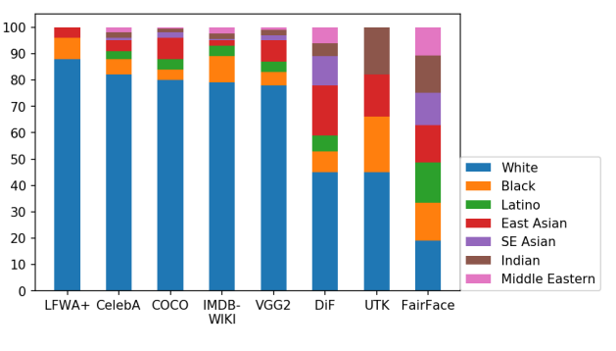
There are other datasets that have been made with the purpose of having a fairer distribution of ethnicities, however only this one was available without making a request. The dataset contains 86,744 training images and 10,954 validation images, with features of age, gender and race. Uniquely, there are 7 values for race, including Southeast Asian and Middle Eastern which are often either underrepresented or not included in many datasets.
Figure 2: Ethnicity Distribution Between Facial Image Datasets (Kärkkäinen and Joo 2019)
Unideally for the task of this project, the age class is in age groups, not specific ages, meaning that the task has had to be modified from the original plan to draw the boundary at 20 instead of 18. This reduces the relevance of the model locally, however 20 is still used as a threshold for age restricted purchases in places such as Japan, Iceland, Thailand and Norway.
The balance in this dataset is not restricted to ethnicity but more importantly to age, since there needs to be a balanced amount of data between the age groups; if there aren’t enough examples either side of the threshold (between 10-19 and 20-29), or one of those classes is heavily overrepresented, this will have a major negative impact on performance.
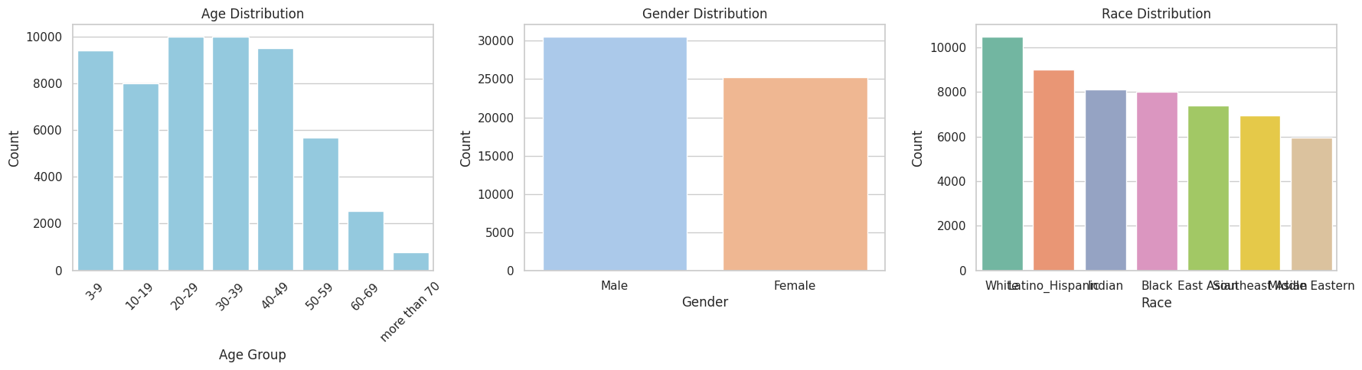
Figure 3: Pre-processed FairFace Training Set
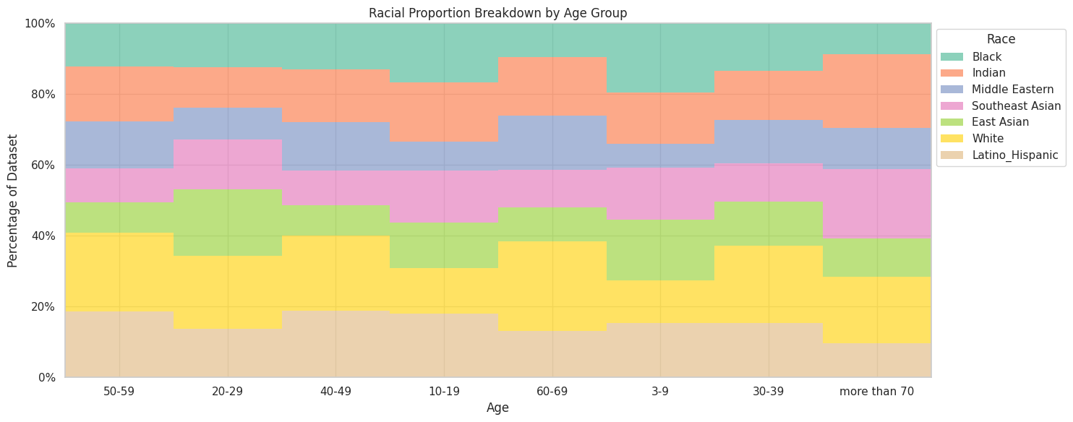
Figure 4: FairFace Age Distribution by Race

Dataset element | Description
Dataset name | FairFace
Source | https://www.kaggle.com/datasets/aibloy/fairface
Number of samples | 86744
Number of features | 4 (Age, Gender, Race, Image)
Target variable/classes | Over_20 (derived from Age)
Data type | Image
Relevance to problem | Contains cleaned and cropped images of faces with very close class balance between race, age and gender. Has more race categories than other popular datasets
Known limitations | Doesn’t have specific age labels, only age categories, therefore the task had to be modified to fit, as this is the only suitable public dataset that was found

3.3 Ethical and Professional Considerations
There are no issues in this dataset surrounding data protection or privacy. The data source for FairFace is the YFCC100M (Thomee et al. 2016) dataset collected from the social media platform Flickr, where each posted image is under a Creative Commons license. Furthermore, all personal user information is removed.
The main ethical consideration of this project is the minimisation of bias in the final model, which has been ensured by using a minimally biased dataset.

3.4 Data Preprocessing
Preprocessing Step | Justification
Removing the “0-2” class | It wouldn’t be possible for somebody under 2 to use a self-checkout or make an age restricted purchase, so including them in the data is not helpful.
Adding the Over_20 Feature | This problem is being modelled as binary classification, so adding this is needed to convert the age groups from being multi-classed.
Removing greyscale images | In a real world setting, greyscale images would not be present when age is being verified
Removing the 10% most blurry images. | Improves data quality by removing images which are too blurry to extract any features from.
Random reduction of records from imbalanced age groups. | The 20-29 and 30-39 age groups had far more images than the other age groups, so they were both reduced to 10,000 records by randomly removing some from the dataset.

3.5 Proposed System Architecture

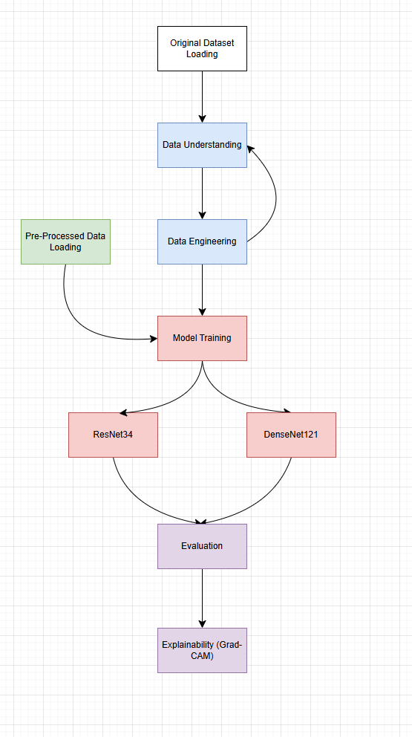
Figure 5: Proposed System Architecture for Artefact

3.6 Implementation Details
Component | Details
Programming language | Python
Development environment | Google Colab
Libraries/frameworks | Pandas, NumPy, Scikit-learn, PyTorch, MatPlotLib, Seaborn
Model(s) implemented | ResNet34, DenseNet121
Evaluation metrics | AUROC, Accuracy, False Positive Rate (FPR), False Negative Rate (FNR)
Version control | Colab Revision History

4. Evaluation, Results and Discussion (maximum 400 words)

4.1 Experimental Setup
Both models were trained and evaluated in the same way using the same structure and data. The models were trained using a dual phase training setup, where in the first phase only the final classification head was receiving weight updates, and the rest of the layers were frozen. This is done so that the randomly initialised heads don’t ruin the pre-trained features of the backbone by sending heavy error signals through the network.
In the second phase, once the head has stabilised, the backbone is unfrozen from the last two blocks with convolutional layers. In this phase the backbone is fine-tuned on the specific dataset, whilst maintaining the shallow pre-trained layers.
The models were evaluated using measures and graphics portraying both overall performance as well as performance separated by age, race and gender.

4.2 Evaluation Metrics
Accuracy: Not ideal on its own for a task where false positives have a much higher cost than false negatives, as well as imbalanced classes, however it is the most intuitive measure and is put into perspective by accompanying metrics
False Positive Rate (FPR): The most important metric for this problem – signifies Minors misclassified as adults. A model with high accuracy but also high FPR would not be useable.
False Negative Rate (FNR): Less important than FPR. Signifies Adults misclassified as Minors. A model with high FNR would still be useable so long as the FPR is low.

4.3 Results
Model | Accuracy | FPR | FNR
ResNet34 | 0.83 | 0.11 | 0.18
DenseNet121 | 0.86 | 0.19 | 0.13

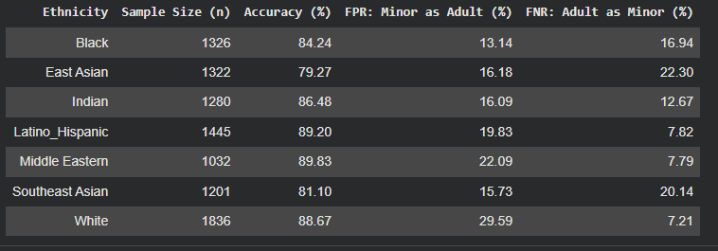
Figure 6: DenseNet121 Performance by Ethnicity
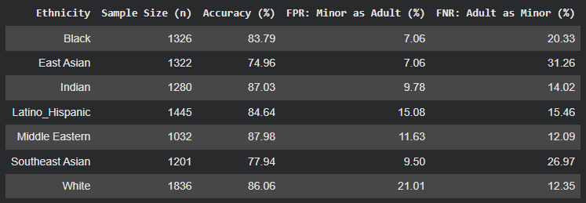
Figure 7: ResNet34 Performance by Ethnicity

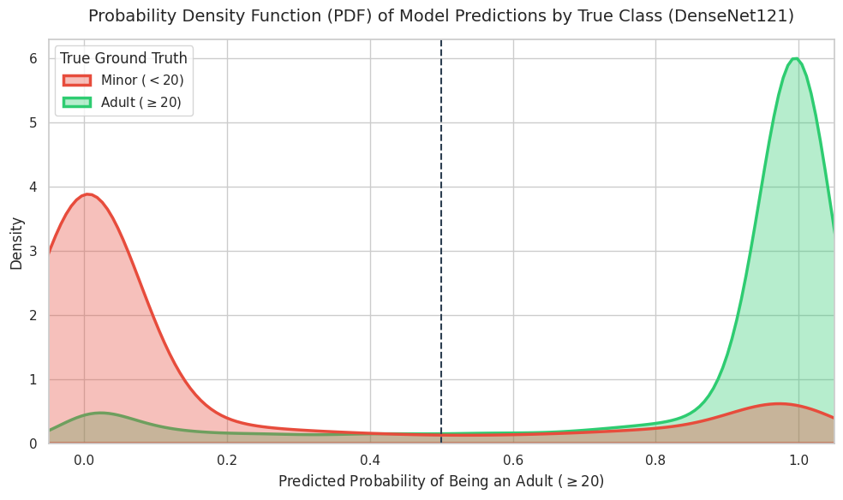
Figure 8: Probability Density Graph for DenseNet121
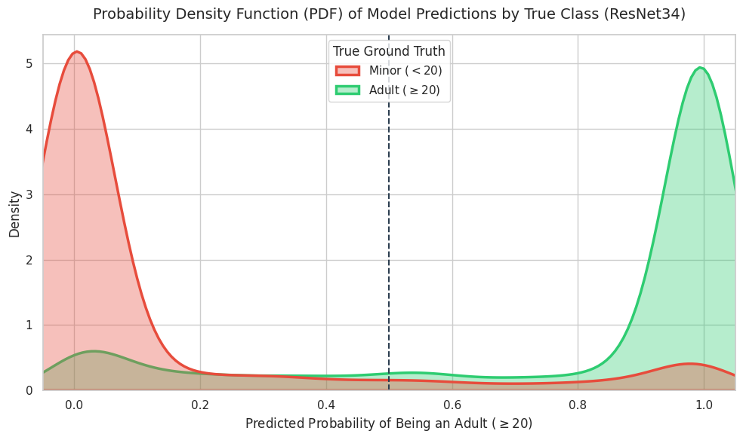
Figure 9: Probability Density Graph for ResNet34
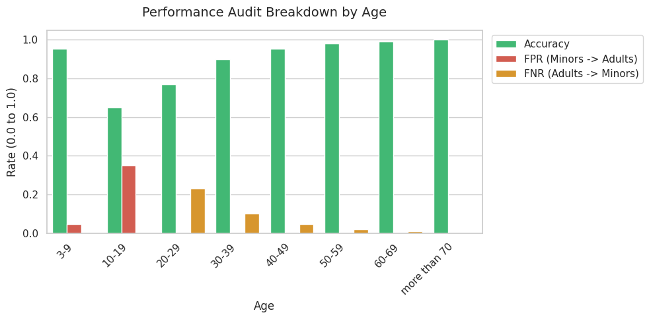
Figure 10: ResNet34 Performance by Age
Figure 11: DenseNet121 Performance by Age

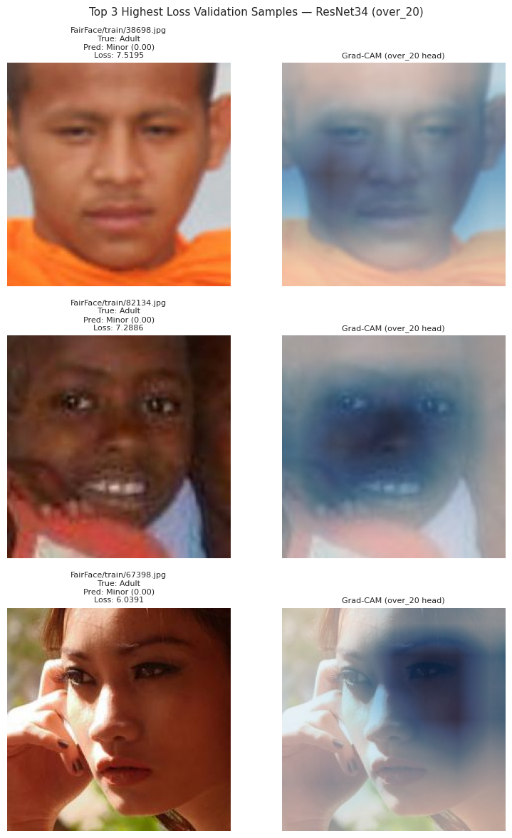
Figure 12: ResNet34 Highest Loss Images Grad-CAM Heatmap

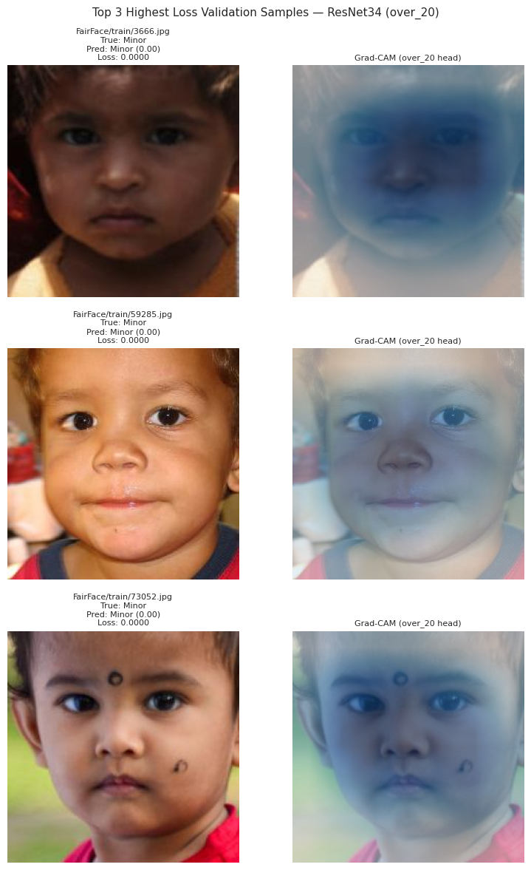
Figure 13: ResNet34 Lowest Loss Images Grad-CAM Heatmap

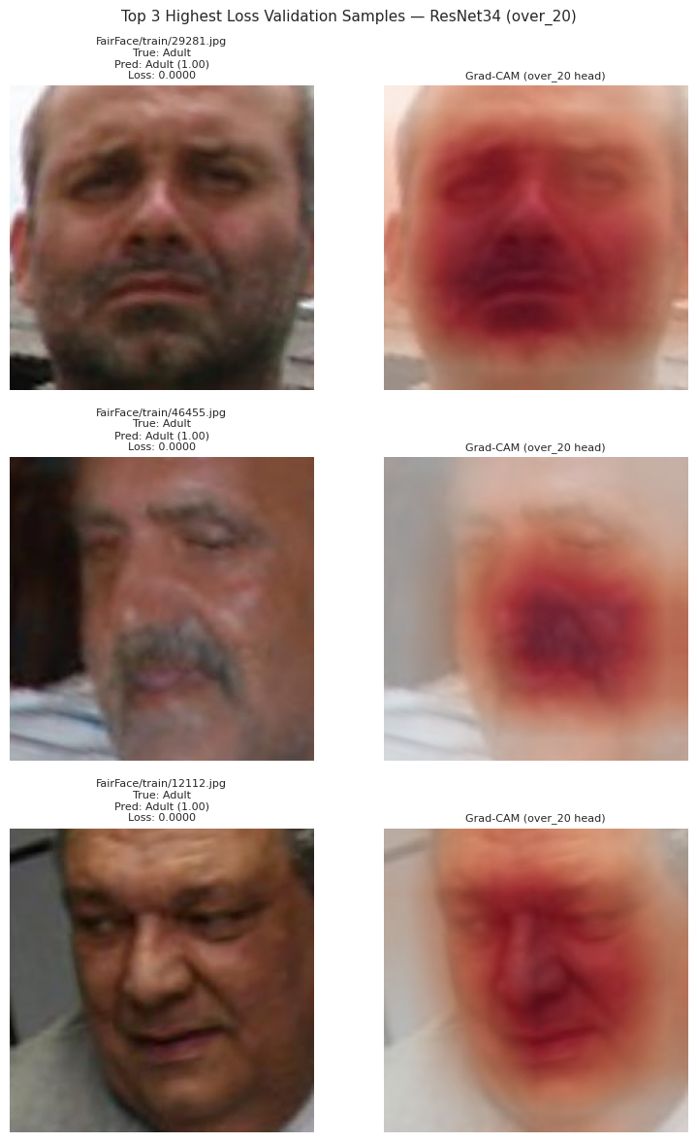
Figure 14: ResNet34 Lowest Loss Adult Images Grad-CAM Heatmap
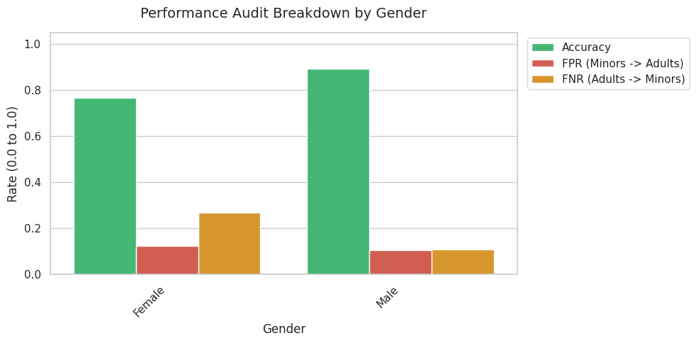
Figure 15: ResNet34 Performance by Gender

4.4 Discussion and Hypothesis Validation
- ResNet34 and DenseNet121 achieved an FPR of 0.11 and 0.19 and accuracy of 83% and 86% respectively. The FPR is too high to be used for POS purposes, but the accuracy would make the model usable for others. Overall ResNet34 would be considered the better model for having lower FPR
- Males and Females had similar performance but with Females getting more false negatives. This makes sense as Males typically have more obvious signs of aging.
- East Asians had a higher FNR than others in both models. This is in line with expectations as they typically have a more neotenous appearance, which is supported by the Grad-CAM visualisation.
- Whites had the highest FPR in both models. This is unexpected, since this class had a plurality in the dataset, so it would be expected to have the best performance.
- Even with very close balance between ethnicities some discrepancy is seen in performance between them. This points to there being inherent issues that make some races more difficult to classify than others, or perhaps there being an issue with training multiple races together in the first place.
- The difference in accuracy between the best and worst performing race in the models is 10% and 14%. This could be considered too much of a difference for the models to be considered equitable.
- The probability density graphs show that neither model could be made suitable for age-restricted sales despite high FPR; If the model had a high rate of FPR but at least did not give high confidence false positives, a system could be setup wherein high confidence positives would be let through automatically, but low confidence positives required human intervention.
- The models typically focus on the midface when making classifications.
- The graphs show that as hypothesized, most of the error occurs in the classes closest to the age threshold, with higher age groups and the lowest age groups having very little error.

5. Conclusion and Future Work (maximum 300 words)

5.1 Conclusion
The aim of this project was to classify age binarily based on a given threshold using deep convolutional architectures. The findings showed that accuracy of 86% could be achieved, but high error in the critical error surrounding the threshold introduces high error to the model which makes it unsuitable for most commercial applications.
The hypothesis has been partially supported by this study; the overall best FPR of 0.11 beats the ID rate of stores for age-restricted sales over 20 of 55.2% (Miščikienė et al. 2023), however this model does not beat commercial products which boast a much higher degree of accuracy.

5.2 Limitations
There did appear to be mislabelled data in this dataset. An attempt was made to remove mislabelled data by computing embeddings from pre-trained face models, clustering, and removing outliers, but this did not prove effective.
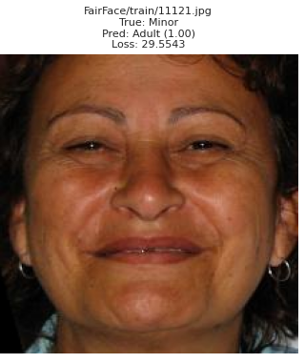
Figure 16: Mislabelled Data Point
There were other potential datasets that could have been used; however these were only available on request and wouldn’t have been accessible within the time constraints. Further on time constraints, the models also took a long time to train even using a T4 GPU.

5.3 Future Work
Future work could:
- Use better quality data
- Model the problem as ordinal regression as opposed to binary classification
- Use a more advanced pipeline, such as training a model to classify ethnicity, which would then pass to an age classifier trained on each ethnicity on its own.

5.4 Dissemination Plan
The findings of this project are not suitable for release on any academic platform yet; However, as a release on a mainstream programming/machine learning platform such as Kaggle or GitHub, they could prove as a suitable place for dissemination of both the artefact and the results of this study.

References
Buolamwini, J. and Gebru, T. (2018) 'Gender shades: Intersectional accuracy disparities in commercial gender classification', Proceedings of Machine Learning Research, 81, pp. 1–15.
European Parliament (2024) Artificial Intelligence Act (Regulation EU 2024/1689). Strasbourg: European Parliament.
Geng, X. (2016) 'Label distribution learning', IEEE Transactions on Knowledge and Data Engineering, 28(7), pp. 1734–1748.
Gosselt, J. F., van Hoof, J. J., de Jong, M. D. T. and Prinsen, S., 2007. Mystery Shopping and Alcohol Sales: Do Supermarkets and Liquor Stores Sell Alcohol to Underage Customers? Journal of Adolescent Health, 41 (3), 302–308.
Guo, C., Pleiss, G., Sun, Y. and Weinberger, K.Q. (2017) 'On calibration of modern neural networks', Proceedings of the 34th International Conference on Machine Learning, PMLR 70, pp. 1321–1330.
Kärkkäinen, K. and Joo, J., 2019. FairFace: Face Attribute Dataset for Balanced Race, Gender, and Age [online]. arXiv.org. Available from: http://arxiv.org/abs/1908.04913.
LeCun, Y., Boser, B., Denker, J. S., Henderson, D., Howard, R. E., Hubbard, W. and Jackel, L. D., 1989. Backpropagation Applied to Handwritten Zip Code Recognition. Neural Computation, 1 (4), 541–551.
Merler, M., Ratha, N., Feris, R.S. and Smith, J.R. (2019) 'Diversity in faces', arXiv preprint, arXiv:1901.10436.
Miščikienė, L., Tran, A., Petkevičienė, J., Rehm, J., Vaitkevičiūtė, J., Galkus, L., Lange, S. and Štelemėkas, M., 2023. A mystery-shopping study to test enforcement of minimum legal purchasing age in Lithuania in 2022. European Journal of Public Health, 33 (2), 317–322.
Mustapha, M. F., Mohamad, N. M., Osman, G. and Ab Hamid, S. H., 2021. Age Group Classification using Convolutional Neural Network (CNN). Journal of Physics: Conference Series, 2084 (1), 012028.
Niu, Z., Zhou, M., Wang, L., Gao, X. and Hua, G. (2016) 'Ordinal regression with multiple output CNN for age estimation', Proceedings of the IEEE Conference on Computer Vision and Pattern Recognition, pp. 4920–4928.
Ramanathan, N., Rama Chellappa and Biswas, S. (2009) 'Computational methods for modelling facial ageing: A survey', Journal of Visual Languages and Computing, 20(3), pp. 131–144.
Thomee, B., Shamma, D. A., Friedland, G., Elizalde, B., Ni, K., Poland, D., Borth, D. and Li, L.-J., 2016. YFCC100M: The New Data in Multimedia Research. Communications of the ACM, 59 (2), 64–73.
Yoti (2023) Yoti Age Estimation White Paper. London: Yoti. Available at: https://www.yoti.com/blog/yoti-age-estimation-white-paper/

Appendix A: Project Proposal Summary
Element | Description
Project title | Automated Age Threshold Verification Using Deep Convolutional Architectures
Problem | Human error in age-restricted sales.
Aim | To create a deep learning pipeline which can classify facial images as being above or below a given threshold.
Research question | Can deep learning classifiers effectively classify faces over/under an age threshold using facial image data?
Hypothesis | A deep learning classifier trained on publicly available facial image data will be able to better classify faces as belong to a person over or under a given age than humans, and can provide similar performance (within 5% TPR) to a state-of-the-art commercial system in identifying 13-17 year olds.
Dataset | FairFace
Proposed method | Utilise CNN architectures to build a deep learning classifier to classify facial images by age.
Expected outcome | The classification performance will rival that of humans and match the performance of commercial state-of-the-art image models.

Appendix B: Data Description and Sample Records
[Include sample records, feature descriptions, metadata, data dictionary, or screenshots where appropriate.]
Feature/variable | Type | Description | Example value
Image | Image | 224x224, cropped facial image | 
Age | Text - Categorical | One of 8 age group labels, spanning from 0 to 70+ | “10-19”
Gender | Text - Categorical | Binary “Male” or “Female” label | “Male”
Race | Text - Categorical | One of 7 ethnicity labels | “Middle Eastern”
Over_20 | Boolean | Marks images of people in the “20-29” age group or above | True

Appendix C: Source Code and Implementation Evidence
Repository or notebook link:
https://colab.research.google.com/drive/1QU7L_kQWomnnl24uYAZZ6RJISgay2bYw?usp=sharing
Code structure:
- Imports
- Data loading and pre-processing: loading the data and making changes to make it better suited to the task of this project, with changes informed by exploratory data analysis.
- Exploratory Data Analysis: Creation of graphs and output of metrics to inform pre-processing.
- Model training: Training two deep learning, pre-trained CNN architectures using a biphasic training structure.
- Evaluation: Evaluating both models on an unseen test set and outputting metrics and graphs showing their performance.
- Visualisation: Using Grad-CAM to display what the models are “looking” at when they are making their decisions.

Final Pre-Submission Checklist
Before submitting, confirm that you have completed each item.
Checklist item | Done?
The report is within the 2,500-word limit, excluding tables, diagrams, references, and appendices. | [X ]
The report has been exported as a PDF for Brightspace/Turnitin submission. | [X]
The abstract is no more than 200 words. | [X ]
The introduction clearly defines the problem and hypothesis. | [ X]
The literature review critically evaluates related work and identifies a research gap. | [ X]
The methodology explains dataset, sampling, ethics, preprocessing, and system architecture. | [ X]
UK GDPR and ethical considerations are addressed where relevant. | [ X]
Experiments and evaluation metrics are clearly explained. | [ X]
Results are presented using labelled tables and/or figures. | [ X]
The hypothesis is validated using evidence and reasoning. | [ X]
The conclusion includes limitations and future work. | [ X]
All references follow APA style. | [ X]
All figures and tables have captions and source details. | [ X]
Source code and supporting evidence are included in the appendix. | [ X]
The final file has been checked for spelling, grammar, formatting, and academic integrity. | [ X]

