JomImpact System Use Case Catalogue
Actors, functions, data relationships, and backend controls identified from the current Flutter/Firebase codebase.

1. System Overview
JomImpact is a volunteering platform with three main roles: volunteer, organizer, and admin. The app uses Flutter with Provider viewmodels, Firebase Authentication for sign-in, Cloud Firestore for core data, and Cloudinary for image upload URLs.
Layer | Main files | Responsibility
Presentation | lib/views/auth, lib/views/volunteer, lib/views/organizer, lib/views/admin, lib/views/shared | Screens and navigation for role-specific workflows.
State / orchestration | AuthViewModel, EventViewModel, FeedViewModel, MarketplaceViewModel | Holds UI state, loading/errors, filters, and calls service methods.
Domain models | UserModel, EventModel, ApplicationModel, ImpactSummary, FeedPostModel, MarketplaceItemModel | Defines fields, enums, serialization, and computed helpers.
Backend services | FirebaseAuthService, FirebaseEventService, FirebaseFeedService, FirebaseMarketplaceService, CloudinaryImageService | Performs Firebase Auth, Firestore reads/writes/transactions, and image uploads.
Security rules | firestore.rules | Enforces role permissions, ownership, approval status, field constraints, and immutable records.

2. Actors
Actor | Primary purpose | Core relationships
Volunteer | Finds opportunities, applies to events, tracks applications and impact, posts in feed, and buys approved marketplace items. | Owns user profile; creates applications; receives impact awards; creates feed posts/comments; creates marketplace purchases.
Organizer | Registers an organization account, waits for admin approval, creates events, reviews applicants, verifies attendance, finalizes impact, and submits marketplace items. | Owns events; reviews applications for own events; awards points after attendance; owns marketplace listings.
Admin | Approves or rejects organizer accounts and marketplace submissions. | Updates organizer approval state; reviews marketplace item status.

3. Use Case Catalogue
ID | Use case | Actor | Function explanation | Key functions | Data
UC-01 | Register account | Volunteer or organizer | Creates Firebase Auth user and matching users document. Organizer accounts start as pending; volunteers are immediately usable. | FirebaseAuthService.register; AuthViewModel.register | users
UC-02 | Log in and route by role | All users | Authenticates credentials, fetches the user profile, then AppRouter sends admins, approved organizers, pending organizers, or volunteers to the correct area. | FirebaseAuthService.login/fetchCurrentUser; AuthViewModel._init/login; AppRouter | users
UC-03 | Complete or edit profile | All users | Updates name, bio, phone, photo URL, location, state, skills, or organization while preserving role and approval state for non-admin users. | FirebaseAuthService.updateUser; AuthViewModel.updateProfile | users
UC-04 | Review organizer registration | Admin | Lists pending organizer accounts and sets approval status to approved or rejected with optional notes. | getPendingOrganizerRequests; reviewOrganizerRequest | users
UC-05 | Browse and filter events | Volunteer | Loads published events and supports search, category, and Malaysian state filtering. | getAllPublishedEvents; EventViewModel.loadAllEvents/setSearchQuery/setCategory/setStateFilter | events, users
UC-06 | View organizer directory and public profile | Volunteer | Shows approved organizers and their public details/events so volunteers can discover organizations. | getAllOrganizers; getUserById; EventViewModel.loadOrganizers | users, events
UC-07 | Apply for event | Volunteer | Creates one pending application for a published event if the event exists, is open, and has capacity. | applyForEvent; EventViewModel.applyForEvent | applications -> events/users
UC-08 | Track and withdraw application | Volunteer | Loads the volunteer's applications and allows withdrawal while the event is still active; accepted withdrawals reduce event capacity. | getApplicationsForVolunteer; withdrawApplication; volunteerApplicationsStream | applications, events
UC-09 | Create event | Approved organizer | Publishes an event with category, date range, capacity, image URL, requirements, benefits, location, and state. Increments organizer totalEvents. | createEvent; EventViewModel.createEvent | events -> users
UC-10 | Manage own events | Approved organizer | Lists, updates, and deletes organizer-owned events; delete also removes related applications and decrements totalEvents. | getOrganizerEvents; updateEvent; deleteEvent; organizerEventsStream | events, applications, users
UC-11 | Review volunteer applications | Approved organizer | Moves applications through pending, reviewing, accepted, waitlisted, or rejected. Accepted status changes keep currentVolunteers in sync. | getApplicationsForEvent; updateApplicationStatus | applications, applicationReviews, events
UC-12 | Complete event | Approved organizer | Marks an event completed only after the end time and before finalization. | markEventCompleted | events
UC-13 | Review attendance | Approved organizer | For accepted applications on completed events, records attended, partial, noShow, or excused plus verified hours. | reviewAttendance | applications
UC-14 | Finalize impact awards | Approved organizer | Requires attendance review for every accepted volunteer, writes impact points as verifiedHours x 10, creates impactAwards, and finalizes the event. | finalizeEvent; impactSummaryStream | events, applications, impactAwards
UC-15 | View impact summary | Volunteer | Aggregates impact awards into points, hours, events, badge tier, and progress toward the next tier. | ImpactSummary; impactSummaryStream | impactAwards
UC-16 | Create social feed post | Organizer or volunteer | Publishes text and/or image URL to the public role feed with author snapshot fields. | FirebaseFeedService.createPost; FeedViewModel.createPost | feedPosts, users
UC-17 | Interact with feed | Organizer or volunteer | Streams posts and comments, adds comments, toggles likes, and tracks comment count. | postsStream; commentsStream; addComment; toggleLike | feedPosts/comments
UC-18 | Edit or delete own feed post | Organizer or volunteer | Service supports post update and delete; model exposes a 10-minute edit window helper. | updatePost; deletePost; FeedPostModel.canEdit | feedPosts
UC-19 | Submit marketplace item | Approved organizer | Creates a pending item with title, description, price, optional image URL, and organizer ownership. | FirebaseMarketplaceService.createItem; MarketplaceViewModel.createItem | marketplaceItems
UC-20 | Review marketplace item | Admin | Approves or rejects pending items and stores admin notes, reviewedBy, and reviewedAt. | reviewItem; pendingItemsStream | marketplaceItems
UC-21 | Browse and buy marketplace item | Volunteer | Streams approved marketplace items and creates a pendingPayment purchase record using item and buyer snapshots. | approvedItemsStream; createPurchase; MarketplaceViewModel.buyItem | marketplaceItems -> marketplacePurchases
UC-22 | Upload image | Organizer or volunteer | Uploads selected file to Cloudinary and stores only the returned secure URL in app records. | CloudinaryImageService.uploadImage | Cloudinary, users/events/feedPosts/marketplaceItems imageUrl fields

4. Class Diagram
The diagram below focuses on the core domain model classes and Firestore-backed document relationships used by the system. Viewmodels and services sit above these models and are summarized in the System Overview table.
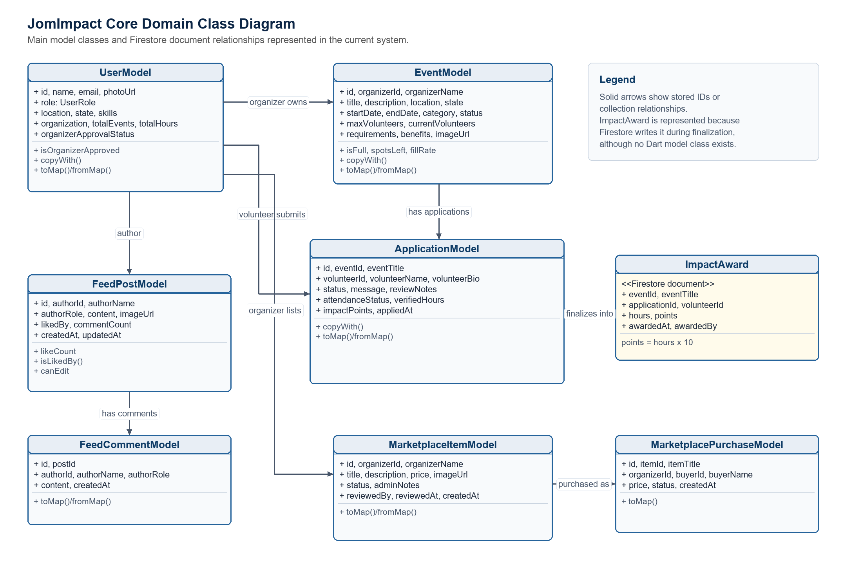
Class / document | Purpose | Important relationships
UserModel | Represents volunteer, organizer, or admin profile data plus approval/location state. | Organizer users own EventModel and MarketplaceItemModel records; volunteer users submit ApplicationModel records, create purchases, and receive impact awards.
EventModel | Represents a volunteer opportunity with organizer ownership, schedule, category, capacity, and lifecycle status. | Has many ApplicationModel records. Completed events can be finalized into ImpactAward documents.
ApplicationModel | Represents a volunteer's application to one event, including review status, attendance status, verified hours, and points. | Joins UserModel and EventModel. Organizer review notes live in applicationReviews; finalized attendance can create impactAwards.
ImpactAward | Firestore document written at finalization time to summarize awarded hours and points. | Connects finalized events, accepted applications, volunteers, and organizer-awarded impact points.
FeedPostModel / FeedCommentModel | Represent the social feed and nested comments with author snapshot data. | FeedPostModel has many FeedCommentModel records; both reference the author's user ID and role.
MarketplaceItemModel / MarketplacePurchaseModel | Represent organizer-submitted marketplace listings and volunteer purchase intents. | Approved MarketplaceItemModel records can be copied into MarketplacePurchaseModel records by volunteer buyers.

5. Main Data Relationships
Relationship | Meaning | Rules / behavior
users -> events | An approved organizer owns each event through organizerId. | Only approved organizers may create events; only the owning organizer may update or delete.
users -> applications -> events | A volunteer applies to an event through an application document. | Volunteer can read own applications; organizer can read applications for owned events.
applications -> applicationReviews | Organizer review notes are stored separately from public application state. | Only the owning event organizer can create/read the private review note document.
events -> applications -> impactAwards | Completed events lead to attendance review; finalized accepted applications can create impact awards. | Points must equal verified hours x 10; noShow/excused records must have zero hours.
users -> feedPosts -> comments | Organizers and volunteers create public community posts and comments. | Posts/comments store author snapshots; likes and comment counts are update-only fields.
users -> marketplaceItems -> marketplacePurchases | Organizers submit items, admins approve them, volunteers create purchase records. | Volunteers can buy only approved items; purchase values must match the approved item snapshot.

6. Permission and State Controls
- Authentication is required for all Firestore reads and writes in the active rules.
- Users can create only their own volunteer or organizer account. Admin creation is outside the UI and seeded manually.
- Non-admin users cannot promote themselves or change organizer approval status.
- Approved organizer status is required for event creation, application review, attendance review, finalization, and marketplace item submission.
- Application review is closed once an event is completed, finalized, or cancelled, except attendance review after completion.
- Deletes are generally blocked in Firestore rules for user-facing records; some service methods include delete calls that require matching deployed rules to allow them.
- Malaysian location and state validation appears in auth/profile, event creation/update, and Firestore rules.

7. Navigation Map
Entry condition | Destination | Purpose
Not logged in | LoginScreen | Start authentication or registration.
Admin | AdminMain | Review organizer requests, marketplace requests, and profile.
Organizer pending or rejected | OrganizerApprovalScreen | Show approval status before organizer features are available.
Missing location/state | LocationSetupScreen | Require location setup before main role area.
Approved organizer | OrganizerMain | Dashboard, events, marketplace, feed, profile.
Volunteer | VolunteerMain | Browse events, organizers, applications, marketplace, feed, profile.

8. Notes and Gaps Observed
- Firestore rules disallow feed post delete and most deletes, while FirebaseFeedService.deletePost and FirebaseEventService.deleteEvent exist. If those features are visible, the deployed rules may block them.
- FeedPostModel exposes canEdit, but Firestore rules shown only allow likedBy and commentCount updates. Post text/image edits may be blocked unless rules are expanded.
- Marketplace purchases are created with pendingPayment status; no payment settlement or fulfillment workflow is implemented in the inspected code.
- Admin accounts are not self-registered in the app and must be seeded or created manually.

