[DEMO-8] Safe Water, Sanitation and Hygiene for Displaced and Host Communities in Borno State (BORNO-WASH) — monthly report
Project: [DEMO-8] Safe Water, Sanitation and Hygiene for Displaced and Host Communities in Borno State (BORNO-WASH)
Reporting period: 2026-03-01 → 2026-03-31
Prepared with DonorDesk

Headline Summary
The project completed and handed over its first two boreholes in March 2026, giving about 2,400 people new or improved access to safe water (1,320 female, 1,080 male) against a target of 30,000. Two water points were delivered against a monthly plan of three because the rig was shared with a second site; one will follow in April. The project also built 40 household latrines against a target of 600, formed 3 water point committees against a target of 16, and reached 2,400 people with hygiene promotion (1,440 female, 960 male), up from 1,500 in February, against a target of 24,000. It conducted 35 water quality tests against a target of 320, up from 20 in February. The main problem: verified monitoring found 50 percent of water points with a free chlorine residual of at least 0.2 mg/l, below the 90 percent target and up from 42 percent, and 20 percent of committees functional against a target of 80 percent. The main decision needed is scheduling the third water point and strengthening chlorination at handover. Evidence includes the handover certificate and verified attendance sheets. This project is implemented with the support of Lake Chad Basin Resilience Fund.

Progress Against Logframe
Code | Indicator | Unit | Baseline | Target | This period | Previous | % of target | Status | Data source
WS-OC1c | Percentage of water points with free chlorine residual of at least 0.2 mg/l | % | 40 | 90 | 50 | 42 | — | Below expectation | Monthly water quality monitoring
WS-OC2b | Percentage of water point committees that are functional | % | 15 | 80 | 20 | — | — | Below expectation | Committee monitoring visits
WS-OP1.1 | Number of water points constructed or rehabilitated | water points | 0 | 20 | 2 | — | 10% | Descriptive only | Contractor and engineer records
WS-OP1.1b | Number of people with new or improved access to safe water | people | 0 | 30000 | 2400 | — | 8% | Descriptive only | Engineer and community records
WS-OP1.2 | Number of household latrines constructed | latrines | 0 | 600 | 40 | — | 6.7% | Descriptive only | Construction registers
WS-OP2.1 | Number of people reached with hygiene promotion | people | 0 | 24000 | 2400 | 1500 | 10% | Descriptive only | Mobiliser registers
WS-OP2.2 | Number of water point committees established and trained | committees | 0 | 16 | 3 | — | 18.8% | Descriptive only | Committee registers
WS-OP2.3 | Number of water quality tests conducted | tests | 0 | 320 | 35 | 20 | 10.9% | Descriptive only | Water quality monitoring logs

The project completed 2 water points in March against a target of 20 (10% of target), giving 2,400 people new or improved access to safe water (1,320 female and 1,080 male) against a target of 30,000 (8% of target). It built 40 household latrines against a target of 600 (6.7% of target) and established and trained 3 water point committees against a target of 16 (18.8% of target). Hygiene promotion reached 2,400 people in March (1,440 female and 960 male), up from 1,500 in the previous period, against a target of 24,000 (10% of target); the cumulative figure is 3,900. The project conducted 35 water quality tests, up from 20 in the previous period, against a target of 320 (10.9% of target), with 55 to date.
Two outcome indicators are behind plan. Chlorine compliance stood at 50 percent, up from 42 percent in the previous period, against a baseline of 40 percent and a target of 90 percent — below expectation. The percentage of water point committees that are functional was 20 percent against a baseline of 15 percent and a target of 80 percent — below expectation. Only 2 of a planned 3 boreholes were completed in March because the rig was shared with a second site; one will follow in April. The indicators WS-IMP1, WS-OC1a, WS-OC1b, WS-OC2a, WS-OP1.3 and WS-OP2.4 were not measured this period.
Data quality notes: No data-quality flags were raised on the verified findings for this period. The mobile network at Mashimari was unreliable for data collection, so mobilisers recorded sessions on paper registers for later entry.
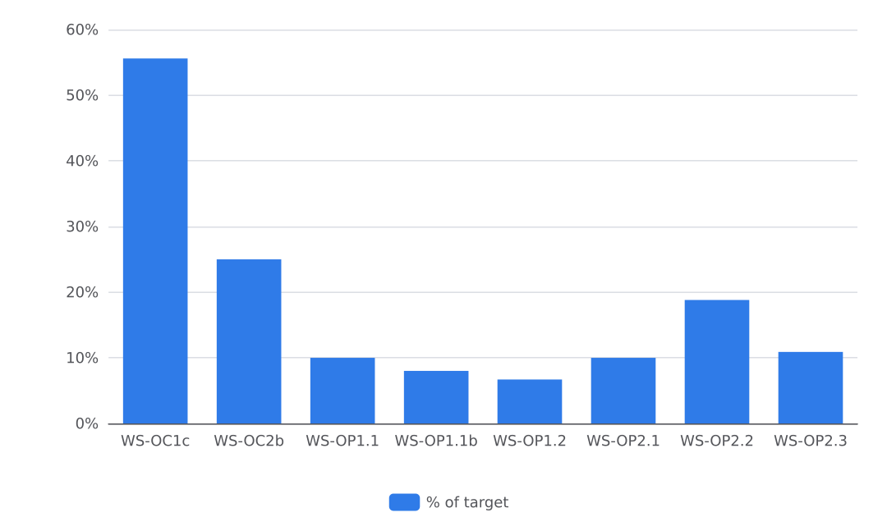
Figure 1. Progress against targets

Activities Completed
In March 2026 the project completed drilling, hygiene promotion and committee formation across Konduga and Jere LGAs. In Konduga LGA (Konduga town), the contractor drilled, developed and test-pumped two boreholes with hand pumps on 10 March; the water quality officer chlorinated and tested both before handover, and about 2,400 people now use them. The project also built 40 household latrines this month against a target of 600. Chlorinating and testing a water point at handover, before the community starts to use it, avoids early contamination complaints (handover certificate and photo on file). In Jere LGA (Mashimari), trained community mobilisers held hygiene promotion sessions at water points, markets and mosques on 17 March, reaching 2400 people (1440 female, 960 male) against a monthly count of 2400; 3900 of 24,000 people have been reached to date. Mobilisers recorded sessions on paper registers for later entry because the mobile network at Mashimari was unreliable (attendance sheet and photo on file). In Jere LGA (Dalori ward), the project formed and trained three water point committees on 24 March, each with seven members including at least four women; 21 people took part (12 female, 9 male). The committees were trained on operation and maintenance, tariff collection and care of the water point (attendance sheet and photo on file). Ramadan fasting hours cut working hours for local labour and masons, so construction was scheduled for early mornings. Two boreholes were completed against a plan of three because the rig was shared with a second site; one will follow in April. No other planned activities went unrecorded in the inputs, and six indicators listed in the logframe were not measured this period; this section reports delivery only.

Water Quality and Public Health Risks
Half of the tested water points met the chlorine standard in March, a result below expectation. The project carried out 35 water quality tests during the month, and 50 percent of the water points tested had a free chlorine residual of at least 0.2 mg/l at the end of it, against a target of 90 percent and a baseline of 40 percent, up from 42 percent in February. As mitigation, each new or rehabilitated water point was chlorinated and tested at handover before the community began using it (see Activities Completed). Water points are designed for at least 15 litres per person per day within 500 metres, and latrines are lockable, lined and fitted with a handwashing station, in line with SPHERE minimum standards. No cholera alert or outbreak event is recorded in the data available for this period. The child diarrhoea indicator (WS-IMP1) and the household-level outcome indicators WS-OC1a, WS-OC1b and WS-OC2a were not measured this period, so no figures for them exist; the project has not recorded why these measurements were not taken in March.

Access, Security and Operating Environment
Ramadan fasting hours cut working hours for local labour and masons in March 2026. The project scheduled construction for early mornings to keep work moving. The mobile network at Mashimari (Jere LGA) was unreliable for data collection, so community mobilisers recorded hygiene sessions on paper registers for later entry (attendance sheet and photo on file). No security incident is recorded in the March records. No request for support or a change requiring the Fund's agreement was recorded this month.

Protection, Gender and Accountability to Affected Populations
The project applied gender, protection and accountability measures to its March 2026 work in Jere and Konduga LGAs. Women hold four of the seven places on each of the three new water point committees formed in Dalori ward. The project sited the new water points in daylight-accessible places agreed with women's groups. For accountability, two complaints about the water point location in Jere were recorded and resolved by moving the tap stand. Hygiene promotion sessions in Mashimari reached 2400 people (1440 female, 960 male), and committee training involved 21 participants, so sex-disaggregated attendance is on record for both activities (attendance sheets on file). No safeguarding incident or protection concern is recorded in the March records.

Plan for Next Month
In April 2026 the project plans to complete the remaining water points, including the third borehole deferred from March, and to hand each completed water point over to its committee. The project will follow up the three committees formed in Dalori ward with monthly monitoring visits. Hygiene promotion sessions will continue, and the mobilisers will add a hygiene club session in schools. Expected results for the month are the next completed and handed-over water points, continued committee monitoring, and further hygiene sessions. These plans draw on the March records: the drilling activity lists the completion of the remaining water points as its next step, and the committee activity lists monthly monitoring visits (handover certificate, attendance sheets and photos on file).

Indicator Progress
Code | Indicator | Baseline | Target | Achievement | Unit | Status
WS-IMP1 | Percentage of households reporting diarrhoea in a child under five in the last two weeks | 31 | 18 | Not measured | % | DRAFT
WS-OC1a | Percentage of households using an improved drinking water source | 42 | 75 | Not measured | % | DRAFT
WS-OC1b | Percentage of households with access to a functional, unshared latrine | 28 | 55 | Not measured | % | DRAFT
WS-OC1c | Percentage of water points with free chlorine residual of at least 0.2 mg/l | 40 | 90 | 50 | % | VERIFIED
WS-OC2a | Percentage of households with a handwashing facility with soap and water | 22 | 60 | Not measured | % | DRAFT
WS-OC2b | Percentage of water point committees that are functional | 15 | 80 | 20 | % | VERIFIED
WS-OP1.1 | Number of water points constructed or rehabilitated | 0 | 20 | 2 | water points | VERIFIED
WS-OP1.1b | Number of people with new or improved access to safe water | 0 | 30000 | 2400 | people | VERIFIED
WS-OP1.2 | Number of household latrines constructed | 0 | 600 | 40 | latrines | VERIFIED
WS-OP1.3 | Number of school and health-facility WASH blocks constructed | 0 | 8 | Not measured | blocks | DRAFT
WS-OP2.1 | Number of people reached with hygiene promotion | 0 | 24000 | 2400 | people | VERIFIED
WS-OP2.2 | Number of water point committees established and trained | 0 | 16 | 3 | committees | VERIFIED
WS-OP2.3 | Number of water quality tests conducted | 0 | 320 | 35 | tests | VERIFIED
WS-OP2.4 | Number of households receiving hygiene kits and household water treatment | 0 | 2500 | Not measured | households | DRAFT

