[DEMO-8] Safe Water, Sanitation and Hygiene for Displaced and Host Communities in Borno State (BORNO-WASH) — monthly report
Project: [DEMO-8] Safe Water, Sanitation and Hygiene for Displaced and Host Communities in Borno State (BORNO-WASH)
Reporting period: 2026-07-01 → 2026-07-31
Prepared with DonorDesk

Headline Summary
This project is implemented with the support of Lake Chad Basin Resilience Fund.
In July 2026, the project's most important result was its cholera response: 600 households received hygiene kits and household water treatment after the cholera alert (600 of 2,500 to date), and 3,200 people were reached with hygiene promotion (1,920 female, 1,280 male), up from 2,400 in June. The Borno State Ministry of Health declared a cholera alert in Jere and Konduga and demand for chlorine and hygiene kits rose sharply, so the project reoriented its hygiene sessions to cholera prevention and brought the kit distribution forward from September. The project also rehabilitated two water points against a monthly plan of three, giving about 3,000 people improved access (3,000 this period; 14,100 to date against 30,000), built 100 household latrines and 1 school or health-facility WASH block, and conducted 50 water quality tests. Water quality remains the main problem: 74 percent of water points had a free chlorine residual of at least 0.2 mg/l against a target of 90 percent (up from 50 percent), and 55 percent of water point committees were functional against a target of 80 percent (up from 20 percent). The main decision needed is how to close the chlorine residual and committee functionality gaps.

Progress Against Logframe
Code | Indicator | Unit | Baseline | Target | This period | Previous | % of target | Status | Data source
WS-OC1c | Percentage of water points with free chlorine residual of at least 0.2 mg/l | % | 40 | 90 | 74 | 50 | — | Below expectation | Monthly water quality monitoring
WS-OC2b | Percentage of water point committees that are functional | % | 15 | 80 | 55 | 20 | — | Below expectation | Committee monitoring visits
WS-OP1.1 | Number of water points constructed or rehabilitated | water points | 0 | 20 | 2 | 2 | 10% | Descriptive only | Contractor and engineer records
WS-OP1.1b | Number of people with new or improved access to safe water | people | 0 | 30000 | 3000 | 2400 | 10% | Descriptive only | Engineer and community records
WS-OP1.2 | Number of household latrines constructed | latrines | 0 | 600 | 100 | 40 | 16.7% | Descriptive only | Construction registers
WS-OP1.3 | Number of school and health-facility WASH blocks constructed | blocks | 0 | 8 | 1 | — | 12.5% | Descriptive only | Contractor and engineer records
WS-OP2.1 | Number of people reached with hygiene promotion | people | 0 | 24000 | 3200 | 2400 | 13.3% | Descriptive only | Mobiliser registers
WS-OP2.2 | Number of water point committees established and trained | committees | 0 | 16 | 2 | 3 | 12.5% | Descriptive only | Committee registers
WS-OP2.3 | Number of water quality tests conducted | tests | 0 | 320 | 50 | 35 | 15.6% | Descriptive only | Water quality monitoring logs
WS-OP2.4 | Number of households receiving hygiene kits and household water treatment | households | 0 | 2500 | 600 | — | 24% | Descriptive only | Distribution registers

The project reached 3,200 people with hygiene promotion in July (1,920 female and 1,280 male), 13.3% of the target of 24,000, and gave 3,000 people new or improved access to safe water (1,650 female and 1,350 male), 10% of the target of 30,000. It rehabilitated 2 water points (10% of a target of 20), built 100 household latrines (16.7% of a target of 600), 1 school or health-facility WASH block (12.5% of a target of 8) and distributed hygiene kits to 600 households (24% of a target of 2,500), a distribution brought forward from September after the cholera alert. Two indicators are below expectation: chlorine compliance of at least 0.2 mg/l stood at 74 percent against a target of 90 percent (below expectation), and the percentage of water point committees that are functional was 55 percent against a target of 80 percent (below expectation). The project established and trained 2 water point committees (12.5% of a target of 16) and conducted 50 water quality tests (15.6% of a target of 320); WS-IMP1, WS-OC1a, WS-OC1b and WS-OC2a were not measured this period.
Data quality notes: No data-quality flags were raised on the verified findings for this period.
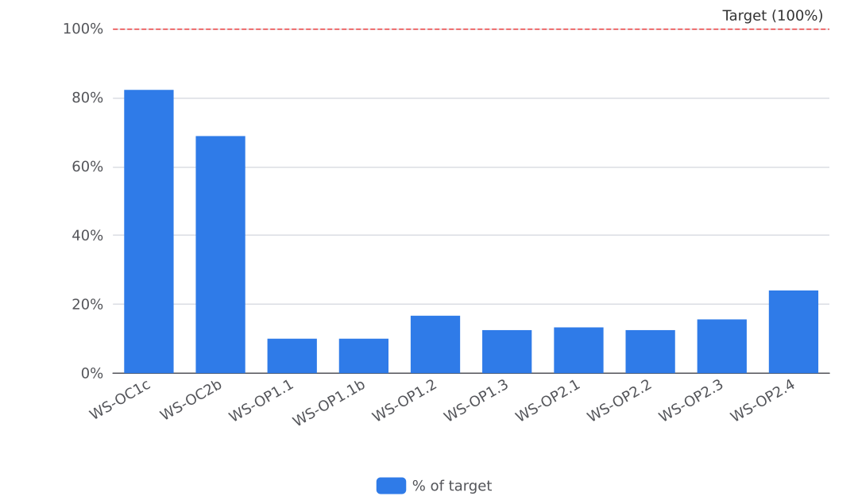
Figure 1. Progress against targets

Activities Completed
The project completed three activities in July 2026, all in Jere LGA. In Dalori ward, the project rehabilitated two broken hand-pump boreholes, chlorinated them and handed them over to their committees on 8 July; about 3,000 people use them, bringing water points rehabilitated to date to 10 of 20. The project recorded 2 water points this month against a plan of three; the shortfall is explained by the cholera response, which took resources forward (handover certificate and photo on file). Also in Dalori ward, the project distributed hygiene kits (soap, bucket with lid, water treatment tablets and a leaflet) to 600 households on 22 July, selected from the community list with the committees and verified at the point of distribution; 600 of 2,500 households have received kits to date (distribution list on file). In Mashimari, trained community mobilisers held hygiene promotion sessions at water points, markets and mosques on 15 July, reaching 3200 people (1920 female, 1280 male); 16300 of 24,000 people have been reached to date. Sessions were reoriented to cholera prevention after the state alert (attendance sheet and photo on file). On planned work not carried out: the third planned water point was not rehabilitated this month, because the cholera alert in Jere and Konduga raised demand for chlorine and hygiene kits sharply, and the project reoriented the planned hygiene sessions to cholera prevention and brought the kit distribution forward from September.

Water Quality and Public Health Risks
Cholera poses the main public health risk this month. The Borno State Ministry of Health declared a cholera alert in Jere and Konduga, and demand for chlorine and hygiene kits rose sharply. The project carried out 50 water quality tests, and 74 percent of the water points tested had a free chlorine residual of at least 0.2 mg/l at the end of the period. This is against a target of 90 percent and a baseline of 40 percent, up from 50 percent in June. The project chlorinated and tested each new or rehabilitated water point before handover. Water points are designed for at least 15 litres per person per day within 500 metres. Latrines are lockable, lined and fitted with a handwashing station, in line with SPHERE minimum standards. The indicators WS-IMP1 (child diarrhoea), WS-OC1a (improved drinking water source), WS-OC1b (functional unshared latrine) and WS-OC2a (handwashing facility with soap and water) were not measured this period, and the data does not record why.

Access, Security and Operating Environment
The operating environment in July 2026 was shaped by a public health emergency rather than by access or security constraints. The Borno State Ministry of Health declared a cholera alert in Jere and Konduga, and demand for chlorine and hygiene kits rose sharply. The project adapted by reorienting its planned hygiene sessions to cholera prevention and by bringing the hygiene kit distribution forward from September; 600 households received kits in Dalori ward, verified against a distribution list checked at the point of distribution (distribution list on file). Hygiene promotion sessions in Mashimari reached 3,200 people (1,920 female, 1,280 male), recorded on attendance registers (attendance sheet on file). The July records contain no security incident, no access constraint and no request for support or a change requiring the Fund's agreement.

Protection, Gender and Accountability to Affected Populations
Women staff led the 600-household hygiene kit distribution in Dalori ward on 22 July, serving beneficiaries at female-only desks. The distribution points were chosen away from the flooded routes, which addressed access and safety concerns during the cholera response. Female participation in the July hygiene promotion sessions is recorded at 1,920 female and 1,280 male (attendance sheet on file). No safeguarding incident or protection concern is reported this month. For accountability, the complaint desk at the distribution recorded 6 queries about the list, of which 5 were resolved on the day; the remaining query was not recorded as resolved in the July records.

Plan for Next Month
In August 2026 the project plans to complete the remaining water points and hand each one over to its committee, the recorded next step of the July rehabilitation work in Dalori ward. The project will continue the hygiene promotion sessions and add a hygiene club session in schools, as recorded in the July session activity. Mobilisers will also follow up use of the hygiene kits during the next sessions, the recorded next step of the July distribution. The project will apply two recorded lessons from July: chlorinating and testing a water point at handover before the community starts to use it, and distributing at the water point with a complaint desk to reduce disputes about the list. Expected results are the next completed and handed-over water points, continued hygiene promotion toward the target of 24,000 people against 16,300 to date, and further kit follow-up. These plans draw on the July records: handover certificate and photos on file for the water points, an attendance sheet for the sessions and the distribution list for the kits.

Indicator Progress
Code | Indicator | Baseline | Target | Achievement | Unit | Status
WS-IMP1 | Percentage of households reporting diarrhoea in a child under five in the last two weeks | 31 | 18 | Not measured | % | DRAFT
WS-OC1a | Percentage of households using an improved drinking water source | 42 | 75 | Not measured | % | DRAFT
WS-OC1b | Percentage of households with access to a functional, unshared latrine | 28 | 55 | Not measured | % | DRAFT
WS-OC1c | Percentage of water points with free chlorine residual of at least 0.2 mg/l | 40 | 90 | 74 | % | VERIFIED
WS-OC2a | Percentage of households with a handwashing facility with soap and water | 22 | 60 | Not measured | % | DRAFT
WS-OC2b | Percentage of water point committees that are functional | 15 | 80 | 55 | % | VERIFIED
WS-OP1.1 | Number of water points constructed or rehabilitated | 0 | 20 | 2 | water points | VERIFIED
WS-OP1.1b | Number of people with new or improved access to safe water | 0 | 30000 | 3000 | people | VERIFIED
WS-OP1.2 | Number of household latrines constructed | 0 | 600 | 100 | latrines | VERIFIED
WS-OP1.3 | Number of school and health-facility WASH blocks constructed | 0 | 8 | 1 | blocks | VERIFIED
WS-OP2.1 | Number of people reached with hygiene promotion | 0 | 24000 | 3200 | people | VERIFIED
WS-OP2.2 | Number of water point committees established and trained | 0 | 16 | 2 | committees | VERIFIED
WS-OP2.3 | Number of water quality tests conducted | 0 | 320 | 50 | tests | VERIFIED
WS-OP2.4 | Number of households receiving hygiene kits and household water treatment | 0 | 2500 | 600 | households | VERIFIED

