[DEMO-8] Safe Water, Sanitation and Hygiene for Displaced and Host Communities in Borno State (BORNO-WASH) — monthly report
Project: [DEMO-8] Safe Water, Sanitation and Hygiene for Displaced and Host Communities in Borno State (BORNO-WASH)
Reporting period: 2026-08-01 → 2026-08-31
Prepared with DonorDesk

Headline Summary
This project is implemented with the support of Lake Chad Basin Resilience Fund.
The most important result of August 2026 was the emergency response to flooding: the project rehabilitated three water points after floods damaged one and contaminated three others in Jere and Konduga, and about 5,000 people regained safe water within a week (5,000 this period against a target of 30,000; 19,100 to date). The project distributed hygiene kits to 1,100 households during the month (1,700 of 2,500 to date), reached 3,600 people with hygiene promotion (2,160 female, 1,440 male), built 60 household latrines and 2 school or health-facility WASH blocks, and conducted 55 water quality tests (290 of 320 to date). The main problem is water quality: 66 percent of water points had a free chlorine residual of at least 0.2 mg/l against a target of 90 percent, down from 74 percent, after floods contaminated three water points; the project disinfected and retested them, released a flood contingency of kits and raised latrine access paths. About 400 households could not reach their latrines for a week. Committee functionality stood at 62 percent against a target of 80 percent, up from 55 percent.

Progress Against Logframe
Code | Indicator | Unit | Baseline | Target | This period | Previous | % of target | Status | Data source
WS-OC1c | Percentage of water points with free chlorine residual of at least 0.2 mg/l | % | 40 | 90 | 66 | 74 | — | Below expectation | Monthly water quality monitoring
WS-OC2b | Percentage of water point committees that are functional | % | 15 | 80 | 62 | 55 | — | Below expectation | Committee monitoring visits
WS-OP1.1 | Number of water points constructed or rehabilitated | water points | 0 | 20 | 3 | 2 | 15% | Descriptive only | Contractor and engineer records
WS-OP1.1b | Number of people with new or improved access to safe water | people | 0 | 30000 | 5000 | 3000 | 16.7% | Descriptive only | Engineer and community records
WS-OP1.2 | Number of household latrines constructed | latrines | 0 | 600 | 60 | 100 | 10% | Descriptive only | Construction registers
WS-OP1.3 | Number of school and health-facility WASH blocks constructed | blocks | 0 | 8 | 2 | 1 | 25% | Descriptive only | Contractor and engineer records
WS-OP2.1 | Number of people reached with hygiene promotion | people | 0 | 24000 | 3600 | 3200 | 15% | Descriptive only | Mobiliser registers
WS-OP2.2 | Number of water point committees established and trained | committees | 0 | 16 | 1 | 2 | 6.2% | Descriptive only | Committee registers
WS-OP2.3 | Number of water quality tests conducted | tests | 0 | 320 | 55 | 50 | 17.2% | Descriptive only | Water quality monitoring logs
WS-OP2.4 | Number of households receiving hygiene kits and household water treatment | households | 0 | 2500 | 1100 | 600 | 44% | Descriptive only | Distribution registers

The project rehabilitated 3 water points in August, 15% of the target of 20. It gave 5,000 people new or improved access to safe water (2,750 female and 2,250 male), 16.7% of the target of 30,000. Hygiene promotion reached 3,600 people (2,160 female and 1,440 male), 15% of the target of 24,000. Hygiene kits reached 1,100 households, 44% of the target of 2,500.
Construction continued at a lower pace. The project built 60 household latrines (10% of a target of 600), 2 school and health-facility WASH blocks (25% of a target of 8), and 1 water point committee was established and trained against a target of 16. The project conducted 55 water quality tests, 17.2% of a target of 320.
Two indicators are behind plan. Chlorine compliance of at least 0.2 mg/l stood at 66 percent against a target of 90 percent, down from 74 percent in the previous period. Floods contaminated three water points; the project disinfected and retested them. The percentage of water point committees that are functional was 62 percent against a target of 80 percent, up from 55 percent in the previous period, and remains below expectation. The indicators WS-IMP1, WS-OC1a, WS-OC1b and WS-OC2a were not measured this period.
Data quality notes: No data-quality flags were raised on the verified findings for this period.
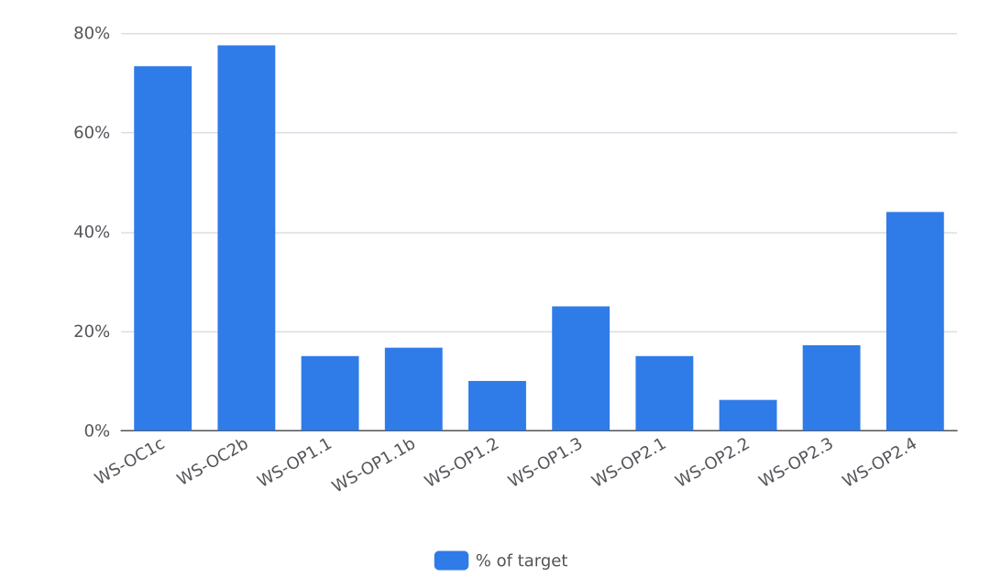
Figure 1. Progress against targets

Activities Completed
Flooding dominated delivery in August 2026, and the project completed three activities across Jere and Konduga LGAs. In Jere LGA (Dalori ward), the project rehabilitated water points on 6 August after floods damaged one water point and contaminated three others; the team repaired the damaged hand pump, flushed and disinfected the three others, and the water quality officer retested four water points. About 5,000 people regained safe water within a week (handover certificate and photo on file). In Konduga LGA (Konduga town), the project distributed flood and cholera response hygiene kits on 12 August; each household received soap, a bucket with lid, water treatment tablets and a leaflet, selected from the community list with the committees and verified at the point of distribution. 1,100 households received kits this month, 1,700 of 2,500 to date, which is 68% of target (distribution list on file). In Jere LGA (Dalori ward), the water quality officer tested 55 water points on 20 August for free chlorine residual and, for a sample, bacteriology using portable test kits; 66 percent had a residual of at least 0.2 mg/l. 290 of 320 planned tests are done to date, about 91% of target (monitoring log on file). Floods also disrupted access: in Jere and Konduga, about 400 households could not reach their latrines for a week, and the project released a flood contingency of hygiene kits and raised latrine access paths. A committee chair in Jere chlorinated the flooded borehole with the project test kit before anyone fell ill. On planned work not carried out: the activity record lists as next steps to complete the remaining water points and hand each over to its committee, but the inputs do not identify any specific planned August activity that was not carried out, and the section does not record one.

Water Quality and Public Health Risks
Flooding contaminated three water points in Jere and Konduga, and chlorine compliance fell as a result. The project carried out 55 water quality tests in August, and 66 percent of the water points tested had a free chlorine residual of at least 0.2 mg/l at the end of the period, against a target of 90 percent and a baseline of 40 percent, down from 74 percent in July. The project repaired the damaged hand pump, flushed and disinfected the three contaminated water points, and the water quality officer retested them (see Activities Completed). The project chlorinated and tested each new or rehabilitated water point before handover. Water points are designed to provide at least 15 litres per person per day within 500 metres, and latrines are lockable, lined and fitted with a handwashing station, in line with SPHERE minimum standards. No cholera alert or outbreak event is recorded in the data available for this period. The project did not measure the indicators WS-IMP1 (child diarrhoea), WS-OC1a (improved drinking water source), WS-OC1b (functional unshared latrine) or WS-OC2a (handwashing facility with soap and water) this period, and the data does not record why.

Access, Security and Operating Environment
Floods, rather than access or security constraints, shaped the operating environment in August 2026. Flooding in Jere and Konduga damaged one water point and contaminated three others, and about 400 households could not reach their latrines for a week. The project adapted by disinfecting and retesting the affected water points, releasing a flood contingency of hygiene kits and raising the latrine access paths. The rehabilitation and retesting are documented in a handover certificate, a photo and the water quality log on file. The records contain no security incident for August. No request for support or a change that needs the Fund's agreement was recorded this month.

Protection, Gender and Accountability to Affected Populations
Gender and protection shaped the August flood response. Women's groups were consulted on the flood-affected latrine access paths, which the project raised after about 400 households could not reach their latrines for a week. At the 12 August kit distribution in Konduga town, the project prioritised unaccompanied women and children; the verified distribution list for that distribution is on file. Project-wide results remain sex-disaggregated: hygiene promotion reached 3,600 people (2,160 female and 1,440 male), and 5,000 people regained safe water (2,750 female and 2,250 male). For accountability, the project recorded 9 queries from affected households during the month and answered all 9 within two days. The records supplied for August contain no safeguarding incident or protection concern, and no separate safeguarding compliance record was supplied.

Plan for Next Month
In September 2026 the project plans to complete the remaining water points and hand each over to its committee, the recorded next step of the August flood rehabilitation in Dalori ward. The water quality officer will retest the water points that failed the free chlorine residual check and train committee members to read the test kit, the recorded next steps of the August post-flood testing. Mobilisers will follow up use of the hygiene kits during the next hygiene sessions, the recorded next step of the August distribution in Konduga town. The project will apply the recorded August lessons: chlorinating and testing a water point at handover before the community starts to use it, a simple chlorinator at the water point with a weekly committee check to raise compliance, and distributing at the water point with a complaint desk. Expected results are the next completed and handed-over water points, retests of the failed water points toward the target of 90 percent chlorine compliance against 66 percent in August, and further kit follow-up. These plans draw on the August records: the handover certificate and photo for the rehabilitation, the distribution list for the kits and the water quality log for the testing, all on file.

Indicator Progress
Code | Indicator | Baseline | Target | Achievement | Unit | Status
WS-IMP1 | Percentage of households reporting diarrhoea in a child under five in the last two weeks | 31 | 18 | Not measured | % | DRAFT
WS-OC1a | Percentage of households using an improved drinking water source | 42 | 75 | Not measured | % | DRAFT
WS-OC1b | Percentage of households with access to a functional, unshared latrine | 28 | 55 | Not measured | % | DRAFT
WS-OC1c | Percentage of water points with free chlorine residual of at least 0.2 mg/l | 40 | 90 | 66 | % | VERIFIED
WS-OC2a | Percentage of households with a handwashing facility with soap and water | 22 | 60 | Not measured | % | DRAFT
WS-OC2b | Percentage of water point committees that are functional | 15 | 80 | 62 | % | VERIFIED
WS-OP1.1 | Number of water points constructed or rehabilitated | 0 | 20 | 3 | water points | VERIFIED
WS-OP1.1b | Number of people with new or improved access to safe water | 0 | 30000 | 5000 | people | VERIFIED
WS-OP1.2 | Number of household latrines constructed | 0 | 600 | 60 | latrines | VERIFIED
WS-OP1.3 | Number of school and health-facility WASH blocks constructed | 0 | 8 | 2 | blocks | VERIFIED
WS-OP2.1 | Number of people reached with hygiene promotion | 0 | 24000 | 3600 | people | VERIFIED
WS-OP2.2 | Number of water point committees established and trained | 0 | 16 | 1 | committees | VERIFIED
WS-OP2.3 | Number of water quality tests conducted | 0 | 320 | 55 | tests | VERIFIED
WS-OP2.4 | Number of households receiving hygiene kits and household water treatment | 0 | 2500 | 1100 | households | VERIFIED

