[DEMO-8] Safe Water, Sanitation and Hygiene for Displaced and Host Communities in Borno State (BORNO-WASH) — quarterly report
Project: [DEMO-8] Safe Water, Sanitation and Hygiene for Displaced and Host Communities in Borno State (BORNO-WASH)
Reporting period: 2026-04-01 → 2026-06-30
Prepared with DonorDesk

1 Executive Summary
This project is implemented with the support of Lake Chad Basin Resilience Fund. The BORNO-WASH project, implemented by Borno Community Water Initiative with Konduga Women's Development Association in Jere, Konduga, Mafa and Dikwa LGAs of Borno State, delivered safe water, sanitation and hygiene to displaced and host communities from 1 April to 30 June 2026, funded in full by Lake Chad Basin Resilience Fund (LCBRF).
The strongest verified results this quarter were 315 household latrines built against a target of 600 (52.5% of target) and 9,200 people reached with hygiene promotion (5,520 female, 3,680 male), 38.3% of the target of 24,000. The project completed 6 water points against a target of 20 (30% of target), with 8,700 people (4,785 female, 3,915 male) gaining new or improved access to safe water, and 130 water quality tests were conducted against a target of 320. All five outcome indicators rose from their baselines but remained below expectation: households using an improved drinking water source reached 58 percent against a baseline of 42 percent and a target of 75 percent, and water points meeting the chlorine residual standard rose from 40 percent to 70 percent against a target of 90 percent. WS-IMP1 (household diarrhoea) and WS-OP2.4 (hygiene kits) were not measured this period, so no figures are reported for them.
Insecurity on the Mafa to Dikwa road restricted movement for about ten days, and the drilling rig broke down for nine days waiting for a spare part from Kano; the project moved work to Konduga and Jere, hired a second smaller rig and added concrete ring pit lining to all remaining latrines. Recorded next steps include completing the remaining water points, continuing latrine construction and retesting water points that failed the chlorine standard.

2 Context and Needs Update
Insecurity on the Mafa to Dikwa road restricted movement for about ten days during the quarter, and the Mafa school site could not be visited at the start of the period. The drilling rig broke down for nine days while waiting for a spare part from Kano, and diesel prices rose by about a fifth. The first rains collapsed latrine pits in sandy soil at Mele and Dalori. These conditions delayed water point completion in April and reduced the June borehole result to three against a plan of four. The project adapted by moving work to Konduga and Jere, starting the Mafa school block once the road was cleared with community leaders, hiring a second smaller rig, pooling diesel purchases, and adding concrete ring pit lining to all remaining latrines; collapsed pits were rebuilt. Evidence for these conditions and responses is recorded in the verified latrine registers, handover certificates and monitoring logs listed below.

3 Results by Outcome
Code | Indicator | Unit | Baseline | Target | This period | Previous | % of target | Status | Data source
WS-OC1a | Percentage of households using an improved drinking water source | % | 42 | 75 | 58 | — | — | Below expectation | Household WASH survey
WS-OC1b | Percentage of households with access to a functional, unshared latrine | % | 28 | 55 | 38 | — | — | Below expectation | Household WASH survey
WS-OC1c | Percentage of water points with free chlorine residual of at least 0.2 mg/l | % | 40 | 90 | 70 | — | — | Below expectation | Monthly water quality monitoring
WS-OC2a | Percentage of households with a handwashing facility with soap and water | % | 22 | 60 | 41 | — | — | Below expectation | Household WASH survey
WS-OC2b | Percentage of water point committees that are functional | % | 15 | 80 | 50 | — | — | Below expectation | Committee monitoring visits

The outcome indicators all moved up from their baselines but remain below target. Households using an improved drinking water source reached 58 percent against a baseline of 42 percent and a target of 75 percent, or 77.3% of target. Access to a functional, unshared latrine rose from a baseline of 28 percent to 38 percent against a target of 55 percent, or 69.1% of target, and water points meeting the chlorine residual standard rose from 40 percent to 70 percent against a target of 90 percent, or 77.8% of target. Handwashing facilities with soap and water stood at 41 percent against a baseline of 22 percent and a target of 60 percent (68.3% of target), and functional water point committees reached 50 percent from a baseline of 15 percent against a target of 80 percent (62.5% of target). All five outcome indicators are below expectation. The quarterly output results in the attached table include 6 water points against a target of 20 (30% of target), 315 household latrines against 600 (52.5% of target), 3 school and health-facility WASH blocks against 8 (37.5% of target), 8 committees against 16 (50% of target) and 130 water quality tests against 320 (40.6% of target). Of the 8700 people reached with new or improved water this period, 4785 were female and 3915 male; of the 9200 people reached with hygiene promotion, 5520 were female and 3680 male. WS-IMP1 (household diarrhoea) and WS-OP2.4 (hygiene kits) were not measured this period, so no figures are reported for them.
Data quality notes. No data-quality flags were recorded against any finding this period. Both unmeasured indicators (WS-IMP1 and WS-OP2.4) were not recorded, and the report therefore states no value for them.
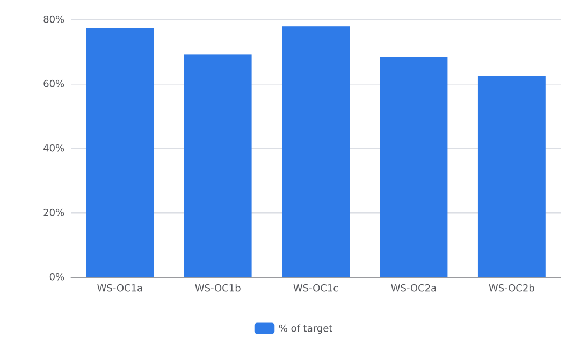
Figure 1. Progress against targets

3.1 Outcome 1: Safe Water and Sanitation
Code | Indicator | Unit | Baseline | Target | This period | Previous | % of target | Status | Data source
WS-OC1a | Percentage of households using an improved drinking water source | % | 42 | 75 | 58 | — | — | Below expectation | Household WASH survey
WS-OC1b | Percentage of households with access to a functional, unshared latrine | % | 28 | 55 | 38 | — | — | Below expectation | Household WASH survey
WS-OC1c | Percentage of water points with free chlorine residual of at least 0.2 mg/l | % | 40 | 90 | 70 | — | — | Below expectation | Monthly water quality monitoring
WS-OC2a | Percentage of households with a handwashing facility with soap and water | % | 22 | 60 | 41 | — | — | Below expectation | Household WASH survey
WS-OC2b | Percentage of water point committees that are functional | % | 15 | 80 | 50 | — | — | Below expectation | Committee monitoring visits

The project completed 6 water points this quarter against a target of 20 (30% of target) and 8 cumulatively. It completed 315 household latrines this quarter against a target of 600 (52.5% of target), with 355 cumulative, and 3 school and health-facility WASH blocks against a target of 8 (37.5% of target), all cumulative. Some 8,700 people (4,785 female, 3,915 male) gained new or improved access to safe water this quarter against a target of 30,000 (29% of target), with 11,100 people cumulative.
No water point was completed in April because the Mafa to Dikwa road closure and the rig repair moved the borehole work into May. Three boreholes were completed against a plan of four in May because the rig broke down for nine days. Water quality monitoring logged 130 tests this quarter against a target of 320 (cumulative 185), and the monthly log for May recorded 45 tests with chlorine compliance at 63 percent, rising to 70 percent in the officer's records for June.
Data quality notes: the rig breakdown and Mafa road closure are recorded in the indicator comments and require no further caveat. No water point or latrine finding in this section carries a quality flag; WS-IMP1 was not measured this period and is reported under the logframe section, not here.
Figure 2. Progress against targets

3.2 Outcome 2: Hygiene and Management
Code | Indicator | Unit | Baseline | Target | This period | Previous | % of target | Status | Data source
WS-OC1a | Percentage of households using an improved drinking water source | % | 42 | 75 | 58 | — | — | Below expectation | Household WASH survey
WS-OC1b | Percentage of households with access to a functional, unshared latrine | % | 28 | 55 | 38 | — | — | Below expectation | Household WASH survey
WS-OC1c | Percentage of water points with free chlorine residual of at least 0.2 mg/l | % | 40 | 90 | 70 | — | — | Below expectation | Monthly water quality monitoring
WS-OC2a | Percentage of households with a handwashing facility with soap and water | % | 22 | 60 | 41 | — | — | Below expectation | Household WASH survey
WS-OC2b | Percentage of water point committees that are functional | % | 15 | 80 | 50 | — | — | Below expectation | Committee monitoring visits

The project reached 9,200 people with hygiene promotion this quarter (5,520 female, 3,680 male), 38.3% of the target of 24,000; the cumulative figure stands at 13,100 of 24,000. In April, mobilisers reached 2,800 people in Dikwa Ward 3 (1,680 female, 1,120 male) and in June 3,300 people in Konduga town (1,980 female, 1,320 male). The percentage of households with a handwashing facility with soap and water stood at 41 percent, up from a baseline of 22 percent, against a target of 60 percent. The project established and trained 8 water point committees against a target of 16 (50% of target), and committee functionality reached 50 percent, up from a baseline of 15 percent, against a target of 80 percent. Officers conducted 130 water quality tests this quarter (40.6% of the target of 320), bringing the cumulative count to 185 of 320. WS-OP2.4 (number of households receiving hygiene kits and household water treatment) was not measured this period. Data quality notes: no data-quality flags were recorded on the Outcome 2 findings. WS-IMP1 (percentage of households reporting diarrhoea in a child under five in the last two weeks) was also not measured this period.
Figure 3. Progress against targets

4 Compliance with Sector Standards
The project reports partial compliance with SPHERE minimum standards. Water quality results for the quarter stand at 130 water quality tests conducted, and 70 percent of the water points tested had a free chlorine residual of at least 0.2 mg/l at the end of the period. Each new or rehabilitated water point was chlorinated and tested before handover. Water points are designed to provide at least 15 litres per person per day within 500 metres, and latrines are lockable, lined and fitted with a handwashing station, in line with SPHERE minimum standards. The verified water quality monitoring log, the handover certificates for the May and June boreholes and the latrine registers record this compliance. Remediation continues through retesting of water points that failed the chlorine residual standard and training of committee members to read the test kits.

5 Protection, Gender and Accountability to Affected Populations
No safeguarding incident or protection concern was reported during the quarter. Insecurity on the Mafa to Dikwa road, described in Context and Needs Update, was handled with community leaders, and no incident arising from it was reported.
On gender and inclusion, the latrine construction in Mele prioritised households headed by women and by older people, as recorded in the April and June latrine registers. The committee training in Mele in May 2026 covered three committees of seven members each with at least four women. Hygiene promotion participation by sex is reported in Outcome 2: Hygiene and Management.
On accountability to affected populations, one complaint was received during the quarter, concerning the beneficiary list at Dikwa, and it was resolved at a community meeting.
No compliance record on safeguarding or protection requirements was supplied with this report, and no further complaints or feedback data were recorded for the period.

6 Financial Summary
The project spent 295000 USD of its 720000 USD budget in the quarter, leaving a balance of 425000 USD and a burn rate of 41 percent. By budget line, Water supply infrastructure spent 118000 USD of 260000 USD (burn rate 45.4 percent, balance 142000 USD); Sanitation and WASH blocks spent 62000 USD of 150000 USD (41.3 percent, balance 88000 USD); Hygiene promotion, kits and household water treatment spent 14000 USD of 80000 USD (17.5 percent, balance 66000 USD); Committees, training and capacity building spent 22000 USD of 50000 USD (44 percent, balance 28000 USD); Water quality monitoring spent 12000 USD of 30000 USD (40 percent, balance 18000 USD); Programme staff and field operations spent 44000 USD of 90000 USD (48.9 percent, balance 46000 USD); Monitoring, evaluation, accountability and learning spent 6000 USD of 25000 USD (24 percent, balance 19000 USD); and Indirect costs spent 17000 USD of 35000 USD (48.6 percent, balance 18000 USD). The lower spending on water supply infrastructure reflects the delays recorded in this section's evidence: the drilling rig broke down for nine days waiting for a spare part from Kano, and diesel prices rose by about a fifth. The lower spending on hygiene promotion, kits and household water treatment aligns with the reach figures reported in Outcome 2: Hygiene and Management. No recorded budget variance explanation exists beyond these narrative records; the quarter's overall burn rate of 41 percent is stated as recorded.

7 Risks, Lessons and Adaptation
The project faced four recorded challenges this quarter: insecurity on the Mafa to Dikwa road, a nine-day drilling rig breakdown, a diesel price rise of about a fifth, and the first rains collapsing latrine pits in sandy soil at Mele and Dalori. Context and Needs Update describes these conditions. The verified latrine registers from April and June record the rain-damaged pits and the rebuilt latrines, and the handover certificates record the borehole completions. The verified water quality log for May records the chlorine monitoring round.
The project took several mitigation steps. Staff moved work to Konduga and Jere during the road closure, and the engineer started the Mafa school block once the road was cleared with the community leaders. The drilling contractor hired a second smaller rig for hand-pump boreholes, and the team pooled diesel purchases across the sites. After the rains, the project added pit lining with concrete rings to the design for all remaining latrines, and masons rebuilt the collapsed pits. The hire of a second rig and the change to the latrine design altered the construction method and procurement arrangements; the project flags these adjustments for the Fund's assessment.
Activity records note four lessons. Households that dig their own pits and are paid for materials, not labour, finish faster. Committees that agree a small monthly tariff before the water point opens keep it working. Chlorinating and testing a water point at handover, before the community starts to use it, avoids early contamination complaints. A simple chlorinator at the water point with a weekly committee check raises compliance.

8 Plan for Next Quarter
The project will complete the remaining water points and hand each over to its committee, continue household latrine construction and inspect completed latrines, and hand over the remaining school and health-facility WASH blocks with training for the school hygiene clubs. Hygiene promotion sessions will continue and a hygiene club session will be added in the schools. Committee follow-up will continue through monthly monitoring visits, and the project will retest the water points that failed and train committee members to read the test kit.
The rationale is set out in Results by Outcome and Outcome 2: Hygiene and Management, where output and outcome indicators remain below their targets, and in Compliance with Sector Standards, which requires retesting of water points that did not meet the chlorine residual standard. The adaptations recorded this quarter — pit lining with concrete rings for all remaining latrines and chlorination at handover — carry into the next quarter's work.

Indicator Progress
Code | Indicator | Baseline | Target | Achievement | Unit | Status
WS-IMP1 | Percentage of households reporting diarrhoea in a child under five in the last two weeks | 31 | 18 | Not measured | % | DRAFT
WS-OC1a | Percentage of households using an improved drinking water source | 42 | 75 | 58 | % | VERIFIED
WS-OC1b | Percentage of households with access to a functional, unshared latrine | 28 | 55 | 38 | % | VERIFIED
WS-OC1c | Percentage of water points with free chlorine residual of at least 0.2 mg/l | 40 | 90 | 70 | % | VERIFIED
WS-OC2a | Percentage of households with a handwashing facility with soap and water | 22 | 60 | 41 | % | VERIFIED
WS-OC2b | Percentage of water point committees that are functional | 15 | 80 | 50 | % | VERIFIED
WS-OP1.1 | Number of water points constructed or rehabilitated | 0 | 20 | 6 | water points | VERIFIED
WS-OP1.1b | Number of people with new or improved access to safe water | 0 | 30000 | 8700 | people | VERIFIED
WS-OP1.2 | Number of household latrines constructed | 0 | 600 | 315 | latrines | VERIFIED
WS-OP1.3 | Number of school and health-facility WASH blocks constructed | 0 | 8 | 3 | blocks | VERIFIED
WS-OP2.1 | Number of people reached with hygiene promotion | 0 | 24000 | 9200 | people | VERIFIED
WS-OP2.2 | Number of water point committees established and trained | 0 | 16 | 8 | committees | VERIFIED
WS-OP2.3 | Number of water quality tests conducted | 0 | 320 | 130 | tests | VERIFIED
WS-OP2.4 | Number of households receiving hygiene kits and household water treatment | 0 | 2500 | Not measured | households | DRAFT

