[DEMO] Safe Water & Sanitation for Flood-Affected Communities — final report
Project: [DEMO] Safe Water & Sanitation for Flood-Affected Communities
Reporting period: 2026-08-01 → 2026-08-31
Prepared with DonorDesk
INTERNAL PREVIEW — NOT FOR DONOR SUBMISSION

Executive Summary
The project met every life-of-project target: 14,000 people gained access to safe drinking water against a target of 14,000 (100% of target), with all infrastructure outputs closed at target.
The [DEMO] Safe Water & Sanitation for Flood-Affected Communities project was implemented by GEC with partner Sindh Rural Support Network in flood-affected union councils of Dadu district, Sindh, Pakistan. It ran over six months to 31 August 2026. This project is implemented with the support of Global Water & Health Fund. Over the full project, the project rehabilitated 24 water points against a target of 24 (100% of target). It formed and trained 12 water user committees against a target of 12 (100% of target). Households constructed 300 latrines against a target of 300 (100% of target), and 6 schools gained gender-separated WASH blocks against a target of 6 (100% of target). Outcome results finished at or above target. 76% of surveyed households had a handwashing station with soap against a target of 75% (101.3% of target), up from a baseline of 28. 91% of tested water samples met the residual chlorine standard against a target of 90% (101.1% of target), up from a baseline of 55. Hygiene promotion reached 12,000 people against a target of 12,000 (100% of target), recorded as 6,480 female and 5,520 male. Safe-water reach comprised 7,700 female and 6,300 male. No indicator fell below expectation and no finding carried a quality flag.
The August water-point work served about 2800 people (1540 female, 1260 male), and August hygiene sessions reached 2000 people (1080 female, 920 male), including 800 children. End-of-project handover meetings coincided with school exams, which limited head teachers' availability; the project replaced new construction with handover sessions in the final weeks. All 12 water user committees now keep dosing and maintenance records without project support.

Project Background
The [DEMO] Safe Water & Sanitation for Flood-Affected Communities project (WASH-DDU-MUVGEJ7O), implemented by GEC with partner Sindh Rural Support Network, addressed the loss of safe water and sanitation in flood-affected union councils of Dadu district, Sindh, Pakistan. The six-month emergency-to-recovery project set out to rehabilitate safe water points, build household and school latrines, promote hygiene and strengthen water-user committees. Its approach combined engineering rehabilitation with disinfection, community labour for household latrines, contractor-built gender-separated school WASH blocks, monthly hygiene promotion sessions with handwashing demonstrations, and the formation and training of water user committees.
Against life-of-project targets, the project rehabilitated 24 water points against a target of 24 (100% of target). It formed and trained 12 water user committees against a target of 12 (100% of target). Households built 300 household latrines against a target of 300 (100% of target). Contractors completed 6 schools with gender-separated WASH blocks against a target of 6 (100% of target). Over the full project, 14,000 people gained access to safe drinking water against a target of 14,000 (100% of target). The life-of-project safe-water figure comprised 7,700 female and 6,300 male. Hygiene promotion reached 12,000 people against a target of 12,000 (100% of target), recorded over the life of the project as 6,480 female and 5,520 male. Endline results stood at 91% of tested water samples meeting the residual chlorine standard (0.2-0.5 mg/L) against a target of 90%. Household handwashing station coverage reached 76% against a target of 75%. Beyond the recorded baselines of 0 for water points, committees, latrines, school blocks and outreach, 55% chlorine compliance and 28% handwashing station coverage, further baseline conditions in the affected communities were not reported.
Delivery records show the approach in operation. Engineer inspection reports verify completed water points and school blocks. Community registers record safe-water reach. Training attendance sheets document committee formation. Chlorine compliance rose from 55% at baseline to 91% at endline, supported by weekly dosing logs kept by committees.

Achievement of Objectives
Code | Indicator | Unit | Baseline | Target | This period | Previous | % of target | Cumulative to date | % of project target | Status | Data source
O1 | Number of people with access to safe drinking water | people | 0 | 14000 | 2800 | — | 20% | 14000 | 100% | On track | Community registers
O2 | Percentage of surveyed households with a handwashing station with soap | % | 28 | 75 | 76 | — | 101.3% | 76 | 101.3% | On track | Monthly spot-check survey
1.1 | Number of water points rehabilitated and functional | water points | 0 | 24 | 4 | — | 16.7% | 24 | 100% | On track | Engineer inspection reports
1.2 | Number of water user committees formed and trained | committees | 0 | 12 | 2 | — | 16.7% | 12 | 100% | On track | Training records
1.3 | Percentage of tested water samples meeting residual chlorine standard (0.2-0.5 mg/L) | % | 55 | 90 | 91 | — | 101.1% | 91 | 101.1% | On track | Monthly water-quality testing
2.1 | Number of household latrines constructed and in use | latrines | 0 | 300 | 55 | — | 18.3% | 300 | 100% | On track | Site engineer records
2.2 | Number of schools with gender-separated WASH blocks completed | schools | 0 | 6 | 1 | — | 16.7% | 6 | 100% | On track | Engineer inspection reports
2.3 | Number of people reached with hygiene promotion | people | 0 | 12000 | 2000 | — | 16.7% | 12000 | 100% | On track | Hygiene promoters' registers

Over the six-month project to 2026-08-31, the project met every life-of-project target recorded in the verified indicator table. Outcome results closed at or above target: 14000 people gained access to safe drinking water against a target of 14000 (100% of target); 76% of surveyed households had a handwashing station with soap against a target of 75% (101.3% of target), up from a baseline of 28; and 91% of tested water samples met the residual chlorine standard against a target of 90% (101.1% of target), up from a baseline of 55.
Output results also closed on target. The project rehabilitated 24 water points against a target of 24 (100% of target), formed and trained 12 water user committees against a target of 12 (100% of target), constructed 300 household latrines against a target of 300 (100% of target), completed gender-separated WASH blocks in 6 schools against a target of 6 (100% of target) and reached 12000 people with hygiene promotion against a target of 12000 (100% of target). No indicator fell below expectation and no indicator lacked a cumulative figure. All performance evaluations for these findings are POSITIVE.
Data quality notes. No quality flags were recorded on any finding: no coverage, denominator, disaggregation, staleness, unit or verification issues were flagged. Life-of-project reach figures carry recorded sex disaggregation: of the 14000 people with safe water, 7700 female and 6300 male; of the 12000 people reached with hygiene promotion, 6480 female and 5520 male. The other five findings carry no recorded disaggregation. Figures draw on community registers, engineer inspection reports, training records, monthly water-quality testing, site engineer records and hygiene promoters' registers, as cited in the indicator table.
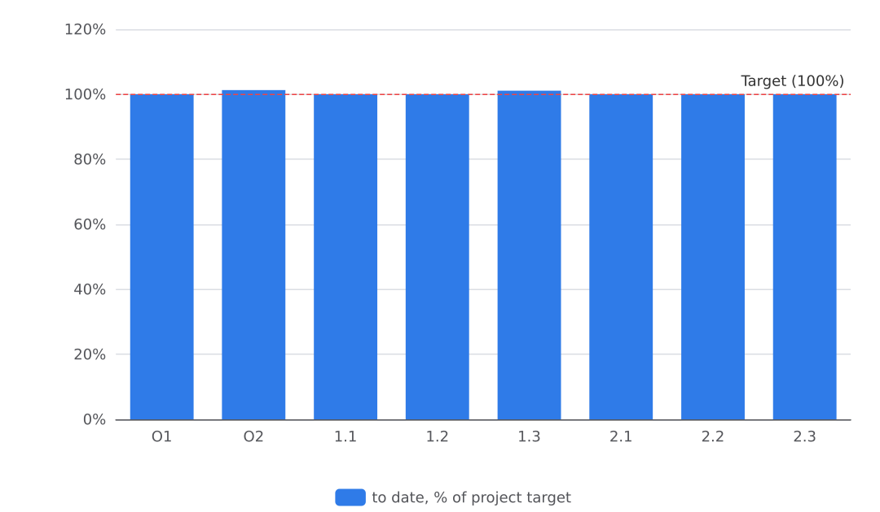
Figure 1. Progress to date against project targets

Outcomes and Impact
Over the full six-month project, 14,000 people gained access to safe drinking water. This reached 100% of the life-of-project target of 14,000 people. Hygiene behaviour also changed: 76% of surveyed households had a handwashing station with soap at the endline spot-check. This is up from a baseline of 28% and equals 101.3% of the 75% target. Residual chlorine compliance rose from a baseline of 55% to 91% of tested water samples in August. That equals 101.1% of the 90% target. The indicator comment records that 91% of 120 samples met the standard. Monthly water-quality testing underpins this result.
These outcomes rest on verified outputs. The project rehabilitated 24 water points against a target of 24 (100% of target). Engineer inspection reports record the final four water points completed and handed over in August in Dadu (Kachho). Trained management underpins the water-quality result. The project formed and trained 12 water user committees against a target of 12 (100% of target). The officer's narrative records that all 12 committees now keep dosing and maintenance records without project support.
Sanitation access also expanded. The project delivered 300 household latrines constructed and in use against a target of 300 (100% of target), including the final 55 completed in Mehar in August. It completed 6 schools with gender-separated WASH blocks against a target of 6 (100% of target). The final block was handed over at Khairpur Nathan Shah primary school in August. Hygiene promotion reached 12,000 people against a target of 12,000 (100% of target). The project-level breakdown of this total records 6,480 female and 5,520 male.
In the final reporting period (August 2026), the project reached 2,800 people with safe drinking water (1,540 female and 1,260 male) and 2,000 people with hygiene promotion (1,080 female and 920 male). It also rehabilitated 4 water points, completed 55 household latrines and handed over the final school WASH block.
One limitation affected the final weeks. End-of-project handover meetings coincided with school exams, which limited availability of head teachers. No other outcome-level data limitations were flagged in the verified findings.

Activities Delivered
Over the six-month project, GEC and the Sindh Rural Support Network delivered all planned activities across the three outputs in flood-affected union councils of Dadu district, closing on every life-of-project target detailed in the Achievement of Objectives section.
Output 1 — Safe water supply. Repair teams rehabilitated 24 water points against a target of 24 water points (100% of target), completing the final 4 water points in August in Dadu (Kachho), where about 2800 people (1540 female, 1260 male) now use them. Earlier batches delivered 2 water points in March (Johi/Bhan Syedabad), 4 in April (Mehar/Dhoro), 5 in May (Mehar/Radhan), 5 in June (Dadu/Sakrand Road) and 4 in July (Khairpur Nathan Shah/Mirpur Bathoro). Field staff chlorinated all rehabilitated points each month and tested residual chlorine; monthly compliance rose from 58% in March to 91% in August, finishing at 91% against a target of 90%. The partner team also formed and trained 12 water user committees against a target of 12 committees (100% of target), the final 2 in August in Johi, each with 24 members (10 women and 14 men). Committee training attendance is documented in verified attendance sheets, and monthly water quality in verified testing logs.
Output 2 — Sanitation. Households built 300 household latrines against a target of 300 latrines (100% of target), with community labour, engineer supervision and project-supplied slabs and pans; monthly completions ran 20 (March), 45 (April), 60 (May), 60 (June), 60 (July) and 55 (August). Contractors completed 6 gender-separated school WASH blocks against a target of 6 schools (100% of target) — 1 in April (Johi), 1 in May (Mehar), 2 in June (Johi), 1 in July (Mehar) and the final 1 in August (Khairpur Nathan Shah). Design consultation with head teachers preceded construction in March.
Output 3 — Hygiene promotion. Hygiene promoters ran community and school sessions with handwashing demonstrations every month, reaching 12000 people against a target of 12000 people (100% of target); the life-of-project reach comprised 6480 female and 5520 male. Monthly session turnouts ranged from 1200 people in March to 2400 people in May and June. Household handwashing station coverage rose in monthly spot-checks from 32 percent in March to 76 percent in August, ending at 76% against a target of 75%.
The project spent the final weeks on handover rather than new construction; the officer notes that handover meetings coincided with school exams, which limited head teachers' availability. All 12 water user committees now keep dosing and maintenance records without project support. Data on post-project sustainability arrangements beyond committee record keeping was not reported.

Beneficiaries Reached
Over the six-month project, 14000 people (7700 female, 6300 male) gained access to safe drinking water, reaching 100% of the 14000-person target, and 12000 people (6480 female, 5520 male) were reached with hygiene promotion against a target of 12000 (100% of target). In the final reporting month of August 2026, the project reached 2800 people with safe water (1540 female, 1260 male) and 2000 people with hygiene promotion (1080 female, 920 male), including 800 children at the August sessions in Dadu.
The recorded reach came through the activities detailed in Achievement of Objectives. The August water-point rehabilitation in Dadu (Kachho) served about 2800 people (1540 female, 1260 male), and the August hygiene sessions reached 2000 people (1080 female, 920 male), of whom 800 were children. Earlier monthly sessions recorded children among participants, such as 480 children of the 1200 people reached in Johi in March and 960 children of the 2400 people reached in Mehar in June.
The following table shows the life-of-project reach as recorded in the verified findings. Age breakdowns beyond the children counts in activity records, and disability data, were not reported in the verified findings, so no disability figures can be given.
Group | Total | Male | Female | Children | People with disabilities
People with access to safe drinking water (life of project) | 14000 people | 6300 | 7700 | Not reported | Not reported
People reached with hygiene promotion (life of project) | 12000 people | 5520 | 6480 | Not reported | Not reported

No quality flags were attached to these findings, and data sources were community registers for safe-water reach and hygiene promoters' registers for hygiene reach. The findings carry no recorded disability or full age breakdown, which limits fuller analysis of who was reached.

Financial Close-out
The project closed its six-month implementation in August 2026 with total expenditure of 460800 USD against a budget of 480000 USD, a committed amount of 0 USD and a balance of 19200 USD, giving a burn rate of 96 percent. Spending aligned with recorded delivery: by the end of August the project had completed all 24 water points against a target of 24 (100% of target), all 300 household latrines against a target of 300 (100% of target), all 6 school WASH blocks against a target of 6 (100% of target) and all 12 water user committees against a target of 12 (100% of target), so the near-full burn rate reflects completed physical outputs.
Every budget line closed with a burn rate of 96 percent. Water point rehabilitation and disinfection spent 144000 USD of 150000 USD, with 0 USD committed and a balance of 6000 USD. Latrines and school WASH blocks spent 163200 USD of 170000 USD, with 0 USD committed and a balance of 6800 USD. Hygiene promotion and materials spent 43200 USD of 45000 USD, with 0 USD committed and a balance of 1800 USD. Water user committees and training spent 33600 USD of 35000 USD, with 0 USD committed and a balance of 1400 USD. Programme management and MEAL spent 76800 USD of 80000 USD, with 0 USD committed and a balance of 3200 USD. The full breakdown by budget line is shown in the financial table below.
No variance explanation was recorded in the reporting inputs: the officer's narrative records what went well and why targets were met, but contains no budget-line variance commentary. The narrative notes only that handover sessions replaced new construction in the final weeks, and that all 12 water user committees now keep dosing and maintenance records without project support. All figures above are the verified financial figures supplied for the final reporting period ending 2026-08-31; no amounts beyond those recorded were estimated or recalculated.
Budget line | Budget (USD) | Expenditure (USD) | Committed (USD) | Balance (USD) | Burn rate
Water point rehabilitation and disinfection | 150000 | 144000 | 0 | 6000 | 96%
Latrines and school WASH blocks | 170000 | 163200 | 0 | 6800 | 96%
Hygiene promotion and materials | 45000 | 43200 | 0 | 1800 | 96%
Water user committees and training | 35000 | 33600 | 0 | 1400 | 96%
Programme management and MEAL | 80000 | 76800 | 0 | 3200 | 96%
**Total** | 480000 | 460800 | 0 | 19200 | 96%

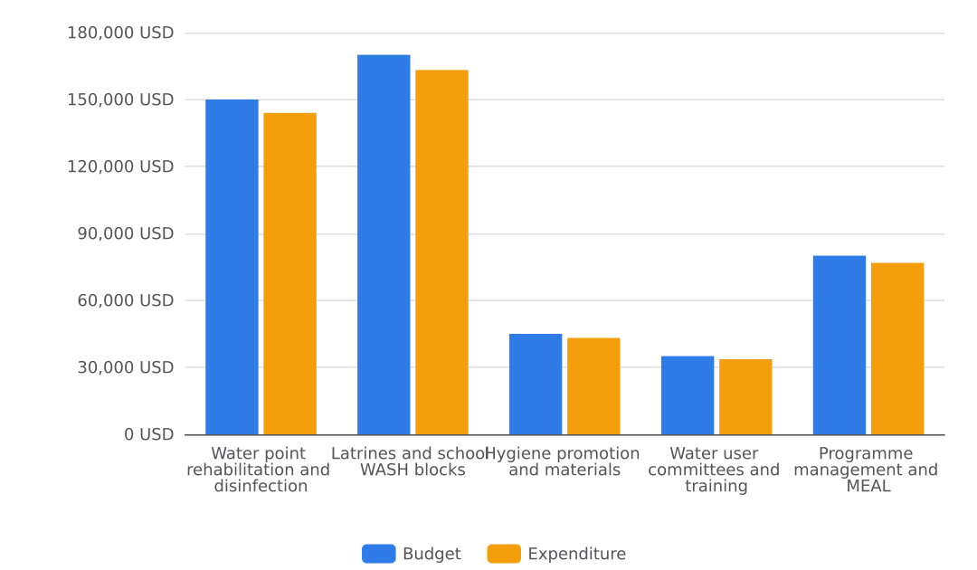
Figure 2. Budget and expenditure by budget line

Sustainability and Exit
The project handed all completed infrastructure to local owners and trained them to maintain it. Repair teams handed each of the 24 rehabilitated water points to the local water user committees as they completed it; the August activity in Dadu (Kachho) recorded the handover of the final 4 water points and noted next steps to hand over all schemes to the committees and the district PHED office. All 12 water user committees against a target of 12 (100% of target) completed training in operation, minor repair, fee collection and record keeping, and the final 2 committees in Johi received handover certificates as a recorded next step. The officer's narrative records that all 12 committees now keep dosing and maintenance records without project support. The final school WASH block at Khairpur Nathan Shah was completed and handed over in August, giving 6 schools with gender-separated WASH blocks against a target of 6 (100% of target). End-of-project handover meetings coincided with school exams, which limited head teachers' availability; in the final weeks the project replaced new construction with handover sessions. Evidence on file includes verified training attendance sheets and water-quality logs for the water user committee and chlorination activities. The data does not record post-project arrangements for household latrines, formal ownership documents, or a maintenance financing mechanism; this was not reported.

Challenges and Lessons Learned
Across the six-month project, delivery faced recurring access and supply constraints that the team addressed through practical adjustments. Three themes recur in the activity records: logistics, water quality management, and community participation. Over the project life, all outputs closed on target, so these challenges caused delay rather than shortfall, as detailed in Achievement of Objectives.
Logistics and materials. Repair teams reported minor delays transporting materials on washed-out roads in March, April, June and August, and flooding at one Mehar (Radhan) site delayed completion by a week in May. In July, spare parts were delayed ten days and bought locally. For latrine construction, materials arrived late in March and cement was occasionally short at the Dadu supplier from April onwards. The team responded by pre-positioning spare parts at the Dadu field office and paying slab suppliers on delivery to avoid construction pauses; no further mitigation was recorded for road access or cement supply.
Water quality management. Monthly testing from March to August showed some samples falling below the residual chlorine standard where dosing records were incomplete. Compliance rose from 58% of tested samples in March to 91% in August, reaching 101.1% of the 90% target. The team continued monthly testing and retrained committees where results were low; the water-quality logs (e.g. 02-A1.3-water-quality-log and 03-A1.3-water-quality-log) record the monthly results behind this trend.
Participation and scheduling. Women's attendance at committee training depended on session timing around household chores, so the team moved sessions to the evening near the water point. Competing agricultural and household work, and extreme heat in June, reduced turnout at some hygiene sessions. In the final weeks, handover meetings coincided with school exams, which limited head teachers' availability, and handover sessions replaced new construction.
Lessons drawn. Weekly dosing logs kept by committees raise chlorine compliance; pre-positioning spare parts prevents repair delays; paying slab suppliers on delivery avoids construction pauses; evening sessions near water points increase women's participation; and involving head teachers in design improves maintenance planning. By project close, all 12 water user committees kept dosing and maintenance records without project support. The records do not report any mitigation for the school-exam clash beyond rescheduling handover sessions.

Recommendations
Chlorine compliance rose from 58 percent of tested samples in March to 91 percent in August against a target of 90 percent (101.1% of target), and the recorded lesson is that weekly dosing logs kept by committees raise compliance. Future programming should schedule water user committee training to include routine dosing-log keeping from the start of rehabilitation, since compliance improved as committees adopted these logs. This recommendation is for the implementing organisation and partner.
Every water user committee training record notes that women's attendance depended on the timing of sessions around household chores, and the recorded lesson is that evening sessions near the water point increase women's participation. Future programming should hold committee training and mentoring sessions in the evening at the water point. This recommendation is for the partner team responsible for committee formation.
Several activity records note that minor delays in transporting materials on washed-out roads, ten-day spare-part delays and late slab deliveries slowed construction. The recorded lesson is that pre-positioning spare parts at the Dadu field office prevents repair delays, and that paying slab suppliers on delivery avoids construction pauses. Future programming should pre-position spare parts before rehabilitation starts and pay slab suppliers on delivery.
Handover meetings coincided with school exams, which limited availability of head teachers. Future programming should schedule school handover sessions outside examination periods; the data does not report an alternative timing that was tested.
All 12 water user committees now keep dosing and maintenance records without project support. This learning suggests future projects should build record-keeping independence into committee mentoring from the outset.

Conclusion
Over the full six-month project, 14,000 people gained access to safe drinking water, reaching 100% of the 14,000-person target, and every life-of-project target was met. The [DEMO] Safe Water & Sanitation for Flood-Affected Communities project, implemented by GEC with the Sindh Rural Support Network, served flood-affected union councils of Dadu district, Sindh, Pakistan, closing on 31 August 2026. Outcome indicators finished at or above target. 76% of surveyed households had a handwashing station with soap against a target of 75% (101.3% of target). Residual chlorine compliance reached 91% of tested samples against a target of 90% (101.1% of target). Output targets closed at 100%: 24 water points rehabilitated, 12 water user committees formed and trained, 300 household latrines constructed and in use, 6 schools with gender-separated WASH blocks, and 12,000 people reached with hygiene promotion against a target of 12,000. The life-of-project hygiene reach comprised 6,480 female and 5,520 male. The main recorded constraint was logistical: minor delays transporting materials on washed-out roads, ten-day spare-part delays and late slab deliveries. The team pre-positioned spare parts at the Dadu field office and paid slab suppliers on delivery. Financially, the project closed with expenditure of 460,800 USD against a 480,000 USD budget, a committed amount of 0 USD, a balance of 19,200 USD and a burn rate of 96 percent. All 12 water user committees now keep dosing and maintenance records without project support, which anchors the project's recorded handover arrangements.

Annexes
The annexes contain supporting documents, handover records and evidence for the completed six-month project. The annexed files, all verified, are: 02-A1.2-training-attendance (attendance sheet, reference c94ff696-1490-4b8e-a3e0-9f5dd5df75ec); 02-A1.3-water-quality-log (KoBo/ODK export, reference c626e600-9893-4a32-9f5c-c6dd09c0e349); 03-A1.2-training-attendance (attendance sheet, reference b04772ec-5421-43ba-b14e-e2d4ff7f1d69); 03-A1.3-water-quality-log (KoBo/ODK export, reference 1bb00099-5f99-4ac7-924c-0fb8754e25d6); 04-A1.2-training-attendance (attendance sheet, reference 6294931d-3531-4cb1-b607-1ad632380d39); and 04-A1.3-water-quality-log (KoBo/ODK export, reference fe1122ba-b4e1-4fdb-9575-b9bd581efa0a). These comprise training attendance records for water user committee sessions and monthly water-quality testing logs. Delivery details and handover outcomes are described in the Activities Delivered and Sustainability and Exit sections.

Indicator Progress
Code | Indicator | Baseline | Target | Achievement | Unit | Status
O1 | Number of people with access to safe drinking water | 0 | 14000 | 2800 | people | VERIFIED
O2 | Percentage of surveyed households with a handwashing station with soap | 28 | 75 | 76 | % | VERIFIED
1.1 | Number of water points rehabilitated and functional | 0 | 24 | 4 | water points | VERIFIED
1.2 | Number of water user committees formed and trained | 0 | 12 | 2 | committees | VERIFIED
1.3 | Percentage of tested water samples meeting residual chlorine standard (0.2-0.5 mg/L) | 55 | 90 | 91 | % | VERIFIED
2.1 | Number of household latrines constructed and in use | 0 | 300 | 55 | latrines | VERIFIED
2.2 | Number of schools with gender-separated WASH blocks completed | 0 | 6 | 1 | schools | VERIFIED
2.3 | Number of people reached with hygiene promotion | 0 | 12000 | 2000 | people | VERIFIED

INTERNAL PREVIEW — NOT FOR DONOR SUBMISSION

