**R-Code for Naïve Bayes**

**########## *Using the partially cleansed dataset from KNN* ###########################**

naive_train<-new_data2

**############ *Filtering out the missing values and N/A’s* ###############################**

naive_train<-naive_train[complete.cases(naive_train),]

naive_train<-na.omit(naive_train)

**######## *Adding a data label for Departure Delay* ####################################**

naive_train$Label_Departure_Delay<-ifelse(naive_train$DepDelay>10,"Yes","No" )

**####### *Repeating the above steps for test dataset* ##################################**

naive_test<-test_subset2

naive_test<-naive_test[complete.cases(naive_test),]

naive_test<-na.omit(naive_test)

str(naive_test)

**################## *Adding Delay Label to testing data* ###########################**

naive_test$Label_Departure_Delay<-ifelse(naive_test$DepDelay>10,"Yes","No")

head(naive_test)

**####### *Converting the training data variables into factor values* ##################**

naive_train$Month<-as.factor(naive_train$Month)

naive_train$DayofMonth<-as.factor(naive_train$DayofMonth)

naive_train$DayOfWeek<-as.factor(naive_train$DayOfWeek)

str(naive_train)

**######### *Converting the testing data variables into factor values* ################**

naive_test$DayOfWeek<-as.factor(naive_test$DayOfWeek)

naive_test$DayofMonth<-as.factor(naive_test$DayofMonth)

naive_test$Month<-as.factor(naive_test$Month)

str(naive_test)

**######### *Applying Naïve Bayes model to training dataset* #####################**

naive_model <- naiveBayes(Label_Departure_Delay ~ ., data=naive_train)

naive_preds<-predict(naive_model,naive_test)

**############ *Install “caret” package, required to creating confusion matrix* #########**

Install.packages(“caret”)

Library(caret)

**####### *Creating confusion matrix for actual labels and prediction labels* ###########**

print(confusionMatrix(naive_preds, naive_test$Label_Departure_Delay,positive="Yes",dnn=c("Prediction","True")))

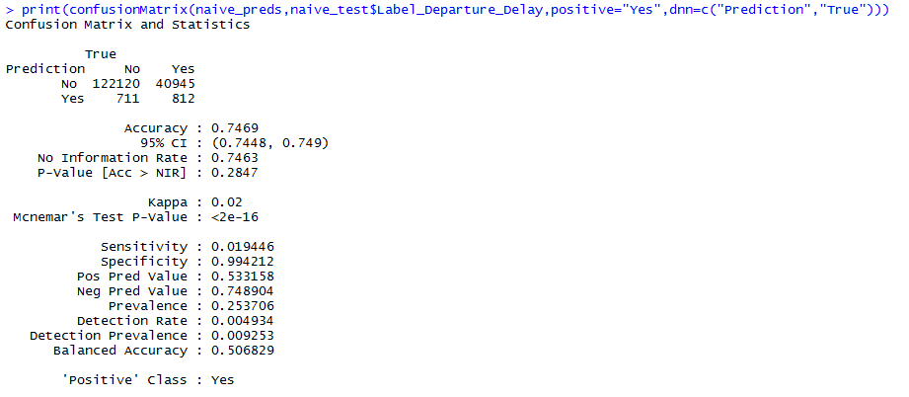

**Accuracy = 74.690743%**