**Group E**

**Submitted by,**

**Jinesh Shah 691-01 Hybrid Electric Vehicle Propulsion**

**Viraj Dave Project-8: EREV Acceleration Model**

**Submitted to,**

**Prof Dr. Craig Hoff.**

**Abstract:**

The main objective of this project is to measure and compare acceleration performance of Audi Q7 2017 model with Electric motor and compare it with Base vehicle model which is an IC engine model. This comparison includes trying different single speed gear ratios, implementing more powerful motors, and different gear ratios with 2 speed shifters. Main parameters to looks for 0-100 kph speed timings, this gives how the vehicle is accelerating in different powertrain conditions. Other drivability parameters are to check for 55-110 kph vehicle speed timings, and Vehicle Top Speed.

As a part 1 the base vehicle acceleration timings and top speed is given. Then vehicle is modified with drivetrain containing electric motor and single speed gear box. Total three gear ratios needed to be checked, which are 5, 2.5, and 3.5. With gear ratio of 5.0, 0-100 acceleration is found to be the best with the timing of 8 seconds. But in that case vehicle’s top speed is limited by 102 kph, that is certainly not good. With smaller gear ratio of 2.5 vehicle’s top speed is 202 kph which is highest among all three. But it has poor acceleration of 0-100 kph, with timing of 11 seconds. Trade of between good acceleration and max speed s found with gear ratio of 3.5. Acceleration timing of 9 seconds for 0-100 kph and top speed of 145.6 kph are decent numbers for any passenger vehicle.

In part 2 of this project the best single speed gear ratio from part 1 is selected, which is 3.5 and considered as Baseline motor. Then motor power is increased by 25 and 50%, which mean using 2.5 or 3.0 motors instead of 2 motors of Baseline model. Result shows that using 2.5 motors will increase the power to 250 kW. Vehicle will give better acceleration of 7.31 seconds for 0-100 kph. But still this is not enough to match base vehicle with 300 kW IC engine. So to do this 3 motors are used, and it gave 6 seconds timing to accelerate from 0 to 100 kph. Which is better than base vehicle but it required 3 motors in vehicle powertrain.

Additional problem statement is to implement 2-speed transmission in base motor of 200kW. 2-speed gear box has 1st gear of 5.0 and 2nd gear of 2.5. Shift strategy is to upshift at 30 kph. The acceleration results as found to be ## seconds and maximum speed of ## kph. This performance was not enough as compare to base vehicle with IC engine. So again with the same 2-speed transmission and upshift strategy, motor power is increased to match the base vehicle acceleration timings. After iterating it is found that ## % more power is required, it means that in this EREV 2.# number of motors are required to reach the performance of base Audi Q7 2017 with gasoline engine.

|  |  |  |  |
| --- | --- | --- | --- |
| **Configuration** | **0-100 kph5** | **55-110 kph** | **Top Speed** |
| Base vehicle | 6.8 | 6.3 | 205 |
| Rt,1 = 5.0, t = 0.95 | 8.08 | -- | 102.3 |
| Rt,2 = 2.5, t = 0.95 | 11.48 | 7 | 202 |
| Rt,1-spd = 3.5, t = 0.95 | 9.24 | 6.54 | 145.6 |

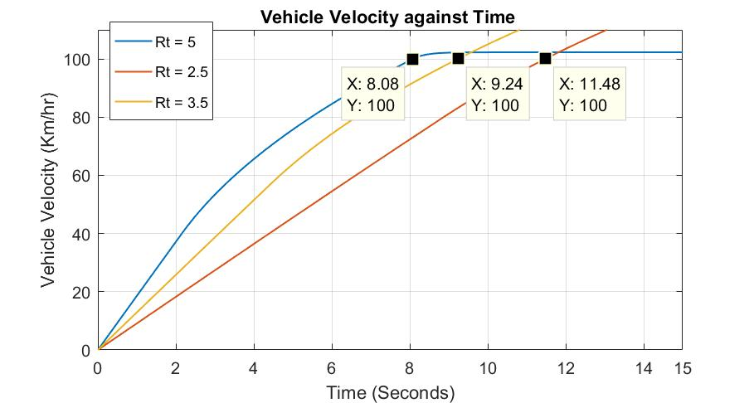

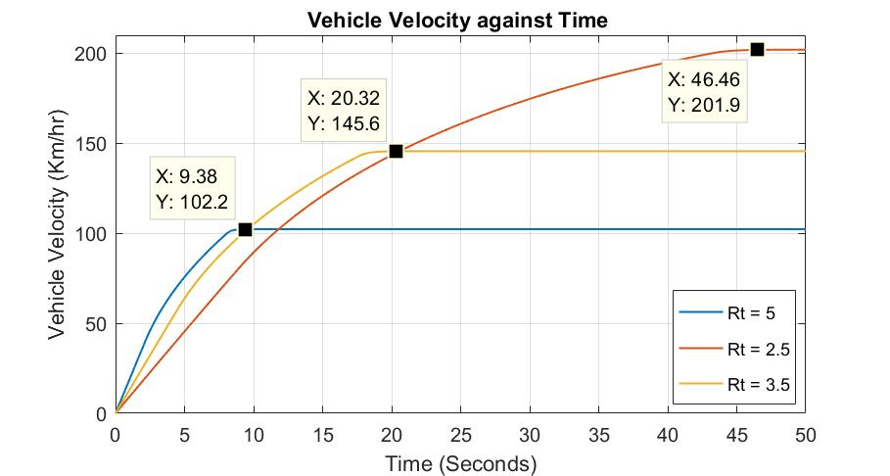

|  |  |  |  |
| --- | --- | --- | --- |
| **Configuration** | **0-100 kph** | **55-110 kph** | **Top Speed** |
| Baseline Motor | 9.24 | 6.53 | 145 |
| Baseline Motor x 1.25 | 7.31 | 5.14 | 145 |
| Baseline Motor x 1.50 | 6.05 | 4.23 | 145 |

