**Group E**

**Submitted by,**

**Jinesh Shah 691-01 Hybrid Electric Vehicle Propulsion**

**Viraj Dave Project-6:**

**Submitted to,**

**Prof Dr. Craig Hoff.**

**Abstract:**

Main objective of this project is to implement a model which was previously created with fix efficiency motor. This model is modified and developed with a variable fuel converter efficiency. Total Energy consumption for each EPA driving cycle i.e, City, Highway, and Aggressive (US06) has been plotted against time. All of this work was done by using single speed gear with a fixed gear ratio. Further for additional problem a 2-speed shifter transmission was included in the same vehicle fuel energy model. And difference of energy consumption with and without 2 speed transmission is observed and discussed later.

In the part 1 of this project variable efficiency of motor and generator is included in City driving, highway driving and Aggressive driving cycle. Fuel energy demand is plotted in individual graphs. After that toatal fuel energy required per 100km for converted Audi Q7 2017 (electric vehicle mode) has been calculated and compared with Base Audi Q7 2017 (IC engine mode). In city driving cycle predicted energy demand/100km for converted vehicle was 24kWh/100km which is 77% less compared to conventional base vehicle. Same trend is observed in Highway driving cycle, for converted EV model fuel energy demand was 29kWh/100km. Comparing this to base model of same vehicle it was observed that even on highways EV has 60% of fuel savings. After that based on the results of fuel energy requirement per 100km the weight of the battery pack was calculated to check how much additional weight will be added to new Electric vehicle.

For the 2nd part operating points for each 3 driving cycles were plotted on the contour map of variable motor efficiency, motor torque, and motor RPM. This was done to check how well this motor with single speed gear is operating in high efficiency region during any of the 3 cycles. Further from the same scatter plot motor outputs for torque can also be compared with chassis road load requirement of driving schedule. For city driving schedule this motor operates mostly in 0.83 to 0.93 efficiency region and between 2000 to 3000 RPM. For Highway driving motor operates mainly on 0.7 to 0.8 efficiency region and between 4000 to 5000 RPM. And for US06 aggressive driving cycle operating point are on 0.75 or less efficiency region, for this cycle RPM range is 6000 to 7000 RPM.

Additional problem to include 2 speed shifter transmission, has given some vital insights in terms of benefits of using more number of gears. In city driving energy demand was found to be 22.06kWh/100km, which is 10% less than vehicle without 2 speed shifter, and even the weight of the required battery pack is also decreased significantly. Same energy demand is calculated for Highway and Aggressive (US06) driving cycles. And energy saving is observed between single speed gear and 2 speed shifter gearbox was 16% and 12% in that order of Highway and US06 driving schedule.

|  |  |  |  |
| --- | --- | --- | --- |
| **Parameter** | **City cycle** | **Highway cycle** | **US06 cycle** |
| **Measured energy consumption – Base (kWh/100km)** | 110.8 | 74.8 | - |
| **Predicted energy consumption – Converted (kWh/100km)** | 24.61 | 29.63 | 37.01 |
| **Percent energy savings in EV mode** | 77.7 % | 60 % | - |
| **Weight of battery pack to go 100 km (kg)** | 307.6 kg | 370.3 kg | 462.6 kg |

**Part-1**

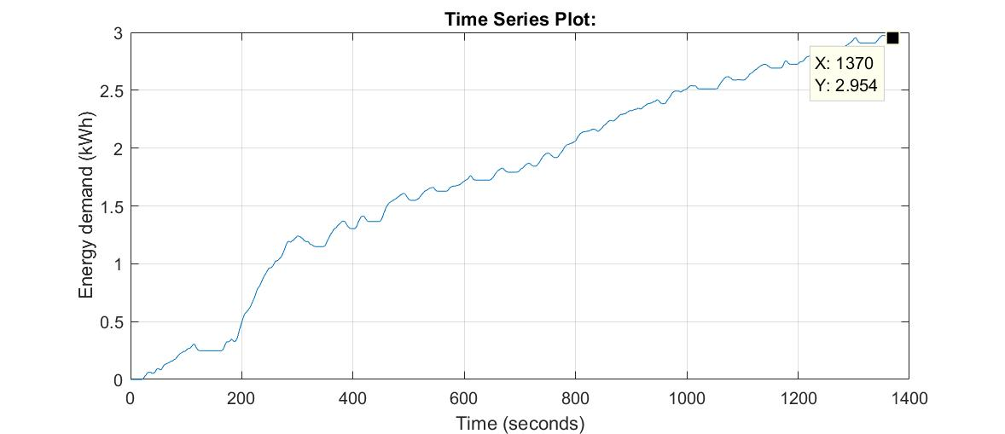

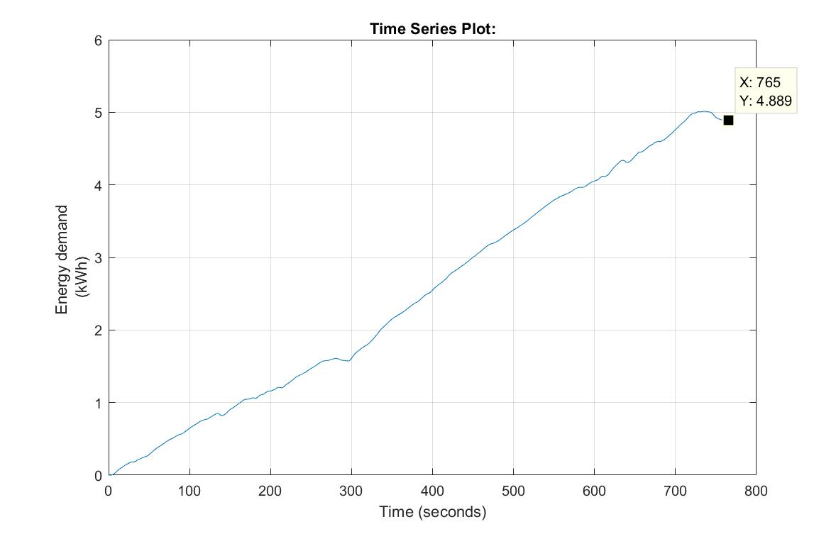

☺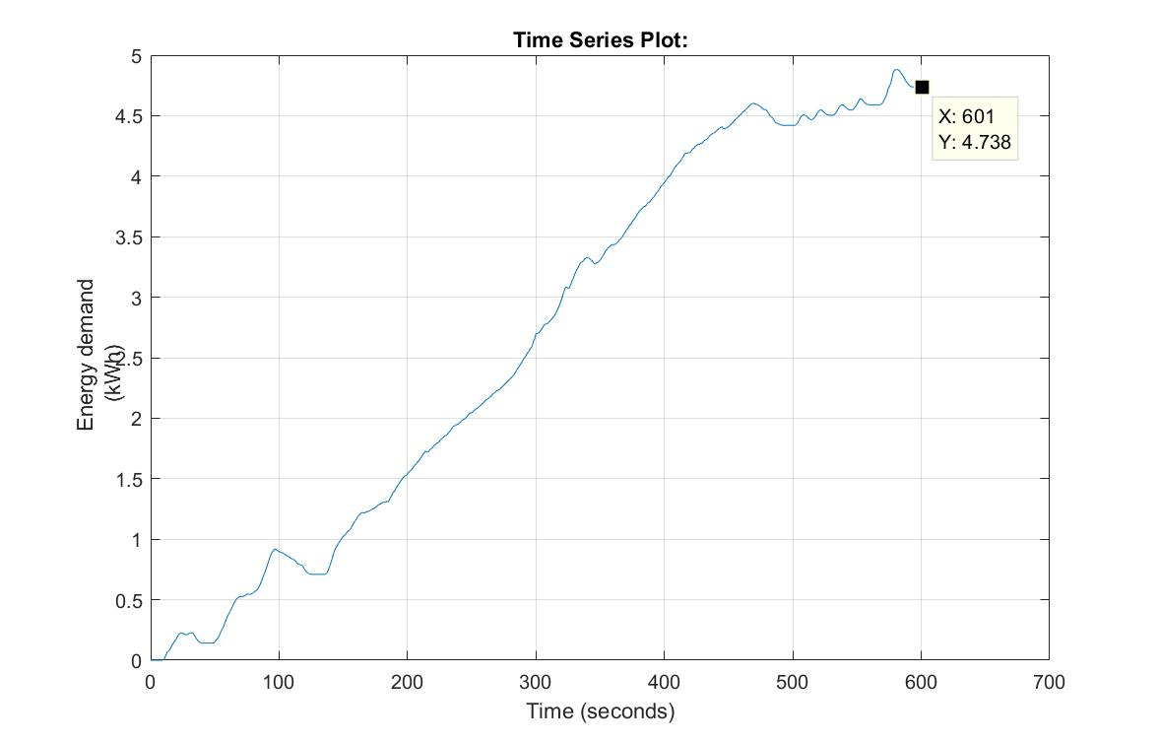

**Part 2**

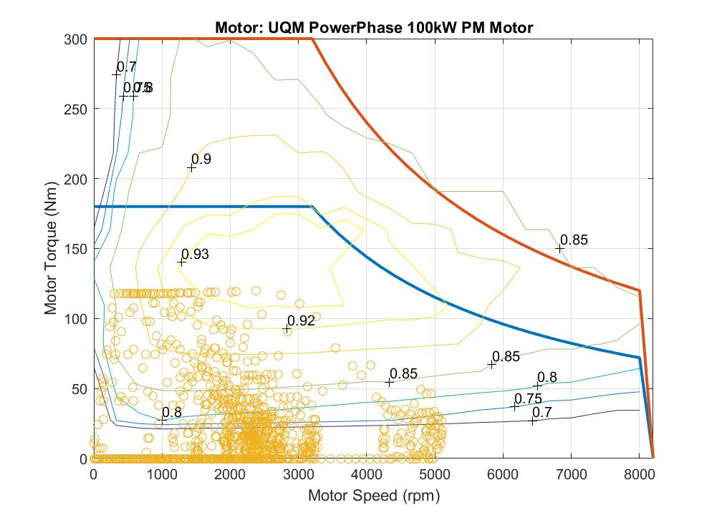

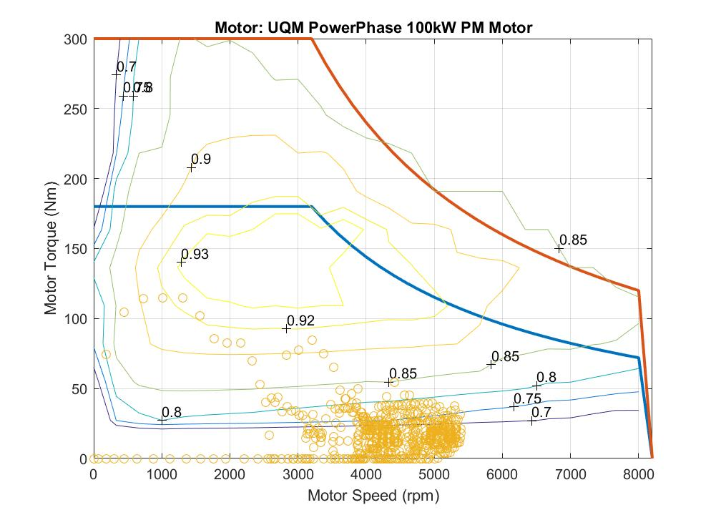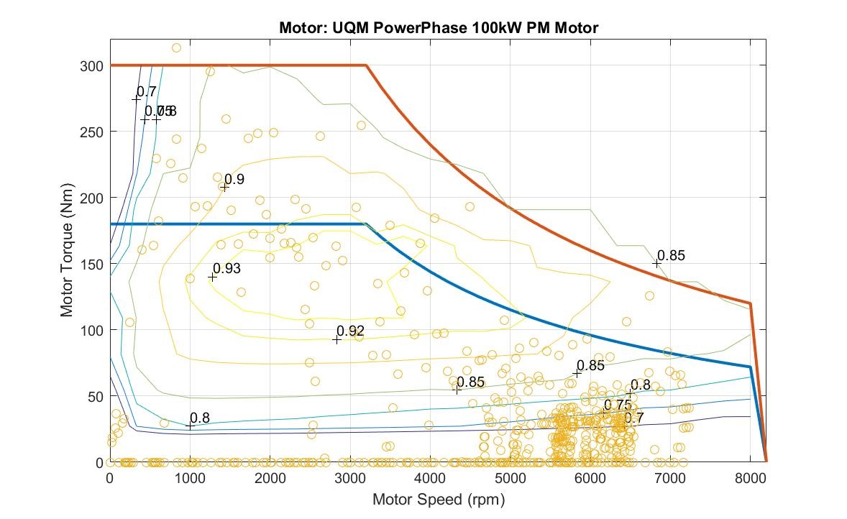

Figure 1 Motor Operating points for US06 Agressive driving cycle

From the above figure it can be observed that for aggressive driving cycle US06 motor operating points are in high RPM range of 6000 to 7000 RPM. These points are very dense in region below 0.75 efficiency contour. One aspect of this graph also shows some of very high torque values at some point, this shows that during this driving cycle acceleration and deceleration of the vehicle was performed aggressively, this could be a reason of higher energy consumption/100km for US06 driving cycle.

But the problem with this graph is that couple of operating points of driving cycle is going outside the region of peak motoring torque. So it can be said that this motor with single speed gear with gear ratio of 3.5 is not sufficient for using in US06 driving schedule. Several iterations were made in Simulink model of this cycle to check for more suitable gear ratio. Gear ratio of 3.8 was found to be the most appropriate for this single speed geared motor.

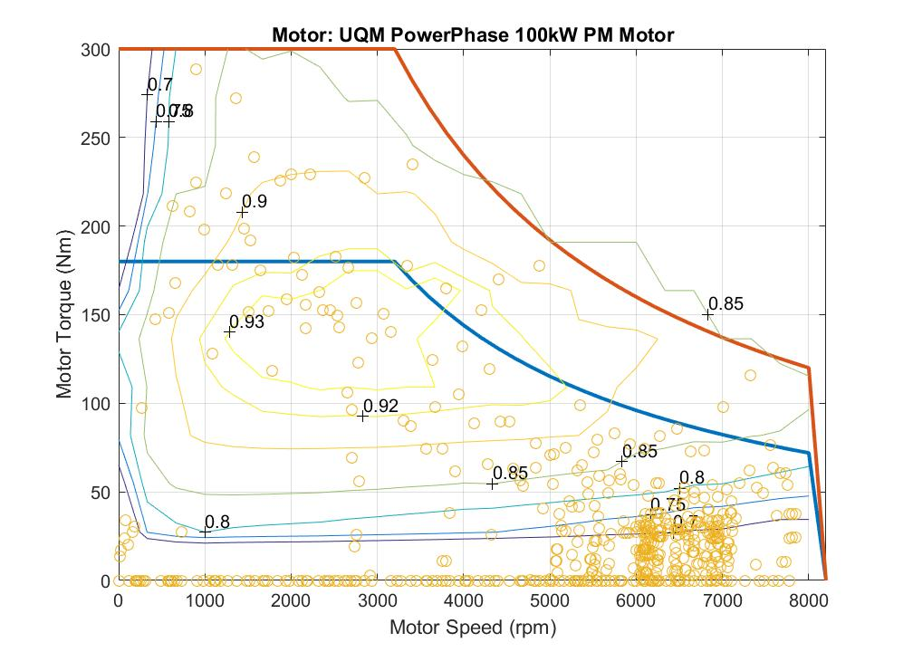

Figure 2Efficiency points with single gear ratio 3.8

**Part 3**

|  |  |  |  |
| --- | --- | --- | --- |
| **Parameter** | **City cycle** | **Highway cycle** | **US06 cycle** |
| **Measured energy consumption – Base (kWh/100km)** | 110.8 | 74.8 | - |
| **Predicted energy consumption – Converted (kWh/100km)** | 22.06 | 24.84 | 32.55 |
| **Percent energy savings in EV mode** | 80.09% | 66 % | - |
| **Weight of battery pack to go 100 km (kg)** | 275.75 kg | 310.5 kg | 406.8 kg |

|  |  |  |  |
| --- | --- | --- | --- |
| **Parameter** | **City cycle** | **Highway cycle** | **US06 cycle** |
| **Predicted energy consumption – Converted single speed gear (kWh/100km)** | 24.61 | 29.63 | 37.01 |
| **Predicted energy consumption – Converted with 2 speed shifter (kWh/100km)** | 22.06 | 24.84 | 32.55 |
| **Percent energy savings using Transmission** | 10% | 16 % | 12 % |

