PRODUCT OVERVIEW
PRISM
Financial Planning & Reporting Tool
A self-contained, browser-based analytics workbook for lending-business financial planning, performance reporting, and management review.

1. What This Tool Is
This is PRISM, a purpose-built financial planning and analysis (FP&A) application delivered as a single interactive file that opens directly in a standard web browser. It replaces a collection of disconnected spreadsheets with one consistent, structured workspace where actual results, budgets/forecasts, and key performance indicators for a multi-channel lending business are brought together, reconciled, and reported.
There is no installation, no server, and no external software dependency. The tool is shared as a single file; anyone with a modern browser can open it, load the relevant data files, and immediately see fully-built management reports.

2. Purpose
The tool was built to address a common challenge in fast-growing lending businesses: financial and operating data originates from several different sources (accounting records, business/operations trackers, and planning files), and consolidating them consistently, every month, in a way leadership can trust, is time-consuming and error-prone when done manually in spreadsheets.
Its purpose is to:
- Standardise how monthly actuals, plan/forecast figures, and key operating metrics are combined into a single, consistent view.
- Reduce the manual effort and risk of error involved in building recurring management reports.
- Give business and finance stakeholders a common, always-current reference point for performance discussions.
- Make month-on-month, quarter-on-quarter, and actual-vs-plan comparisons fast and reliable, rather than rebuilt from scratch each cycle.

3. What It Does — Core Capabilities
The tool is organised as a set of report modules (“tabs”) inside one workbook-style interface. Each module addresses a specific reporting need:
- Profitability reporting — consolidated and channel-level profit-and-loss views, allowing performance to be reviewed both for the business as a whole and for individual business lines/channels.
- Variance analysis — automatic comparison of actual results against plan and against prior periods, with the drivers of any change (e.g. volume-driven vs. rate/pricing-driven) broken out so reviewers can see not just “what changed” but “why.”
- Year-to-date performance tracking — a rolled-up, cumulative view of performance across the financial year, refreshed automatically as each new month is loaded.
- Key performance indicator (KPI) reporting — a dedicated dashboard of the operating and financial metrics the business tracks regularly (e.g. volumes, portfolio metrics, funnel and conversion metrics), shown with trends over time.
- Goal-tracking (objectives dashboard) — a view for tracking progress of business objectives/targets against actual outcomes.
- Presentation-ready output — a summarised, formatted view suitable for sharing directly with leadership or external stakeholders, without needing to rebuild slides or reports separately.
- Supporting reference tabs — structured mapping and schedule tabs that keep source data classifications (e.g. how raw accounting/business data lines up with reporting categories) consistent and auditable.

4. How It Works — Data Flow
The tool follows a simple, repeatable cycle each reporting period:
- Load source files — the user uploads standard Excel exports covering actual financial results, business/operations data, and plan or forecast figures.
- Parse and reconcile — the tool reads these files, recognises the relevant time periods and categories automatically, and aligns them against a consistent internal reporting structure (so a given business channel or income/cost line is always reported the same way, regardless of how it was labelled in the source file).
- Compute — the tool calculates the full set of reporting outputs on the fly: consolidated and channel-level profitability, variances versus plan and prior periods, KPI trends, and year-to-date figures.
- Review — results are immediately available across the report modules described above, ready for review, drill-down, or export.
- Export / share — finished views can be exported back into Excel for distribution, or the workbook itself (with its data) can be saved and shared as a single file so a colleague can open it and pick up exactly where the previous user left off.

5. Architecture, in Plain Terms
The application is intentionally simple and self-contained by design, which keeps it easy to distribute, easy to trust, and easy to maintain. The diagram below traces a file from the moment it is loaded to the moment a report comes out the other side:
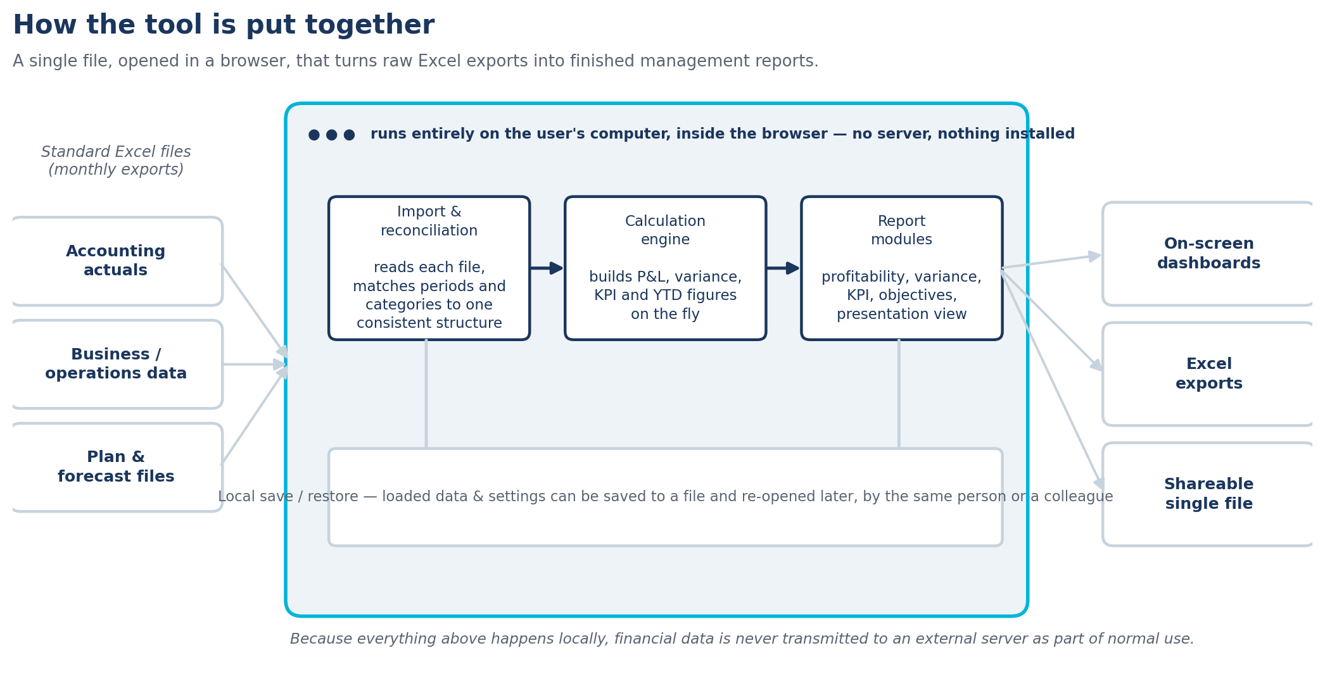
- Single-file application — the entire tool — interface, calculation logic, and reporting templates — is packaged into one file. Nothing needs to be installed, and there is no ongoing hosting or infrastructure requirement.
- Runs entirely in the browser — all data loading, calculation, and report rendering happens locally on the user's own computer, inside the browser, as shown by the outlined boundary above. No data is uploaded to an external server as part of normal use.
- Standard file formats in and out — the tool reads and writes ordinary Excel files, so it fits into existing workflows without requiring anyone to learn a new data format.
- Local save/restore — a user's loaded data and settings can be saved to a file and reloaded later (by the same person or a colleague), so work is never dependent on a live connection or a central database.
- Modular reporting layer — each report module (profitability, KPIs, objectives, presentation view, etc.) is built on top of the same underlying, reconciled dataset, which is what keeps every view consistent with every other view.

6. A Glimpse of the Output
To make the above concrete, the mock-up below shows the shape of what a user sees once data is loaded — a channel-level performance trend, a mix breakdown, and a profit-and-loss summary with automatic variance highlighting. Every figure here is a placeholder used purely to illustrate layout and formatting.
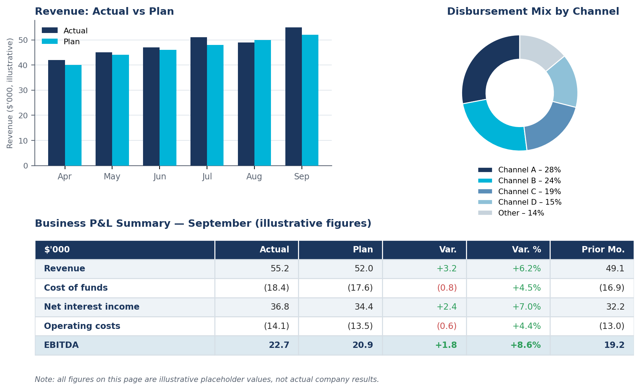
In the live tool, this view updates automatically as soon as a new month's files are loaded — the trend chart, mix breakdown, and P&L table above are simply illustrations of that same output using placeholder numbers.

7. Data Handling & Confidentiality
Because the tool runs entirely on the user's own machine and does not depend on an external server, the financial and business data loaded into it is not transmitted anywhere as part of normal operation. This design was a deliberate choice, given the sensitivity of financial planning data, to keep control of the data with the business at all times.
An optional, clearly-gated assistant feature exists for ad-hoc, natural-language querying of the loaded data. It is off by default, requires the user to supply their own access credentials for the underlying AI service, and stores those credentials only in the user's own browser — they are never embedded in, or distributed with, the shared file.

8. Who Uses It and How It Is Shared
The tool is designed for finance and business teams who own recurring management reporting. A single person typically maintains the workbook and reporting logic, refreshing it each period as new data becomes available, while a wider group of stakeholders consumes the resulting dashboards and exports for review and decision-making.
Because it is a single file, distribution is straightforward: it can be emailed, shared via a file link, or handed over on request, and the recipient can start using it immediately without any setup.

9. Summary
In short, this is a lightweight but comprehensive FP&A reporting solution purpose-built for a multi-channel lending business. It consolidates actual, budget/forecast, and operating data into one consistent structure; automates the recurring work of building profitability, variance, KPI, and objective-tracking reports; and does all of this in a self-contained, easily-shared file that keeps sensitive financial data under the business's own control.

