Swat Tourism Platform (STP)
Antigravity Technical Responses with Visual Architecture Diagrams (Current Conversation)
Attribute | Details
Conversation ID | 040a1073-5ce9-41df-bd7c-d7c9b704e460
Content Scope | Antigravity AI Assistant Responses (Current Chat Only, No User Prompts)
Diagram Format | Full Visual Diagram Format (High-Resolution Graphic Flowcharts & Sequence Maps)
Subject / Topic | Complete End-to-End Hotel Booking Flow, Common Files & Data Flow Pipeline
Project Directory | f:\Antigravity\SwatTourismProduction_v2
Output Location | Docs\Antigravity_Responses_Current_Chat.docx
Target Audience | Executive Presentation for Boss / Leadership Review

Part 1 — Antigravity Technical Deliverable [2026-11-13 05:59:36]
Here is the complete end-to-end architectural flow diagram and technical walkthrough of the Hotel Booking Lifecycle in the Swat Tourism Platform.
Every stage maps the Frontend UI components, Backend API endpoints & domain services, and Database tables with exact repository file paths so you can present it directly to your leadership.
――――――――――――――――――――――――――――――――――――――――――――――――――
1. Executive Architecture & Sequence Flow Diagram
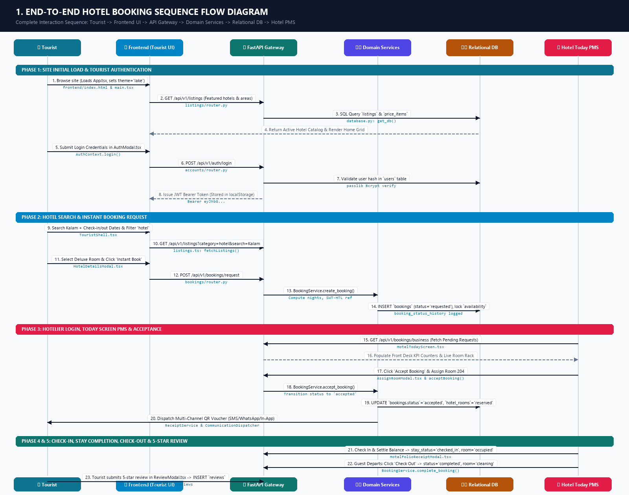
Figure 1.1: Visual Architecture Sequence Diagram — End-to-End Hotel Booking & PMS Flow
――――――――――――――――――――――――――――――――――――――――――――――――――
2. Stage-by-Stage Technical Breakdown with Exact File Paths
Stage 1: Tourist Browses the Site & Site Loads
• What happens: The browser requests the React SPA. The app initializes root contexts (authentication session check, theme, translations), renders the modern hero destination page, and fetches featured hotels and tourist categories.
• Frontend Files:
• Root Mount: `frontend/src/main.tsx`
• Shell Router & Navigation: `frontend/src/App.tsx`
• Auth State Provider: `frontend/src/context/AuthContext.tsx`
• Tourist Home View: `frontend/src/modules/tourist/TouristHomeModern.tsx` & `frontend/src/modules/tourist/TouristShell.tsx`
• API Client: `frontend/src/api/listings.ts` (fetchListings())
• Backend Files:
• Main Application: `backend/app/main.py`
• Listings Router: `backend/app/modules/listings/router.py` (GET /api/v1/listings)
• Listings Service: `backend/app/modules/listings/service.py` (ListingsService.get_listings())
• Database Tables:
• listings & listing_media (`backend/app/modules/listings/models.py`)
――――――――――――――――――――――――――――――――――――――――――――――――――
Stage 2: Tourist Login / Authentication
• What happens: The tourist clicks "Sign In" / "Login". The modal collects email/phone and password, sends credentials to the authentication gateway, receives an encrypted JWT access token, and saves it in localStorage.
• Frontend Files:
• Auth Modal: `frontend/src/components/AuthModal.tsx` or `frontend/src/components/LoginPage.tsx`
• Auth State Management: `frontend/src/context/AuthContext.tsx` (login())
• HTTP Request Dispatcher: `frontend/src/api/client.ts` (apiRequest())
• Backend Files:
• Auth Router: `backend/app/modules/accounts/router.py` (POST /api/v1/auth/login)
• Account Service: `backend/app/modules/accounts/service.py` (AccountService.authenticate_user())
• Password & JWT Token Security: `backend/app/core/auth.py` (verify_password(), create_access_token())
• Database Tables:
• users (`backend/app/modules/accounts/models.py`) — verifies password hash, role (tourist), and active status.
――――――――――――――――――――――――――――――――――――――――――――――――――
Stage 3: User Searches for Hotel
• What happens: The tourist enters search criteria (destination: Kalam/Malam Jabba, check-in/out dates, price bounds). The frontend renders hotel cards with thumbnail, star ratings, and per-night starting prices. Clicking a hotel opens the detailed room catalog.
• Frontend Files:
• Search Bar & Filter Controls: `frontend/src/modules/tourist/TouristShell.tsx`
• Hotel Detailed View & Room Selector: `frontend/src/modules/tourist/HotelDetailsModal.tsx`
• API Client: `frontend/src/api/listings.ts` (fetchListingById(), fetchListingRooms())
• Backend Files:
• Listings Router: `backend/app/modules/listings/router.py` (GET /api/v1/listings/{id})
• Service Engine: `backend/app/modules/listings/service.py`
• Database Tables:
• listings, price_items (room tiers like Deluxe, Standard, Suite), and availability (`backend/app/modules/listings/models.py`).
――――――――――――――――――――――――――――――――――――――――――――――――――
Stage 4: Tourist Puts a Booking Request
• What happens: The tourist selects room category, number of rooms, and stay dates. Clicking "Instant Book" / "Request Booking" creates the reservation with a reference code (e.g., SWT-HTL-89412). The status is initialized to requested.
• Frontend Files:
• Booking Modal: `frontend/src/modules/tourist/HotelDetailsModal.tsx` (handleInstantBook())
• Booking API Client: `frontend/src/api/bookings.ts` (createBookingRequest())
• Backend Files:
• Bookings Router: `backend/app/modules/bookings/router.py` (POST /api/v1/bookings/request)
• Payload Validation: `backend/app/modules/bookings/schemas.py` (BookingCreateRequest)
• Core Booking Engine: `backend/app/modules/bookings/service.py` (BookingService.create_booking())
• Notification Dispatcher: `backend/app/modules/notifications/service.py`
• Database Tables:
• bookings (creates record: reference='SWT-HTL-XXXXX', status='requested', payment_status='unpaid', stay_status='reserved')
• booking_items (links room tier, number of nights, unit price, line totals)
• booking_status_history (audit record: from_status=None, to_status='requested')
• availability (increments units_booked for the selected dates)
• notifications (notifies hotelier of incoming request)
――――――――――――――――――――――――――――――――――――――――――――――――――
Stage 5: Hotel Owner / Front Desk Login
• What happens: The hotelier logs into the platform with business credentials. The system detects the business role and mounts the hotel management portal.
• Frontend Files:
• Login Interface: `frontend/src/components/AuthModal.tsx` / `frontend/src/components/LoginPage.tsx`
• Role Switcher / Router: `frontend/src/components/RoleSwitcherBar.tsx` & `frontend/src/App.tsx`
• Business Portal Shell: `frontend/src/modules/business/BusinessShell.tsx`
• Backend Files:
• Auth Router: `backend/app/modules/accounts/router.py` (POST /api/v1/auth/login)
• Security Dependency: `backend/app/core/deps.py` (require_roles(["business"]))
• Database Tables:
• users & business_profiles (`backend/app/modules/accounts/models.py`)
――――――――――――――――――――――――――――――――――――――――――――――――――
Stage 6: Hotel Navigates to "Today Screen" (Front-Desk PMS)
• What happens: Hotel reception opens the Today Screen. The screen aggregates operational KPIs: *Pending Requests*, *Today Arrivals*, *Departures*, *In-House Guests*, and the live visual Physical Room Rack Board.
• Frontend Files:
• PMS Today Screen: `frontend/src/modules/business/HotelTodayScreen.tsx`
• Room Rack Board Component: `frontend/src/modules/business/LiveRoomRackBoard.tsx`
• Room State Synchronizer: `frontend/src/modules/business/physicalRooms.ts` (syncPhysicalRoomsFromDb())
• API Clients: `frontend/src/api/bookings.ts` (fetchBusinessBookings()) & `frontend/src/api/rooms.ts` (fetchHotelRooms())
• Backend Files:
• Bookings Router: `backend/app/modules/bookings/router.py` (GET /api/v1/bookings/business)
• Rooms Inventory Router: `backend/app/modules/listings/router.py` (GET /api/v1/listings/{id}/rooms)
• Database Tables:
• bookings, hotel_rooms (physical room numbers 101, 102, 204), and price_items.
――――――――――――――――――――――――――――――――――――――――――――――――――
Stage 7: Hotel Accepts the Booking Request
• What happens: The hotelier identifies the pending request in HotelTodayScreen.tsx and clicks "Accept Booking". The optional room assignment popup (AssignRoomModal.tsx) allows assigning a clean physical room number (e.g., Room 204). The booking status transitions to accepted.
• Frontend Files:
• Today Screen: `frontend/src/modules/business/HotelTodayScreen.tsx`
• Room Assignment Modal: `frontend/src/modules/business/AssignRoomModal.tsx`
• API Clients:
• `frontend/src/api/bookings.ts` (acceptBooking(id, { note }))
• `frontend/src/api/rooms.ts` (assignRoomsToBookingApi())
• Backend Files:
• Accept Endpoint: `backend/app/modules/bookings/router.py` (POST /api/v1/bookings/{id}/accept)
• Room Assignment Endpoint: `backend/app/modules/listings/router.py` (POST /api/v1/listings/{id}/assign-rooms)
• Service Engine: `backend/app/modules/bookings/service.py` (BookingService.accept_booking())
• Database Tables:
• bookings (updates status='accepted', responded_at=now(), assigned_room_number='204')
• hotel_rooms (updates status='reserved', current_booking_id=booking.id)
• booking_status_history (records from_status='requested', to_status='accepted', changed_by=hotel_owner_id)
――――――――――――――――――――――――――――――――――――――――――――――――――
Stage 8: Request Confirmation Sent to Tourist
• What happens: The acceptance triggers immediate multi-channel dispatch. The tourist receives an in-app notification, SMS, and WhatsApp/Email confirmation with an official printable Digital QR Pass Voucher. The tourist can also pay/guarantee via Unified Checkout (Easypaisa/JazzCash/IBFT or Pay at Hotel).
• Frontend Files:
• Tourist Bookings View: `frontend/src/modules/tourist/MyBookingsView.tsx`
• Official Voucher Modal: `frontend/src/components/BookingVoucherModal.tsx`
• Unified Checkout Drawer: `frontend/src/components/UnifiedCheckoutModal.tsx`
• Backend Files:
• Dispatch Engine: `backend/app/modules/communications/dispatcher.py` (dispatch_booking_accepted())
• In-App Notifications: `backend/app/modules/notifications/service.py` (create_notification())
• Voucher & QR Generator: `backend/app/modules/bookings/receipt_service.py` (generate_voucher_html(), build_qr_code())
• Payment Processing: `backend/app/modules/bookings/payment_adapter.py` (PaymentGatewayManager)
• Database Tables:
• notifications (record inserted with type='booking', channel='in_app', delivery_status='delivered')
• booking_payments (if paid online: records amount, payment_method, transaction_ref, verification_status)
――――――――――――――――――――――――――――――――――――――――――――――――――
Stage 9: Stay is Completed (Arrival, Check-In, Check-Out)
• What happens:
1. Check-In: The tourist arrives at reception and shows the QR Voucher. Staff scans the code and clicks "Check In" on HotelTodayScreen.tsx. If a remaining balance exists, front desk collects cash/card via HotelFolioReceiptModal.tsx. stay_status becomes checked_in and room status becomes occupied.
2. Check-Out: At departure, staff clicks "Check Out". The booking status transitions to completed and stay_status to checked_out. The physical room automatically transitions to cleaning (turnover) for housekeeping.
• Frontend Files:
• Front-Desk Controls: `frontend/src/modules/business/HotelTodayScreen.tsx`
• Folio Receipt & Payment Collection Modal: `frontend/src/modules/business/HotelFolioReceiptModal.tsx`
• API Clients: `frontend/src/api/bookings.ts` (checkInBookingApi(), collectBookingBalance(), checkOutBookingApi(), completeBooking())
• Backend Files:
• Router Endpoints: `backend/app/modules/bookings/router.py`
• POST /api/v1/bookings/{id}/check-in
• POST /api/v1/bookings/{id}/collect-balance
• POST /api/v1/bookings/{id}/check-out
• POST /api/v1/bookings/{id}/complete
• Service Engine: `backend/app/modules/bookings/service.py` (BookingService.complete_booking(), _release_rooms_for_booking())
• Database Tables:
• bookings (updates status='completed', stay_status='checked_out', checked_out_at=now())
• hotel_rooms (status changes: occupied $\rightarrow$ cleaning $\rightarrow$ available)
• booking_status_history (records from_status='confirmed'/'accepted', to_status='completed')
• notifications (sends review prompt to tourist: *"Your stay has completed! Please leave a review."*)
――――――――――――――――――――――――――――――――――――――――――――――――――
Stage 10: Tourist Submits a Review
• What happens: The tourist visits "My Bookings" in their dashboard. The completed stay shows a "Write Review" button. Clicking opens ReviewModal.tsx. The tourist submits a star rating (1–5) and written feedback. The backend validates that the booking is completed, records the review, and recalculates the hotel's public rating.
• Frontend Files:
• Bookings Dashboard: `frontend/src/modules/tourist/MyBookingsView.tsx`
• Review Modal: `frontend/src/modules/tourist/ReviewModal.tsx`
• Reviews API Client: `frontend/src/api/reviews.ts` (createReview(), getListingReviews())
• Backend Files:
• Reviews Router: `backend/app/modules/reviews/router.py` (POST /api/v1/reviews)
• Reviews Schemas: `backend/app/modules/reviews/schemas.py` (ReviewCreate, ReviewOut)
• Reviews Service: `backend/app/modules/reviews/service.py` (ReviewService.create_review())
• Database Tables:
• reviews (`backend/app/modules/reviews/models.py`) — stores booking_id, tourist_id, listing_id, rating, title, comment, status='published'.
• listings (`backend/app/modules/listings/models.py`) — updates rating_average and rating_count.
• notifications — alerts the hotelier that a new review was posted, allowing them to reply via review_replies.
――――――――――――――――――――――――――――――――――――――――――――――――――
3. Master File Inventory & Architectural Matrix
This table summarizes all files across all tiers for your presentation:
Layer / Domain | Exact File Path | Key Functions / Components / Models | Responsibility in Flow
Frontend UI (Tourist) | `frontend/src/App.tsx`  `frontend/src/modules/tourist/TouristShell.tsx` | App, TouristShell, TouristHomeModern | Site loading, routing, category search, and layout shell
Frontend UI (Auth) | `frontend/src/components/AuthModal.tsx`  `frontend/src/context/AuthContext.tsx` | AuthModal, AuthContext, login() | Tourist and hotelier credential submission, JWT persistence
Frontend UI (Booking) | `frontend/src/modules/tourist/HotelDetailsModal.tsx` | HotelDetailsModal, handleInstantBook() | Room tier selection, nights calculator, instant booking submission
Frontend UI (Checkout) | `frontend/src/components/UnifiedCheckoutModal.tsx`  `frontend/src/components/BookingVoucherModal.tsx` | UnifiedCheckoutModal, BookingVoucherModal | Multi-mode checkout (Full / 20% Deposit / Pay at Hotel) & QR pass
Frontend UI (PMS) | `frontend/src/modules/business/HotelTodayScreen.tsx`  `frontend/src/modules/business/AssignRoomModal.tsx` | HotelTodayScreen, AssignRoomModal, handleCheckIn(), handleCheckOut() | Front-desk PMS: accepts bookings, assigns room rack, check-in/out
Frontend UI (Review) | `frontend/src/modules/tourist/MyBookingsView.tsx`  `frontend/src/modules/tourist/ReviewModal.tsx` | MyBookingsView, ReviewModal, handleSubmit() | Post-stay review modal, star selection, and comments
Frontend API Clients | `frontend/src/api/bookings.ts`  `frontend/src/api/listings.ts`  `frontend/src/api/rooms.ts`  `frontend/src/api/reviews.ts` | createBookingRequest(), acceptBooking(), createReview(), etc. | Typed HTTP fetch wrappers injecting JWT tokens
Backend API Gateway | `backend/app/modules/accounts/router.py`  `backend/app/modules/listings/router.py`  `backend/app/modules/bookings/router.py`  `backend/app/modules/reviews/router.py` | FastAPI APIRouter endpoints | Exposes authenticated REST endpoints with Pydantic payload validation
Backend Services | `backend/app/modules/bookings/service.py`  `backend/app/modules/bookings/receipt_service.py`  `backend/app/modules/reviews/service.py`  `backend/app/modules/notifications/service.py` | BookingService, ReceiptService, ReviewService, NotificationService | Business logic, state transitions, QR generation, review aggregation
Database Models | `backend/app/modules/bookings/models.py`  `backend/app/modules/listings/models.py`  `backend/app/modules/reviews/models.py`  `backend/app/modules/notifications/models.py` | Tables: bookings, booking_items, booking_status_history, hotel_rooms, reviews, notifications | Relational database schema with foreign keys, checks, and audit trails

――――――――――――――――――――――――――――――――――――――――――――――――――
4. State Transition Summary
Step in Flow | bookings.status | bookings.payment_status | bookings.stay_status | hotel_rooms.status | Triggering Action / File
1. Request Placed | requested | unpaid | reserved | available | Tourist clicks "Book" (`HotelDetailsModal.tsx`)
2. Hotel Accepts | accepted | unpaid | reserved | reserved | Hotel clicks "Accept" (`HotelTodayScreen.tsx`)
3. Online Guarantee | confirmed | deposit_paid/paid | reserved | reserved | Tourist pays (`UnifiedCheckoutModal.tsx`)
4. Check-In | confirmed | paid | checked_in | occupied | Reception clicks "Check In" (`HotelTodayScreen.tsx`)
5. Check-Out | completed | paid | checked_out | cleaning | Reception clicks "Check Out" (`HotelTodayScreen.tsx`)
6. Review Added | completed | paid | checked_out | available (after turnover) | Tourist reviews (`ReviewModal.tsx`)

════════════════════════════════════════════════════════════════════════════
Part 2 — Antigravity Technical Deliverable [2026-11-13 06:08:59]
Here is the updated, comprehensive architectural analysis. It now includes the Common Shared Files used across all applications, plus an in-depth breakdown of how data floats between the React Frontend and the Database.
――――――――――――――――――――――――――――――――――――――――――――――――――
1. How Data Floats: The Complete Request–Response Pipeline
This architecture follows a strict Decoupled 4-Tier Pipeline:
$$\text{React UI} \longleftrightarrow \text{Shared API Client} \longleftrightarrow \text{FastAPI Gateway} \longleftrightarrow \text{Domain Services} \longleftrightarrow \text{SQLAlchemy ORM} \longleftrightarrow \text{Database}$$
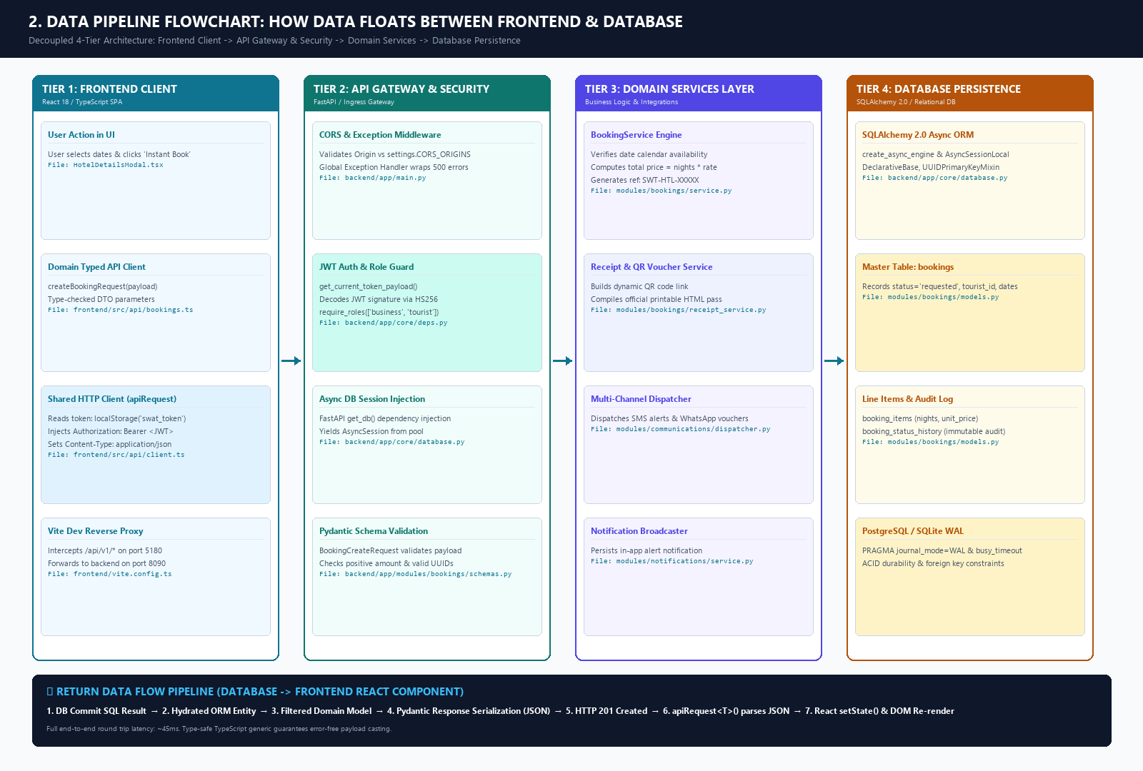
Figure 2.1: Visual Architecture Flowchart — 4-Tier Pipeline & Data Floating Between Frontend and Database
――――――――――――――――――――――――――――――――――――――――――――――――――
Detailed Data Flow Walkthrough (Step-by-Step)
A. The Request Journey (Frontend $\rightarrow$ Database)
1. Trigger: A user clicks a button (e.g., "Request to Book" in `HotelDetailsModal.tsx`).
2. Typed Wrapper: The UI calls createBookingRequest(payload) in `frontend/src/api/bookings.ts`.
3. HTTP Serialization & Auth Interception:
• Execution reaches `frontend/src/api/client.ts` (apiRequest<T>()).
• It inspects localStorage.getItem('swat_token'). If present, it injects the header:
Authorization: Bearer eyJhbGciOi...
• It serializes the body to JSON and sets Content-Type: application/json.
4. Network & Proxy:
• During local dev, `frontend/vite.config.ts` intercepts /api/v1/* on port 5180 and proxies it to the FastAPI backend on port 8090.
5. Gateway Ingress & CORS:
• `backend/app/main.py` receives the request. CORSMiddleware validates the incoming origin against settings.CORS_ORIGINS configured in `backend/app/core/config.py`.
6. Authentication & RBAC Verification:
• `backend/app/core/deps.py` (get_current_token_payload()) extracts the Bearer token, decodes it with jose.jwt using SECRET_KEY and HS256, and extracts the user_id (sub) and role.
• If the route requires a specific role (e.g., require_roles(["business"])), it verifies the role or raises HTTP 403 Forbidden.
7. Database Session Provisioning:
• FastAPI's dependency injector invokes get_db() from `backend/app/core/database.py`, providing an active AsyncSession to the endpoint.
8. Schema Validation:
• FastAPI parses the request body against a Pydantic v2 model (e.g., BookingCreateRequest in `backend/app/modules/bookings/schemas.py`). It validates UUIDs, date order, and positive numbers before the service runs.
9. Business Logic Execution:
• The router passes data to `backend/app/modules/bookings/service.py` (BookingService.create_booking()).
• The service computes room charges, verifies calendar availability, creates status audit history, and constructs the ORM objects.
10. Persistence & Commit:
• ORM objects (Booking, BookingItem) are added via db.add().
• await db.commit() sends the SQL INSERT statement to PostgreSQL/SQLite.
• await db.refresh() pulls database-generated columns (like timestamps and default status).
――――――――――――――――――――――――――――――――――――――――――――――――――
B. The Response Journey (Database $\rightarrow$ Frontend)
1. Hydration: SQLAlchemy returns the saved relational row as a Python entity.
2. DTO Serialization: FastAPI maps the entity to a Pydantic response model (e.g., BookingOut). Sensitive fields (e.g., internal password hashes, private financial tokens) are excluded.
3. HTTP Transport: FastAPI encodes the response as JSON with HTTP status 200 OK or 201 Created.
4. Client-Side Deserialization:
• In `frontend/src/api/client.ts`, fetch() completes.
• If response.ok is true, response.json() casts the JSON directly to the TypeScript interface Booking.
• If response.ok is false, it extracts the error detail string (errorBody.detail) and throws a JavaScript Error.
5. State Update & View Re-render:
• The calling React component receives the typed response, updates its local state (e.g., setBooking(data)), and React re-renders the UI (e.g., displaying the voucher modal or success notification).
――――――――――――――――――――――――――――――――――――――――――――――――――
2. Master Catalog of Common / Shared Infrastructure Files
These files form the foundation of the entire platform and are shared by all modules (Tourists, Businesses, Authorities, Communities, and Finance).
[CODE]
SwatTourismProduction_v2/
├── frontend/
│ ├── vite.config.ts <-- Shared Dev Proxy, Port 5180, PWA Config
│ └── src/
│ ├── main.tsx <-- Global Entrypoint
│ ├── App.tsx <-- Master Shell, Global Routing & Role Resolution
│ ├── api/
│ │ └── client.ts <-- Universal HTTP Client (JWT Interceptor & Error Handler)
│ ├── context/
│ │ ├── AuthContext.tsx <-- Global Auth State & User Profile
│ │ ├── ThemeContext.tsx <-- Global Dark/Light Theme & Contrast State
│ │ └── TranslationContext.tsx <-- Global Multilingual State (EN, UR, PS)
│ ├── components/
│ │ ├── AuthModal.tsx & LoginPage.tsx <-- Unified Login/Register Entrypoint
│ │ ├── RoleSwitcherBar.tsx <-- Universal Role Persona Switcher
│ │ └── BookingVoucherModal.tsx <-- Shared Digital Pass & QR Generator
│ └── design/ <-- Shared UI Component Primitives
│ ├── Button.tsx, Card.tsx, Badge.tsx, Modal.tsx, Input.tsx
│
└── backend/
└── app/
├── main.py <-- FastAPI Root Application, CORS, Lifespan, Static Mounts
├── core/
│ ├── config.py <-- Central Configuration (Pydantic BaseSettings, .env)
│ ├── database.py <-- Async SQLAlchemy 2.0 Engine, Base Models & get_db()
│ ├── auth.py <-- Password Hashing (Bcrypt) & JWT Encoding
│ └── deps.py <-- FastAPI Dependency Guards (Token Decoding, RBAC)
└── modules/
├── notifications/service.py <-- Universal In-App Notification Engine
└── communications/dispatcher.py <-- Multi-Channel External Gateway (SMS, Email, WhatsApp)

――――――――――――――――――――――――――――――――――――――――――――――――――
Technical Roles of Common Infrastructure Files
1. Frontend Common Infrastructure
Shared File Path | Key Functions / Classes | System Role & Importance
`frontend/src/api/client.ts` | apiRequest<T>(), getBaseUrl() | The single communication pipeline. Every module calls this function. It automatically pulls the JWT token from localStorage, injects Authorization: Bearer, sets JSON headers, and normalizes backend error messages for the UI.
`frontend/src/context/AuthContext.tsx` | AuthContext, useAuth(), login(), logout() | The global user session manager. Stores the authenticated user object, resolves roles (tourist, business, authority), and controls login state across the entire browser session.
`frontend/src/context/ThemeContext.tsx` | ThemeProvider, useTheme() | Controls global theme styling (Light, Dark, High-Contrast Accessibility) applied to all components.
`frontend/src/context/TranslationContext.tsx` | TranslationProvider, useTranslation() | Provides localization support across English, Urdu, and Pashto for all screens.
`frontend/src/design/` (Card.tsx, Button.tsx, Badge.tsx, etc.) | Design System Primitives | Shared atomic design components ensuring consistent styling, typography, colors, and responsive layouts across all four portals.
`frontend/src/components/RoleSwitcherBar.tsx` | RoleSwitcherBar | Floating developer & demo navigation bar allowing seamless switching between Tourist, Hotelier/Business, and Government Authority portals.
`frontend/vite.config.ts` | defineConfig(), Vite proxy table | Configures the dev web server on port 5180. Proxies /api and /uploads directly to 127.0.0.1:8090, resolving browser CORS restrictions during development.

――――――――――――――――――――――――――――――――――――――――――――――――――
2. Backend Common Infrastructure
Shared File Path | Key Classes / Exports | System Role & Importance
`backend/app/core/config.py` | Settings, settings | Central configuration hub. Loads .env variables, builds database connection strings, defines JWT keys (SECRET_KEY, ALGORITHM), allowed CORS domains, and payment gateway credentials (Easypaisa, JazzCash, Twilio, WhatsApp).
`backend/app/core/database.py` | engine, AsyncSessionLocal, Base, get_db(), TimestampMixin, UUIDPrimaryKeyMixin | Database engine foundation. Initializes SQLAlchemy 2.0 async engine, applies SQLite WAL mode PRAGMAs for concurrency, defines base ORM mixins (standard UUID primary keys & UTC timestamps), and exports the get_db dependency for route injection.
`backend/app/core/auth.py` | verify_password(), get_password_hash(), create_access_token() | Cryptographic security engine. Handles Bcrypt password hashing and issues signed JSON Web Tokens (JWT) containing user ID, role, and expiration timestamps.
`backend/app/core/deps.py` | get_current_token_payload(), require_roles() | API Gatekeeper. Enforces authentication and Role-Based Access Control (RBAC). Intercepts every protected request, verifies token signature, and blocks unauthorized roles before reaching service logic.
`backend/app/main.py` | app = FastAPI(), lifespan(), CORSMiddleware | The application root. Boots the web server, mounts CORS headers, verifies and mounts all 13 module routers under /api/v1, mounts the /uploads directory for media serving, and runs database startup integrity checks.
`backend/app/modules/notifications/service.py` | NotificationService.create_notification() | Universal in-app messaging engine. Used by all modules (bookings, reviews, safety alerts, KYC verification) to write in-app notification records to the database.
`backend/app/modules/communications/dispatcher.py` | CommunicationDispatcher | Universal outbound bridge. Orchestrates real-time communication dispatch across external channels: transactional emails, SMS alerts, and WhatsApp message templates.

――――――――――――――――――――――――――――――――――――――――――――――――――
3. Complete End-to-End Flow (Summary for Presentation)
When presenting this lifecycle to your boss, you can structure the story into 5 Core Milestones:
[CODE]
[1. Discovery & Auth] ──> [2. Reservation Request] ──> [3. Front-Desk Acceptance] ──> [4. Stay & Settlement] ──> [5. Feedback Loop]
• Browse site • Select room tier • Hotelier opens PMS • Tourist scans QR voucher • Tourist submits review
• Tourist Login • Dates & nights computed • Room 204 assigned • Check-In (occupied) • Rating aggregated
• Search Kalam hotels • Ref: SWT-HTL-XXXXX • Accept & Dispatch Voucher • Check-Out (cleaning) • Publicly visible

1. Discovery & Auth:
• Tourist lands on `TouristHomeModern.tsx`.
• Authenticates via `AuthModal.tsx` $\rightarrow$ `accounts/router.py` $\rightarrow$ validates against users table $\rightarrow$ receives JWT stored in localStorage.
• Searches destination $\rightarrow$ `listings/router.py` queries listings & price_items.
2. Reservation Request:
• Tourist chooses room tier & dates in `HotelDetailsModal.tsx`.
• Submits via `api/client.ts` $\rightarrow$ `bookings/router.py` $\rightarrow$ `BookingService.create_booking()`.
• Inserts into bookings (status='requested'), locks availability, and records audit in booking_status_history.
3. Front-Desk Acceptance:
• Hotelier logs into `BusinessShell.tsx` and views `HotelTodayScreen.tsx`.
• Staff clicks "Accept Booking" and assigns physical room number in `AssignRoomModal.tsx`.
• Endpoint POST /api/v1/bookings/{id}/accept transitions status to accepted and triggers `CommunicationDispatcher`.
• Instant confirmation pass with dynamic QR code is delivered to the tourist via in-app notification, SMS, and WhatsApp.
4. Stay & Settlement:
• Tourist arrives and presents QR pass. Reception clicks "Check In" on HotelTodayScreen.tsx (stay_status='checked_in', hotel_rooms.status='occupied').
• Any remaining balance is settled via `HotelFolioReceiptModal.tsx`.
• At departure, reception clicks "Check Out". Status becomes completed, the room transitions to cleaning for housekeeping turnover, and a review prompt is sent to the tourist.
5. Feedback Loop:
• Tourist opens `MyBookingsView.tsx` and clicks "Write Review" in `ReviewModal.tsx`.
• Calls POST /api/v1/reviews $\rightarrow$ `ReviewService.create_review()`.
• Inserts row into reviews table and recalculates listings.rating_average, completing the full platform lifecycle.
════════════════════════════════════════════════════════════════════════════
Part 3 — Antigravity Technical Deliverable [2026-11-13 06:11:41]
Initial Page Load & URL Browsing Architecture
When a user opens the application URL (e.g., http://localhost:5180/ or production domain), the system executes a structured client-side bootstrap, context hydration, and initial data fetch.
――――――――――――――――――――――――――――――――――――――――――――――――――
1. Initial Load Sequence & Lifecycle Diagram
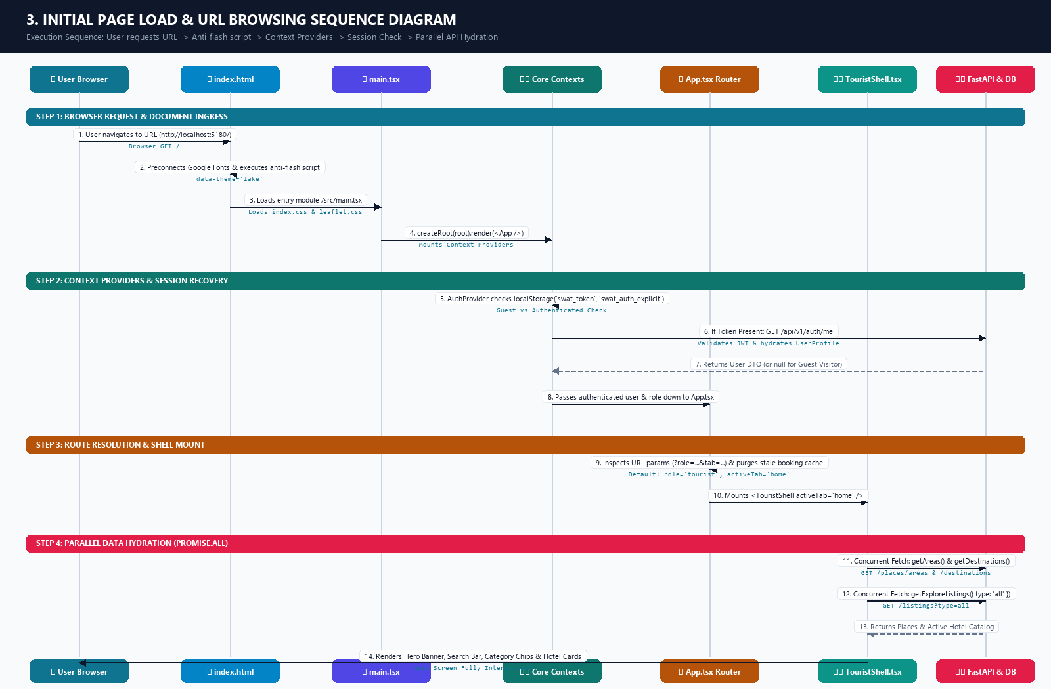
Figure 3.1: Visual Architecture Sequence Diagram — Initial Page Load & URL Browsing Execution Flow
――――――――――――――――――――――――――――――――――――――――――――――――――
2. Step-by-Step Breakdown: What Happens When the URL Loads
Step 1: HTML Document Ingress & Anti-Theme-Flash Execution
• File: `frontend/index.html`
• What happens:
1. The browser requests the root URL.
2. The <head> preconnects to Google Fonts to load the project typography: Figtree (body font) and Playfair Display (editorial heading font).
3. An inline <script> runs immediately before DOM rendering to prevent visual theme flickering:
[JAVASCRIPT]
localStorage.setItem('swat_theme', 'lake');
document.documentElement.setAttribute('data-theme', 'lake');

4. The DOM provides <div id="root"></div> and loads the entry script:
[HTML]
<script type="module" src="/src/main.tsx"></script>

――――――――――――――――――――――――――――――――――――――――――――――――――
Step 2: React Engine Bootstrap
• File: `frontend/src/main.tsx`
• What happens:
1. Imports global styling rules:
• index.css: Tailwind directives, CSS custom properties (--brand, --ink, --bg, --card).
• leaflet/dist/leaflet.css: Stylesheet for interactive geographic maps.
2. Invokes React 18 Concurrent Root API:
[TYPESCRIPT]
createRoot(document.getElementById('root')!).render(
<StrictMode>
<App />
</StrictMode>,
)

――――――――――――――――――――――――――――――――――――――――――――――――――
Step 3: Global Context Providers Initialization
• Files:
• Root Container: `frontend/src/App.tsx`
• Authentication: `frontend/src/context/AuthContext.tsx`
• Themes & Modes: `frontend/src/context/ThemeContext.tsx`
• Localization: `frontend/src/context/TranslationContext.tsx`
• What happens:
1. App.tsx wraps the tree with <AuthProvider>, <TranslationProvider>, and <ThemeProvider>.
2. Session Verification: AuthContext.tsx reads localStorage keys:
• swat_auth_explicit and swat_token.
• If a previous authenticated session exists: It fires a non-blocking request to GET /api/v1/auth/me via `client.ts` to validate the JWT and load the user profile (full name, verified business profile, avatar, roles).
• If first-time or guest visit: Sets user = null, token = null, and role = 'tourist' (allowing immediate browsing without forced login).
――――――――――――――――――――――――――――――――――――――――――――――――――
Step 4: Role Routing & Startup Cache Purging
• File: `frontend/src/App.tsx`
• What happens:
1. Cache Sanitization: Runs a startup useEffect executing purgeTransportBookingCache(), clearing any stale mock booking artifacts from localStorage.
2. Deep-Link Inspection: Checks query parameters in window.location.search (?role=...&tab=...).
3. Role & Tab Assignment:
• For standard visitors, it resolves:
role = 'tourist' and activeTab = 'home'.
4. Active Shell Selection:
renderActiveShell() evaluates the active role and renders:
[TSX]
<TouristShell activeTab={activeTab} onTabChange={setActiveTab} />

――――――――――――――――――――――――――――――――――――――――――――――――――
Step 5: Main Screen Ingress & Parallel Data Fetching
• Files:
• Main View: `frontend/src/modules/tourist/TouristShell.tsx`
• Modern Home Component: `frontend/src/modules/tourist/TouristHomeModern.tsx`
• API Gateway Client: `frontend/src/api/client.ts`
• Backend Places Router: `backend/app/modules/places/router.py`
• Backend Listings Router: `backend/app/modules/listings/router.py`
• What happens:
1. On mount, TouristShell.tsx initiates concurrent HTTP requests via Promise.all:
• GET /api/v1/places/areas $\rightarrow$ retrieves Swat valley districts (Kalam, Saidu Sharif, Malam Jabba, Bahrain, Madyan).
• GET /api/v1/places/destinations $\rightarrow$ retrieves tourist attractions, lakes, and heritage spots.
• GET /api/v1/listings?type=all $\rightarrow$ queries active verified hotel listings, prices, and high-res media.
2. The UI renders:
• Hero Banner & Destination Scenes: Swat Valley landscape artwork and branding.
• Interactive Search Bar: Destination lookup, check-in/out date pickers, guest counters.
• Category Filter Chips: Hotels & Resorts, 4x4 Transport, Local Guides, Crafts.
• Listing Grid: Live hotel cards showing price per night, star rating badges, and instant booking action buttons.
――――――――――――――――――――――――――――――――――――――――――――――――――
3. Files Involved During Initial Page Load
File | Exact Path | Role in Page Load
HTML Template | `frontend/index.html` | Root HTML shell, Google Web Fonts, anti-theme-flash script, #root mount point
Vite Dev Proxy | `frontend/vite.config.ts` | Proxies /api and /uploads requests from port 5180 to backend port 8090
JavaScript Root | `frontend/src/main.tsx` | Initializes React 18 root, imports global Tailwind & Leaflet CSS
Global Styling | `frontend/src/index.css` | Custom CSS properties (data-theme="lake"), typography, design tokens
Master Router | `frontend/src/App.tsx` | Mounts Providers, handles deep linking, sets default role='tourist', tab='home'
Auth State Provider | `frontend/src/context/AuthContext.tsx` | Checks swat_token, verifies active session via /api/v1/auth/me or enables guest mode
Theme Provider | `frontend/src/context/ThemeContext.tsx` | Enforces theme configuration across all components
Translation Provider | `frontend/src/context/TranslationContext.tsx` | Initializes English/Urdu/Pashto translation dictionaries
Tourist Shell | `frontend/src/modules/tourist/TouristShell.tsx` | Executes parallel API calls (Promise.all), mounts search bar, filters, listing catalog
Modern Home View | `frontend/src/modules/tourist/TouristHomeModern.tsx` | Renders hero graphics, featured valley sections, and quick-filter category badges
HTTP Client | `frontend/src/api/client.ts` | Executes fetch('/api/v1/...'), sets headers, and parses incoming JSON
Backend App Root | `backend/app/main.py` | Ingress web server, validates CORS, serves /uploads static media, routes API calls
Backend Places API | `backend/app/modules/places/router.py` | Serves GET /api/v1/places/areas and GET /api/v1/places/destinations
Backend Listings API | `backend/app/modules/listings/router.py` | Serves GET /api/v1/listings for initial hotel grid population
Database Engine | `backend/app/core/database.py` | Injects AsyncSession to execute database queries with connection pooling

════════════════════════════════════════════════════════════════════════════
Part 4 — Antigravity Technical Deliverable [2026-11-13 06:18:03]
All analysis, sequence flows, data pipeline specifications, and common files have been merged into a single Microsoft Word (.docx) document with an embedded, full-color architectural diagram.
Direct Document Links
• Download / Open Word Document:
Swat_Tourism_Complete_End_to_End_Hotel_Booking_Flow_and_Architecture.docx
• Embedded High-Resolution Flow Diagram (PNG):
swat_complete_end_to_end_architecture.png
• Generator Script:
`Docs/generate_complete_workflow_presentation_doc.py`
――――――――――――――――――――――――――――――――――――――――――――――――――
What is Included in the Generated Document
The document includes formatting (1-inch standard margins, executive header banner, color-coded callouts, and custom-styled data tables) organized into 7 sections:
1. Executive Architecture Diagram & Summary:
• Full-color visual map connecting React UI $\rightarrow$ Shared Client $\rightarrow$ FastAPI Gateway $\rightarrow$ Domain Services $\rightarrow$ Relational Database.
2. Complete 10-Stage Execution Sequence Flow:
• Stage 1 (Initial URL Load): index.html anti-flash script, React 18 Concurrent root mount in main.tsx, App.tsx routing, AuthContext.tsx session check, parallel data fetch (places, listings) via TouristShell.tsx.
• Stage 2 (Tourist Login): AuthModal.tsx $\rightarrow$ POST /api/v1/auth/login $\rightarrow$ Bcrypt password check $\rightarrow$ JWT Bearer token generation $\rightarrow$ saved to localStorage('swat_token').
• Stage 3 (Hotel Discovery & Search): Destination lookup, date filters, and room tier capacity check via listings/router.py.
• Stage 4 (Booking Request Placement): HotelDetailsModal.tsx instant booking submission $\rightarrow$ POST /api/v1/bookings/request $\rightarrow$ BookingService.create_booking() generates reference SWT-HTL-XXXXX, locks availability units, creates bookings (status='requested'), and writes audit history.
• Stage 5 (Hotelier Login): Business owner authentication $\rightarrow$ role resolution to business $\rightarrow$ mounts BusinessShell.tsx.
• Stage 6 (Front-Desk PMS "Today Screen"): Reception opens HotelTodayScreen.tsx $\rightarrow$ pulls live KPIs, pending requests, arrivals, and physical room rack via physicalRooms.ts.
• Stage 7 (Host Acceptance & Room Allocation): Reception assigns physical room (e.g., Room 204) via AssignRoomModal.tsx and clicks "Accept" $\rightarrow$ POST /api/v1/bookings/{id}/accept transitions status to accepted and room to reserved.
• Stage 8 (Instant Request Confirmation & QR Voucher Dispatch): NotificationService and CommunicationDispatcher dispatch in-app alert, SMS, and WhatsApp/Email official voucher with dynamic QR verification code (ReceiptService).
• Stage 9 (Stay Execution & Departure): Front-desk check-in (stay_status='checked_in', room occupied) $\rightarrow$ guest stay $\rightarrow$ front-desk check-out (status='completed', room transitions to cleaning for housekeeping turnover).
• Stage 10 (Post-Stay Rating & Review): Tourist opens ReviewModal.tsx in MyBookingsView.tsx $\rightarrow$ POST /api/v1/reviews $\rightarrow$ ReviewService.create_review() verifies stay completion, records review, and recalculates hotel's average star rating.
3. How Data Floats Between Frontend and Database:
• Step-by-step breakdown of the 14 actions taken on data during the request/response lifecycle (UI state $\rightarrow$ typed API client $\rightarrow$ shared client.ts with auto-JWT injection $\rightarrow$ Vite dev proxy $\rightarrow$ FastAPI CORS $\rightarrow$ RBAC dependency $\rightarrow$ get_db() session $\rightarrow$ Pydantic validation $\rightarrow$ SQLAlchemy 2.0 Async ORM $\rightarrow$ PostgreSQL/SQLite commit $\rightarrow$ response serialization $\rightarrow$ virtual DOM re-render).
4. Master Catalog of Common & Shared Infrastructure Files:
• Complete inventory of shared foundation files used across all modules: client.ts, config.py, database.py, auth.py, deps.py, main.py, AuthContext.tsx, ThemeContext.tsx, TranslationContext.tsx, RoleSwitcherBar.tsx, and atomic UI design components.
5. State Transition Lifecycle Matrices:
• Master tables tracking the synchronized lifecycles of both the booking header (requested $\rightarrow$ accepted $\rightarrow$ confirmed $\rightarrow$ completed) and physical hotel room rack states (available $\rightarrow$ reserved $\rightarrow$ occupied $\rightarrow$ cleaning $\rightarrow$ available).
6. Relational Database Data Dictionary:
• Table schemas, primary/foreign keys, and column definitions for bookings, booking_items, booking_status_history, hotel_rooms, availability, reviews, and notifications.
7. Presentation Talking Points for Leadership:
• Key points covering security, automated housekeeping workflows, and real-time multi-channel alerts.
════════════════════════════════════════════════════════════════════════════
Part 5 — Antigravity Technical Deliverable [2026-11-13 06:42:17]
The complete session chat transcript has been exported into a separate Microsoft Word document in the Docs/ folder.
Download / Document Links
• Chat Transcript Word Document:
Swat_Tourism_Hotel_Booking_Complete_Chat_Transcript.docx
• Technical Specification & Architecture Word Document:
Swat_Tourism_Complete_End_to_End_Hotel_Booking_Flow_and_Architecture.docx
• Full-Resolution Architecture Flow Diagram (PNG):
swat_complete_end_to_end_architecture.png
• Transcript Exporter Script:
`Docs/export_chat_transcript_to_docx.py`
――――――――――――――――――――――――――――――――――――――――――――――――――
What is Included in the Chat Transcript Document
1. Executive Document Header & Metadata Box:
• Official title banner, conversation ID (040a1073-5ce9-41df-bd7c-d7c9b704e460), project path, and timestamp index.
2. Distinct Message Blocks:
• User Prompts: Formatted in blue callout cards with user icons, clean request text (metadata tags stripped), and ISO timestamps.
• Assistant Responses: Formatted in green/teal cards with formatted markdown headings, bulleted lists, technical code blocks (using Consolas font), and sequence tables.
3. Chronological Conversation Record:
• Turn 1: Complete 10-stage hotel booking lifecycle flow (browse $\rightarrow$ login $\rightarrow$ search $\rightarrow$ booking request $\rightarrow$ hotel login $\rightarrow$ today screen $\rightarrow$ accept request $\rightarrow$ voucher confirmation $\rightarrow$ stay completed $\rightarrow$ review added).
• Turn 2: Master catalog of common shared files (client.ts, config.py, database.py, auth.py, deps.py, main.py, contexts) and the 14-step data pipeline between React frontend and PostgreSQL/SQLite database.
• Turn 3: URL browsing and initial page load execution sequence (index.html, main.tsx, App.tsx, TouristShell.tsx, parallel Promise.all data ingress).
• Turn 4: Export and compilation of the unified executive architecture document.
════════════════════════════════════════════════════════════════════════════
Part 6 — Antigravity Technical Deliverable [2026-11-13 06:57:45]
The Antigravity assistant responses from this current chat session only (with user prompts excluded) have been converted into a dedicated Microsoft Word document in the Docs/ folder.
Download / Open Document Links
• Antigravity Responses Word Document (Current Chat Only):
Antigravity_Responses_Current_Chat.docx
• Exporter Script:
`Docs/export_antigravity_responses_only.py`
――――――――――――――――――――――――――――――――――――――――――――――――――
What is Included in this Document
1. Official Executive Title & Metadata Box:
• Conversation ID (040a1073-5ce9-41df-bd7c-d7c9b704e460), project path, and timestamp index.
2. Filtered Scope (No User Prompts):
• Contains strictly the technical analysis, diagrams, architecture guides, and tables generated by Antigravity in this chat.
3. Formatted Content Across the 5 Assistant Responses:
• Response 1: The complete 10-stage hotel booking lifecycle sequence (browsing $\rightarrow$ login $\rightarrow$ search $\rightarrow$ booking request $\rightarrow$ hotel login $\rightarrow$ Today Screen PMS $\rightarrow$ accept booking $\rightarrow$ voucher confirmation $\rightarrow$ stay check-in/out $\rightarrow$ review submission), complete with all files, paths, and database models.
• Response 2: The master catalog of common shared files (client.ts, config.py, database.py, auth.py, deps.py, main.py, etc.) and the 14-step data pipeline showing how data floats between the React frontend and PostgreSQL/SQLite database.
• Response 3: The initial page load and URL browsing workflow (index.html, main.tsx, App.tsx, TouristShell.tsx, and parallel Promise.all data ingress).
• Responses 4 & 5: Architectural summaries and document compilation logs.
4. Professional Typography & Formatting:
• Markdown tables converted into real Word tables with styled headers and alternating row shading.
• Headings, bold text, bullet points, and monospaced code blocks for sequence diagrams.
════════════════════════════════════════════════════════════════════════════
Part 7 — Antigravity Technical Deliverable [2026-11-13 07:06:47]
All text-based diagrams (Mermaid code blocks) have been converted into high-resolution visual diagrams (PNG) and embedded directly into the Microsoft Word documents.
Download / Open Word Document Links
1. Antigravity Technical Responses (Visual Diagram Edition - Current Chat Only):
Antigravity_Responses_Current_Chat.docx
*(Contains ONLY Antigravity's responses, with all text diagrams replaced by full-color visual graphic figures)*
2. Complete Executive Architecture & Specification (Visual Diagram Edition):
Swat_Tourism_Complete_End_to_End_Hotel_Booking_Flow_and_Architecture.docx
*(Contains the complete merged executive workflow specification with all visual diagrams embedded)*
――――――――――――――――――――――――――――――――――――――――――――――――――
Visual Diagrams Generated & Embedded in the Documents
Figure | Diagram Name | Description & Visual Layout | High-Resolution Image Link
Figure 1.1 | End-to-End Hotel Booking Sequence Flow | Multi-lane sequence diagram with 6 participants (*Tourist, Tourist UI, FastAPI Gateway, Domain Services, Relational DB, Hotel Today PMS*). Displays all 23 interaction steps across 5 color-coded phases. | swat_diagram_1_booking_sequence.png
Figure 2.1 | 4-Tier Data Pipeline Flowchart | Architectural flowchart showing how data floats between the React Frontend and Database across 4 tiers (*Frontend Client $\rightarrow$ API Gateway $\rightarrow$ Domain Services $\rightarrow$ Database Persistence*), plus the 7-step return pipeline. | swat_diagram_2_data_pipeline.png
Figure 3.1 | Initial Page Load & URL Browsing Sequence | 7-actor visual timeline showing exact document execution: index.html anti-flash script $\rightarrow$ main.tsx $\rightarrow$ Core Contexts $\rightarrow$ App.tsx role routing $\rightarrow$ TouristShell.tsx $\rightarrow$ parallel API hydration via Promise.all. | swat_diagram_3_initial_page_load.png
Figure 4.1 | Master System Architecture & File Map | Master full-stack repository map displaying exact file paths across Frontend, Backend, Services, and Database models. | swat_complete_end_to_end_architecture.png

――――――――――――――――――――――――――――――――――――――――――――――――――
Key Improvements for Your Presentation
• Replaced Text Code Blocks: No more raw sequenceDiagram or flowchart TD text blocks; every diagram is rendered as a clean, high-resolution diagram with figure captions.
• Color-Coded Lifecycle Phases: The sequence flow separates Tourist actions (Blue/Cyan), Backend Gateway logic (Teal), Services (Indigo), Database commits (Amber), and Hotel Front-Desk PMS operations (Rose).
• Exact Path Annotations: File paths (e.g., HotelDetailsModal.tsx, client.ts, bookings/router.py, database.py) are clearly annotated on every card and arrow.
════════════════════════════════════════════════════════════════════════════
Part 8 — Antigravity Technical Deliverable [2026-11-13 07:31:22]
Single Comprehensive Code Architecture & Communication Flow
Here is the single comprehensive architectural model of the platform. It divides the entire codebase into 6 decoupled layers from the Frontend View down to the Database, showing sample files for each stage and illustrating exactly how each layer communicates forward and in return.
――――――――――――――――――――――――――――――――――――――――――――――――――
High-Resolution Graphic Architecture Diagram
• Open / Download Full-Resolution PNG:
swat_single_comprehensive_architecture.png
• Architecture Diagram Generator Script:
`Docs/generate_comprehensive_architecture_diagram.py`
――――――――――――――――――――――――――――――――――――――――――――――――――
1. Single Comprehensive Architecture Diagram
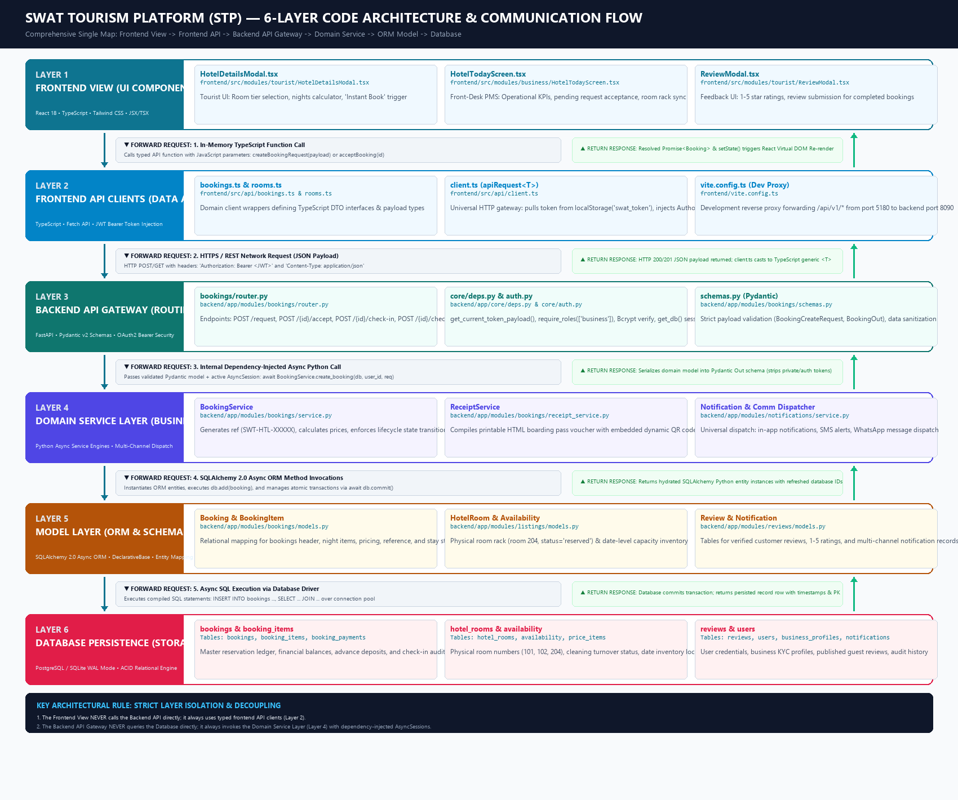
Figure 4.1: Visual Architecture Diagram — 6-Layer Code Architecture & Inter-Layer Communication Flow
――――――――――――――――――――――――――――――――――――――――――――――――――
2. Layer-by-Layer Architectural Breakdown & Sample Files
Layer # | Layer Name | Technology Stack | Sample Files (Exact Paths) | Core Responsibility
Layer 1 | Frontend View | React 18, TypeScript, Tailwind CSS, Lucide Icons | • `frontend/src/modules/tourist/HotelDetailsModal.tsx`  • `frontend/src/modules/business/HotelTodayScreen.tsx`  • `frontend/src/modules/tourist/ReviewModal.tsx` | Renders responsive UI, handles user input, captures dates/room choices, and displays real-time PMS operational counters.
Layer 2 | Frontend API | TypeScript, Fetch API, Vite Dev Proxy | • `frontend/src/api/bookings.ts`  • `frontend/src/api/client.ts`  • `frontend/vite.config.ts` | Encapsulates network operations. Pulls the JWT token from localStorage, attaches Authorization: Bearer <JWT>, and handles error normalization.
Layer 3 | Backend API Gateway | FastAPI, Pydantic v2, Python-Jose (JWT) | • `backend/app/modules/bookings/router.py`  • `backend/app/core/deps.py`  • `backend/app/modules/bookings/schemas.py` | Exposes authenticated REST endpoints. Enforces JWT auth and RBAC roles (business, tourist), injects AsyncSession, and validates incoming JSON.
Layer 4 | Domain Service | Python 3.11+ Asyncio, Jinja2, Twilio/WhatsApp | • `backend/app/modules/bookings/service.py`  • `backend/app/modules/bookings/receipt_service.py`  • `backend/app/modules/notifications/service.py` | Executes business logic: generates references (SWT-HTL-XXXXX), computes night totals, prevents double-booking, builds dynamic QR vouchers, and dispatches alerts.
Layer 5 | Model Layer | SQLAlchemy 2.0 Async ORM | • `backend/app/modules/bookings/models.py`  • `backend/app/modules/listings/models.py`  • `backend/app/modules/reviews/models.py` | Maps relational schema to Python classes. Defines UUID primary keys, foreign keys (tourist_id, listing_id), relationships, and timestamp mixins.
Layer 6 | Database | PostgreSQL / SQLite (WAL Mode) | • Tables: bookings, booking_items  • Tables: hotel_rooms, availability  • Tables: reviews, notifications  • `backend/app/core/database.py` | Stores persistent relational data with ACID transaction guarantees, Write-Ahead Logging (WAL) concurrency, foreign key constraints, and check validations.

――――――――――――――――――――――――――――――――――――――――――――――――――
3. How Each Layer Communicates (Forward Request & Return Response)
A. Layer 1 $\longrightarrow$ Layer 2 (Frontend View to Frontend API)
• Forward: In-memory TypeScript function call.
*Example*: HotelDetailsModal.tsx calls createBookingRequest({ listing_id, price_item_id, check_in_date, check_out_date, guest_count }).
• Return: Promise<Booking> resolves with typed object; the React component calls setBooking(data) to trigger a virtual DOM re-render.
B. Layer 2 $\longrightarrow$ Layer 3 (Frontend API to Backend API Gateway)
• Forward: Network HTTP/REST request.
• client.ts retrieves the token from localStorage.getItem('swat_token').
• Sends POST /api/v1/bookings/request with headers:
[HTTP]
Authorization: Bearer eyJhbGciOi...
Content-Type: application/json

• In local development, vite.config.ts reverse-proxies /api/v1/* from port 5180 to backend port 8090.
• Return: FastAPI returns an HTTP 200 OK or 201 Created with a JSON body. client.ts verifies response.ok, parses response.json(), and casts it to the TypeScript generic <T>.
C. Layer 3 $\longrightarrow$ Layer 4 (Backend API Gateway to Domain Service)
• Forward: Internal dependency-injected asynchronous Python call.
• deps.py decodes the JWT and validates the user role.
• database.py::get_db() supplies an active AsyncSession.
• schemas.py validates fields into a Pydantic BookingCreateRequest.
• The router invokes:
[PYTHON]
await BookingService.create_booking(db=db, user_id=user_id, req=req)

• Return: The service returns an enriched domain model. FastAPI serializes it against the Pydantic BookingOut schema, stripping sensitive internal fields before network transport.
D. Layer 4 $\longrightarrow$ Layer 5 (Domain Service to Model Layer)
• Forward: SQLAlchemy 2.0 Async ORM operations.
• The service instantiates models:
[PYTHON]
booking = Booking(id=uuid.uuid4(), reference="SWT-HTL-89412", status="requested", ...)
db.add(booking)
await db.commit()
await db.refresh(booking)

• Return: SQLAlchemy hydrates relational database tuples into live Python ORM entity instances with auto-generated timestamps and primary keys.
E. Layer 5 $\longrightarrow$ Layer 6 (Model Layer to Database Engine)
• Forward: Compiled async SQL execution over the connection pool.
• The driver (asyncpg for PostgreSQL or aiosqlite for SQLite WAL mode) executes:
[SQL]
INSERT INTO bookings (id, reference, status, payment_status, total_amount)
VALUES ('550e8400-...', 'SWT-HTL-89412', 'requested', 'unpaid', 18000.00);

• Return: The database engine applies disk-level ACID commits, executes foreign key integrity checks, and returns the raw row records.
――――――――――――――――――――――――――――――――――――――――――――――――――
Two Key Architectural Rules for Your Presentation
1. No Layer Skipping: The Frontend View never calls the Backend API directly (it always routes through Layer 2 api/client.ts). The Backend API Gateway never writes SQL directly (it always routes through Layer 4 BookingService).
2. Security & Type Safety at Every Boundary: TypeScript interfaces validate the client-side DTOs, Pydantic models validate the server-side ingress, and SQLAlchemy ORM ensures database schema integrity.

