Swat Tourism Platform (STP)
6-Layer Code Architecture & Inter-Layer Communication Specification
Attribute | Details
System Domain | Decoupled 6-Tier Hospitality Architecture & Inter-Process Communication
Layer Structure | Frontend View -> Frontend API -> Backend Gateway -> Domain Service -> ORM Model -> Database
Workspace Root Path | f:\Antigravity\SwatTourismProduction_v2
Embedded Diagram | swat_single_comprehensive_architecture.png (Full Visual Diagram Format)
Document Output | Docs\Swat_Tourism_6_Layer_Code_Architecture_and_Communication_Flow.docx
Target Audience | Executive Presentation for Boss / Leadership Review & Full-Stack Developers

📌 Executive Summary: Decoupled 6-Layer Architecture
This specification presents the single comprehensive architectural model of the platform. The codebase is partitioned into 6 distinct, decoupled layers. Each layer has strict responsibilities, well-defined sample files, and explicit communication boundaries that prevent tight coupling, ensure transactional integrity, and maintain type safety across the entire application stack.

1. Single Comprehensive 6-Layer Architecture Diagram
Figure 1.1 illustrates the single comprehensive map of all 6 layers, showcasing sample files for each layer, downward forward request communication mechanisms, and upward return response pipelines:
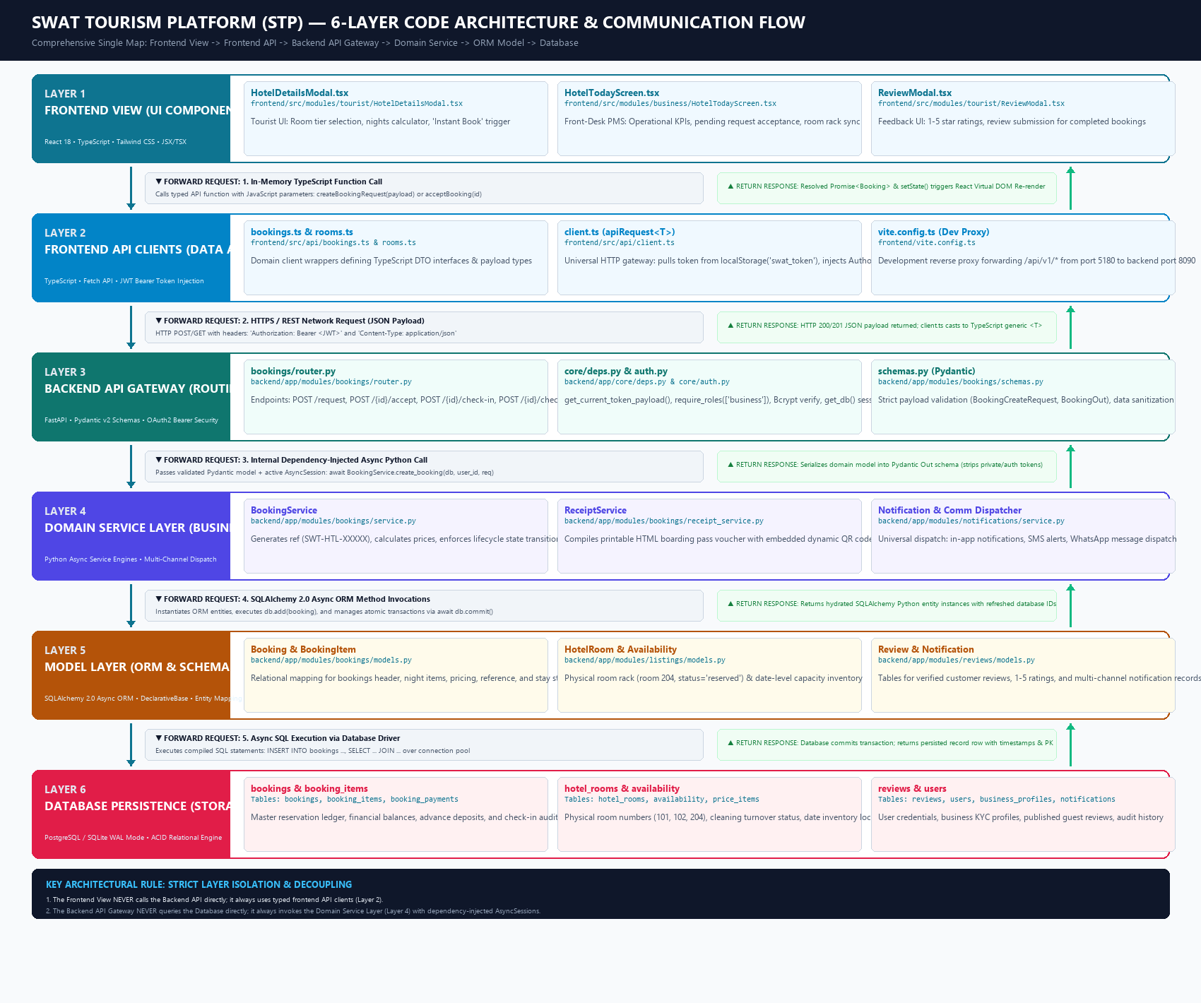
Figure 1.1: Single Comprehensive 6-Layer Code Architecture & Inter-Layer Communication Flow

2. Layer-by-Layer Breakdown & Sample Files Index
Layer # & Name | Core Technology | Sample Files (Exact Paths) | Primary System Task
Layer 1:  Frontend View | React 18  TypeScript  Tailwind CSS  JSX/TSX | • frontend/src/modules/tourist/HotelDetailsModal.tsx  • frontend/src/modules/business/HotelTodayScreen.tsx  • frontend/src/modules/tourist/ReviewModal.tsx | Presents UI, captures user input, calculates nights, displays room rack matrix, triggers instant bookings, and renders reviews.
Layer 2:  Frontend API | TypeScript  Fetch API  Vite Dev Proxy | • frontend/src/api/bookings.ts & rooms.ts  • frontend/src/api/client.ts (apiRequest)  • frontend/vite.config.ts (Port 5180 -> 8090) | Encapsulates network operations. Pulls token from localStorage('swat_token'), injects Authorization: Bearer <JWT>, normalizes errors.
Layer 3:  Backend Gateway | FastAPI  Pydantic v2  Python-Jose (JWT) | • backend/app/modules/bookings/router.py  • backend/app/core/deps.py & core/auth.py  • backend/app/modules/bookings/schemas.py | Exposes REST endpoints. Enforces JWT auth and RBAC roles ('business', 'tourist'), injects AsyncSession, validates incoming JSON payloads.
Layer 4:  Domain Service | Python Asyncio  Jinja2 Templates  Twilio / WhatsApp | • backend/app/modules/bookings/service.py  • backend/app/modules/bookings/receipt_service.py  • backend/app/modules/notifications/service.py | Core business logic: generates ref (SWT-HTL-XXXXX), computes rates, locks availability, compiles HTML QR vouchers, and dispatches alerts.
Layer 5:  Model Layer | SQLAlchemy 2.0  Async ORM  DeclarativeBase | • backend/app/modules/bookings/models.py (Booking, BookingItem)  • backend/app/modules/listings/models.py (HotelRoom, Availability)  • backend/app/modules/reviews/models.py (Review) | Maps relational database schema to Python classes. Defines UUID primary keys, foreign keys (tourist_id, listing_id), and relationships.
Layer 6:  Database Engine | PostgreSQL /  SQLite WAL Mode  ACID Engine | • Tables: bookings, booking_items, booking_payments  • Tables: hotel_rooms, availability, price_items  • Tables: reviews, users, business_profiles  • backend/app/core/database.py | Stores persistent relational data with ACID transaction guarantees, Write-Ahead Logging (WAL) concurrency, foreign keys, and unique checks.

3. Detailed Inter-Layer Communication Protocol
▶ A. Layer 1 (Frontend View) → Layer 2 (Frontend API Client)
• Forward Request: In-memory synchronous TypeScript function call passing a structured JavaScript object.
Code Example: HotelDetailsModal.tsx calls createBookingRequest({ listing_id, price_item_id, check_in_date, check_out_date, guest_count }).
• Return Response: Promise<Booking> resolves with typed TypeScript generic <T>. The calling component updates state (e.g., setBooking(data)), triggering React 18 Virtual DOM re-rendering.
▶ B. Layer 2 (Frontend API Client) → Layer 3 (Backend API Gateway)
• Forward Request: Asynchronous HTTPS / REST network request.
client.ts retrieves the active JWT bearer token from localStorage.getItem('swat_token'). It sends an HTTP POST request to /api/v1/bookings/request with headers: 'Authorization: Bearer <JWT>' and 'Content-Type: application/json'. In local development, vite.config.ts reverse-proxies the request from port 5180 to backend port 8090.
• Return Response: FastAPI returns an HTTP 200/201 JSON payload. client.ts verifies response.ok, parses response.json(), and casts it to the TypeScript generic interface.
▶ C. Layer 3 (Backend API Gateway) → Layer 4 (Domain Service Layer)
• Forward Request: Internal dependency-injected asynchronous Python call.
deps.py decodes the JWT and validates the user role via require_roles(['business', 'tourist']). database.py::get_db() yields an active AsyncSession. schemas.py validates fields into a Pydantic BookingCreateRequest model. The router executes: await BookingService.create_booking(db=db, user_id=user_id, req=req).
• Return Response: The service returns an enriched domain model. FastAPI serializes it against the Pydantic BookingOut schema, stripping private fields before network transmission.
▶ D. Layer 4 (Domain Service Layer) → Layer 5 (Model Layer)
• Forward Request: SQLAlchemy 2.0 Async ORM entity instantiations and session operations.
The service engine initializes the model (booking = Booking(id=uuid.uuid4(), reference='SWT-HTL-89412', status='requested')), adds it to the transaction (db.add(booking)), commits changes (await db.commit()), and refreshes instance state (await db.refresh(booking)).
• Return Response: SQLAlchemy hydrates relational database tuples into live Python ORM entity instances with auto-generated timestamps and primary keys.
▶ E. Layer 5 (Model Layer) → Layer 6 (Database Storage Engine)
• Forward Request: Compiled asynchronous SQL execution over connection pool.
The database driver (asyncpg for PostgreSQL or aiosqlite for SQLite WAL mode) executes: INSERT INTO bookings (id, reference, status, total_amount) VALUES ('550e8400-...', 'SWT-HTL-89412', 'requested', 18000.00).
• Return Response: The relational engine commits the transaction to disk, enforces foreign key constraints and triggers, and returns raw persisted row tuples.

4. Key Architectural Rules for Executive Presentation
📌 Two Golden Architectural Rules
1. Strict Layer Isolation (No Layer Skipping):
The Frontend View never accesses the Backend API directly; it always invokes typed functions in Layer 2 (api/client.ts). Similarly, the Backend API Gateway never executes raw SQL directly against the database; it always delegates business logic to the Domain Service Layer (Layer 4) with dependency-injected AsyncSessions.
2. End-to-End Type Safety & Data Integrity:
Data is validated at every single boundary. TypeScript interfaces guard client-side parameter contracts, Pydantic v2 schemas guard the HTTP ingress gateway, and SQLAlchemy 2.0 ORM enforces database column constraints and relational cascades.

