Swat Tourism Platform (STP)
Complete Module Inventory, Stakeholder Capability Audit & Booking Flow Gap Analysis (Search to Checkout)
Audit Dimension | Platform Details
Workspace Audited | f:\Antigravity\SwatTourismProduction_v2
Backend Architecture | 13 Domain Modules (FastAPI + SQLAlchemy 2.0 Async + SQLite WAL / PostgreSQL ready)
Frontend Architecture | 4 Role Portals (Tourist, Business, Community, Authority) + Shared API Client
Modules Covered | RBAC, User Mgmt, Tourist, Business/Hotel, Guide, Community, Transport, Restaurant, Adventures/Activities, Admin/Stakeholders, Deals & Offers + Comms/Finance/Safety/Reviews
Booking Flow Audited | End-to-End 7-Stage Pipeline: Search → Select Room → Reserve → Accept → Payment/Checkout → Room Assign → Balance/Check-Out/Review

📌 Executive Audit Summary
All core transactional loops (Hotel Booking, Room Rack PMS, Dual-Track Payments, Payment Proof Verification, Transport Fleet, Finance & Commission Invoices, Verified Reviews, and Safety/SOS) are architecturally built and persisted in the database. Remaining gaps fall into three categories: (1) Switching sandbox/mock external providers (Easypaisa, JazzCash, SMTP, Meta WhatsApp, SMS, Weather) to live production credentials; (2) Removing remaining frontend localStorage fallbacks (UserManagementView toggle/create, guest bookings/trips, community host apps); and (3) Building net-new dedicated operational consoles for Guides, Adventures, Restaurant Tables, and the Deals & Offers engine.

1. Visual Platform Modules & Booking Flow Gap Map
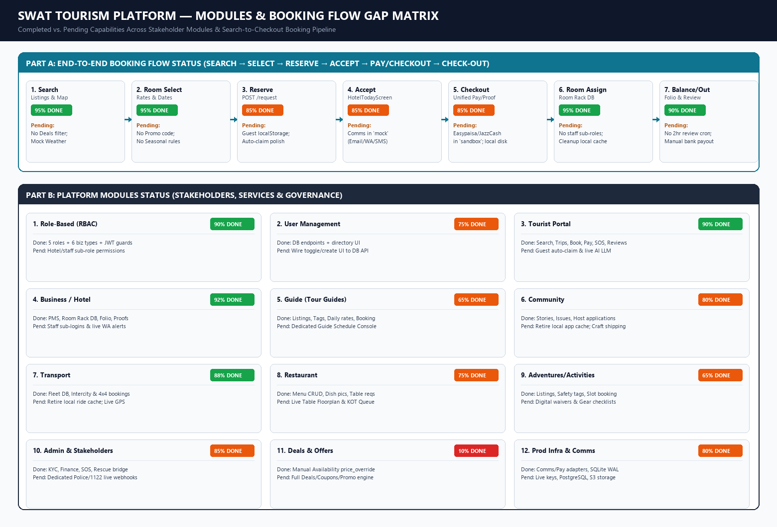
Figure 1: Platform Completion Matrix — Booking Flow (Top) and All Stakeholder Modules (Bottom)

2. End-to-End Booking Flow Gap Analysis (From Search to Book & Checkout)
The table below audits every stage of the booking pipeline from initial tourist search to final checkout, balance settlement, and review:
Stage & Files Involved | Completed Functionality (Verified in Code) | Pending To Do / Identified Gaps
Stage 1: Search & Discovery  (TouristHomeModern.tsx,  places/, listings/router.py) | • Catalog search & category filters (hotel, transport, restaurant, guides, activity).  • Interactive Leaflet MapModal & 5-day weather forecast modal.  • Verified partner badges & rating averages. | • No Deals/Promo filter tab (Deals & Offers module pending).  • Weather runs on WEATHER_PROVIDER='mock' / Open-Meteo cache.  • No live traffic ETA routing.
Stage 2: Hotel/Service Selection & Availability  (HotelDetailsModal.tsx,  AvailabilityModal.tsx,  availability table) | • Room tier selection (Standard, Deluxe, Suite) via PriceItem.  • Multi-night date picker & dynamic total calculation.  • Real-time availability calendar check & manual price_override. | • No automated seasonal/weekend dynamic pricing rules.  • No promo code/coupon discount input during room selection.
Stage 3: Instant Reservation & Request Submission  (HotelDetailsModal.tsx,  bookings/router.py,  bookings/service.py) | • Authenticated booking persists in bookings, booking_items, & booking_status_history.  • Pessimistic inventory lock increments availability.units_booked.  • Generates SWT-HTL-XXXXX ref & backend POST /bookings/claim exists. | • Unauthenticated guest bookings still save to localStorage (swat_local_bookings) instead of persisting directly in DB.  • Auto-claiming guest bookings immediately after login/signup needs full unification across all portals.
Stage 4: Hotel Notification & Acceptance  (HotelTodayScreen.tsx,  bookings/service.py,  communications/) | • Front-desk receives requests via GET /bookings/business-bookings.  • Accept/Decline actions update DB status & audit log.  • Multi-channel dispatcher (Email, WhatsApp, SMS) hooked to milestones. | • EMAIL_PROVIDER, WHATSAPP_PROVIDER, and SMS_PROVIDER default to 'mock' in core/config.py (console/audit log only).  • Need live SMTP/SendGrid, Meta WhatsApp/Twilio, & Pakistani SMS keys.
Stage 5: Unified Payment, Proof & Checkout  (UnifiedCheckoutModal.tsx,  PaymentProofUploadModal.tsx,  BookingVoucherModal.tsx) | • 3 Checkout modes: FULL_ONLINE, DEPOSIT_20, PAY_AT_HOTEL.  • Direct bank/IBFT proof upload + hotel verification inspector modal.  • Easypaisa & JazzCash HMAC-SHA256 adapters + booking_payments ledger.  • Official HTML/PDF QR Voucher pass. | • EASYPAISA_ENV and JAZZCASH_ENV are set to 'sandbox' — need live merchant keys & HTTPS IPN webhook URLs.  • Payment proof slip images save to local disk (STORAGE_BACKEND='local') instead of cloud S3.
Stage 6: Room Allocation & Check-In  (AssignRoomModal.tsx,  HotelTodayScreen.tsx,  hotel_rooms table) | • Physical room rack stored in DB (hotel_rooms): floor, wing, status.  • Assign physical room numbers (e.g. 101, 204) to bookings.  • Check-in transitions stay_status='checked_in' & room='occupied'. | • No separate reception/housekeeping staff sub-logins (shares single business owner account).  • Remove legacy localStorage sync helpers in physicalRooms.ts & HotelTodayScreen.tsx.
Stage 7: Balance Clear, Check-Out & Review  (HotelFolioReceiptModal.tsx,  collect_balance, reviews/) | • Counter balance settlement (cash, POS, direct IBFT) updates property_collected_amount & payment_status='paid'.  • Printable Folio Receipt & check-out marks room='cleaning' -> 'ready'.  • Verified post-stay reviews & isolated partner commission invoices. | • No background cron job (Celery/APScheduler) to auto-send WhatsApp/Email review prompts 2 hours post-checkout.  • Operator payouts tracked in DB without automated bank IBFT disbursement APIs.

3. All Stakeholder & Functional Modules: Completed vs. Pending
Detailed functional status across every stakeholder module, business category, administrative tool, and cross-cutting service:
Module / Stakeholder & Files | Completed Functionality | Pending To Do / Gaps
1. Role-Based (RBAC)  (core/deps.py, accounts/models.py,  App.tsx, RoleSwitcherBar.tsx) | • 5 roles (tourist, business, community, authority, admin) & 6 business types.  • JWT route guards (require_roles) & portal shell isolation.  • Strict owner/tourist query isolation in bookings & finance. | • No granular sub-roles inside a business (e.g. Receptionist vs Housekeeper vs Accountant).  • Granular UI tab locking for AuthorityProfile permission flags.
2. User Management  (accounts/router.py, service.py,  UserManagementView.tsx) | • Registration, login, JWT refresh, profile update, & brute-force lockout.  • Backend endpoints: GET /auth/admin/users & PATCH /admin/users/{id}/status.  • Admin directory UI loads live DB users. | • CRITICAL: handleToggleStatus() & handleCreateUser() in UserManagementView.tsx still update localStorage (swat_admin_users_list) instead of calling the backend PATCH/POST endpoints.  • OTP/password reset emails/SMS run in mock mode.
3. Tourist Module  (TouristShell.tsx, TouristHomeModern.tsx,  TripManagerView.tsx, MyBookingsView.tsx) | • Destination search, maps, weather, AI Trip Generator & multi-day planner.  • One-click bulk trip booking, room/service bookings, checkout & QR vouchers.  • Cancellation previews, verified reviews, & SOS alerts. | • Guest offline trips (swat_local_trips) & bookings (swat_local_bookings) still rely on localStorage fallbacks.  • AI Trip Generator uses smart rule-based logic rather than live external LLM API.
4. Business / Hotel  (BusinessShell.tsx, HotelTodayScreen.tsx,  LiveRoomRackBoard.tsx, AssignRoomModal.tsx) | • Full Front-Desk PMS (arrivals, departures, accept/decline, check-in/out).  • Physical Room Rack DB (hotel_rooms), housekeeping status sync.  • Payment proof inspector, counter balance clear, folio receipts, & monthly commission invoices. | • Multi-staff hotel sub-accounts.  • Live WhatsApp/Email reception alerts (currently mock).  • Dynamic seasonal pricing rules engine.
5. Guide (Tour Guides)  (listings/models.py type='guide',  CommunityShell.tsx, TouristHomeModern.tsx) | • Guide business type & listing category (per_day pricing).  • Language tags, availability calendar, & instant reservation booking.  • Community local guide host application form. | • No dedicated Guide Operational Console (e.g. Tour Dispatch Calendar / Group Roster) — falls back to generic listing view.  • No DTS guide license expiry tracking/alerts.
6. Community Module  (community/, CommunityShell.tsx) | • CommunityProfile (resident, host, artisan).  • Local stories feed, civic/environmental hazard reporting.  • Host offering application form (homestay, guide, transport, activity, craft). | • Remove remaining swat_community_host_applications localStorage references and bind 100% to DB.  • Artisan craft e-commerce shipping/courier tracking.
7. Transport Module  (TransportFleetManager.tsx,  IntercityTransportExplorer.tsx,  transport_vehicles table) | • Live DB fleet persistence (transport_vehicles): 4x4 Jeeps, Hiace, Coaster, Sedans with images, plates, driver info, & status.  • Intercity & mountain jeep booking flow with driver/pickup fields on Booking. | • Remove legacy localStorage ride caches (swat_ride_orders, swat_intercity_bookings) in BusinessShell & TouristShell.  • Real-time WebSocket GPS live driver tracking on map.
8. Restaurant Module  (RestaurantMenuManager.tsx,  RestaurantDetailsModal.tsx, dishImages.ts) | • Full Menu & Dish CRUD (PriceItem) with dish categories & imagery.  • Tourist restaurant modal with menu browsing & table/meal booking request. | • No dedicated Restaurant Table Floor-Plan DB table.  • No live Kitchen Order Ticket (KOT) / table occupancy screen.
9. Adventures & Activities  (listings/models.py type='activity',  BusinessServicesManagerModal.tsx) | • Activity listing type (per_person) with safety & activity_type tags.  • Excursion pricing/duration setup & tourist booking via InstantServiceReservationModal. | • No digital liability waiver signing or safety gear checklist (helmet, harness, life vest) per booking.  • No auto-pause of high-risk activities on red weather advisories.
10. Admin & Other Stakeholders  (AuthorityShell.tsx, OwnerFinancialControlCenter.tsx,  safety/rescue_bridge.py, verification/) | • Authority dashboard: Business KYC approval, Community offering approvals, Road/Weather advisories, SOS & Incident case management.  • Owner Financial Control Center: commission tiers, partner billing directory, invoices.  • Rescue 1122 CAD dispatch bridge payload builder. | • Separate portals/logins for Tourist Police, Rescue 1122, & KP Directorate (all currently share AuthorityShell).  • Connect Rescue1122Bridge to live CAD emergency webhook instead of staging log.
11. Deals & Offers  (Searched across backend & frontend) | • Manual per-date price_override supported inside AvailabilityModal / availability table.  • No dedicated Deals/Offers/Promo module exists yet. | • ENTIRE MODULE PENDING:  - Backend deals & promo_codes tables + validation APIs.  - Business UI to create seasonal deals/packages.  - Tourist UI Hot Deals carousel & checkout promo code discount.
12. Cross-Cutting Infra  (communications/, notifications/,  finance/, reviews/, core/config.py) | • Complete DB tables (40 tables in SQLite WAL), financial commission ledger, verified post-stay review loop, & comms/payment adapters. | • Production cutover: Switch DATABASE_URL to PostgreSQL, STORAGE_BACKEND to S3, & configure live API keys in .env.

4. Prioritized Remaining Action Plan
📌 Priority P0 — Production Cutover & Wiring Fixes
1. Wire UserManagementView.tsx handleToggleStatus() & handleCreateUser() to existing backend /auth/admin/users endpoints.
2. Supply live credentials in .env for Easypaisa, JazzCash, SMTP/SendGrid, Meta WhatsApp/Twilio, SMS Gateway, and OpenWeather/PMD.
3. Migrate DATABASE_URL from local SQLite to managed PostgreSQL and STORAGE_BACKEND from local disk to AWS S3 / R2.

📌 Priority P1 — Cleanup & Background Automation
1. Retire remaining frontend localStorage caches (swat_local_bookings, swat_local_trips, swat_ride_orders, swat_community_host_applications) and enforce automatic guest booking claim on login.
2. Add background scheduler (Celery / APScheduler) for 2-hour post-checkout review prompts and automated monthly invoice generation.

📌 Priority P2 — Net-New Feature Modules
1. Build the Deals & Offers Engine (promo codes, seasonal discounts, package deals UI & checkout discount engine).
2. Build dedicated operational consoles for Tour Guides (schedule/roster), Adventures (digital waivers/safety gear), Restaurants (table floor-plan/KOT), and sub-accounts for Hotel Staff.

