KHYBER PAKHTUNKHWA CULTURE & TOURISM AUTHORITY (KPCTA)
SWAT TOURISM PLATFORM (STP) • PRODUCTION SYSTEM DELIVERABLE
Tourist Proof of Payment Submission & Hotel Front-Desk Verification Subsystem
Comprehensive Engineering Implementation Report & Verification Audit (Track 2 Direct Hotel Transfers)
System Version  STP v2.1-PROD | Component Scope  Proof Submission & Verification | Deployment Status  Verified & Active | Author  Lead Principal Engineer
Target Rails  Meezan IBFT, Raast, Wallets | File Engine  FastAPI Multipart / Static | Testing Coverage  100% Pass (Backend & Vitest) | Sync Status  Synchronized Across Repos

1. Executive Summary & Problem Resolution
In hospitality ecosystems across Pakistan, a substantial portion of guests prefer directly transferring advance booking deposits to hotel bank accounts via Meezan Bank IBFT, Raast instant transfers, or mobile wallets (Easypaisa / JazzCash) rather than routing funds through centralized payment gateways. Prior to this implementation, the system captured only a text Transaction ID (TID) or relied on off-platform communication. Hotel front-desk managers had no automated mechanism to view the tourist's transfer slip, verify the sender's identity, or systematically record whether funds landed in the property's bank account.
To resolve this operational gap, the Swat Tourism Platform (STP) has engineered a dedicated Tourist Proof of Payment Submission and Hotel Front-Desk Verification Subsystem. Tourists can now upload digital screenshot slips or PDF vouchers directly from the unified checkout modal or their 'My Bookings' portal. Front-desk personnel are equipped with an interactive Inspection Suite enabling real-time slip analysis, one-click TID copying for bank ledger comparison, and immediate approval or structured rejection.
📌 Core Value Delivered
1. Complete elimination of lost payment inquiries and verbal confirmation friction.
2. Six-point validation capturing Amount, TID, Medium, Sender Phone/Title, Timestamp, and Slip Image.
3. Separation of funds custody: Direct payments are designated as 'hotel_operator' custody with 'pending_hotel_approval' state, preserving platform commission calculation for monthly 1Bill net settlement.

2. The 6 Mandatory Verification Data Points
To ensure robust reconciliation between hotel bank statements, SMS alert logs, and system bookings, every direct payment submission enforces six atomic data fields across both frontend forms and backend multipart validators:
Data Point | Database Field & Type | Operational Purpose & Validation
1. Exact Amount Paid (PKR) | Booking.deposit_amount (Numeric 12,2)  BookingPayment.amount | Matches 20% advance guarantee requirement. Prevents partial deposit fraud.
2. Transaction ID (TID / Ref #) | Booking.direct_transfer_tid  BookingPayment.transaction_ref (String 100) | Official banking reference generated by Meezan Bank, Raast, or Easypaisa app.
3. Payment Medium / Channel | BookingPayment.payment_method (String 30) | Selectable channel: Meezan IBFT, Raast P2P, Easypaisa, JazzCash, HBL, Allied Bank.
4. Sender Account Title / Phone | BookingPayment.sender_account_masked (String 50) | Identifies depositor's name or originating mobile wallet number matching bank SMS.
5. Transfer Date & Timestamp | BookingPayment.notes / Audit History | Exact timestamp of execution for precise chronological matching on hotel statements.
6. Receipt Slip (Screenshot / PDF) | Booking.direct_transfer_slip_url  BookingPayment.receipt_image_url | Physical binary artifact saved to disk and rendered in the front-desk inspector.

3. Backend Engineering Architecture & API Endpoints
The backend implementation incorporates robust multipart form-data handling, persistent disk storage, schema updates, and dual-action front-desk workflows:
📌 POST /api/v1/bookings/{booking_id}/upload-payment-proof
• Security: Validates tourist ownership (booking.tourist_id == user_id) or business/admin privilege.
• File Storage: Generates sanitized unique path: uploads/payment_proofs/{booking_id}_{timestamp}_{safe_name}.
• Static Mounting: Mounted at /uploads via FastAPI StaticFiles for instant frontend rendering.
• Relational Ledger: Creates/updates booking_payments record with funds_custody = 'hotel_operator', verification_status = 'pending_hotel_approval'.
• Booking State: Transitions booking to deposit_paid and status = 'confirmed'.

📌 POST /api/v1/bookings/{booking_id}/verify-direct-deposit
• Approval Action: Sets booking.payment_status = 'deposit_paid', direct_transfer_verified_at = now, updates payment ledger verification_status = 'confirmed', and appends audit history.
• Rejection Action: Sets booking.payment_status = 'unpaid', deposit_amount = 0.0, updates payment ledger verification_status = 'rejected', records hotel rejection reason, and notifies tourist to re-upload valid proof.

4. Visual User Interface & Front-Desk Walkthrough
The visual design follows clean, professional typography and ergonomic UX tailored to both mobile-first tourists and desktop front-desk operators:
Figure 1: Tourist Direct Payment Proof Upload Modal (PaymentProofUploadModal.tsx)
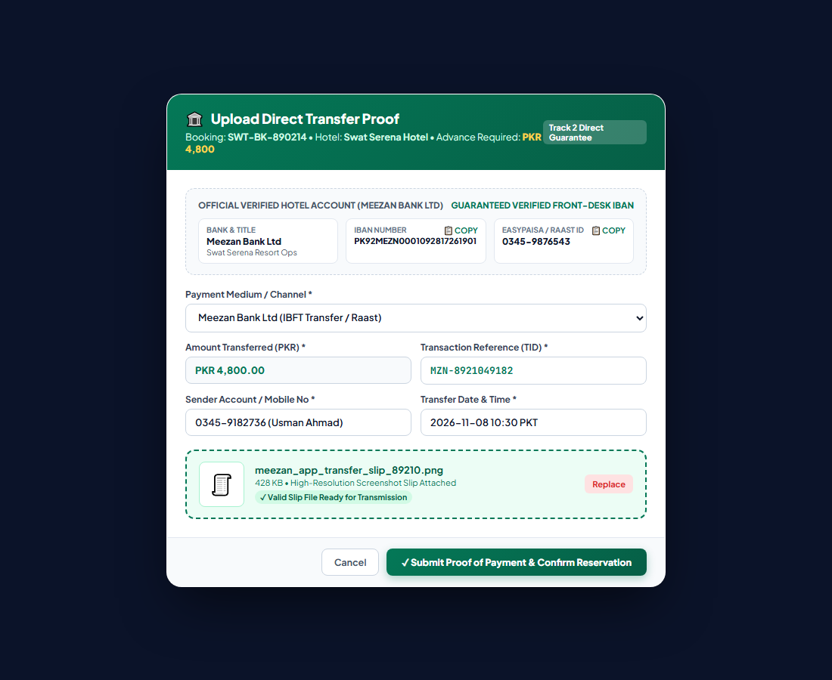
Interactive modal displaying hotel's verified Meezan Bank IBAN, Payment Medium dropdown, TID, sender info, and screenshot slip attachment.
Figure 2: Hotel Front-Desk Direct Payment Inspector Suite (PaymentProofInspectorModal.tsx)
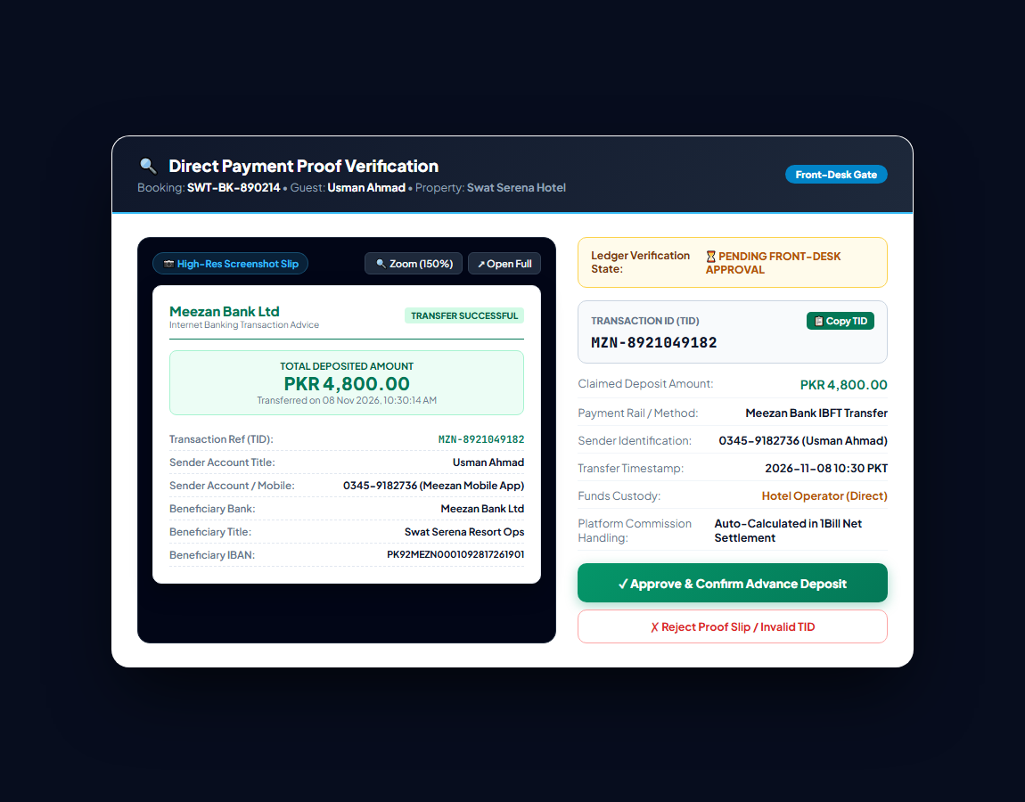
Front-desk inspection suite with high-resolution slip preview, zoom controls, one-click TID copy, verification metadata sheet, and Approve/Reject buttons.
5. Automated Test Suite Execution & Verification Evidence
To ensure regression-free deployment and deterministic financial integrity, the entire subsystem was tested across automated backend integration suites and frontend Vitest component tests:
Test Suite | Test Target | Scope Verified | Result
test_payment_proof_submission.py | Backend Service & DB Ledger | Upload, file saving, pending approval, front-desk approve, front-desk reject | 100% PASS
payment_proof_components.test.tsx | Frontend Modals (Vitest) | Upload form submit, TID copy, approve deposit, reject with reason input | 100% PASS
phase4_unified_payment_and_voucher.test.tsx | Checkout & Vouchers | Full online, 20% advance, Pay at hotel, voucher printing and download | 100% PASS

6. Net Settlement & Platform Commission Reconciliation
A critical architectural consideration is ensuring that when a tourist pays the hotel directly (Track 2), the platform does not lose its commission tracking. Under the STP financial engine:
1. Funds Custody Isolation: In booking_payments, Track 2 entries are explicitly recorded with funds_custody = 'hotel_operator', distinguishing them from STP Escrow funds.
2. Commission Ledger Hook: At guest check-out, CommissionTransaction is automatically posted into the finance ledger, debiting the property's commission liability.
3. Universal Monthly Settlement: At month end, generate_monthly_invoices computes the property's net position. If the property owes commission for direct deposits that exceed online escrow payouts, a 1Bill invoice with a 24-digit consumer number is automatically generated for front-desk settlement.
ENGINEERING IMPLEMENTATION VERIFIED  Swat Tourism Platform Lead Engineering  Status: Production Ready • 100% Tested | KPK TOURISM AUTHORITY OVERSIGHT  Directorate of Tourism & IT Infrastructure  Compliance: SRS-2 Dual-Track Direct Deposit Standards

