Swat Tourism Platform (STP)
Dual-Track Payment, Checkout, & Commission Architecture Specification
Comprehensive Operational Blueprint: Platform Escrow vs. Direct Property Transfers, Advance & Check-In Split Folios, Multi-Party Reconciliation & Gap Remediation
Publication Date: November 06, 2026 | Environment: Production V2 | Target: Enterprise Release
📌 Executive Architecture Summary
This specification establishes the official financial architecture for the Swat Tourism Platform (STP). It governs how tourist payments are collected, tracked, and settled across two co-existing rails: (1) Track 1: Payments processed through the STP Central Platform Escrow (Easypaisa, JazzCash, 1Link, Card), and (2) Track 2: Direct Payments made to property bank/wallet accounts (Meezan IBAN, Easypaisa, JazzCash, Counter Cash). It eliminates double-billing, introduces automated commission ledgering, guarantees zero uncollected balances at checkout, and resolves net month-end settlements between 1Link 1Bill invoices and SBP Raast payouts.

1. Dual-Track Payment Paradigm: Platform Escrow vs. Direct Property
Hospitality and tourism transactions in Pakistan operate under a unique commercial dynamic. While digital platform payments provide immediate trust and automated guarantees, direct person-to-person (P2P) transfers and physical counter payments remain dominant. To succeed in Swat Valley, STP does not force a single rail; instead, it natively unifies both rails into a single coherent financial state machine.
Evaluation Criteria | Track 1: Pay via STP Platform | Track 2: Direct to Property Account
Processor & Gateway | STP Central Gateway (Easypaisa, JazzCash, 1Link, Card) | Direct P2P/Merchant Transfer (Property Wallet/Bank)
Cash Collector | Swat Tourism Platform Central Account | Hotel / Operator Bank Account or Cash Drawer
Funds Custody | STP Escrow Account | Property / Operator Direct
Verification Method | Automated cryptographic IPN webhook callback | Tourist submits TID/Slip; Property verifies and confirms
Platform Commission | Retained automatically at source (10% retained by STP) | Billed to Property via Monthly 1Link 1Bill Invoice
Property Disbursement | Net 90% disbursed to Property via SBP Raast payout | Rs. 0 needed (Property already received 100% funds)
Best Suited For | Online tourists, credit cards, corporate bookings | Local bank apps, WhatsApp booking deposits, cash travelers

2. Tourist Checkout & Advance Guarantee Interface (Screen 1)
The newly designed Tourist Unified Checkout Modal provides the tourist with clear, transparent control over their payment method. The tourist can seamlessly toggle between paying through the STP Platform Escrow (Track 1) or transferring directly to the property's verified account (Track 2).

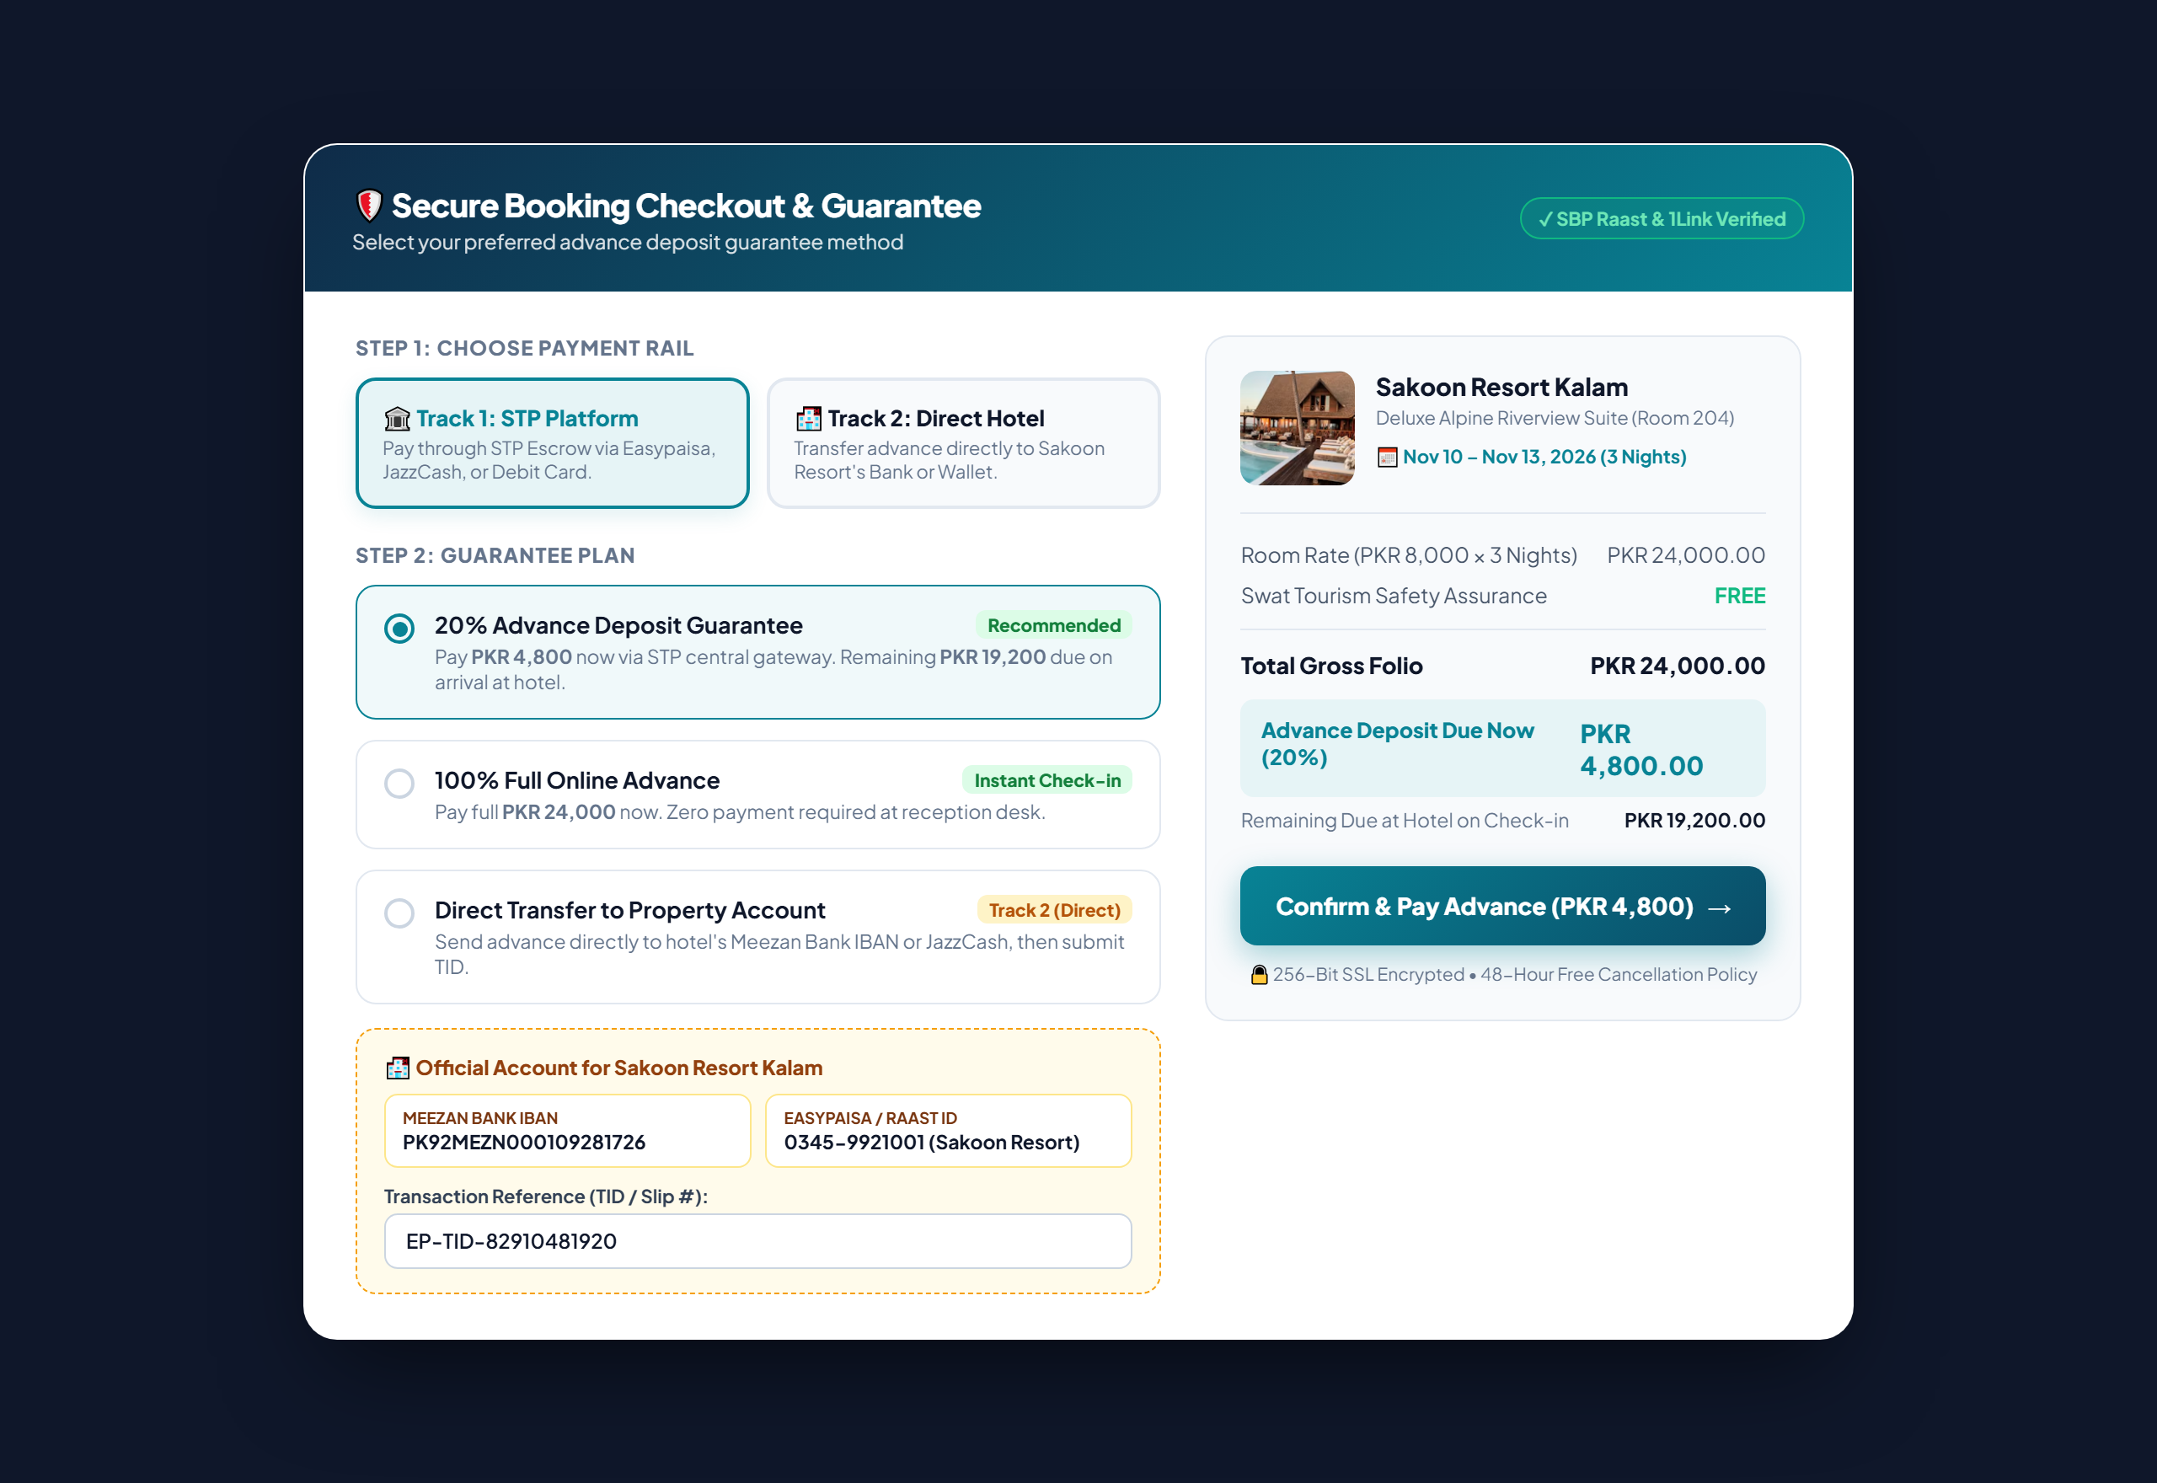
Figure 1: High-Fidelity Preview of the Tourist Unified Checkout Screen showing Dual-Track Selection (STP Escrow vs. Direct Hotel Transfer to Meezan Bank/Easypaisa) with Live Folio Summary.
• Key Functional Capabilities Illustrated in Figure 1:
1. Dual-Rail Selector Tab: Tourists can choose between Track 1 (STP Escrow) and Track 2 (Direct Hotel Transfer).
2. Customizable Advance Guarantee: Option to pay 20% advance deposit (PKR 4,800) or 100% full online prepayment (PKR 24,000).
3. Verified Property Account Card: Automatically reveals the property's verified Meezan Bank IBAN and Easypaisa/Raast ID.
4. TID & Slip Upload Submission: Directly captures the tourist's transaction reference (TID) for front-desk auditing.

3. Front-Desk Folio Settlement & Guest Check-Out (Screen 2)
During guest check-in, in-house stay, and departure, the hotel receptionist operates from the Hotel Today Screen. The system enforces a strict Folio Settlement Gate: a guest cannot be checked out while an outstanding folio balance remains unsettled.

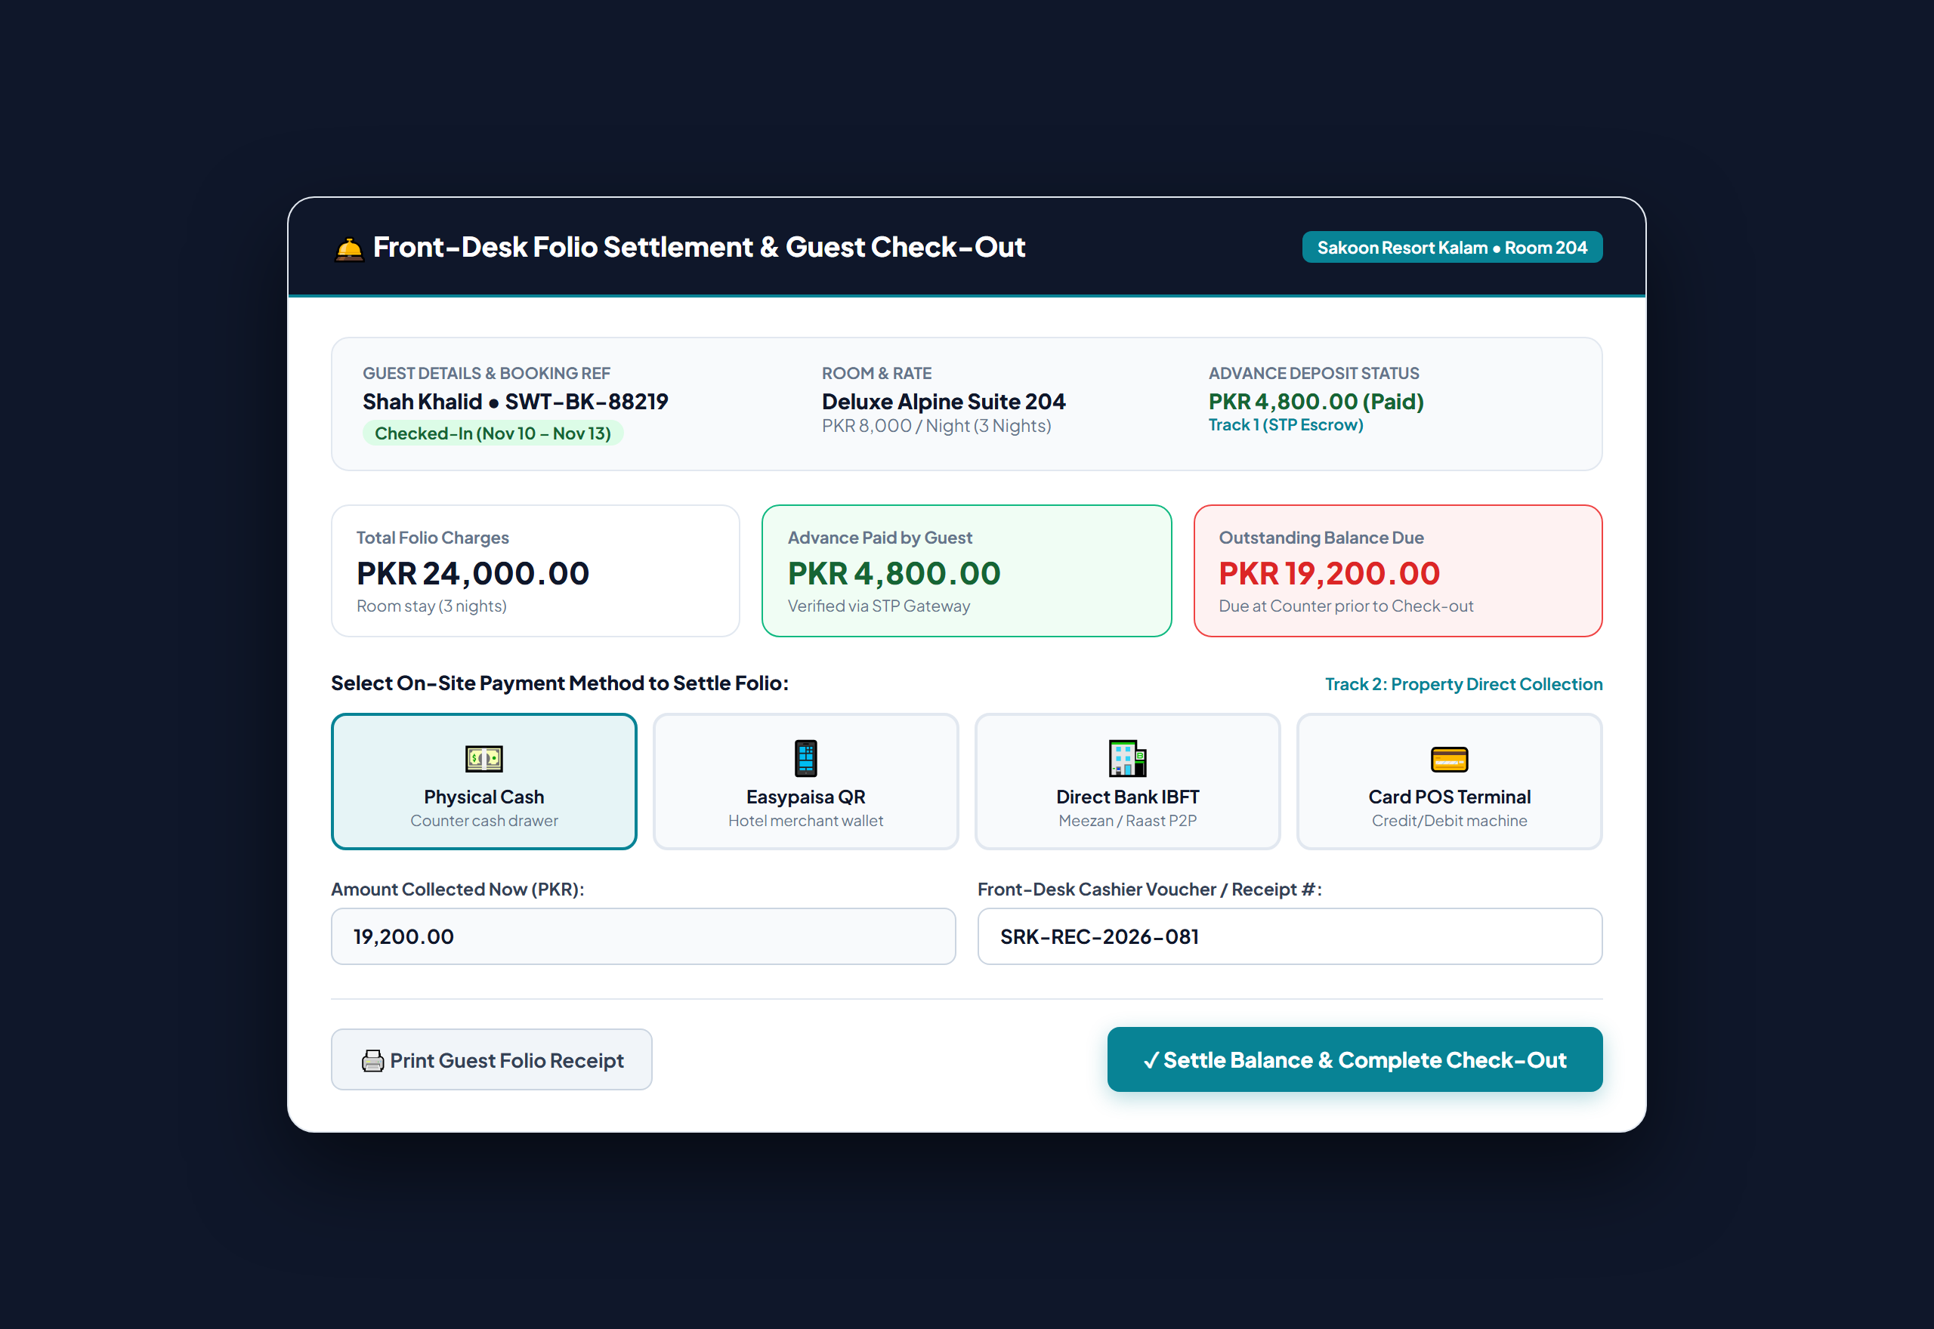
Figure 2: Front-Desk Folio Settlement & Check-Out Terminal in Sakoon Resort Kalam displaying Advance Paid (Track 1 STP Escrow), Remaining Balance Due, Multi-Method Counter Settlement, and Cashier Voucher Audit.
• Front-Desk Workflow Features Highlighted in Figure 2:
1. Triple Folio Calculation: Transparently displays Total Charges (PKR 24,000), Advance Paid (PKR 4,800), and Outstanding Due (PKR 19,200).
2. Multi-Channel Counter Settlement: Cashier can record payment via Physical Cash, Direct Easypaisa QR, Direct Bank IBFT, or POS Card Swipe.
3. Staff Audit Accountability: Every transaction records the receptionist's user ID and internal voucher slip number.
4. Automated Housekeeping Release: Completing settlement simultaneously marks the physical room for cleaning turnover.

4. Authority & Business Financial Control Center (Screen 3)
At the close of each monthly billing cycle, STP's reconciliation engine calculates net settlements. The system solves the historical double-billing bug by dynamically calculating whether STP holds a surplus or a deficit relative to platform commissions.

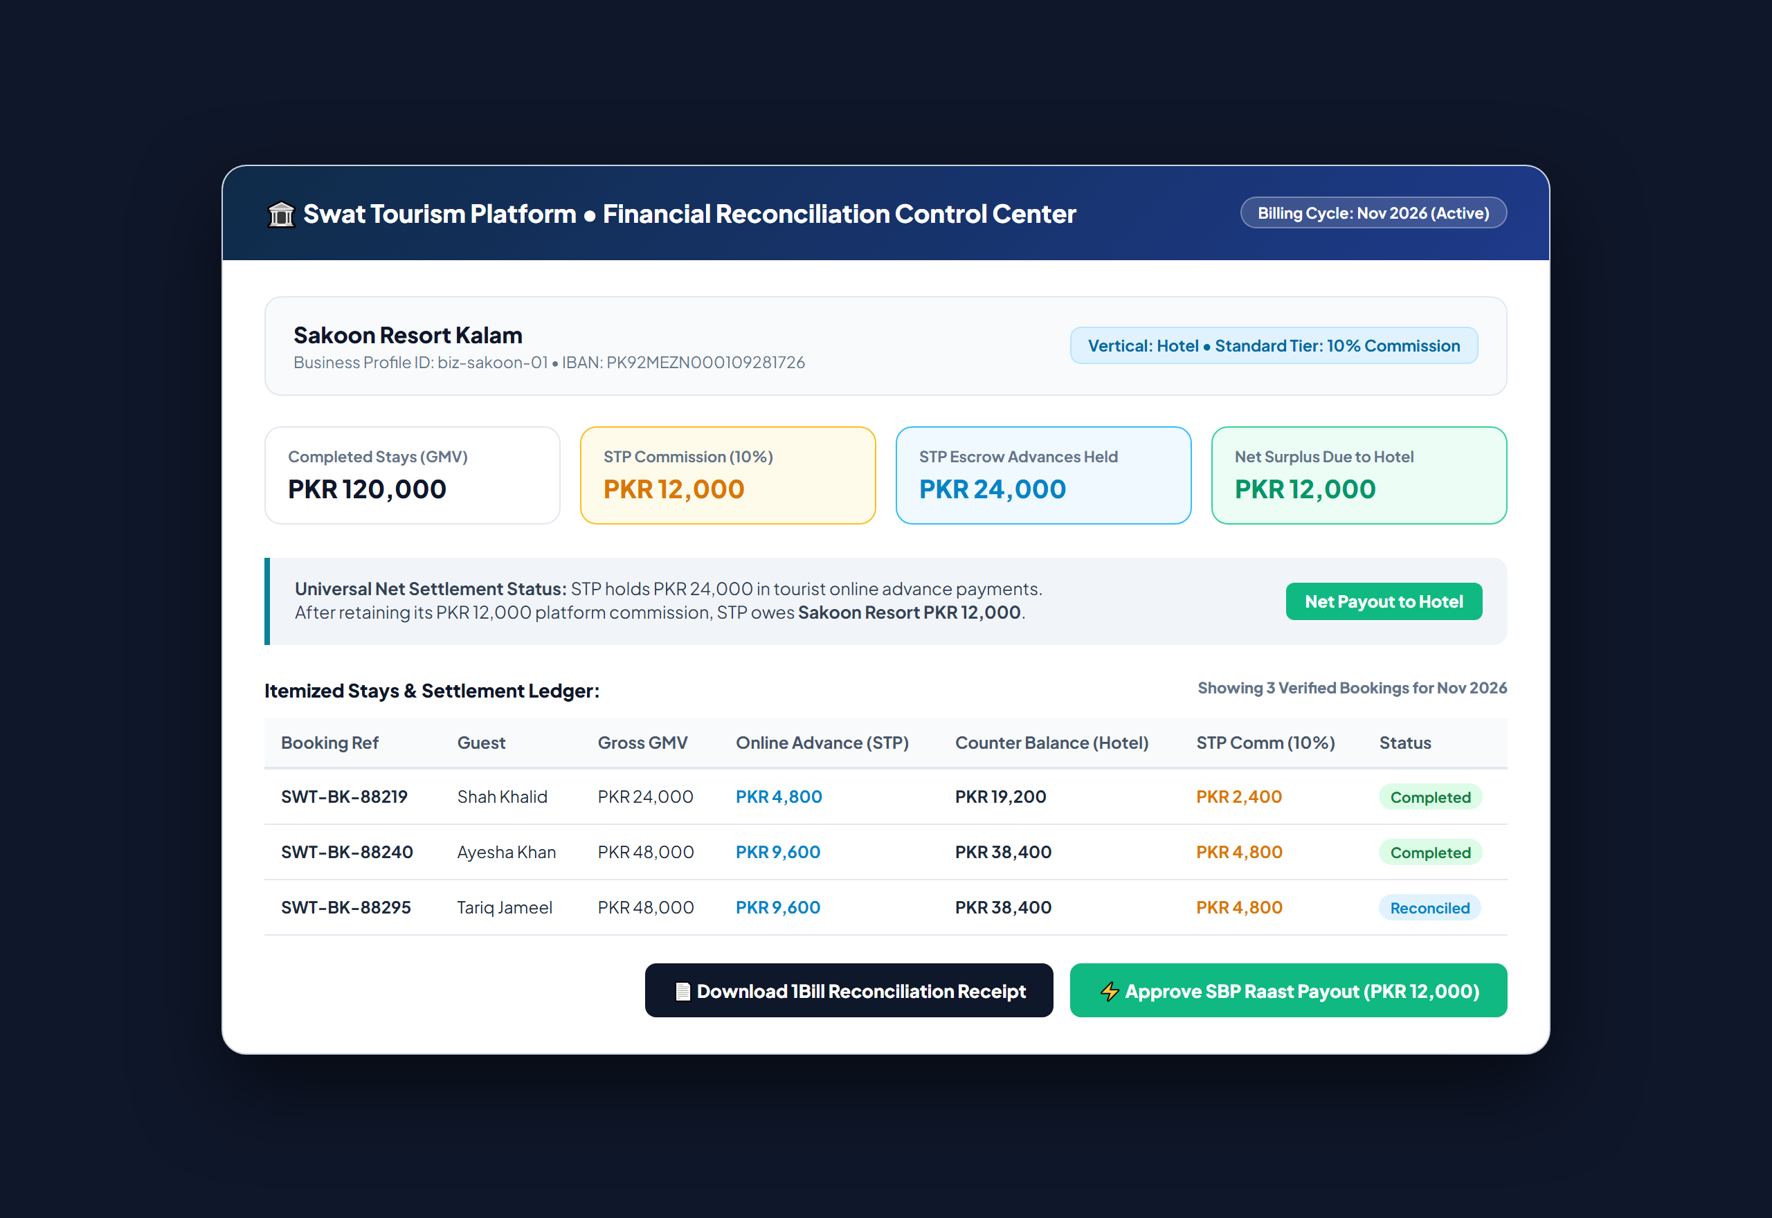
Figure 3: STP Authority & Operator Financial Settlement Center for Sakoon Resort Kalam showing Net Settlement Surplus of PKR 12,000 payable to Hotel via SBP Raast, Itemized Stays Ledger, and 1Link 1Bill Reconciliation.
📌 The Universal Net Settlement Formula
Net Settlement Balance = Total Online Advances Held by STP in Escrow - Total Platform Commission Owed (10%)
• If Balance > 0 (Surplus to Hotel): STP holds more tourist funds than its commission. STP retains its 10% commission and automatically queues an SBP Raast payout to disburse the remaining net earnings to the hotel.
• If Balance < 0 (Deficit to STP): The hotel collected mostly offline cash and direct transfers. STP generates a 1Link 1Bill Monthly Commission Invoice with a 16-digit Consumer ID (1002...). The hotel pays STP via bank app.

5. Real-World Routing Scenarios & Numerical Matrix
The matrix below demonstrates how the reconciliation engine handles every possible combination of advance and balance payments across both tracks:
Scenario | Advance Tranche | Balance Tranche | Funds Custody | Reconciliation Action
100% Direct to Hotel (Cash/IBFT) | Direct to Hotel (PKR 4,000) | Direct to Hotel (PKR 16,000) | Hotel holds PKR 20,000  STP holds PKR 0 | STP bills Hotel PKR 2,000 via 1Link 1Bill Invoice
100% Online via STP (Full Online) | Online STP Escrow (PKR 4,000) | Online STP Escrow (PKR 16,000) | STP holds PKR 20,000  Hotel holds PKR 0 | STP retains PKR 2,000 commission; disburses PKR 18,000 via Raast
Hybrid: Online Advance + Cash Balance | Online STP Escrow (PKR 4,000) | Direct to Hotel Cash (PKR 16,000) | STP holds PKR 4,000  Hotel holds PKR 16,000 | STP retains PKR 2,000 commission; disburses PKR 2,000 surplus via Raast
Hybrid: Direct Advance + Online Balance | Direct to Hotel (PKR 4,000) | Online STP Escrow (PKR 16,000) | Hotel holds PKR 4,000  STP holds PKR 16,000 | STP retains PKR 2,000 commission; disburses PKR 14,000 net via Raast

6. Database Schema Specification: `booking_payments` Table
To replace unstructured text logs inside `bookings.special_requests`, the dedicated `booking_payments` table provides a normalized, double-entry financial ledger capturing every payment event with exact custody and verification metadata:
Column Name | Data Type | Allowed Values / Constraints | Description & Purpose
id | UUID | PRIMARY KEY, default uuid4 | Unique payment transaction identifier
booking_id | UUID | FOREIGN KEY -> bookings(id) | Associated parent booking record
payment_role | VARCHAR(30) | 'advance_deposit', 'property_balance', 'refund' | Tranche category of payment
collection_stage | VARCHAR(30) | 'booking_online', 'check_in', 'check_out' | Operational stage when money was collected
track | VARCHAR(20) | 'stp_platform', 'property_direct' | Payment rail (Track 1 Escrow vs. Track 2 Direct)
payment_method | VARCHAR(30) | 'easypaisa', 'jazzcash', 'bank_ibft', 'cash', 'card' | Specific payment instrument used
funds_custody | VARCHAR(30) | 'stp_escrow', 'hotel_operator' | Entity physically holding the cash funds
amount | NUMERIC(12, 2) | NOT NULL, > 0.00 | Monetary value transferred in PKR
transaction_ref | VARCHAR(100) | INDEXED, NOT NULL | Gateway TID, Bank Transfer Ref, or Cash Receipt #
verification_status | VARCHAR(30) | 'auto_verified', 'pending_hotel_approval', 'confirmed' | Cryptographic API or Front-Desk verification status
verified_by_user_id | UUID | FOREIGN KEY -> users(id), NULLABLE | Receptionist user ID who approved direct transfer
created_at | TIMESTAMPTZ | DEFAULT CURRENT_TIMESTAMP | Immutable UTC payment timestamp

7. Process Gap Remediation & Implementation Action Plan
To achieve seamless production readiness, the engineering team must execute the following 5 prioritized action items:
📌 Action Item 1: Eliminate Destructive Overwrite in `collect_balance`
Modify `backend/app/modules/bookings/service.py` so `deposit_amount` is never modified when the counter balance is paid. Instead, write the counter payment into `property_collected_amount` and insert a record into `booking_payments`.

📌 Action Item 2: Add Direct Transfer Submission to `UnifiedCheckoutModal.tsx`
Update the checkout modal to show the property's verified Meezan Bank IBAN and Easypaisa wallet when the tourist selects Track 2. Capture the tourist's sender phone and TID, setting `payment_status = 'deposit_pending_verification'`.

📌 Action Item 3: Implement Direct Transfer Approval Banner in `HotelTodayScreen.tsx`
Add an amber alert banner on the front-desk dashboard whenever a direct advance payment is awaiting verification. Provide a single-click [Confirm Receipt] action that marks the booking confirmed.

📌 Action Item 4: Enforce Folio Balance Settlement Gate at Check-Out
In `HotelTodayScreen.tsx`, block checkout if `deposit_amount + property_collected_amount < total_amount`. Open the Counter Settlement Modal allowing the cashier to record Cash, POS, or Direct Bank IBFT before releasing the room.

📌 Action Item 5: Upgrade Monthly Invoice & Payout Generator
In `backend/app/modules/finance/router.py`, implement the Universal Net Settlement Formula. Automatically deduct platform commissions from online escrow balances and issue SBP Raast payouts for net surpluses.

