Swat Tourism Platform (STP)
Core Backend Architecture: router.py, service.py, models.py & database.py
Attribute | Details
Scope | Concise Guide to Core Backend File Responsibilities, Linkage, & Bidirectional Call Flow
Workspace Root | f:\Antigravity\SwatTourismProduction_v2
Key Modules Covered | bookings/router.py, bookings/service.py, bookings/models.py, app/core/database.py
Frameworks | FastAPI, SQLAlchemy 2.0 Async ORM, Pydantic Schemas

1. What Each File Does
File & Path | Architectural Role | Core Responsibilities
router.py  (backend/app/modules/  bookings/router.py) | The Doorway  (API Layer) | Defines HTTP URLs (e.g., POST /bookings/request), checks JWT login tokens, validates incoming JSON via schemas.py, acquires a DB session via Depends(get_db), and calls service.py.
service.py  (backend/app/modules/  bookings/service.py) | The Brain  (Business Logic) | Executes all business rules (calculating nights/totals, checking room availability, generating booking references) and runs ORM database queries (select(), db.add(), await db.commit()).
models.py  (backend/app/modules/  bookings/models.py) | The Blueprint  (Table Definitions) | Defines Python classes (Booking, BookingItem, HotelRoom) that map directly to database tables, columns, data types, constraints, and foreign key relationships.
database.py  (backend/app/core/  database.py) | The Connection Pipe  (Engine & Session) | Connects to PostgreSQL/SQLite (create_async_engine), provides the Base class inherited by all models.py classes, and creates isolated per-request DB sessions via get_db().

2. How These Four Files Are Linked
1. models.py → database.py: Every database table class in models.py (such as Booking or HotelRoom) inherits from Base, which is imported from database.py.
2. router.py → database.py: Every API endpoint function injects a live database session using db: AsyncSession = Depends(get_db) imported from database.py.
3. router.py → service.py: router.py passes that live db session along with validated user request data into a method on BookingService in service.py.
4. service.py → models.py: service.py imports table classes from models.py (Booking, Availability) and uses the db session to query, insert, or update them.

3. Call Flow Diagram: Forth & Back
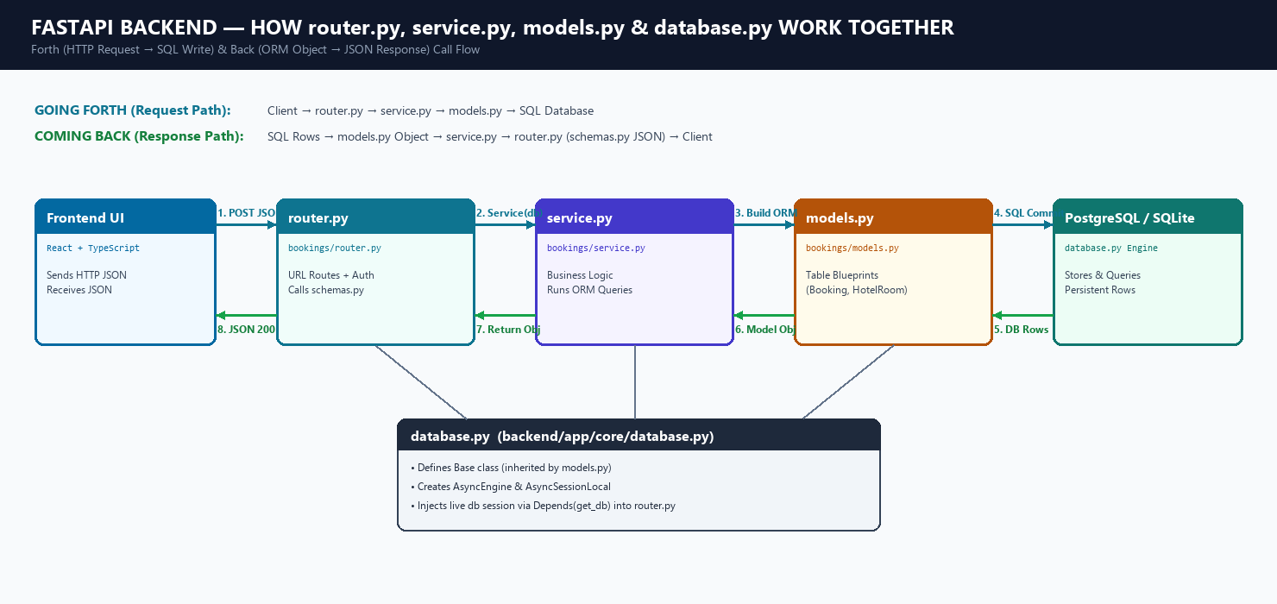
Figure 1: Request (Forth) and Response (Back) Call Flow across router.py, service.py, models.py & database.py

4. Step-by-Step Summary: Forth & Back
📌 GOING FORTH (Frontend Request → Database Write)
1. Frontend sends an HTTP POST/GET JSON request to an endpoint in router.py.
2. router.py borrows a live database connection (db) from database.py via Depends(get_db) and passes the validated payload to service.py.
3. service.py executes business rules, creates or updates objects defined in models.py, and calls await db.commit() through database.py to execute SQL on PostgreSQL/SQLite.

📌 COMING BACK (Database Rows → Frontend JSON Response)
4. PostgreSQL/SQLite returns the saved or queried rows to service.py hydrated as models.py Python objects (e.g., a Booking instance).
5. service.py returns that Python object back to router.py.
6. router.py automatically serializes the object (using response_model=BookingOut from schemas.py) into JSON and sends HTTP 200/201 back to the Frontend.
7. database.py automatically closes and releases the session back to the connection pool.

