Swat Tourism Platform (STP)
Where Database Queries Are Stored: Architecture, Service Layer & ORM Execution Guide
Attribute | Value Details
System Domain | Database Persistence Architecture, SQLAlchemy 2.0 Async ORM, & Query Storage
Application Architecture | Domain-Driven Service Layer Pattern (FastAPI Router → Service Layer ORM → Database Engine)
Workspace Root Directory | f:\Antigravity\SwatTourismProduction_v2
Core Technologies | Python 3.12, FastAPI, SQLAlchemy 2.0 Async, aiosqlite / asyncpg, PostgreSQL / SQLite, Alembic
Document Classification | Full Technical Architecture Specification of Query Storage & Execution Pathways
Target Audience | Backend Engineers, Database Administrators, System Architects, & Code Reviewers

📌 Core Finding: Where Are Queries Stored?
In the Swat Tourism Platform, database queries are NOT stored as static .sql text files. Instead, they are written as modern Python asynchronous object-relational expressions (SQLAlchemy 2.0 Async ORM) located inside the Domain Service Layer files (e.g., backend/app/modules/bookings/service.py, backend/app/modules/listings/service.py, backend/app/modules/trips/service.py). The database schema is defined in models.py, connection pooling and session management are in app/core/database.py, and raw DDL table migrations are tracked in backend/alembic/versions/.

1. Database Query Execution & Storage Diagram
Figure 1.1 illustrates the architectural pathway from FastAPI route dependencies to the Domain Service Layer (where queries reside), through the SQLAlchemy 2.0 AsyncSession engine, down to the database persistence layer:
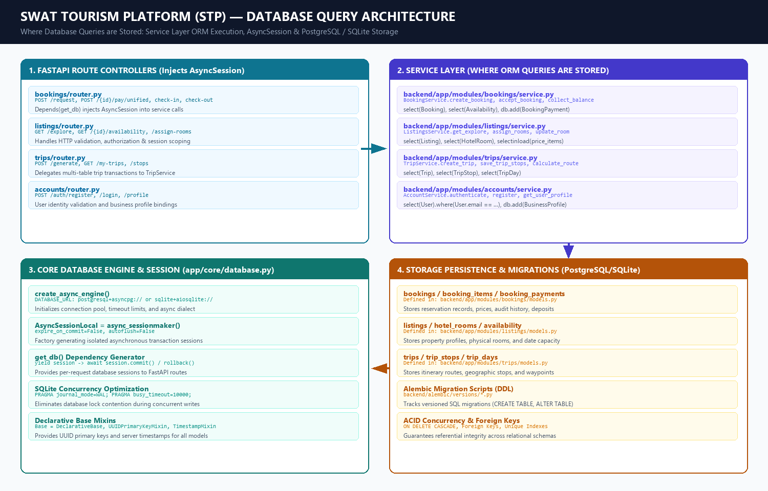
Figure 1.1: Database Query Storage & Execution Flow Architecture

2. Master Query Storage Index by Functional Domain
Every database interaction is strictly encapsulated in its dedicated domain service file. The table below indexes every backend module, its service file path, the class managing queries, and typical query operations:
Functional Domain | Service File Path (Where Queries Live) | Managing Class | Key Query Constructs Contained
Room Bookings & Payments | backend/app/modules/bookings/  service.py | BookingService | • select(Booking).where(...)  • select(Availability).where(...)  • db.add(Booking(...)) (Insert)  • db.add(BookingPayment(...))  • db.add(BookingStatusHistory(...))
Hotels, Rooms & Availability | backend/app/modules/listings/  service.py | ListingsService | • select(Listing).where(status='published')  • select(Availability).where(...)  • select(HotelRoom).where(...)  • db.add(HotelRoom(...))  • selectinload(Listing.price_items)
Trips & Itinerary Routes | backend/app/modules/trips/  service.py | TripService | • select(Trip).where(Trip.tourist_id == ...)  • select(TripStop).order_by(TripStop.day_number)  • db.add(Trip(...))  • db.add_all(stops)
User Accounts & Business Profiles | backend/app/modules/accounts/  service.py | AccountService | • select(User).where(User.email == ...)  • select(BusinessProfile).where(...)  • db.add(User(...))  • db.add(BusinessProfile(...))
Verified Reviews & Ratings | backend/app/modules/reviews/  service.py | ReviewService | • select(Review).where(Review.listing_id == ...)  • db.add(Review(...))  • select(func.avg(Review.rating))
Multi-Channel Notifications | backend/app/modules/notifications/  service.py | NotificationService | • select(Notification).where(...)  • db.add(Notification(channel='sms', ...))  • db.add(Notification(channel='whatsapp', ...))

3. Concrete Query Code Snippets from the Repository
▶ A. Master Booking Insertion (backend/app/modules/bookings/service.py)
# Lines 360-395 in service.py: create_booking()
booking = Booking(
id=uuid.uuid4(),
reference=reference,
tourist_id=user_id,
business_id=listing.business_id,
listing_id=listing.id,
status='requested',
payment_status='unpaid',
start_date=request.start_date,
end_date=request.end_date,
total_amount=total_amount,
)
db.add(booking)
await db.commit() # Translates to: INSERT INTO bookings (...) VALUES (...)

▶ B. Calendar Inventory Decrement (backend/app/modules/bookings/service.py)
# Lines 320-335 in service.py: Checking and locking availability
avail_q = select(Availability).where(
Availability.price_item_id == item_req.price_item_id,
Availability.date == current_d
)
avail = (await db.execute(avail_q)).scalar_one_or_none()
avail.units_booked += item_req.quantity # Translates to: UPDATE availability SET units_booked = units_booked + :qty

▶ C. Fetching Pending Business Reservations (backend/app/modules/bookings/service.py)
# Lines 480-510 in service.py: get_business_bookings()
query = (
select(Booking)
.options(
selectinload(Booking.items).selectinload(BookingItem.price_item),
selectinload(Booking.history),
selectinload(Booking.tourist),
selectinload(Booking.listing),
)
.where(Booking.business_id == business_id)
.order_by(Booking.created_at.desc())
)
res = await db.execute(query) # Translates to: SELECT ... FROM bookings WHERE business_id = :id

▶ D. Front-Desk Balance Settlement (backend/app/modules/bookings/service.py)
# Lines 940-975 in service.py: collect_balance()
booking.property_collected_amount = already_collected + collected_now
booking.payment_status = 'paid'
pay_entry = BookingPayment(
id=uuid.uuid4(),
booking_id=booking.id,
payment_role='property_balance',
track='property_direct',
payment_method=payment_method,
funds_custody='hotel_operator',
amount=collected_now,
verification_status='confirmed',
)
db.add(pay_entry)
await db.commit()

4. Table Models, Engine Setup & Migration Scripts
Layer / Subsystem | Exact Relative File Path | Role in Database Architecture
Table Schema Models (ORM) | backend/app/modules/bookings/models.py  backend/app/modules/listings/models.py  backend/app/modules/accounts/models.py  backend/app/modules/trips/models.py | Defines database tables, primary keys (UUID), foreign keys (CASCADE / RESTRICT), column data types, check constraints, and relationships.
Engine & Async Session | backend/app/core/database.py | Initializes create_async_engine(), AsyncSessionLocal, connection pool, and the get_db() FastAPI dependency generator.
Configuration Settings | backend/app/core/config.py | Loads settings.DATABASE_URL from environment variables (e.g. postgresql+asyncpg:// or sqlite+aiosqlite:///).
Alembic Schema Migrations | backend/alembic/versions/*.py | Stores versioned Python migration scripts executing raw DDL (CREATE TABLE, ALTER TABLE, ADD COLUMN, CREATE INDEX).

📌 Architectural Rationale: Why Queries Live in Service Layer
Placing SQLAlchemy queries in the Service Layer rather than loose SQL files provides four massive architectural benefits:
1. Compile-Time Type Safety: Model attributes (e.g. Booking.reference, Availability.units_booked) are type-checked by Python.
2. SQL Injection Immunity: Parameter binding is automatically handled by SQLAlchemy prepared statements.
3. Database Portability: Queries execute identically on PostgreSQL (Production) and SQLite (Development/Test) without syntax modifications.
4. Transaction Atomicity: Multi-table mutations (decrementing availability while creating a booking and writing status history) occur within a single atomic async transaction block.

