Swat Tourism Platform (STP)
Full-Stack Architecture Guide: Frontend Click → API Client → router.py → service.py → models.py → database.py
Attribute | Details
Scope | Complete End-to-End Frontend to Backend Architecture & Bidirectional Call Flow
Workspace Root | f:\Antigravity\SwatTourismProduction_v2
Frontend Files Covered | HotelDetailsModal.tsx, HotelTodayScreen.tsx, api/bookings.ts, api/rooms.ts, api/client.ts
Backend Files Covered | bookings/router.py, bookings/service.py, bookings/models.py, core/database.py
Frameworks | React 18, TypeScript, Vite Proxy, FastAPI, SQLAlchemy 2.0 Async ORM, Pydantic

1. What Each File Does (Frontend & Backend)
File & Repository Path | Layer Role | What It Does
UI Component  (frontend/src/modules/tourist/  HotelDetailsModal.tsx) | The Trigger  (Frontend UI) | Captures user clicks (e.g. clicking 'Instant Book' runs handleInstantBook()), validates dates/inputs, calls the API module, and updates the screen with the response.
API Module  (frontend/src/api/  bookings.ts & rooms.ts) | The Messenger  (Typed API Functions) | Defines typed helper functions like createBookingRequest(payload) or acceptBooking(id). Specifies the target backend URL path and HTTP method.
HTTP Core Client  (frontend/src/api/  client.ts) | The Transport  (Fetch + Auth Wrapper) | Executes apiRequest(). Reads the JWT token from localStorage.getItem('swat_token'), adds Authorization: Bearer headers, runs fetch('/api/v1/...'), and parses JSON.
router.py  (backend/app/modules/  bookings/router.py) | The Doorway  (Backend API Layer) | Receives HTTP requests on endpoints (POST /bookings/request), checks JWT tokens, validates JSON via schemas.py, gets a DB session via Depends(get_db), and calls service.py.
service.py  (backend/app/modules/  bookings/service.py) | The Brain  (Business Logic) | Executes all business rules (calculating nights/totals, checking room availability, generating booking references) and runs ORM queries (select(), db.add(), await db.commit()).
models.py  (backend/app/modules/  bookings/models.py) | The Blueprint  (Table Definitions) | Defines Python classes (Booking, BookingItem, HotelRoom) that map directly to database tables, columns, data types, constraints, and foreign keys.
database.py  (backend/app/core/  database.py) | The Connection Pipe  (Engine & Session) | Connects to PostgreSQL/SQLite (create_async_engine), provides the Base class inherited by models.py, and creates per-request DB sessions via get_db().

2. How All Files Are Linked Together
1. UI Component → API Module: HotelDetailsModal.tsx imports and calls createBookingRequest() from frontend/src/api/bookings.ts inside its button click handler (handleInstantBook()).
2. API Module → client.ts: bookings.ts passes the endpoint ('/bookings/request') and JSON body into apiRequest() inside frontend/src/api/client.ts.
3. client.ts → router.py (Network Boundary): client.ts calls fetch('/api/v1/bookings/request'), which Vite proxies over HTTP to FastAPI's bookings/router.py.
4. models.py → database.py: Every database table class in models.py (such as Booking) inherits from Base imported from database.py.
5. router.py → database.py: Every endpoint injects a live database session using db: AsyncSession = Depends(get_db) imported from database.py.
6. router.py → service.py → models.py: router.py passes the live db session and request payload into BookingService in service.py, which imports Booking from models.py to read/write rows.

3. Visual Call Flow Diagram: Frontend Click to Database & Back
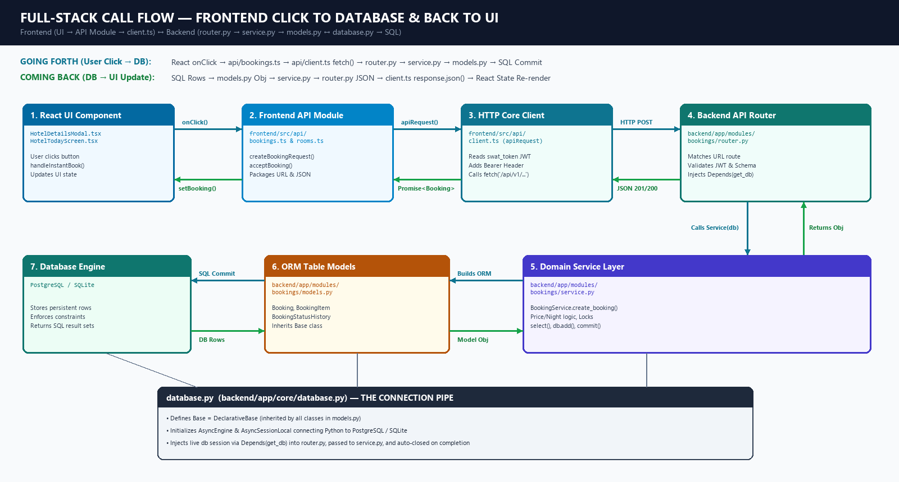
Figure 1: Complete Bidirectional Call Flow (Frontend Click → client.ts → router.py → service.py → models.py ↔ database.py)

4. Step-by-Step Summary: Forth & Back
📌 GOING FORTH (User Click → Database Write)
1. User clicks 'Instant Book' in HotelDetailsModal.tsx, triggering handleInstantBook().
2. handleInstantBook() calls createBookingRequest() in frontend/src/api/bookings.ts.
3. bookings.ts calls apiRequest() in frontend/src/api/client.ts, which attaches the Bearer JWT token and fires HTTP POST /api/v1/bookings/request.
4. FastAPI routes the call to router.py, which validates the token/JSON, borrows a DB session (db) from database.py via Depends(get_db), and calls service.py.
5. service.py enforces business logic, constructs ORM objects defined in models.py (Booking, BookingItem), and runs await db.commit() to save rows to PostgreSQL/SQLite.

📌 COMING BACK (Database Rows → Frontend UI Re-Render)
6. PostgreSQL/SQLite returns the newly committed row data to service.py as models.py Python objects (Booking).
7. service.py returns that Booking object to router.py.
8. router.py serializes the object into JSON using response_model=BookingOut (schemas.py) and sends HTTP 201 Created back across the network.
9. database.py automatically closes and releases the DB session.
10. client.ts parses response.json() and resolves the Promise back through bookings.ts to HotelDetailsModal.tsx, which calls setBookingSuccess(newBooking) to display the confirmation screen.

