Swat Tourism Platform (STP)
Payment Proof Submission & Hotel Verification — Manual Testing & Code Flow Guide
Attribute | Details
Scope | Manual Testing Walkthrough & Technical Architecture for 20% Deposit Proof Submission and Front-Desk Verification
Workspace Root | f:\Antigravity\SwatTourismProduction_v2
Frontend Components | UnifiedCheckoutModal.tsx, MyBookingsView.tsx, PaymentProofUploadModal.tsx, HotelTodayScreen.tsx, PaymentProofInspectorModal.tsx
Backend Endpoints | POST /api/v1/bookings/{id}/pay/unified, POST /api/v1/bookings/{id}/upload-payment-proof, POST /api/v1/bookings/{id}/verify-direct-deposit

📌 Why Proof Upload Was Hidden When Selecting Easypaisa (Track 1 vs. Track 2)
In UnifiedCheckoutModal.tsx, Step 1 ('Select Payment Rail') defaults to 'Track 1: STP Platform' (Instant STP Escrow via Easypaisa/JazzCash/Card). Because Track 1 simulates an automated wallet push, it does NOT ask for a screenshot slip or TID.
To test manual Easypaisa / Bank Transfer Proof Upload, you MUST select 'Track 2: Direct Hotel Transfer' at the top of Step 1—OR upload your slip afterwards from Tourist Portal → My Bookings using the 'Upload Slip / TID' button.

1. Payment Proof Submission & Verification Diagram
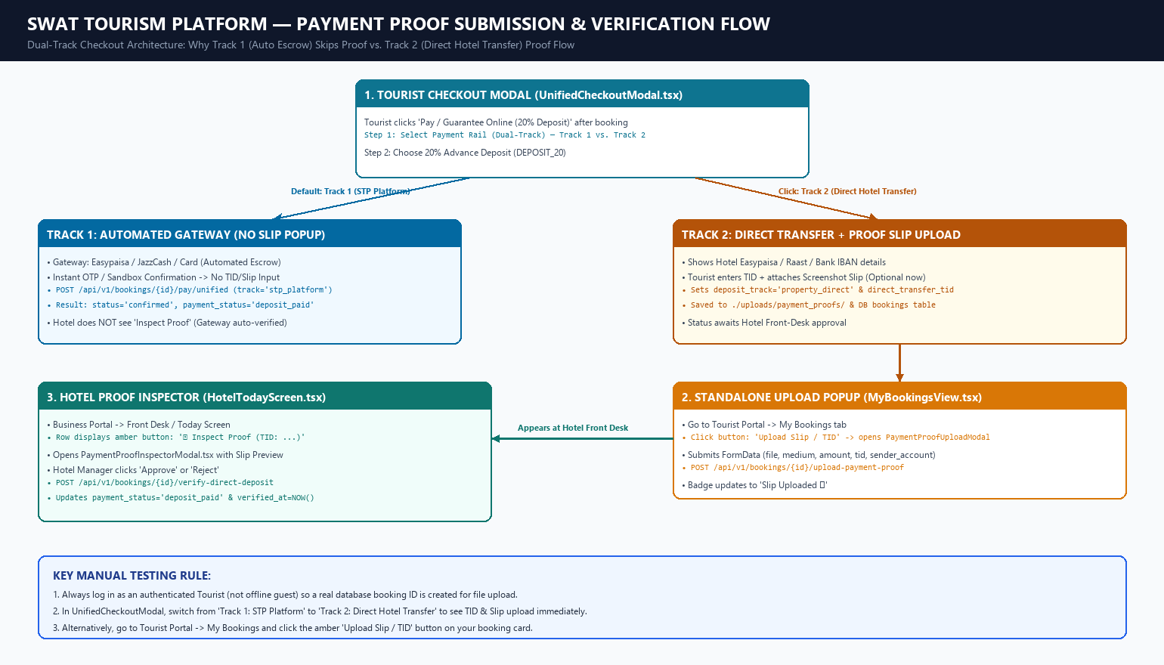
Figure 1: Dual-Track Checkout Branching & Proof Verification Sequence

2. Step-by-Step Manual Testing Instructions
▶ Part A — Tourist Side: Book Room & Submit 20% Proof (Option 1: During Checkout)
1. Log in as an authenticated Tourist account (not offline guest mode) so the booking persists in the backend database.
2. Search and open a hotel (e.g., Swat Serena Hotel) in HotelDetailsModal.tsx.
3. Choose dates and room type, then click 'Instant Book' to create the booking.
4. On the confirmation screen, click 'Pay / Guarantee Online (20% Deposit)' to open UnifiedCheckoutModal.tsx.
5. In Step 1 ('Select Payment Rail'), click 'Track 2: Direct Hotel Transfer' (amber card on the right).
6. In Step 2 ('Choose Guarantee Plan'), select '20% Advance Guarantee Deposit'.
7. View the hotel's Easypaisa / Raast ID / Bank IBAN details, enter a Transaction Reference ID (e.g., EP-8829104), click 'Click to Attach Screenshot Slip' to select a PNG/JPG/PDF slip, and submit.
→ Backend calls POST /api/v1/bookings/{id}/pay/unified and POST /api/v1/bookings/{id}/upload-payment-proof.
▶ Part B — Tourist Side: Upload or Update Proof Later (Option 2: Via My Bookings)
1. Navigate to Tourist Portal → My Bookings (MyBookingsView.tsx).
2. Locate your booking card. If deposit_track='property_direct', payment_status='deposit_paid', or booking is accepted/confirmed and unpaid, you will see an amber/green button labeled 'Upload Slip / TID' (or 'Slip Uploaded ⏳' / 'Slip Verified ✓').
3. Click 'Upload Slip / TID' to open the standalone PaymentProofUploadModal.tsx popup.
4. Fill in Payment Medium (e.g., Easypaisa), Amount Paid (20%), Transaction Ref (TID), Sender Account, and attach the screenshot slip.
5. Click Submit → saves file to ./uploads/payment_proofs/ and updates booking.direct_transfer_tid & direct_transfer_slip_url in DB.
▶ Part C — Hotel Front-Desk Side: Inspect & Verify Proof
1. Log in as the Hotel Business Manager (or switch to Business role in demo mode) and open Business Portal → Today / Front Desk (HotelTodayScreen.tsx).
2. Find the tourist's booking row. When direct_transfer_tid is present and not yet verified, an amber button appears:
'🔍 Inspect Proof (TID: ...)'
3. Click '🔍 Inspect Proof' to open PaymentProofInspectorModal.tsx.
4. Review the attached transfer slip image, copy the TID to verify against the hotel's Easypaisa/Bank statement, and click 'Approve Deposit' (or 'Reject').
→ Backend calls POST /api/v1/bookings/{id}/verify-direct-deposit, setting direct_transfer_verified_at=NOW() and payment_status='deposit_paid'.

3. File, API & Troubleshooting Reference Matrix
Component / Layer | Exact Repository File Path | Trigger Condition / Endpoint / Notes
Dual-Track Checkout Modal | frontend/src/components/  UnifiedCheckoutModal.tsx | Must select 'Track 2: Direct Hotel Transfer' (line 258) to reveal TID input & slip file attachment inside checkout.
My Bookings Proof Button | frontend/src/modules/tourist/  MyBookingsView.tsx (lines 1176-1202) | Button 'Upload Slip / TID' renders when deposit_track=='property_direct', direct_transfer_tid exists, payment_status=='deposit_paid', or unpaid accepted/confirmed.
Standalone Proof Popup | frontend/src/components/  PaymentProofUploadModal.tsx | Submits multipart FormData via uploadPaymentProofApi() in frontend/src/api/bookings.ts.
Hotel Front-Desk Proof Button | frontend/src/modules/business/  HotelTodayScreen.tsx (lines 3506-3527) | Button '🔍 Inspect Proof' renders ONLY when booking.direct_transfer_tid is populated and direct_transfer_verified_at is null.
Hotel Proof Inspector Popup | frontend/src/components/  PaymentProofInspectorModal.tsx | Displays slip preview, TID copy, and Approve/Reject actions calling verifyDirectDepositApi().
Backend Upload & Verify APIs | backend/app/modules/bookings/  router.py & service.py | POST /bookings/{id}/upload-payment-proof (saves slip & TID)  POST /bookings/{id}/verify-direct-deposit (business/admin verifies deposit).
Database Columns | backend/app/modules/bookings/  models.py (Booking & BookingPayment) | bookings: deposit_track, direct_transfer_tid, direct_transfer_slip_url, direct_transfer_verified_at, direct_transfer_verified_by.  booking_payments: receipt_image_url, verification_status.

📌 Common Troubleshooting Checklist
1. Missing 'Inspect Proof' button on Hotel screen? Check if you paid via Track 1 (STP Platform Easypaisa) instead of Track 2 (Direct Hotel Transfer). Track 1 does not populate direct_transfer_tid unless you upload a slip from My Bookings.
2. Upload fails for guest booking? Ensure you are logged in as a Tourist user before creating the booking so a backend UUID exists in the bookings table.

