Swat Tourism Platform (STP)
Room Booking Call Flow Architecture & Technical Execution Trace
Attribute | Value Details
System Domain | Hotel & Hospitality Reservation Engine, Front Desk PMS, & Financial Clearance
Application Architecture | Decoupled 4-Tier Architecture (Frontend UI → API Gateway → Domain Services → Relational DB)
Workspace Root Directory | f:\Antigravity\SwatTourismProduction_v2
Core Technologies | React 18, TypeScript, Tailwind CSS, FastAPI, SQLAlchemy 2.0 Async, PostgreSQL / SQLite
Document Classification | Full Chronological Call Flow & Technical Execution Specification (Frontend to Database)
Target Audience | Software Engineers, System Architects, Quality Assurance Engineers, & Operations Staff

📌 Executive Call Flow Summary
This specification traces the chronological end-to-end call flow of a hotel room booking across the Swat Tourism Platform. It documents the exact user actions: searching for a hotel, selecting a property, choosing room category and dates, clicking instant reservation, submitting the booking request, receiving and accepting the request at hotel reception, clearing remaining balance, assigning physical rooms, and executing check-in/out. Every step identifies the exact participating file path, method, HTTP endpoint, service logic, and database mutations.

1. Visual Call Flow Sequence Diagram
Figure 1.1 illustrates the chronological sequence of calls traversing the five architectural swimlanes: Tourist Client UI, Frontend API Client, FastAPI Gateway, Domain Services, and Database Persistence / Front Desk PMS:
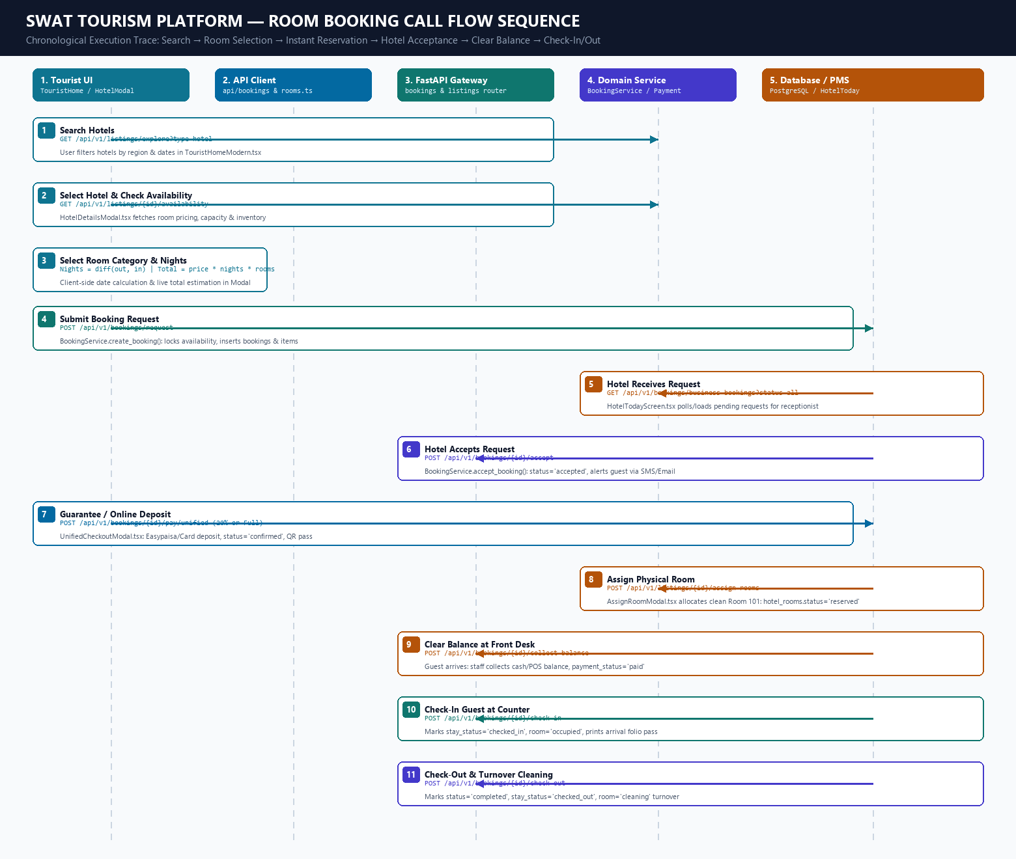
Figure 1.1: Chronological Call Flow Architecture from Frontend to Database

2. Comprehensive Call Trace Matrix (Frontend to Database)
The following matrix outlines every step in the room booking lifecycle, detailing the frontend component, API client call, HTTP endpoint, backend router, service class, and database query:
# | User / Staff Action | Frontend File & Function | HTTP Request & Endpoint | Backend Router & Service | Database Query & Table Updates
1 | User searches hotels | frontend/src/modules/tourist/  TouristHomeModern.tsx  fetchExploreListings() | GET /api/v1/listings/explore  ?type=hotel | listings/router.py::explore_listings()  ListingsService.get_explore_listings() | SELECT * FROM listings WHERE type_id = (SELECT id FROM listing_types WHERE code='hotel') AND status='published'
2 | User selects hotel | frontend/src/modules/tourist/  HotelDetailsModal.tsx  fetchAvailability() | GET /api/v1/listings/{id}/availability  ?start_date=...&end_date=... | listings/router.py::get_listing_availability()  ListingsService.get_availability() | SELECT * FROM availability WHERE price_item_id IN (SELECT id FROM price_items WHERE listing_id = :id)
3 | User selects room & dates | frontend/src/modules/tourist/  HotelDetailsModal.tsx  currentSelectedRoom state | Client-Side Calculation  (No HTTP Request) | Client State Engine  (React Hooks) | Calculates nights: diff(checkOut, checkIn)  Calculates totalAmount: price * nights * roomsCount
4 | Clicks Instant Reservation  & submits booking | frontend/src/modules/tourist/  HotelDetailsModal.tsx  handleInstantBook() | POST /api/v1/bookings/request  Body: { listing_id, start_date,  end_date, travellers, items } | bookings/router.py::create_booking_request_endpoint()  BookingService.create_booking() | 1. UPDATE availability SET units_booked = units_booked + 1  2. INSERT INTO bookings (status='requested', payment_status='unpaid', ref='SWT-HTL-...')  3. INSERT INTO booking_items & booking_status_history
5 | Hotel receives request | frontend/src/modules/business/  HotelTodayScreen.tsx  fetchBusinessBookings('all') | GET /api/v1/bookings/business-bookings  ?status=all | bookings/router.py::get_business_bookings_endpoint()  BookingService.get_business_bookings() | SELECT * FROM bookings WHERE business_id = :biz_id ORDER BY created_at DESC  Populates Pending Requests list on front-desk screen
6 | Hotel accepts request | frontend/src/modules/business/  HotelTodayScreen.tsx  onAcceptBooking() | POST /api/v1/bookings/{id}/accept  Body: { note: 'Accepted' } | bookings/router.py::accept_booking_endpoint()  BookingService.accept_booking() | 1. UPDATE bookings SET status = 'accepted', responded_at = NOW()  2. INSERT INTO booking_status_history (to_status='accepted')  3. NotificationService dispatches SMS/Email to guest
7 | Guarantee / Online Deposit | frontend/src/components/  UnifiedCheckoutModal.tsx  handleProcessPayment() | POST /api/v1/bookings/{id}/pay/unified  Body: { payment_mode: 'DEPOSIT_20',  gateway: 'EASYPAISA' } | bookings/router.py::pay_unified_booking_endpoint()  BookingService & PaymentGatewayManager | 1. UPDATE bookings SET status = 'confirmed', deposit_amount = 0.20 * total, payment_status = 'deposit_paid'  2. INSERT INTO booking_payments (role='advance_deposit', amount=...)  3. Generates QR voucher pass
8 | Front desk assigns room | frontend/src/modules/business/  AssignRoomModal.tsx  handleSaveAssignment() | POST /api/v1/listings/{id}/assign-rooms  Body: { room_ids: ['room-101'],  booking_id: '...' } | listings/router.py::assign_rooms_endpoint()  ListingsService.assign_rooms_to_booking() | 1. UPDATE hotel_rooms SET status = 'reserved', current_booking_id = :booking_id WHERE id = 'room-101'  2. UPDATE bookings SET assigned_room_number = '101'
9 | Clear balance at front desk | frontend/src/modules/business/  HotelTodayScreen.tsx  handleCollectBalance() | POST /api/v1/bookings/{id}/collect-balance  Body: { payment_method: 'cash',  amount: 16000 } | bookings/router.py::collect_balance_endpoint()  BookingService.collect_balance() | 1. UPDATE bookings SET property_collected_amount = property_collected_amount + 16000, payment_status = 'paid'  2. INSERT INTO booking_payments (role='property_balance', method='cash')  3. INSERT INTO booking_status_history (to_status='paid')
10 | Check-in guest at counter | frontend/src/modules/business/  HotelTodayScreen.tsx  handleCheckIn() | POST /api/v1/bookings/{id}/check-in  Body: { note: 'Keys issued' } | bookings/router.py::check_in_endpoint()  BookingService.check_in_booking() | 1. UPDATE bookings SET stay_status = 'checked_in', checked_in_at = NOW()  2. UPDATE hotel_rooms SET status = 'occupied', stay_state = 'occupied'  3. Renders arrival pass folio via HotelFolioReceiptModal.tsx
11 | Check-out & turnover | frontend/src/modules/business/  HotelTodayScreen.tsx  handleCheckOut() | POST /api/v1/bookings/{id}/check-out  Body: { note: 'Departure' } | bookings/router.py::check_out_endpoint()  BookingService.check_out_booking() | 1. UPDATE bookings SET status = 'completed', stay_status = 'checked_out', checked_out_at = NOW()  2. UPDATE hotel_rooms SET status = 'cleaning', stay_state = 'turnover'  3. When clean: PATCH /listings/rooms/{id}/status sets room to 'available'

3. Detailed Operational Walkthrough by Phase
▶ Phase 1: Hotel Search & Inventory Discovery
1. Discovery Trigger: The tourist enters destination and dates in TouristHomeModern.tsx. The component triggers fetchExploreListings({ type: 'hotel' }) via frontend/src/api/listings.ts.
2. Network Request: apiRequest() issues GET /api/v1/listings/explore?type=hotel with Bearer token authentication.
3. Database Filtering: In backend/app/modules/listings/service.py, ListingsService executes a SELECT query filtering listings by status='published' and type_id matching the hotel listing type. It eager-loads images, address, amenities, and price tier summaries.
4. Property Selection: Tourist selects a hotel (e.g. Serena Swat), opening HotelDetailsModal.tsx, which immediately queries GET /api/v1/listings/{id}/availability to verify daily unit capacity.
▶ Phase 2: Room Selection & Instant Reservation Submission
1. Selection & Client Calculation: The tourist chooses a room tier (e.g. Deluxe Room, PKR 10,000/night), selects check-in/out dates, and adjusts guest count. HotelDetailsModal.tsx computes the stay duration in nights and multiplies by unit rate to calculate totalAmount.
2. Reservation Submission: Clicking 'Instant Book' triggers handleInstantBook(), calling createBookingRequest() in frontend/src/api/bookings.ts.
3. Gateway & Auth: Request reaches POST /api/v1/bookings/request in backend/app/modules/bookings/router.py. get_current_token_payload() validates the JWT token and resolves user identity.
4. Database Mutation: BookingService.create_booking() in backend/app/modules/bookings/service.py initiates an async database transaction:
• Verifies room capacity and increments availability.units_booked for each date in the reservation range.
• Generates a human-readable booking reference: SWT-HTL-XXXXX.
• Inserts master row into bookings with status='requested' and payment_status='unpaid'.
• Inserts line items into booking_items (price_item_id, unit_price, quantity, line_total).
• Inserts status history record into booking_status_history.
• Dispatches asynchronous booking alerts via NotificationService (SMS, Email, WhatsApp).
▶ Phase 3: Hotel Reception Receipt & Acceptance
1. Front Desk Dashboard: Staff opens HotelTodayScreen.tsx (frontend/src/modules/business/HotelTodayScreen.tsx). The screen calls fetchBusinessBookings('all') reaching GET /api/v1/bookings/business-bookings.
2. Business Query: BookingService.get_business_bookings() queries bookings table matching the business_id, returning all active and pending reservations.
3. Staff Acceptance: Staff reviews the new reservation and clicks 'Accept Request', triggering acceptBooking() in frontend/src/api/bookings.ts.
4. Backend Mutation: POST /api/v1/bookings/{booking_id}/accept is handled by BookingService.accept_booking():
• Verifies business ownership or administrative authorization.
• Updates bookings.status to 'accepted' and records responded_at timestamp.
• Appends status history row with note 'Accepted by Front Desk'.
• Dispatches acceptance notification to the tourist with confirmation instructions.
▶ Phase 4: Guarantee / Advance Online Payment
1. Payment Drawer: Tourist opens UnifiedCheckoutModal.tsx and selects guarantee mode: Full Online (100%), Confirmation Deposit (20%), or Pay at Hotel (0% online).
2. Payment Gateway: Tourist enters Easypaisa Mobile Account number or Card details. UnifiedCheckoutModal calls payUnifiedBooking().
3. Backend Settlement: POST /api/v1/bookings/{booking_id}/pay/unified routes to PaymentGatewayManager in payment_adapter.py.
4. Ledger Update: Upon success, bookings.status transitions to 'confirmed', deposit_amount is recorded, and payment_status becomes 'deposit_paid'. An entry is inserted into booking_payments with gateway transaction reference.
5. Dynamic QR Voucher: ReceiptService compiles the official HTML boarding pass encoding verification QR URL (/api/v1/bookings/{id}/voucher), displayed in BookingVoucherModal.tsx.
▶ Phase 5: Clear Balance & Front Desk Check-In
1. Physical Room Allocation: Reception allocates a clean room (e.g. Room 101) via AssignRoomModal.tsx calling POST /api/v1/listings/{id}/assign-rooms, updating hotel_rooms.status='reserved'.
2. Balance Collection: Upon guest arrival, reception clicks 'Clear / Collect Balance' on HotelTodayScreen.tsx.
3. Counter Settlement: Staff enters collected cash/POS amount. System executes POST /api/v1/bookings/{id}/collect-balance. BookingService.collect_balance() updates property_collected_amount, sets payment_status='paid', and inserts a counter collection entry into booking_payments.
4. Guest Check-In: Staff clicks 'Check In' (POST /api/v1/bookings/{id}/check-in). Stay status transitions to 'checked_in', hotel_rooms.status becomes 'occupied', and HotelFolioReceiptModal.tsx prints the arrival folio bill.
▶ Phase 6: Check-Out & Housekeeping Turnover
1. Guest Departure: Reception clicks 'Check Out' on HotelTodayScreen.tsx calling POST /api/v1/bookings/{id}/check-out.
2. Final State Mutation: BookingService.check_out_booking() marks bookings.status='completed' and stay_status='checked_out'.
3. Turnover State: The assigned physical room is transitioned to status='cleaning' and stay_state='turnover'.
4. Housekeeping Reset: Once sanitized, housekeepers update the room via PATCH /api/v1/listings/rooms/{id}/status to cleaning_status='ready', returning the room status to 'available'.

4. Key Participating Files & Method Reference
Subsystem | Exact Relative File Path | Primary Methods & Functions
Frontend UI | frontend/src/modules/tourist/TouristHomeModern.tsx | fetchExploreListings(), handleHotelClick()
Frontend UI | frontend/src/modules/tourist/HotelDetailsModal.tsx | handleInstantBook(), handleGuestSubmit(), calculateTotal()
Frontend UI | frontend/src/components/UnifiedCheckoutModal.tsx | handleProcessPayment(), handleDirectTransferSubmit()
Frontend UI | frontend/src/components/BookingVoucherModal.tsx | BookingVoucherModal, getBookingVoucherUrl()
Frontend UI | frontend/src/modules/business/HotelTodayScreen.tsx | handleCheckIn(), handleCheckOut(), handleCollectBalance()
Frontend UI | frontend/src/modules/business/AssignRoomModal.tsx | AssignRoomModal, handleSaveAssignment()
Frontend UI | frontend/src/modules/business/HotelFolioReceiptModal.tsx | HotelFolioReceiptModal, renderFolioReceipt()
Frontend API | frontend/src/api/bookings.ts | createBookingRequest(), acceptBooking(), collectBookingBalance(), checkInBookingApi(), checkOutBookingApi()
Frontend API | frontend/src/api/rooms.ts | fetchHotelRooms(), assignRoomsToBookingApi(), updateHotelRoomStatus()
Backend Gateway | backend/app/modules/bookings/router.py | create_booking_request_endpoint, accept_booking_endpoint, collect_balance_endpoint, check_in_endpoint
Backend Service | backend/app/modules/bookings/service.py | BookingService.create_booking, accept_booking, collect_balance, check_in_booking, check_out_booking
Backend Adapter | backend/app/modules/bookings/payment_adapter.py | PaymentGatewayManager.process_payment, EasypaisaPaymentAdapter, JazzCashPaymentAdapter
Backend Voucher | backend/app/modules/bookings/receipt_service.py | ReceiptService.generate_voucher_html, generate_receipt_html
Backend DB Models | backend/app/modules/bookings/models.py | Booking, BookingItem, BookingStatusHistory, BookingPayment
Backend DB Models | backend/app/modules/listings/models.py | Listing, PriceItem, Availability, HotelRoom

