Swat Tourism Platform (STP)
Complete Code Workflow & Architecture Specification: Hotel Room Booking Process
Attribute | Value Details
System Domain | Hotel & Hospitality Reservation Engine, Front Desk PMS, & Financial Clearance
Application Architecture | Decoupled 4-Tier Architecture (Frontend UI → API Gateway → Domain Services → Relational DB)
Workspace Root Directory | f:\Antigravity\SwatTourismProduction_v2
Core Technologies | React 18, TypeScript, Tailwind CSS, FastAPI, SQLAlchemy 2.0 Async, PostgreSQL / SQLite
Document Classification | Full Technical & Code Workflow Specification with Repository File Paths & Map
Target Audience | Software Engineers, System Architects, Quality Assurance Engineers, & Operations Staff

📌 Executive Architecture Summary & File Navigation
This specification details the complete hotel room booking lifecycle in the Swat Tourism Platform. It maps every single layer, file, class, method, API endpoint, database table, and state transition. Every file path in this document is explicitly referenced against the project root (f:\Antigravity\SwatTourismProduction_v2), guaranteeing exact code traceability for engineers and auditors.

1. End-to-End Architecture Diagram & File Map
The following diagram illustrates the interaction between the Frontend UI Layer, the FastAPI Security & Routing Gateway, the Business Logic & Service Layer, and the underlying Database Persistence Layer, with exact repository file paths annotated on every block:
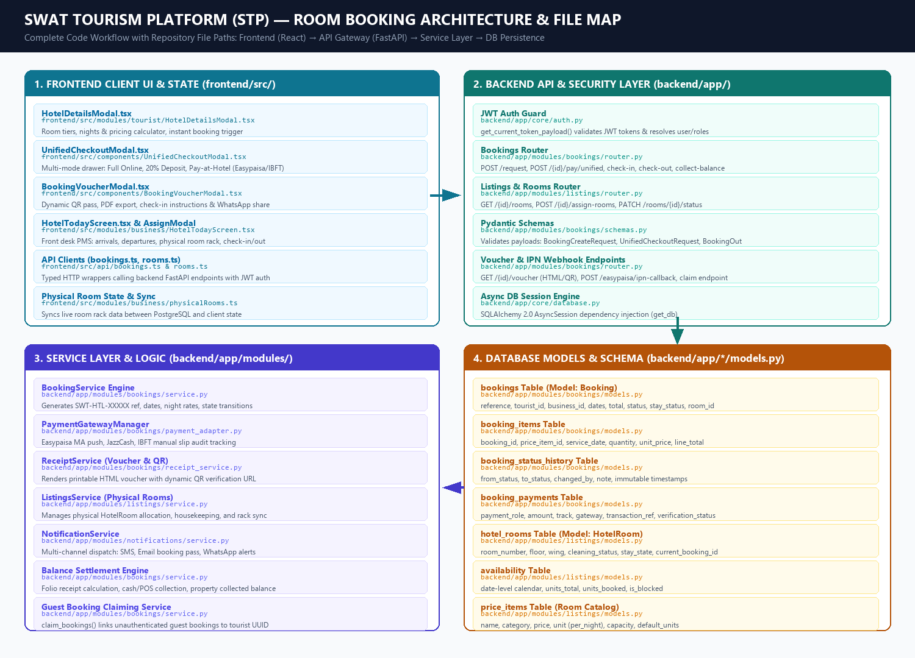
Figure 1.1: Complete Architectural Flow of the Hotel Room Booking System with Repository File Paths

2. Comprehensive Source File Directory & Exact Path Index
The table below indexes every file participating in the Room Booking workflow, including its exact relative path, primary classes/methods, and architectural domain:
Layer / Subsystem | Exact Relative File Path | Key Classes, Functions & Exports | Primary Task
Frontend (Tourist UI) | frontend/src/modules/tourist/  HotelDetailsModal.tsx | HotelDetailsModal,  handleInstantBook(),  handleGuestSubmit(),  currentSelectedRoom | Room selection, nights computation, booking submission for both authenticated and guest users.
Frontend (Payment Drawer) | frontend/src/components/  UnifiedCheckoutModal.tsx | UnifiedCheckoutModal,  handleProcessPayment(),  handleDirectTransferSubmit() | Multi-channel guarantee checkout: Full Online, 20% Deposit, or Pay at Hotel (Easypaisa/JazzCash/IBFT).
Frontend (QR Pass & Voucher) | frontend/src/components/  BookingVoucherModal.tsx | BookingVoucherModal,  window.print(),  getBookingVoucherUrl() | Visual boarding pass with live QR code, PDF export, check-in instructions, and WhatsApp sharing.
Frontend (Front-Desk PMS) | frontend/src/modules/business/  HotelTodayScreen.tsx | HotelTodayScreen,  handleCheckIn(),  handleCheckOut(),  handleCollectBalance() | PMS screen displaying arrivals, departures, stayed guests, and interactive Room Rack matrix.
Frontend (Room Allocation) | frontend/src/modules/business/  AssignRoomModal.tsx | AssignRoomModal,  handleSaveAssignment() | Front desk popup to select and allocate clean physical room numbers (e.g., 101, 204) to reservations.
Frontend (Folio Receipt) | frontend/src/modules/business/  HotelFolioReceiptModal.tsx | HotelFolioReceiptModal,  renderFolioReceipt() | Generates check-in arrival pass and check-out folio receipt with deposit and cash/card breakdown.
Frontend (Room Rack State) | frontend/src/modules/business/  physicalRooms.ts | syncPhysicalRoomsFromDb(),  getPhysicalRoomsForHotel(),  updatePhysicalRoomStatus() | Maintains physical room state, performs PostgreSQL DB sync, and emits swat_physical_rooms_updated.
Frontend (Bookings API Client) | frontend/src/api/bookings.ts | createBookingRequest(),  payUnifiedBooking(),  collectBookingBalance(),  checkInBookingApi(),  claimBookingsApi() | Typed frontend API client wrapping all /api/v1/bookings endpoints with JWT token transmission.
Frontend (Rooms API Client) | frontend/src/api/rooms.ts | fetchHotelRooms(),  assignRoomsToBookingApi(),  updateHotelRoomStatus(),  releaseHotelRoomApi() | Typed frontend API client wrapping hotel room rack inventory and housekeeping endpoints.
Frontend (HTTP Core Client) | frontend/src/api/client.ts | apiRequest<T>(),  getAuthHeaders() | Base HTTP fetch wrapper injecting Authorization: Bearer <JWT> and handling JSON serialization.
Backend (API Routing) | backend/app/modules/bookings/  router.py | POST /request,  POST /{id}/pay/unified,  POST /{id}/check-in,  POST /{id}/check-out,  POST /claim | Exposes REST endpoints for the full booking lifecycle, balance settlement, and IPN callbacks.
Backend (Pydantic Schemas) | backend/app/modules/bookings/  schemas.py | BookingCreateRequest,  UnifiedCheckoutRequest,  BookingOut, BookingItemOut,  ClaimBookingsRequest | Strict request payload validation, date format checks, positive amounts, and JSON output formatting.
Backend (Booking Engine) | backend/app/modules/bookings/  service.py | BookingService.create_booking(),  pay_unified_booking(),  check_in_booking(),  claim_bookings() | Generates booking references, computes night rates, manages availability locks, and executes state transitions.
Backend (Payment Adapter) | backend/app/modules/bookings/  payment_adapter.py | PaymentGatewayManager,  EasypaisaPaymentAdapter,  JazzCashPaymentAdapter | Processes online payments (Easypaisa MA push, JazzCash, Card) and tracks direct transfer proofs.
Backend (Voucher Engine) | backend/app/modules/bookings/  receipt_service.py | ReceiptService.generate_voucher_html(),  generate_receipt_html(),  build_qr_code() | Compiles responsive HTML/PDF vouchers with embedded dynamic QR codes pointing to verification URLs.
Backend (Rooms & Listings) | backend/app/modules/listings/  router.py & service.py | GET /{id}/rooms,  POST /{id}/assign-rooms,  PATCH /rooms/{id}/status,  ListingsService | Manages physical room rack inventory, room assignments, and housekeeping cleaning states.
Backend (Notifications) | backend/app/modules/notifications/  service.py | NotificationService.send_sms(),  send_email(),  send_whatsapp() | Dispatches multi-channel booking alerts, email vouchers, and WhatsApp boarding passes to guests and staff.
Backend (Bookings Models) | backend/app/modules/bookings/  models.py | Booking, BookingItem,  BookingStatusHistory,  BookingPayment | SQLAlchemy ORM models defining bookings, item line details, state transition audit trails, and payments.
Backend (Listings Models) | backend/app/modules/listings/  models.py | Listing, PriceItem,  Availability, HotelRoom | SQLAlchemy ORM models defining hotel listings, room tier pricing, inventory calendars, and physical rooms.
Test Suite (Frontend) | frontend/src/test/  guest_and_user_hotel_booking.test.tsx | describe('Hotel Booking Flow') | Automated test verifying guest checkout, authenticated checkout, room selection, and payment drawers.
Test Suite (Backend) | backend/tests/  test_bookings.py | test_create_booking_request(),  test_check_in_booking() | Pytest test suite validating API endpoints, date availability decrements, and status transitions.

3. Layer-by-Layer Technical & File Architecture
The room booking process is strictly partitioned across four coordinated architectural layers. Each layer encapsulates specific responsibilities to ensure separation of concerns, transactional safety, and high performance.
Layer | Repository File Paths | Assigned Tasks & Core Responsibilities
Layer 1: Frontend Client UI | frontend/src/modules/tourist/HotelDetailsModal.tsx  frontend/src/components/UnifiedCheckoutModal.tsx  frontend/src/components/BookingVoucherModal.tsx  frontend/src/modules/business/HotelTodayScreen.tsx  frontend/src/modules/business/AssignRoomModal.tsx  frontend/src/api/bookings.ts & rooms.ts | Presents room tiers, calculates night totals, triggers instant reservations, provides multi-gateway checkout drawers, generates printable QR passes, and manages front-desk room rack operations.
Layer 2: API & Security Gateway | backend/app/core/auth.py  backend/app/modules/bookings/router.py  backend/app/modules/listings/router.py  backend/app/modules/bookings/schemas.py  backend/app/core/database.py | Enforces JWT bearer authentication, parses HTTP payloads against strict Pydantic schemas, maps REST routes, handles IPN callbacks, and routes requests to domain services.
Layer 3: Business Logic & Services | backend/app/modules/bookings/service.py  backend/app/modules/bookings/payment_adapter.py  backend/app/modules/bookings/receipt_service.py  backend/app/modules/listings/service.py  backend/app/modules/notifications/service.py | Generates unique references (SWT-HTL-XXXXX), enforces date-range inventory locks, handles state transitions, triggers payment gateway pushes, compiles HTML vouchers, and sends WhatsApp/SMS alerts.
Layer 4: Relational Persistence | backend/app/modules/bookings/models.py  backend/app/modules/listings/models.py  backend/app/modules/accounts/models.py | Provides ACID-compliant relational data persistence in PostgreSQL/SQLite via SQLAlchemy 2.0 Async ORM with foreign key cascades, unique indexes, and audit logs.

4. End-to-End Execution Sequence Flow (With File Paths)
▶ Step 1: Room Selection & Reservation Submission
File: frontend/src/modules/tourist/HotelDetailsModal.tsx
API Wrapper: frontend/src/api/bookings.ts::createBookingRequest()
API Endpoint: backend/app/modules/bookings/router.py::create_booking_request_endpoint (POST /api/v1/bookings/request)
Service Execution: backend/app/modules/bookings/service.py::BookingService.create_booking()
Database Insert: backend/app/modules/bookings/models.py::Booking & BookingItem
Description: The tourist chooses a room category (e.g. Deluxe Room), selects check-in/out dates, and clicks 'Instant Book'. BookingService calculates nights, verifies capacity, generates reference code (SWT-HTL-XXXXX), increments availability.units_booked, and inserts records into bookings and booking_items with status 'requested'.
▶ Step 2: Guarantee & Unified Checkout
File: frontend/src/components/UnifiedCheckoutModal.tsx
API Wrapper: frontend/src/api/bookings.ts::payUnifiedBooking()
API Endpoint: backend/app/modules/bookings/router.py::pay_unified_booking_endpoint (POST /api/v1/bookings/{id}/pay/unified)
Payment Adapter: backend/app/modules/bookings/payment_adapter.py::PaymentGatewayManager
Database Insert: backend/app/modules/bookings/models.py::BookingPayment
Description: The tourist chooses their preferred payment mode:
• Full Online (100%): Pays total room price upfront via Easypaisa, JazzCash, or Card.
• Confirmation Deposit (20%): Pays 20% deposit online to lock room; balance payable at front desk.
• Pay at Hotel: Guarantees reservation without immediate payment; 100% collected on arrival.
PaymentGatewayManager validates the transaction, records it in booking_payments, and updates booking status to 'confirmed' with payment_status set to 'paid' or 'deposit_paid'.
▶ Step 3: Official Voucher & Dynamic QR Code Generation
File: frontend/src/components/BookingVoucherModal.tsx
API Endpoint: backend/app/modules/bookings/router.py::get_booking_voucher_endpoint (GET /api/v1/bookings/{id}/voucher)
Service Execution: backend/app/modules/bookings/receipt_service.py::ReceiptService.generate_voucher_html()
Notifications: backend/app/modules/notifications/service.py::NotificationService
Description: Upon confirmation, the frontend opens BookingVoucherModal.tsx. The backend ReceiptService generates an official booking pass with a dynamic QR code pointing to /api/v1/bookings/{id}/voucher. Concurrently, NotificationService sends confirmation alerts via SMS, HTML Email, and WhatsApp.
▶ Step 4: Front-Desk Room Allocation & Arrival
File: frontend/src/modules/business/HotelTodayScreen.tsx & AssignRoomModal.tsx
State Sync: frontend/src/modules/business/physicalRooms.ts::syncPhysicalRoomsFromDb()
API Wrapper: frontend/src/api/rooms.ts::assignRoomsToBookingApi()
API Endpoint: backend/app/modules/listings/router.py::assign_rooms_endpoint (POST /api/v1/listings/{id}/assign-rooms)
Database Update: backend/app/modules/listings/models.py::HotelRoom
Description: The hotel front-desk agent logs into HotelTodayScreen.tsx and inspects the Room Rack matrix. Using AssignRoomModal.tsx, the agent assigns an available, clean room number (e.g. Room 204) to the reservation, updating hotel_rooms to status 'reserved' with current_booking_id.
▶ Step 5: Check-In & Remaining Balance Settlement
File: frontend/src/modules/business/HotelTodayScreen.tsx & HotelFolioReceiptModal.tsx
API Wrapper: frontend/src/api/bookings.ts::collectBookingBalance() & checkInBookingApi()
API Endpoints: POST /api/v1/bookings/{id}/collect-balance & POST /api/v1/bookings/{id}/check-in
Database Updates: bookings (stay_status='checked_in') & hotel_rooms (status='occupied', stay_state='occupied')
Description: Upon guest arrival at reception, the front desk scans the QR voucher. If a remaining balance exists, staff records cash or POS payment. Then staff clicks 'Check In', which marks bookings.stay_status = 'checked_in' and hotel_rooms.status = 'occupied'.
▶ Step 6: Check-Out & Housekeeping Turnover
File: frontend/src/modules/business/HotelTodayScreen.tsx
API Wrapper: frontend/src/api/bookings.ts::checkOutBookingApi() & api/rooms.ts::updateHotelRoomStatus()
API Endpoints: POST /api/v1/bookings/{id}/check-out & PATCH /api/v1/listings/rooms/{id}/status
Database Updates: bookings (status='completed', stay_status='checked_out') & hotel_rooms (status='cleaning' → 'available')
Description: At departure, staff executes check-out. The booking transitions to 'completed'. The assigned physical room automatically transitions to status 'cleaning' and stay_state = 'turnover'. Once housekeepers finish sanitization, they update the room to 'ready', making it 'available' again.

5. Database Relational Schema & Data Dictionary
The room booking process relies on seven primary database tables modeled in SQLAlchemy 2.0 Async ORM. The exact model file paths and table definitions are detailed below:
Table Name & File Path | Key Columns & Foreign Keys | Role in Room Booking Process
bookings  (backend/app/modules/  bookings/models.py) | id (UUID PK)  reference (String 20, unique)  tourist_id (FK users.id)  business_id (FK business_profiles.id)  listing_id (FK listings.id)  status, payment_status, stay_status  total_amount, deposit_amount  assigned_room_number, assigned_room_id | Master reservation record. Stores booking reference, tourist identity, check-in/out dates, price calculations, guarantee track, and front-desk stay states.
booking_items  (backend/app/modules/  bookings/models.py) | id (UUID PK)  booking_id (FK bookings.id)  price_item_id (FK price_items.id)  service_date (Date)  quantity (Integer)  unit_price, line_total (Numeric 12,2) | Individual room line items. Records which room tier was selected, the quantity of rooms booked, price per night, and line totals.
booking_status_history  (backend/app/modules/  bookings/models.py) | id (UUID PK)  booking_id (FK bookings.id)  from_status, to_status (String 20)  changed_by (FK users.id)  note (Text), created_at (DateTime) | Immutable audit trail capturing every state transition (requested → accepted → confirmed → checked_in → completed) with timestamp and user attribution.
booking_payments  (backend/app/modules/  bookings/models.py) | id (UUID PK)  booking_id (FK bookings.id)  payment_role, collection_stage  track, payment_method, funds_custody  amount, currency, transaction_ref  verification_status | Financial ledger recording online advance deposits, direct bank transfer references, and front-desk balance collections.
hotel_rooms  (backend/app/modules/  listings/models.py) | id (UUID PK)  listing_id (FK listings.id)  price_item_id (FK price_items.id)  room_number, floor, wing  status, cleaning_status, stay_state  current_booking_id (FK bookings.id) | Physical room inventory representing individual hotel rooms (e.g. 101, 102, 201). Tracks live occupancy, reservation links, and housekeeping cleanliness.
price_items  (backend/app/modules/  listings/models.py) | id (UUID PK)  listing_id (FK listings.id)  name, category, price, unit  capacity, default_units, is_bookable | Catalog of room tiers offered by the property (e.g. Standard Room, Deluxe River View, Executive Suite) with nightly pricing and capacity.
availability  (backend/app/modules/  listings/models.py) | id (UUID PK)  price_item_id (FK price_items.id)  date (Date)  units_total, units_booked (Integer)  is_blocked (Boolean) | Date-level calendar matrix preventing double-booking by tracking total room inventory against booked room units per day.

6. State Transition Matrices
The booking header and physical room inventory progress through synchronized state lifecycles:
Lifecycle Stage | Booking status | payment_status | stay_status | Trigger Endpoint & File
1. Reservation | requested | unpaid | reserved | POST /bookings/request  (bookings/router.py)
2. Guarantee | confirmed | deposit_paid / paid | reserved | POST /bookings/{id}/pay/unified  (bookings/router.py)
3. Check-In | confirmed | paid | checked_in | POST /bookings/{id}/check-in  (bookings/router.py)
4. Check-Out | completed | paid | checked_out | POST /bookings/{id}/check-out  (bookings/router.py)
5. Cancellation | cancelled | refunded / unpaid | null | POST /bookings/{id}/cancel  (bookings/router.py)

Room Rack State | room status | stay_state | cleaning_status | Operational Trigger & File
Vacant Clean | available | vacant | ready | Default ready state for check-in
Allocated | reserved | reserved | ready | Front desk assigns room to booking  (AssignRoomModal.tsx)
Guest In-House | occupied | occupied | ready | Guest check-in executed  (HotelTodayScreen.tsx)
Turnover | cleaning | turnover | cleaning | Guest check-out executed  (HotelTodayScreen.tsx)
Sanitized | available | vacant | ready | Housekeeping turnover finished  (PATCH /rooms/{id}/status)

📌 Guest Booking Claiming Architecture & File Path
The system supports instant frictionless booking for unauthenticated guests via HotelDetailsModal.tsx by storing local reservation tracking tokens. When the guest later registers or logs into a verified tourist account, the frontend triggers claimBookingsApi() in frontend/src/api/bookings.ts calling POST /api/v1/bookings/claim handled in backend/app/modules/bookings/router.py and executed by BookingService.claim_bookings() in backend/app/modules/bookings/service.py. The backend matches guest phone/email or reference codes, updates booking.tourist_id to the authenticated user UUID, and seamlessly merges all reservations into their account history.

