Swat Tourism Platform (STP)
Shared Core Files Across All Modules: Browser Rendering → Frontend Pipeline → FastAPI Core → Database
Attribute | Details
Scope | Application-Wide Shared Infrastructure Files (Frontend, Proxy, Backend Core, Database)
Workspace Root | f:\Antigravity\SwatTourismProduction_v2
Frontend Entry & Shared | index.html, main.tsx, App.tsx, context/*.tsx, api/client.ts, vite.config.ts
Backend Entry & Core | app/main.py, core/config.py, core/deps.py, core/security.py, core/database.py, core/storage.py, core/sms.py
Modules Served | Bookings, Listings/Hotels, Trips, Accounts, Safety, Community, Verification, Finance, Reviews, Notifications

1. End-to-End Shared Core Architecture Diagram
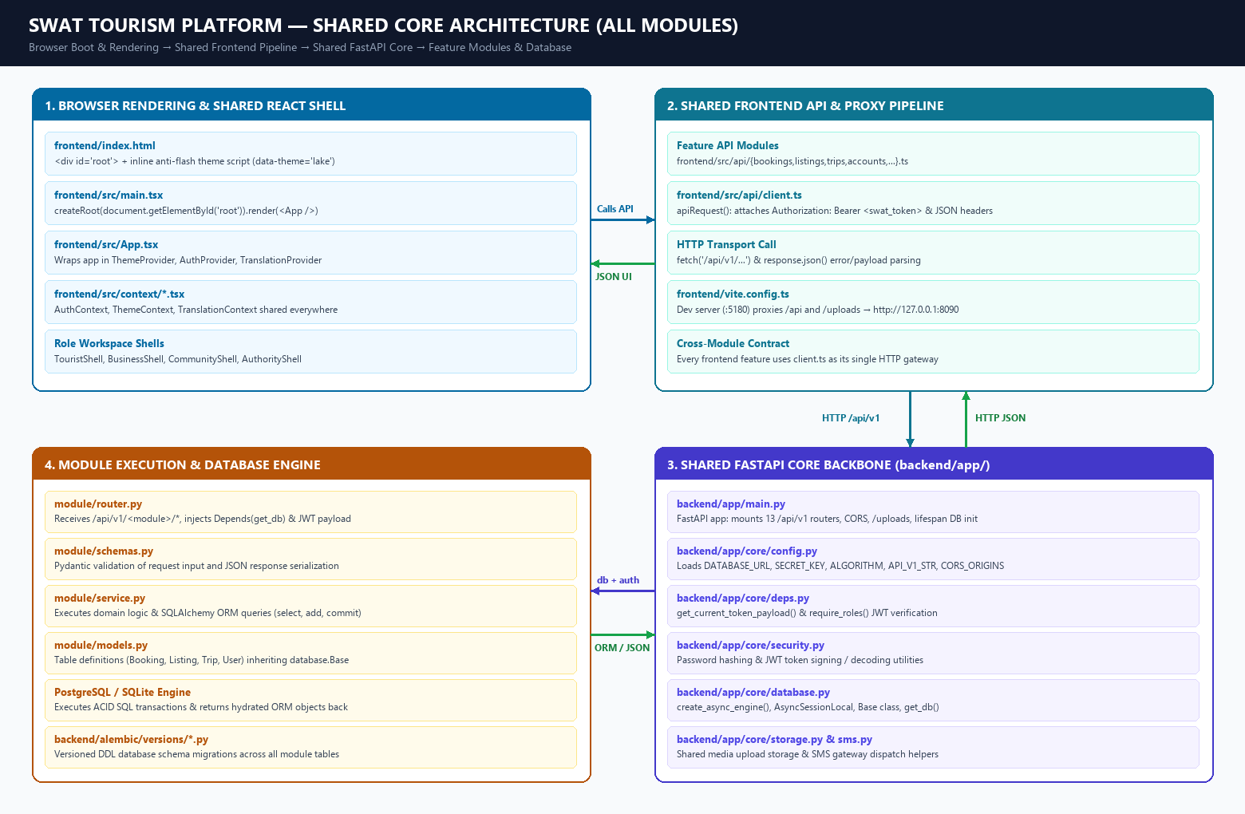
Figure 1: Application-Wide Shared Core Backbone from Browser Rendering to Database Execution

2. Shared Frontend Core Files (Used by All UI Modules)
File Path | Shared Responsibility Across Whole App
frontend/index.html | Browser entry HTML. Provides <div id='root'></div>, loads Google Fonts, and runs the inline anti-flash theme script before React loads.
frontend/src/main.tsx | React bootstrapper. Mounts <App /> into #root via createRoot() and imports global CSS (index.css, leaflet.css).
frontend/src/App.tsx | Master shell. Wraps the entire app in ThemeProvider, AuthProvider, and TranslationProvider, manages role/tab state, and renders TouristShell, BusinessShell, CommunityShell, or AuthorityShell inside ResponsiveLayout.
frontend/src/context/  AuthContext.tsx | Shared authentication state (user, login, logout, demoLogin) and JWT storage across every screen and role.
frontend/src/context/  ThemeContext.tsx &  TranslationContext.tsx | Shared visual theme switching and multi-language translation providers accessible from any component.
frontend/src/api/client.ts | Single shared HTTP client (apiRequest<T>()). Every module API file (bookings.ts, listings.ts, trips.ts, etc.) calls this to attach Authorization: Bearer <swat_token>, run fetch('/api/v1/...'), and parse JSON responses/errors.
frontend/vite.config.ts | Development server (port 5180) that proxies all /api and /uploads calls to the FastAPI backend at http://127.0.0.1:8090.

3. Shared Backend Core Files (Used by All API Modules)
File Path | Shared Responsibility Across Whole Backend
backend/app/main.py | FastAPI application entrypoint. Initializes app, adds CORS middleware, mounts /uploads static media, installs global exception handler, runs startup lifespan (Base.metadata.create_all), and registers all 13 module routers under /api/v1.
backend/app/core/config.py | Centralized Pydantic Settings loading DATABASE_URL, SECRET_KEY, ALGORITHM, API_V1_STR, and CORS_ORIGINS from environment.
backend/app/core/deps.py | Shared FastAPI dependencies: get_current_token_payload(), get_optional_token_payload(), and require_roles() for JWT decoding and role-based access control.
backend/app/core/security.py | Shared password hashing/verification and JWT token signing utilities.
backend/app/core/database.py | Single shared DB engine & session factory: defines Base (inherited by all module models.py), UUIDPrimaryKeyMixin, TimestampMixin, create_async_engine(), AsyncSessionLocal, and get_db().
backend/app/core/storage.py &  backend/app/core/sms.py | Shared file upload storage manager and SMS notification dispatch helper used across modules.

4. Whole-App Workflow: Browser Render → Backend → Database
📌 STEP 1: How the App Renders in the Browser
1. Browser loads frontend/index.html, sets data-theme='lake' via inline script, and exposes <div id='root'>.
2. frontend/src/main.tsx runs createRoot(document.getElementById('root')!).render(<App />).
3. frontend/src/App.tsx mounts ThemeProvider, AuthProvider (restoring saved session from localStorage), and TranslationProvider.
4. MainAppContent checks user.role and renders the active portal shell (TouristShell, BusinessShell, CommunityShell, or AuthorityShell) inside ResponsiveLayout.

📌 STEP 2: How Any Action Calls the Backend & Database (and Returns)
1. UI Interaction: A component in any module calls its feature API file (e.g., api/bookings.ts, api/listings.ts, api/trips.ts).
2. Shared Transport (api/client.ts): All feature API files call apiRequest(), which attaches localStorage.getItem('swat_token') as Authorization: Bearer <JWT> and calls fetch('/api/v1/...').
3. Vite Dev Proxy (vite.config.ts): Port 5180 intercepts /api requests and forwards them to the FastAPI backend on port 8090.
4. FastAPI Core (main.py + deps.py + database.py): main.py routes the path to the matching module/router.py, deps.py verifies the JWT, and database.py injects an AsyncSession (db) via Depends(get_db).
5. Execution & Return: router.py passes db + payload to module/service.py, which executes SQLAlchemy ORM queries against module/models.py (inheriting database.Base). SQL results return as ORM objects → serialized to JSON by router.py → parsed by client.ts response.json() → React re-renders the UI.

