|  |  |
| --- | --- |
|  | DEPARTMENT OF SCIENCE AND TECHNOLOGY(CSE) |
| Name | Kishal shah |
| Class | SY-A |
| Roll No | 31 |
| SRN No | 202101296 |
| Subject | ASA LAB |

|  |  |
| --- | --- |
| PRACTICAL TITLE | Assignment-9 |

**results of the t-test as follows**

|  |  |  |  |
| --- | --- | --- | --- |
| T value | df | p-value | 95% Conf. Interval (CI) of mean difference |
| 3.776 | 19 | 0.001278 | 0.2274728  0.97932545 |

**Compute descriptive statistics of DV - mean & SD of DV for each category of IV**

|  |  |  |  |
| --- | --- | --- | --- |
| Group | Mean (DV) | Sd (DV) | No of records |
| control | 5.06 | 0.283 | 10 |
| exercise | 4.55 | 0.332 | 11 |

Compute mean_difference => difference in mean of DV for both groups ( from above table) mean_difference = 1 0.5103636

SIGNIFICANCE OF DIFFERENCE

Is there a significant difference between mean Cholestrol levels of the two groups ?

t.test gives(a) t-value (t), (b) degrees of freedom (df), (c) p-value

t = 3.776, df = 19, p-value = 0.001278

p-value is used to determine if there is statistically significant difference in means of groups

if p < 0.05 --> there is statistically significant difference between Cholestrol levels if p >= 0.05 --> there is no statistically significant difference between Cholestrol levels

In this case p-value = 0.001278< 0.05 Hence both group means are significantly difference Population mean also exbits the same difference as of the sample mean

**#Visualization**

**Mean +/- standard deviation**

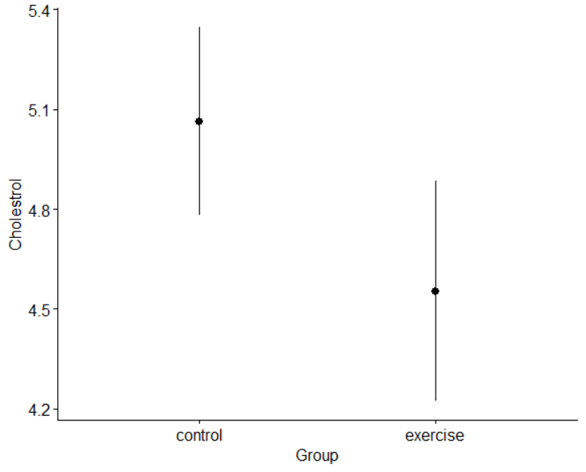

**Changing error plot type and add mean points**

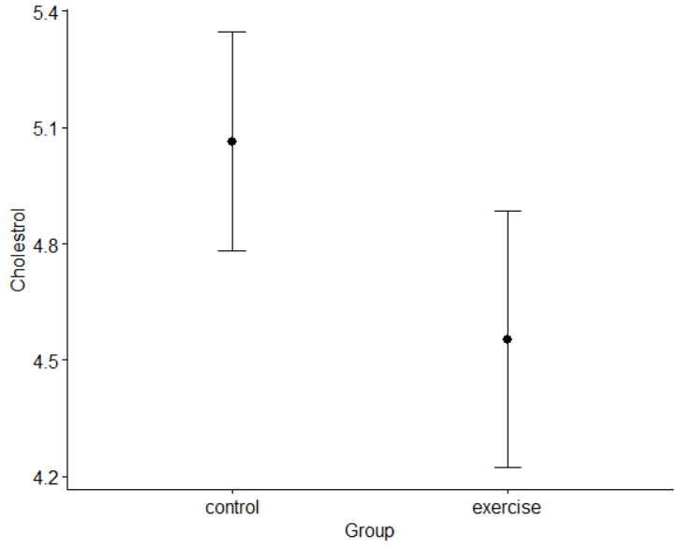

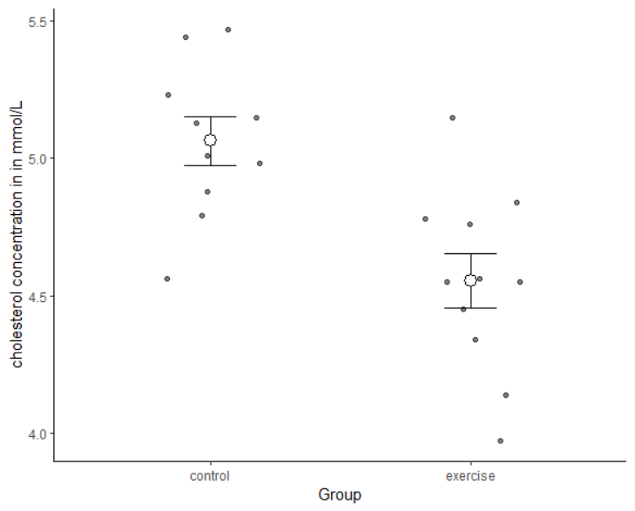

**Creating A Plot**

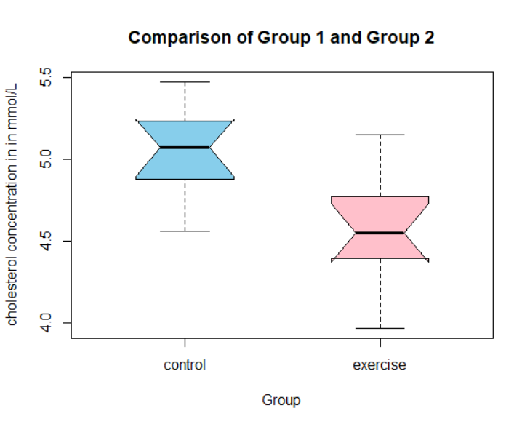

**The side-by-side boxplot with mean, median, quartiles, and outliers**

**PART-2**

**results of the t-test as follows**

|  |  |  |  |
| --- | --- | --- | --- |
| T value | df | p-value | 95% Conf. Interval (CI) of mean difference |
| -4.1375 | 37 | 0.0001941 | -29.99712  -10.27530 |

**Compute descriptive statistics of DV - mean & SD of DV for each category of IV**

|  |  |  |  |
| --- | --- | --- | --- |
| Group | Mean (DV) | Sd (DV) | No of records |
| Female | 65.6 | 15.8 | 10 |
| Male | 65.6 | 15.8 | 29 |

Compute mean_difference => difference in mean of DV for both groups ( from above table) mean_difference = 1 0.5103636

SIGNIFICANCE OF DIFFERENCE

t.test gives(a) t-value (t), (b) degrees of freedom (df), (c) p-value

t = -4.1375, df = 37, p-value = 0.0001941

**#Visualization**

**Mean +/- standard deviation**

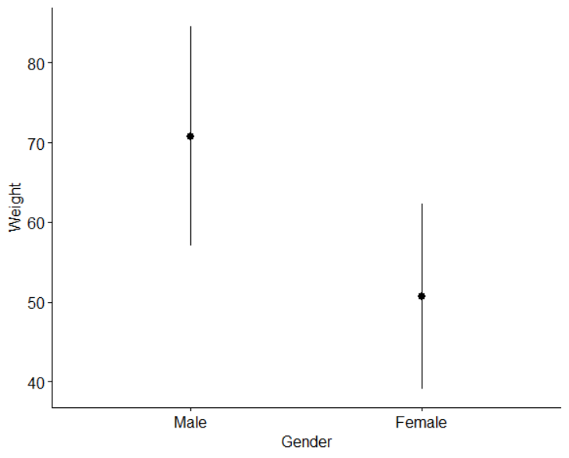

**Changing error plot type and add mean points**

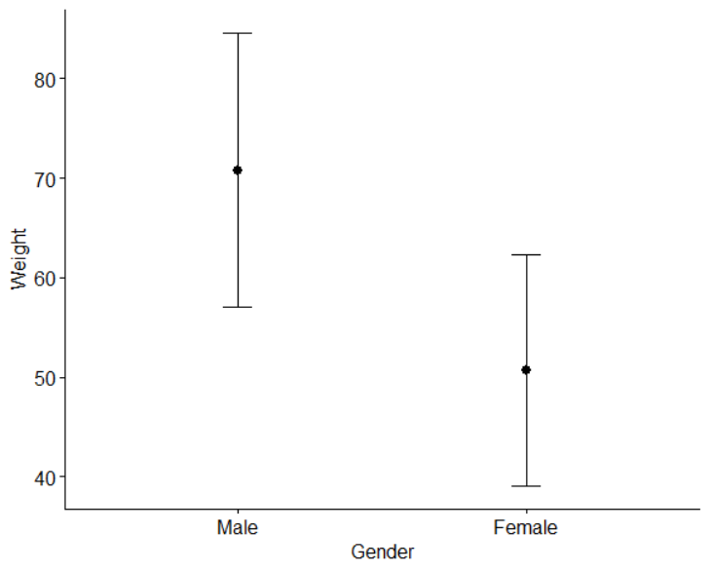

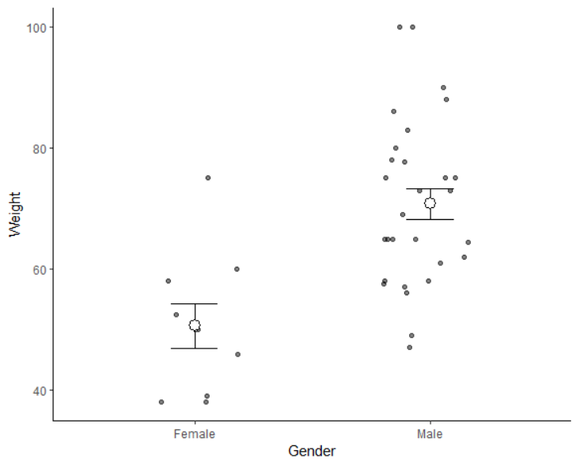

**Creating A Plot**

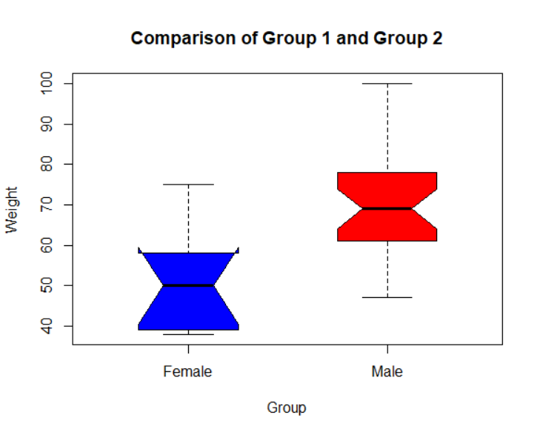

**The side-by-side boxplot with mean, median, quartiles, and outliers**