# Testimonial

Testimonials are an idea of a public tribute to some person or an organization and to their achievements.

Here on the hospital website the patient reviews are showcased as an effort of the hospital and its staff in the form of testimonials. On this page, the visitors of the website will be able to see some of the efforts and achievements of the hospital in the form of images and statements based on the testimonial i.e. feedback shared by the patients who have been treated successfully and had satisfactory services.

The patients will be able to submit testimonial upload image and statements of the accomplishments of the hospital on the page. Then hospital staff will have the access to publish or unpublish any of the posts they have uploaded and it will reflect on the page as they save the changes. The staff can also delete some old testimonials and can update the page with new testimonials.

The benefit of testimonial page on a hospital website is that it highlights the services offered by the hospital and its staff; the hospital can advertise and attract the patients and visitors based on the feedbacks and testimonials. The viewers gets advantage of comparing and can discern visually the successful treatments done by the doctors of hospital.

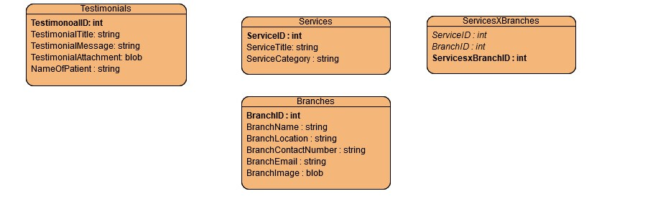

* User/Patient can only submit a testimonial through form available in the page.
* Staff can see the submission in list, have access to publish or unpublish, and delete testimonial.
  1. Publishing the testimonial will upload the testimonial to the user view of the website.
  2. Unpublishing will only remove the testimonial from the user view.
  3. Deleting testimonial will remove from the database.

# Service availability

This page is an informational page for the website visitors. This page displays the services that are available at three different locations of the Mics Group of Hospital. Visitors will be able to see and get information about what services are available at different locations. This can help hospital reduce staff members’ engagement with people calling for the service availabilities.



Services – Branches (Many to Many relationship)

A branch can have many services and a service can be available to many locations.

* 3 pre-defined locations of the hospital
* Staff can list the services, can update and delete a service.
* Staff can choose branch(s) a service is available at the time of creating or updating a service.
* Users can see the list of services available at various locations of the hospital under different branch section.