**Turtle**

Turtle is a pre-installed library in Python that we can draw pictures and attractive shapes on windows or screen. It provides the onscreen pen that we can use for drawing.

The Python turtle library consists of all important methods and functions that we will need to create our designs and images. Import the turtle library using the following command.



Now, we can access all methods and functions. First, we need to create a dedicated window where we carry out each drawing command. We can do it by initializing a variable for it.

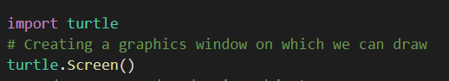

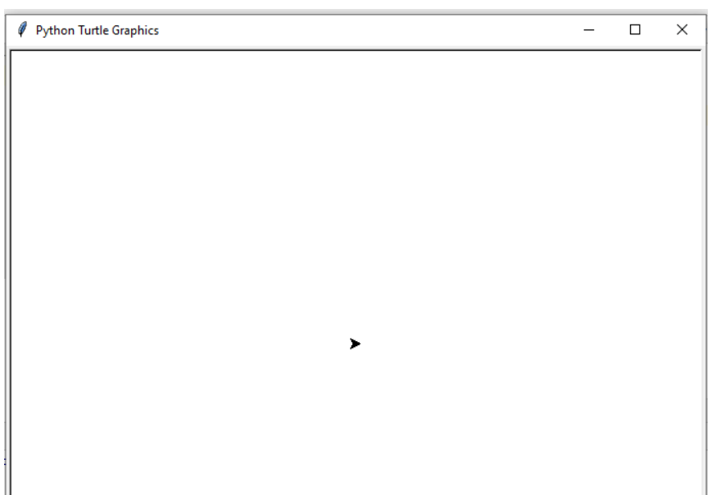

It will look like an above image and the little triangle in the middle of the screen is a turtle. If the screen is not appearing in your computer system, use the below code.

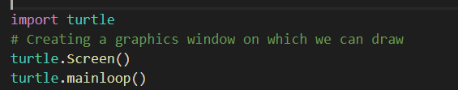

You can move the turtle to design the desired shape. The turtle has certain changeable features such as color, speed, and size. It can be moved to a specific direction, and move in that direction unless we tell it otherwise.

First, we need to learn to move the turtle all direction as we want. We can customize the pen like turtle and its environment. Let's learn the couple of commands to perform a few specific tasks.

**Turtle Shapes**



**To change the shape type command**

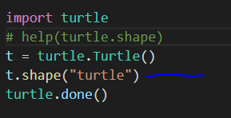

**To change the turtle and line color type command**

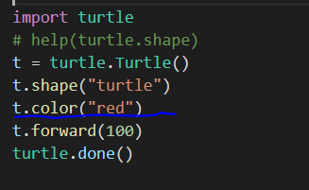

**If you want line color is different and turtle color is different type command**



**To change the Screen title type command**

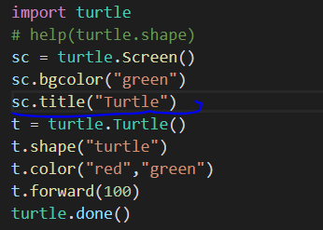

**Changing the Screen Color**

By default, the turtle screen is opened with the white background. However, we can modify the background color of the screen using the following function.

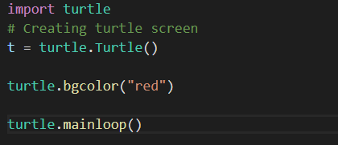

**OUTPUT**

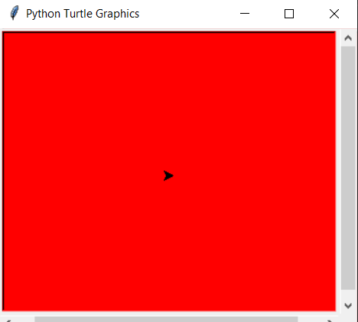

**Changing the Screensize**

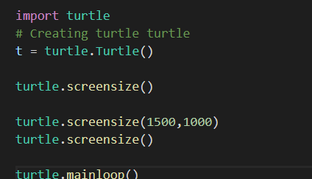

## Changing the Pen Size

## 

## OUTPUT

## 

## Changing the Pen Speed

## The speed of the turtle can be changed. Generally, it moves at a moderate sped over the screen but we can increase and decrease its speed. Below is the method to modify the turtle speed.

## 

## 

## Clearing Screen

## 

**There are different methods available for drawing:**

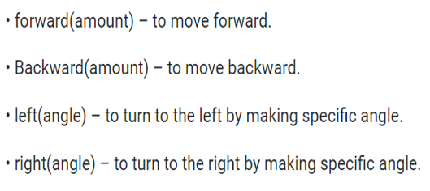

**Forward**

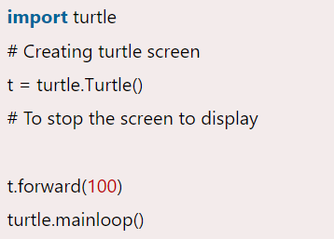

**Backward**

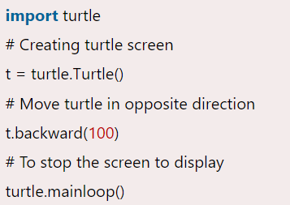

**Left**

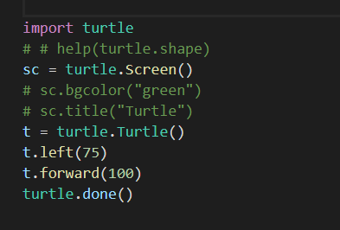

**Right**

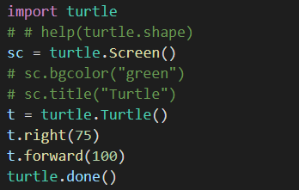

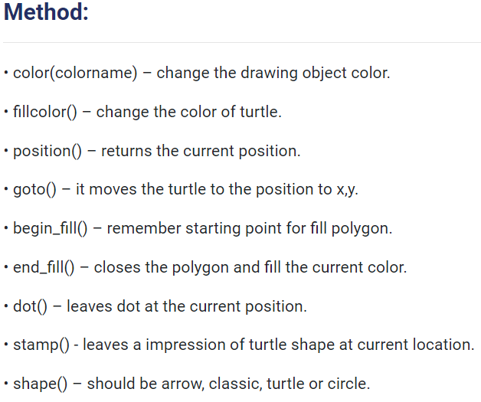

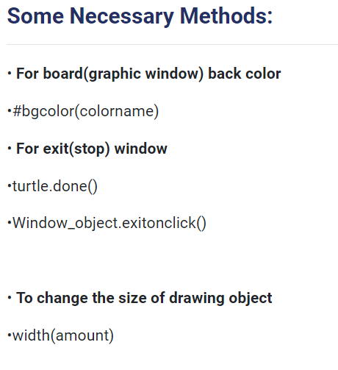

**Drawing a Shape**

We discussed the movement of the turtle. Now, we learn to move on to making actual shape. First, we draw the **polygon** since they all consist of straight lines connected at the certain angles. Let's understand the following example.

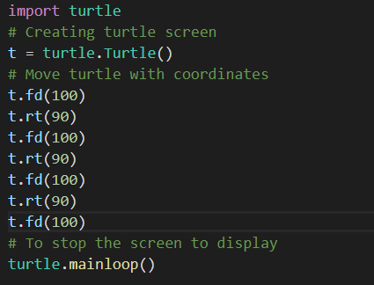

**OUTPUT**

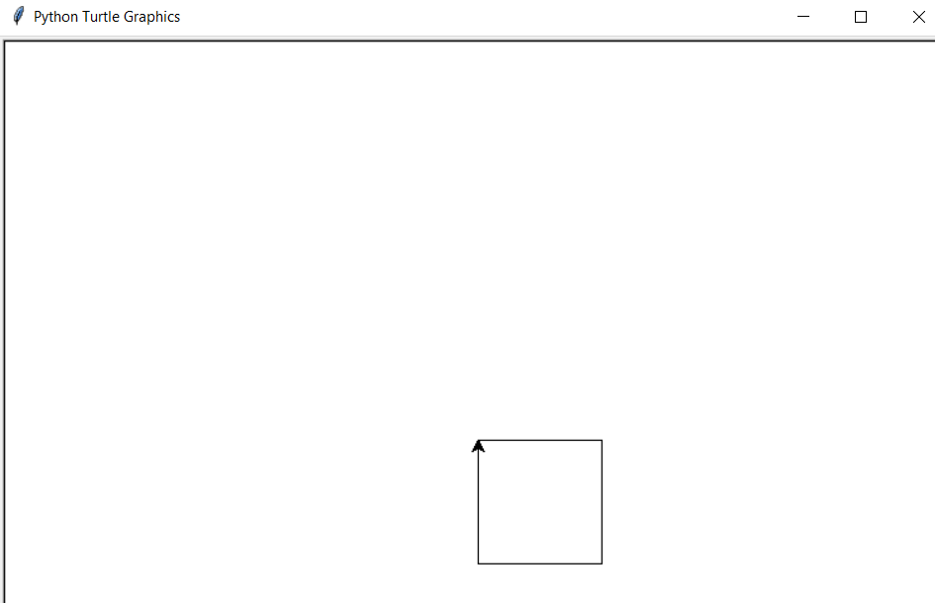

**Drawing a Square using loop**

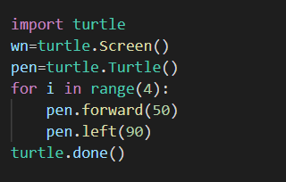

**OUTPUT**

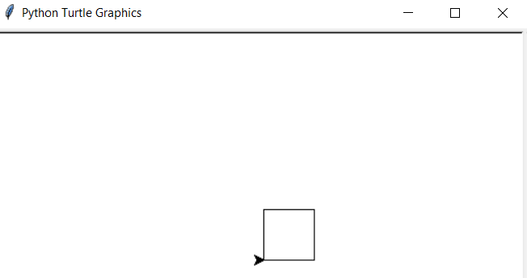

**To fill the color inside square shape**

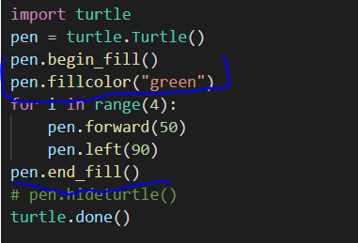

**OUTPUT**

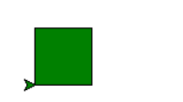

**How to hide turtle**

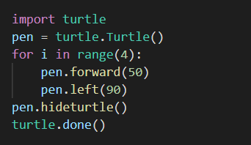

**OUTPUT**

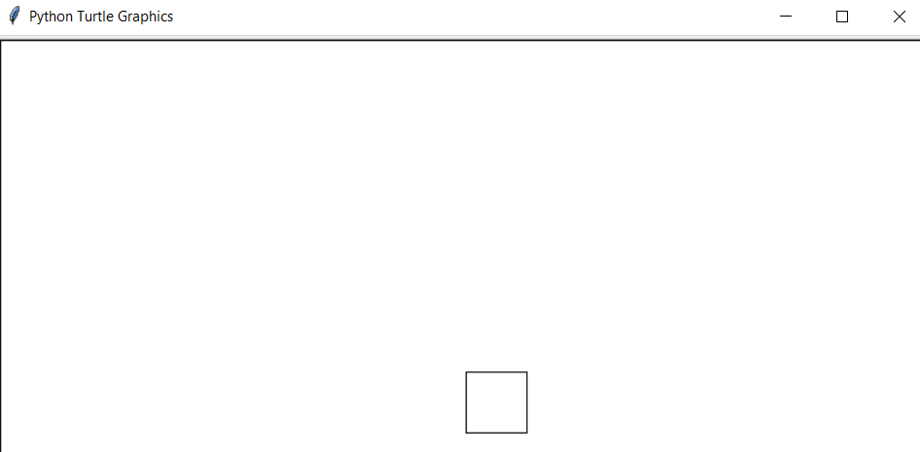

**Drawing a Hexagon**

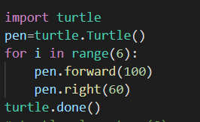

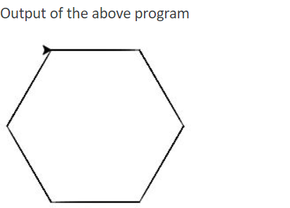

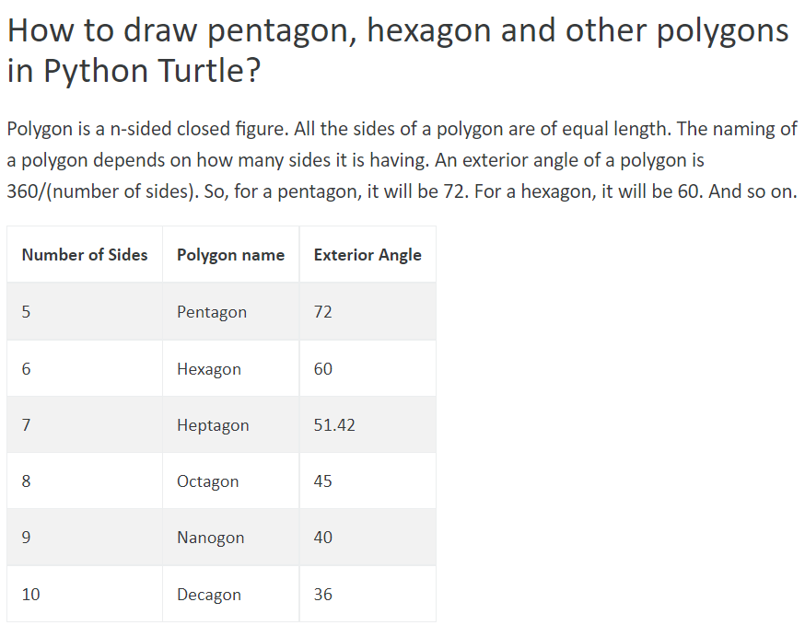

Suppose you want to draw a **circle**. If you attempt to draw it in the same way as you drew the square, it would be extremely tedious, and you'd have to spend a lot of time just for that one shape. Thankfully, the Python turtle library provides a solution for this. You can use a single command to draw a circle.

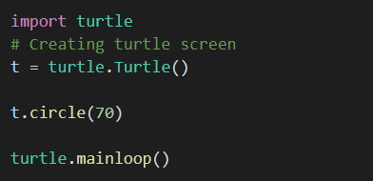

**OUTPUT**

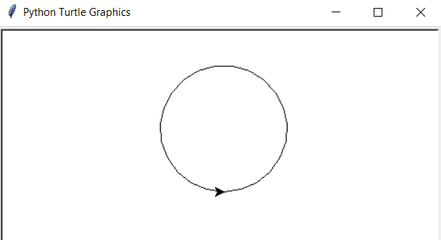

We can also draw a dot, which is also known as a filled-in circle. Follow the given method to draw a filled-in circle.

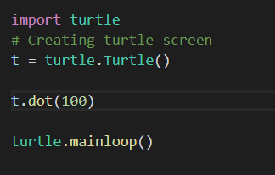

**OUTPUT**

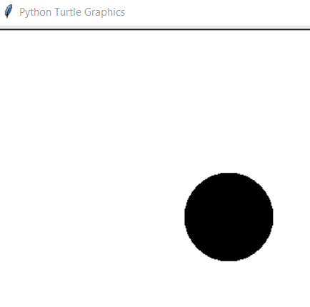

# **To draw shape from different position**

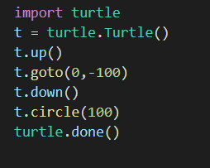

# **turtle.seth()** function in Python

This method is used to set the orientation of the turtle to **to_angle**. This method requires only one argument as an angle.

### 

**Below is the implementation of the above method with an example:**

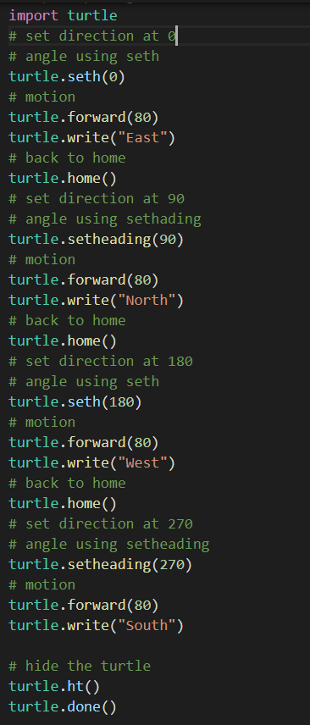

**OUTPUT**

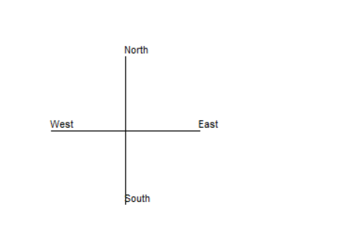

### **Attractive Designs using Python Turtle Library**

We have learned basic and advance concepts of Python turtle library. We explain every possible feature of this library. By using its function, we can design games, unique shapes and many more things. Here, we mention a few designs using the turtle library.

### **Design -1 Circle Spiro graph**

## 

## 

## Implementation of Methods

## 

## 

## 