**Knowledge Transfer System**

Kshitij Shah(48)

Tirth Parekh(37)

Tejas Paranjape(35)

**Overview:-**

Knowledge transfer System(KTS) is an online system which will help transfer not only explicit but also tacit knowledge from a senior employee to the new employee. Today whenever a senior employee leaves a project or office a huge void is left cause the incoming employee is not aware about the working of the office/project and hence KTS is needed

KTS records all the search history of the employee and maps it into the database to a particular topic. The system automatically generated a document after listening to clients requirements. Videos, blogs and FAQs are posted on it for other employees to see. All of this is made available to the entire organization thus making the process of transfer of knowledge super easy, quick and efficient

**Data Flow Diagram:-**

**LEVEL 0**

Level 0 gives the basic function done by the employees. It gives an outline of all the major things the senior and new employee can do respectively. The entire process is shown in one circle that is Knowledge Transfer System. The senior employee sends some data and the new employee uses the output . The main function of new employee are to view generated document, blogs, calendar etc. The input for these things are given by the senior employee

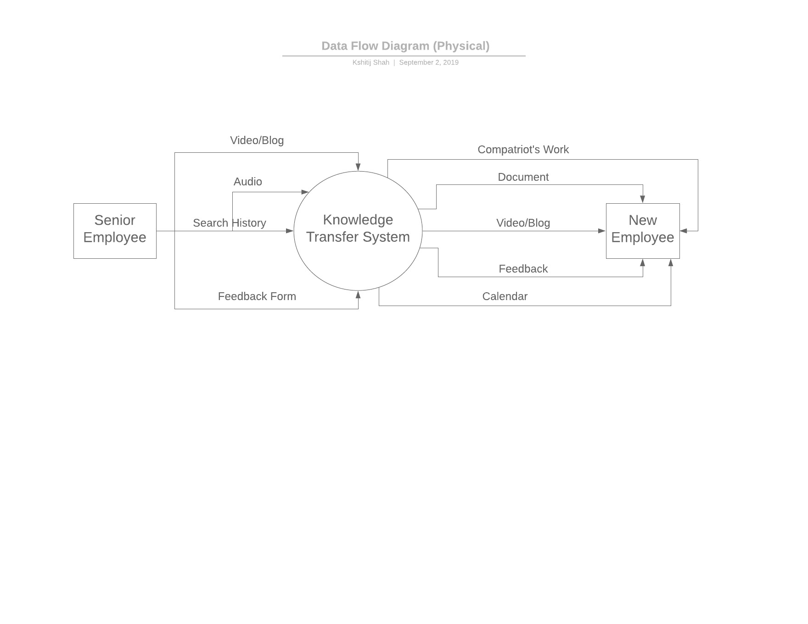

**LEVEL 1**

Level 1 is basically an expansion of things happening in level 0. Here I have expanded the things done by the new employee with respect to the system.

In process 1.0 the employee will verify his credentials and enter the system.

In process 2.0 and 3.0 the employee passes a keyword and he/she is able to retrieve recommendations, blogs and videos related to the keyword as uploaded by the senior employee.

In process 4.0 and 5.0 the new employee is able to view the document generated from the audio given to the process by the client

In process 6.0 the new employee can view all the project done by his/her compatriot and sort according to the field.

In process 7.0 the new employee can view all the schedules and deadlines for the week and plan accordingly.

This is how the level 1 DFD has been built.

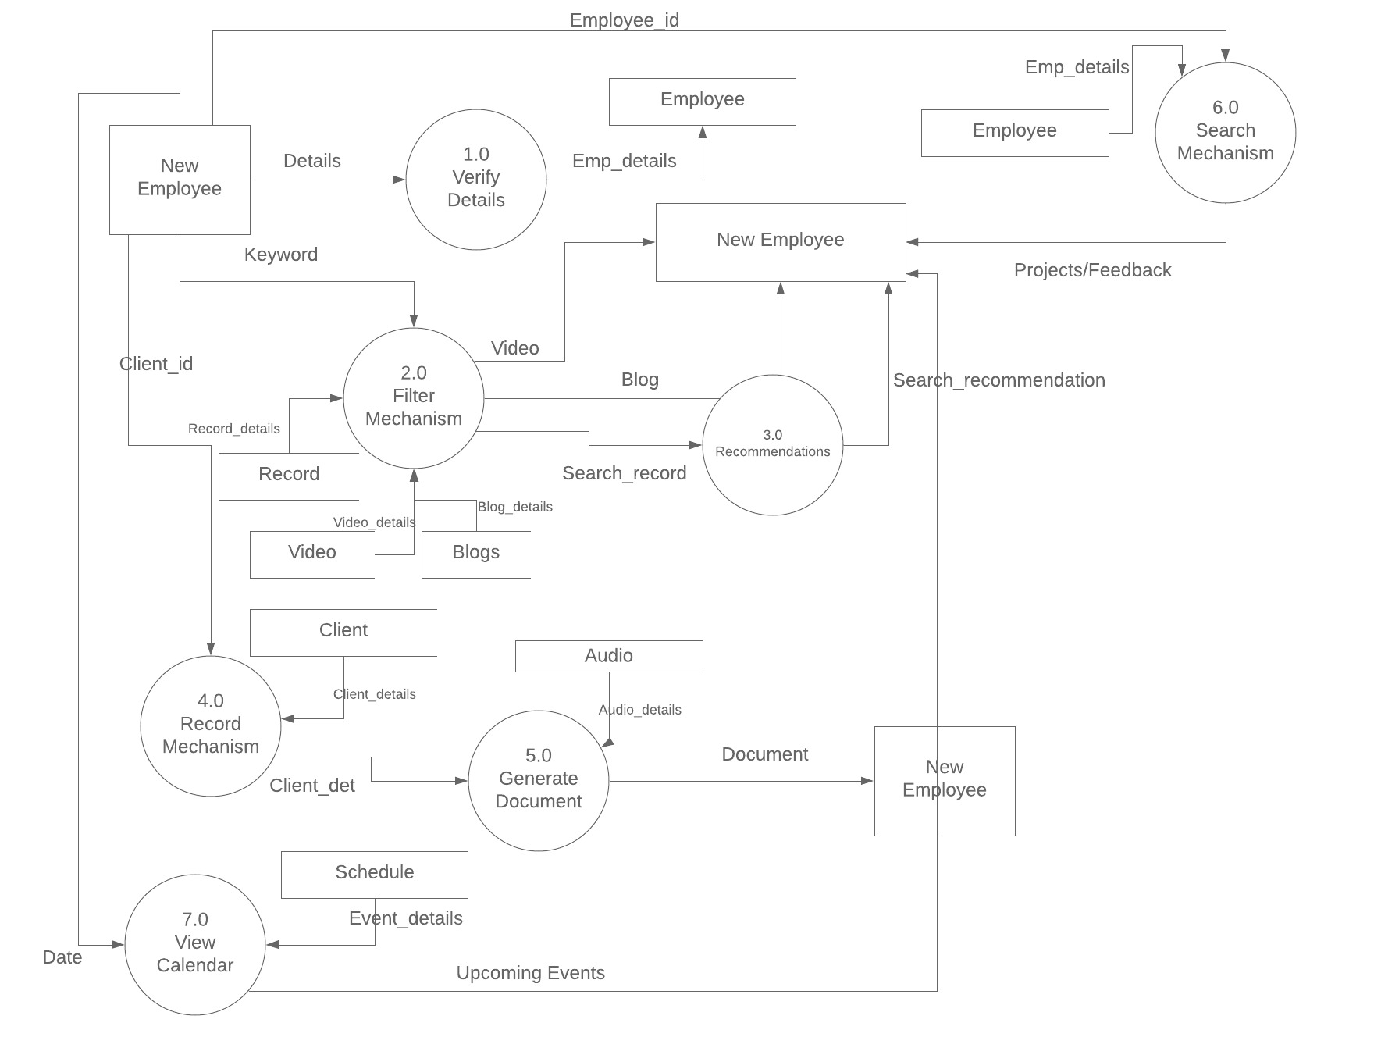

**LEVEL 2**

In level 2 the process accessing multiple datastore is divided hence we are dividing the filter mechanism of level 1 into several parts. In level 2 three separate process are created with each accessing different data store. One process is responsible for video, the other for blogs and the third one for search recommendations

