Double click lineage_launcher.exe

Order of steps doesn’t matter but tiff radio button needs to be set before choosing the image.

Set end time

Make sure ‘make 8 bit tiff slices’ radio button is marked if this is first time analyzing this data set

Click on browse by ‘base parameter file name:’ and select provide param file ‘detection_parameters-tiffdata.txt’

Click browse by ‘output directory:’ and select directory for acetree file output

Select radio button for image type:

Matlab file (image stack in a 3d array, one timepoint per .mat file)

Simple tiff (multi slice single channel tif per timepoint)

SplitChannel (Bao lab specific metamorph file red and green channel side by side in single file)

Click browse near ‘image name’ select any image from the series to analyze

Draw a loose circle around the embryo, closing it by clicking on first point

Click run

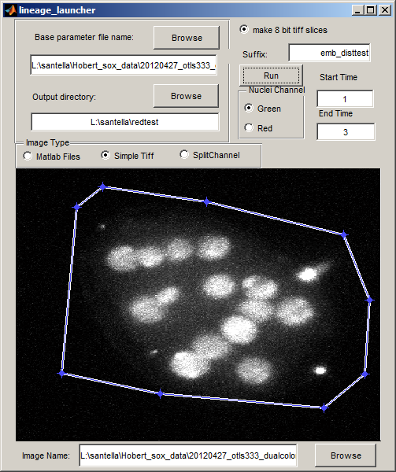

Should output 8 bit slices in format expected by acetree, and acetree zip and xml files

These will include two copies of identical content one suffixed –edited the _edited one will have an auxinfo file accompanying. See Lineage_Editing_Notes.doc for instructions on how to edit this file and the lineage to ensure accurate Sulston naming.