Memory Lifter[1]

|  |  |
| --- | --- |
| Hamid Shahrestani Mehr | 9729747 |
| Shahla Noori | 5972671 |

# Background on OSS Project

## The history and motivation behind the project

**MemoryLifter** is educational software following flashcard patterns that uses spaced repetition and mnemonic learning elements to speed up learning process.

## Information on who uses the project and the domain

There is a huge community of people interested in this software using it. Learning modules are a huge part of it. Currently there are 153 registered modules on its website.

## Level of activity on the project

Some of the reasons we considered this project is:

- The software is written in C#. We are C# programmers, thus easier for us to fully comprehend it.

- The business domain is easy to grasp and quite interesting.

- The project is active and a community of people is using it.

- The software by itself is fascinating and very useful for learning purposes.

The project is that of an Alpha. The last major release (2.4.1) was conducted in December 2012. The project started in 2008. They switched their source control software to Microsoft Team Foundation in 2012. The first recorded change in TFS was done in March 2012.

Currently there are 23 developers including us working on the project. 2 of them are coordinators and 3 of them are editors.

As of now 13 major issues are recorded in TFS that needs to be fixed.

As far as our expertise:

- Shahla Noori: 8 years’ experience in programming with Microsoft Platform, C# .net2/3/3.5

- Hamid Mher: 3 years’ experience in programming with Microsoft Platform, C#, .net2/3/3.5

Our expertise tightly relates with the project specification as it was initially started with .net2 and evolved to .net3.5 over time. So we will have very good opportunities to understand and contribute to the project.

# Management and Process

## The project governance structure

We discussed two types of governance structure in class; Oligarchy and Dictatorship. We discussed how Linux is that of a Dictatorship and how FreeBSD is Oligarchy. This project also follows Oligarchy structure. There are 23 contributors out of which there are 2 coordinators, 3 editors and the rest are developers. The whole team makes decision about project changes.

## The projects source code management practices

They initially hosted their code on SVN. But starting from 20012, they migrated to Microsoft Team Foundation Server which has inherent integration on Codeplex. TFS like SVN is not distributed. For our internal coordination we used a Git repository among the two of us.

## How review and bug tracking is handled

Issue tracker is hosted on Codeplex.com. There are no other independent tools used for this purpose. To submit a pull request in TFS you have to send a review request through TFS for this project.

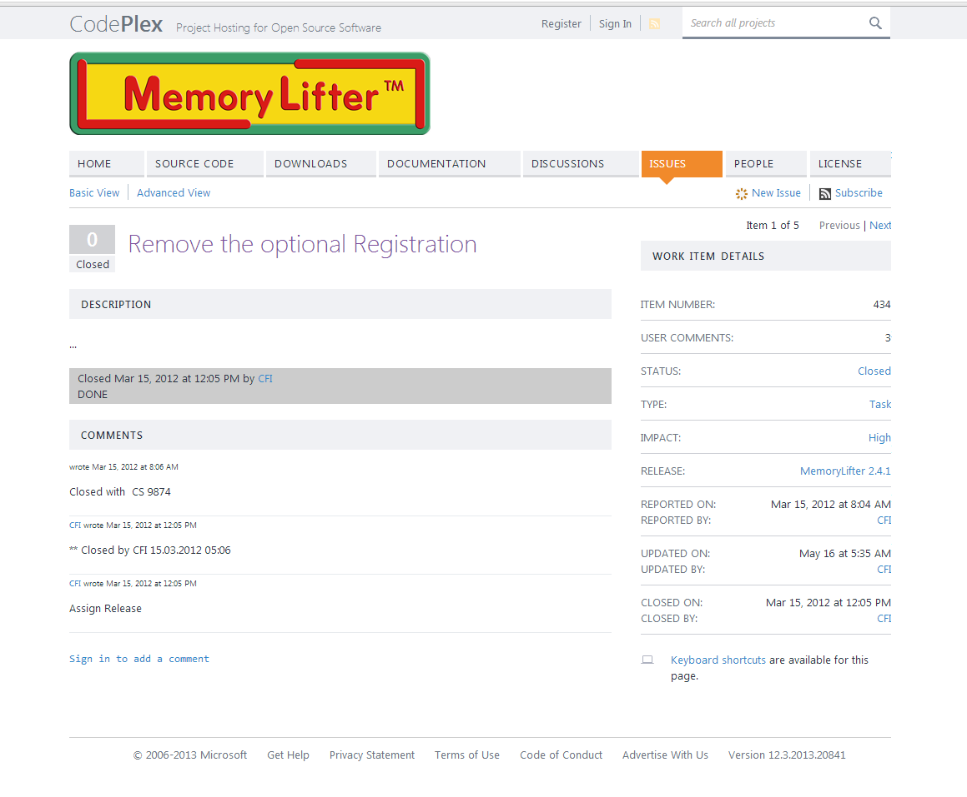

## Legal and licensing information

Copyright holder is an American company named LearnLift. They have released the source code under LGPL license. They have also registered “MemoryLifet” as a Trademark.

## How releases are managed

The latest stable version is 2.4.1. The releases are published by project leader which in this case is [one](https://www.codeplex.com/site/users/view/CFI) of the coordinators. This was also our contact person during our contribution. When there are significant changes they release a new version. In case of small patchsets they publish a new release of the software. This is all managed by the project team leader.

# Appendix

**Correspondence**

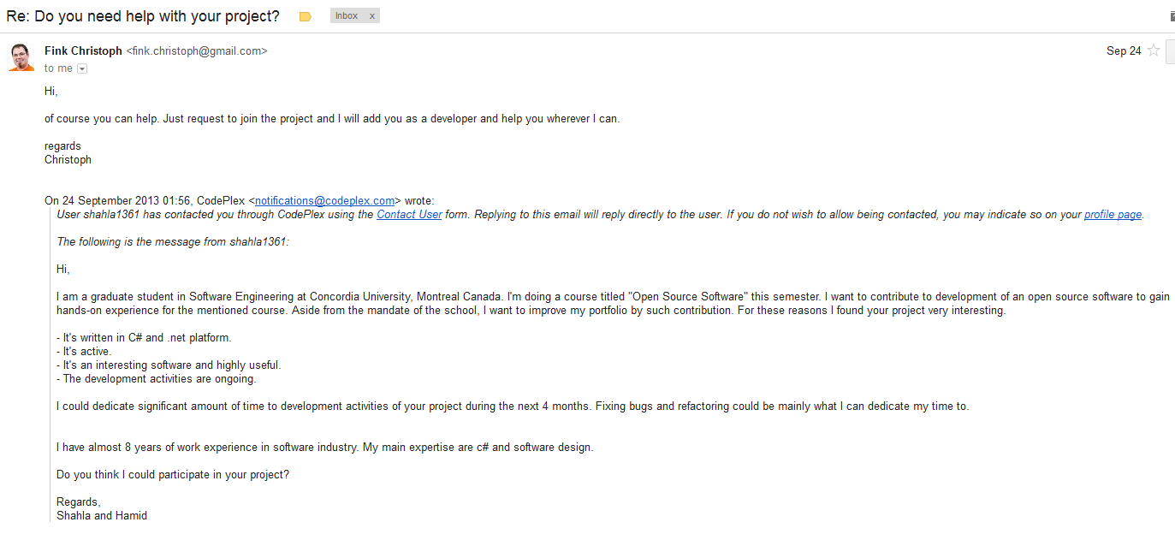

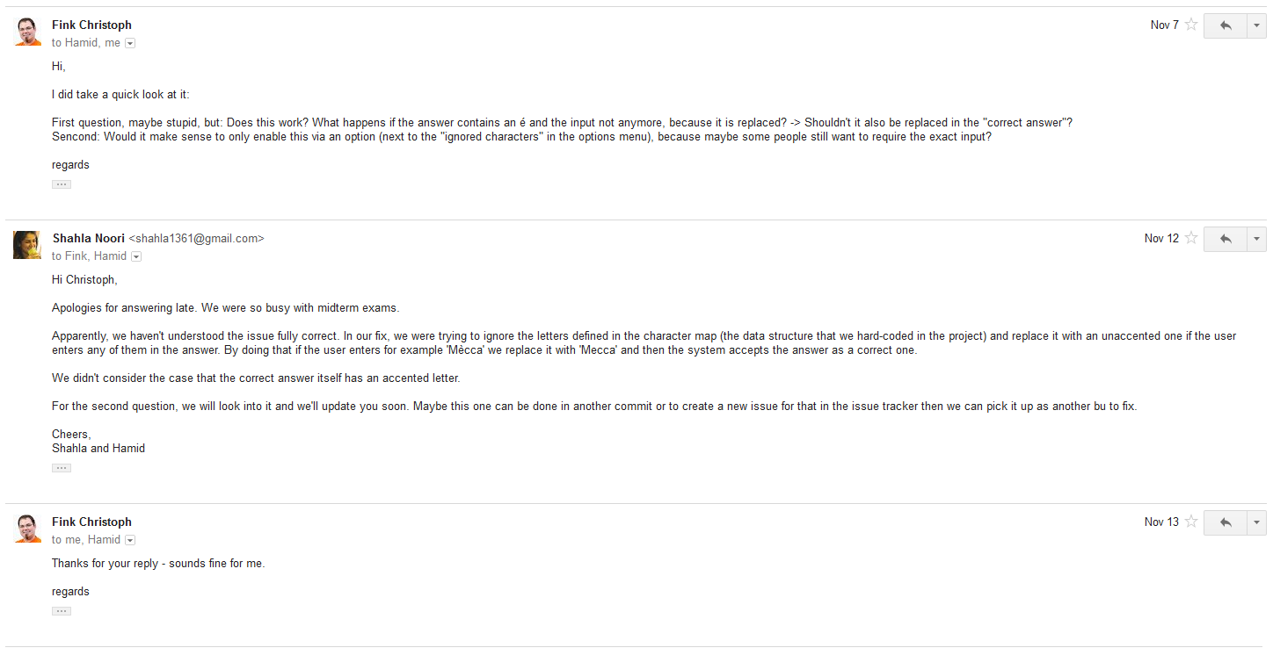

1. <http://memorylifter.codeplex.com/>