Mujeeb Rahaman T
Calicut, Kerala, India
Mob:+919766912558/+918129424825
mujeebrahman1984@gmail.com

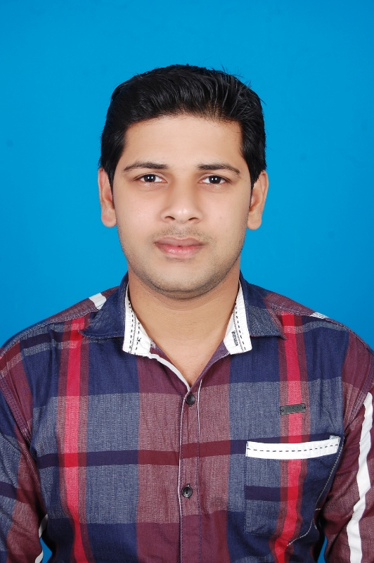

Career Objective
Work and learn in challenging environment, taking up innovative assignments and to establish a position in which I can utilize my skills and abilities that offers professional growth while being resourceful, innovative and flexible.

Education
VNIT, Nagpur, India
Master of Technology in Computer Science Engineering, June 2010.
CGPA: 8.34
Institution of Engineers (India), Kolkata, India
Degree in Computer Science & Engineering, March 2008.
CGPA: 8.87
Kerala Govt. Polytechnic College, Calicut, India
Diploma in Computer Engineering, April 2005

Relevant Coursework: Computer Networks, Object Oriented and Procedural Oriented Programming, Design & Analysis of Algorithms, Operating Systems, Software Engineering, Digital Logic Designs, Industrial Management, Database Management, Computer Architecture.

Skills
Development: Java, C, C++, VB, SQL, HTML, ASP, ODBC, JDBC, JSP
Platforms: Microsoft Visual Studio, JDK, MS Office, Open Office, Packet Tracer
Environments: Microsoft Windows family, Ubuntu, Cent OS, Internet, DOS
Languages: English, Hindi, Malayalam

Projects And Research
User Experience Enhancement to OfficeBox Product, Nov 2014 – Present
- OfficeBox Software Pvt. Ltd. is one of the pioneer in indian cloud based ERP’s.
- The project work involves upgrading the existing features which were developed using ASP.NET controls to the newer Telerik controls.
Network Intrusion Detection System Using Soft Computing, Sept 2014 – Present
- Project work involves detecting the new attack or anomalous traffic in a network with high intrusion detection rate while maintaining low false alarm rate.
Dynamic Programming Approach for Reliable Network Design, Sept 2014 - Present
- Designing an efficient network topology with maximum all-terminal reliability subject to a cost constraint.
- Planning to use CAREL technique for network reliability calculation.

Automatic Accident Detection and Reporting Framework for Two Wheelers, March 2014
- Designed an inexpensive but intelligent framework that can identify and report an accident for two wheelers.
- This framework includes a microcontroller-based low-cost Accident Detection Unit (ADU) that contains a GPS positioning system and a GSM modem to sense and generate accidental events to a centralized server.
Performance Analysis of Image Segmentation using Parallel Processing, June 2014
- Developed algorithm improved the performance of image segmentation using parallel processing.
PC Monitoring and Security Using Cell Phone, March 2013
- Project designed to send the notification and live video to the owner’s mobile phone.
- Implemented by using Java, JMF, socket programming and Android programming.
Website for Microsoft User Group Nagpur, March 2013
- Website gives the information about various Microsoft technologies events, seminars and workshops in Nagpur region.
- Developed by using Visual Studio 2010, SQL server 2008.
Development of an Algorithm for Integrated Traffic Management System, for the completion of M.Tech in Computer Science Engineering, VNIT, June 2010

Professional Experience
St.Vincent Pallotti College of Engineering & Technology, Nagpur, India
Assistant Professor, Dec 2010 – Present
- Guide various academic as well as live projects.
- Participate in project planning sessions with project analysts and team members to analyze academic live projects.
- Coordinate Institute-Industry-Interaction Cell.
- Teach subjects such as Computer Networks, Programming Languages, Algorithms, Operating Systems, Digital Electronics and Computer Architecture for UG and PG students.
- Teach computer laboratories for programming students.
- Teach Computer Networking practical for UG students.
- Coordinate the Training & Placement activities.
- Team member to develop MIS.
- Team member for SAP B1 training.
- Work as class counselor.

Rajagiri School of Engineering & Technology, Cochin, India
Assistant Professor, July 2010 – Dec 2010
- Taught computer laboratories for programming students.
- Taught subjects such as Computer Networks and Programming Languages for UG students.
- Worked as class counselor and exam committee member.

Professional Affiliation
Cisco Id : CSCO12817679
Associate Member of Institution of Engineers India (IEI).
Associate Member No - AM134907-7
Associate Member of Computer Society of India (CSI).
Membership Number – I1500553
Achievements
GATE 2007 Qualified.
CISCO CCNA certified, May 2015.
Completed SAP B1 training course, July 2014.
College Team Coach for ACM ICPC programming contest, Dec 2013.
Completed JAVA Programming certification course. Oct 2012.

Activities
Syllabus Restructuring workshop for CE & IT branch, Nagpur University. March 2015.
- Participated in Syllabus restructuring workshop for CE & IT branch organized by RTMNU, Nagpur.
AEECIT’14, St.Vincent Pallotti College of Engineering & Technology. April 2014.
- Organized Short Term Training Program on “Advanced Engineering Education for Computing and Information Technology”.
TACIT’12, St.Vincent Pallotti College of Engineering & Technology. Sept 2012.
- Organized National conference on “trends in Advanced Computing and Information technology”.
Management of Data, VNIT, Dec 2010.
- Attended International Conference on “Management of Data”.

Publications
- Research paper entitled “Accident Detection and Reporting framework for Two Wheelers” published in IEEE Xplore (paper id- IEEE 072, pg 962-967)
- Research paper entitled “Alert Me App! An Android based Mobile Application to Save Human Life” published in International Journal IJRITCC (Volume 3, Issue 2, pg 335-337)
- Research paper entitled “Comparative study for analyzing image segmentation algorithms” published in international journal IJERA (special issue April-2014)
- Research paper entitled “Improving the Performance of CPU Scheduling in Interactive Systems” published in International Journal IJARCS (Volume 4, No. 1, January 2013, 25-28).
- Research paper entitled “Query Processing in Graphical Data” published in International Journal IJARCS (Volume 4, No. 1, January 2013, 34-37).

Interests
Badminton, Football, Cricket, Music.

Declaration:
I hereby declare that above mentioned particulars furnished by me are true to best of my knowledge.

Place: Calicut Mujeeb Rahaman T
Date: 27-May-2015

